




Cisco Systems Advanced Services
Customer Requirements Document (CRD) Template
Version <1.0>

Corporate Headquarters
Cisco Systems, Inc.
170 West Tasman Drive
San Jose, CA 95134-1706
USA
http://www.cisco.com
Tel: 408 526-4000
800 553-NETS (6387)
Fax: 408 526-4100

Introduction 4
Document Purpose and Usage 4
Document History 4
Related Documents 4
Technologies/Solution Scope 5
Primary Technology/Solution 5
Other Technologies/Solutions 5
Scope 5
Overview 6
Customer Description 6
Opportunity Type 6
Revenue Impact to Cisco and Strategic Impact 7
Engagement Profile 7
Deployment Timeframes 8
Service Descriptions 9
Requirements for Service (X) 9
Service/Application Overview 9
Customer Availability Requirements 9
Customer Performance Requirements 9
Customer Security Requirements 9
Customer NMS/OSS Requirements 9
Customer Required Features 10
Assumptions 10
Requirements for Service (Y) 10
Service/Application Overview 11
Customer Availability Requirements 11
Customer Performance Requirements 11
Customer Security Requirements 11
Customer NMS/OSS Requirements 11
Customer Required Features 11
Assumptions 11
Network Description 12
Physical Topology 12
Hardware/Software Matrix 13
Logical Topology 14
Data Specific Information 14
Voice Specific Information 14
Lab and Field Trial Requirements 14
Potential Risks 15
Network Management and Operation Management Requirements 16
Existing NMS/OSS Systems 16
Modification to Existing NMS/OSS Systems 16
New NMS/OSS Requirements 16
NMS Transport Network 17
NMS/OSS Integration with Other Vendors 17
Interoperability 18
Interoperability Requirements 18
Interconnection/Integration with Other Networks 18
Network Elements of Other Vendors 18
Appendices 19

Introduction

Document Purpose and Usage
This document should be used to detail the customer requirements for a project in which CA Network Integration will be proposed. It is only required to be completed upon the request of the AS Geography or Vertical Leader, after initial deal qualification has been performed.
Upon completion and submission, this document will be uploaded into EDCS and subject to document control. The template for this document can be found at: http://wwwin-tools/sales/go/as/stamps/templates . Questions regarding this template should be sent to: crd-registration-emea@cisco.com.>
Normally, this document is completed by a Cisco Account Team.
SE Author(s): <SE’s Name>
AM Author(s): <AM’s Name>

Document History
Version No. | Issue Date | Status | Reason for Change
<1.0> | xx.yy.abcd | Draft | Initial Document

Change Forecast: <High/Medium/Low>
This document will be kept under revision control.
A printed copy of this document is considered uncontrolled.

Related Documents
<Please list any documents that provide additional information to this CRD.>
Doc No. | Title | Rev. | Date | File Name | Location

Technologies/Solution Scope

Primary Technology/Solution
<Please provide a headline for the Primary solution>
<The sample below is for a specific customer. Do not use this sample. Please put your customer’s details>
MPLS Edge (Cisco7600) Leased l Line

Other Technologies/Solutions
<Please provide what other technologies/solutions can be used in conjunction with the primary solution>
<The sample below is for a specific customer. Do not use this sample. Please put your customer’s details>
Focus on a complex QoS Design

Scope
<Please provide scope of this CRD>
<The sample below is for a specific customer. Do not use this sample. Please put your customer’s details>

Overall is our message to build up a network with a simple structure for production until mid of next year.
We need follow tasks:
- Backbone and Edge Engineering Manual (LLD) inclusive Configuration Templates
- Proof of Concept (Cisco Lab)
- Migration concept / M40e customer to Cisco7600
- On-Site Support INMC for the build phase and migration (INMC = International Network Management Center)
- Installation Service for the Cisco7600 with Site Planning

Overview

Customer Description
<Please provide a Customer Description in terms of their business, network and services they provide and want to provide going forward>
<The sample below is for a specific customer. Do not use this sample. Please put your customer’s details>
The customer ABC is a subsidiary of Funky Telekom Group (FT) and responsible for FT’s business customers.
ABC offers Managed VPN Services and other value-added services. Also a complete outsourcing is offered to the customer base.
In October 2002, ABC started to deploy its global MPLS infrastructure, called IPLS (International Production Line Services). This infrastructure has been built in a traditional way exclusively with Cisco 12000 Series, Cisco 7500 Series, and Cisco 7200 Series routers, based on a SDH infrastructure. This network – which will be referred to as “SDH-based IPLS” and is described in detail later on – consist of about 15 POPs in Funkyland and 30 POPs worldwide.
In September 2003, ABC decided to build a major extension of IPLS with 30 new POPs in Funkyland, which are connected to T-Com’s IP Backbone via CsC. ABC decided to roll-out collapsed POPs, which means a single SPE/PE box per POP, based on Juniper M40e. This network – which is connected to the SDH-based IPLS via redundant Cisco 12000 gateways – is referred to as “CsC-based IPLS”. The Low Level Design document for this CsC architecture has been developed by AS and is included later on in this document.
ABC had certified the Cisco 7600 as Multi-Service Edge in their Labs. We expect official order for a production system in Q1/2005.
ABC has decided to have only one responsible pillar for the VPN services. The legacy VPN Service Intraselect Smart is today produce from T-COM on the IP2 Backbone. For a clear boarder get the ABC the responsibility over whole VPN Services within ABC-
ABC has at the moment large problems with the provisioning tools and process handling. The single vendor approach was discussed in the last month intensive with management of ABC.
The scope of the cover extension:
We want to over to models for the coverage extension:
A) Extension of the current national coverage of 30 PoPs (M40e) to 74 PoP locations with redundant systems with Cisco7600 (148 Router Systems) in each firewall section in the different locations. The connections of the M40e will migrate to the Cisco7600 after a successful roll-out of it. The M40e hardware is a part of the trade in program offered by Cisco.
B) Extension of the current national coverage of 30 PoPs (M40e) to 74 PoP locations with redundant systems in each firewall section in the different locations. Cisco offer in this case 44 Pops with redundant Cisco7600 (88 Router Systems).

Opportunity Type
<Choose one of the following types:
“Existing network/application. Please give an overview of the current network and future direction, if known Please summarize the services that customer will offer to its own customers. Also please summarize the applications/services that they will support on this network.>
<The sample below is for a specific customer. Do not use this sample. Please put your customer’s details>
ABC is a Service Provider and owned all business customers from ABC. The highest priority at for service is a scalable VPN Production platform.
Different initiatives are under progress:
- Consultation of the L3 VPN Service => under progress (part of this CRD)
- Voice Solution for Enterprise Customer (MSP) => RFP lost
- Managed LAN Services => under progress
- L2VPN’s Services => Future
- Integration of L2 Service (FR) on the IP Backbone (MSE) => Future

Revenue Impact to Cisco and Strategic Impact
<Indicate the projected Cisco revenue for products and services over the next 12 months:
Option A (144 Systems)
Product: $17.539.696 (E1 discrete.) or $8.863.808 (CHOC3)
Services: $3.855.326 (E1 discrete.) or $2.634.028 (CHOC3)
Option B (88 Systems)
Product: $12.037.488 (E1 discrete.) or $6.879.712 (CHOC3)
Services: $ 2.310.631 (E1 discrete.) or $1.584.575 (CHOC3)

What is the strategic impact of this opportunity to the customer? For example, is the required technology/ solution required in order to solve an important issue, make them more profitable, give them a competitive edge over competition, etc?>
<The sample below is for a specific customer. Do not use this sample. Please put your customer’s details>
We are in competition which Juniper for the extension of the Backbone. ABC search for a solution to simplify the current Network Solution. The main topic is the complex provisioning (hand make) in the current structure. The management has understand that a single vendor reduce the complexity and help to accelerate the service development.

Engagement Profile
<Consider the following questions for this subsection:
Is Cisco expected to be the prime contractor for services on this opportunity?

If the customer is a current Cisco customer, how do they get CA support?
__Direct from Cisco, or ___via a Partner: _______

Does the customer currently have an Advanced Services contract?

Does the customer have budget allocated for services?>

Deployment Timeframes

Deployment Target | Start Date | End Date
Entire Project (if known)
Deal Closure, Product
Deal Closure, Services
Project Kick-off
Equipment Installation
Test Period
Network in Production

Service Descriptions
<Please provide details about the type of services they plan to offer using the proposed equipment and solution. Please provide details about the internal applications and/or services they will offer. Please duplicate the section below for each service.>

Requirements for Service (X)

Service/Application Overview
<Please provide a technical overview of the application/service that the customer wishes to provide with this network.>
<The sample below is for a specific customer. Do not use this sample. Please put your customer’s details>

ABC would like to deploy the following services in their network
- MPLS-L3VPN service
- MPLS-L2VPN service
- Traffic Engineering
- IPv6/6PE services
- Multicast VPN services
- Etc, etc

Customer Availability Requirements
<Please provide a technical overview of the Customer Availability Requirements in this network.>
<The sample below is for a specific customer. Do not use this sample. Please put your customer’s details>
The goal is to reach a core availability of 99.999%.
The customer would like to have NSF, SSO and Hitless Software Upgrade

Customer Performance Requirements
<Please provide a technical overview of the Customer Performance Requirements in this network.>
<The sample below is for a specific customer. Do not use this sample. Please put your customer’s details>
While >80% of connections to the PE’s will be E1 and below over the next period of time, ABC’s expectation is to deploy only boxes with highest performance also with enabled features. That is the background to ABC’s decision to not purchase any new Cisco 7500 Series, but test and certify the Cisco 7600 as well as Juniper PE systems.

Customer Security Requirements
<Please provide a technical overview of the Customer Security Requirements in this network.>
<The sample below is for a specific customer. Do not use this sample. Please put your customer’s details>
ABC has no special security requirement as Service Provider. They follow in past Cisco recommendation about Service Provider PE Security.

Customer NMS/OSS Requirements
<Please identify all aspects of Service Management features for this service:
Service Fulfillment (Service Provisioning and Configuration Management)
Service Assurance (Fault Management and Performance Management)
Billing and Accounting>

Customer Required Features
<Please identify all critical Cisco features required in order to provide this service/application, including those that are not yet FCS.>

Assumptions
<Please state all assumptions made by the account team and the customer when defining the service (i.e. availability of equipment, software release availability, etc.)>

Requirements for Service (Y)
<Please provide a technical overview of the Customer Service Y in this network.>
<The sample below is for a specific customer. Do not use this sample. Please put your customer’s details>

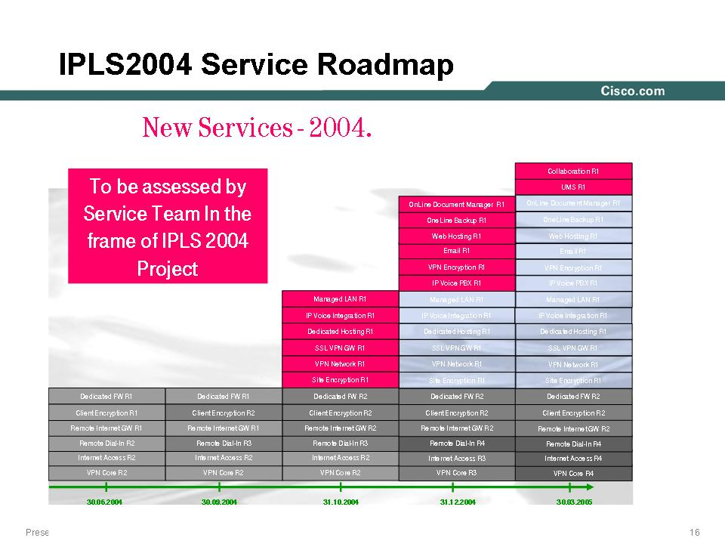

Service/Application Overview
<Please provide a technical overview of the application/service that the customer wishes to provide with this network.>

Customer Availability Requirements
<Please identify the network requirements for this service, considering system availability, behavior under failure scenarios, service restoration, etc.>

Customer Performance Requirements
<Please identify all performance requirements for this service.>

Customer Security Requirements
<Please identify all security requirements for this service.>

Customer NMS/OSS Requirements
<Please identify all aspects of Service Management features for this service:
Service Fulfillment (Service Provisioning and Configuration Management)
Service Assurance (Fault Management and Performance Management)
Billing and Accounting>

Customer Required Features
<Please identify all critical Cisco features required in order to provide this service/application, including those which are not yet FCS.>

Assumptions
<Please state all assumptions made by the account team and the customer when defining the service (i.e. availability of equipment, software release availability, etc.)>

Network Description

Physical Topology
<Please provide a Physical Topology of the customer’s current network Also mention any on going deployments. >
<The sample below is for a specific customer. Do not use this sample. Please put your customer’s details>

Three networks are involved in the “IPLS Big Bang” approach:
- SDH-based IPLS
- CsC-based IPLS
In October 2002, ABC started to deploy its global MPLS infrastructure, called IPLS (International Production Line Services). This infrastructure has been built in a traditional way exclusively with Cisco 12000 Series, Cisco 7500 Series, and Cisco 7200 Series routers, based on a SDH infrastructure. This network – which will be referred to as “SDH-based IPLS” and is described in detail later on – consist of about 15 POPs in Funkyland and 30 POPs worldwide.
In September 2003, ABC decided to build a major extension of IPLS with 30 new POPs in Funkyland, which are connected to T-Com’s IP Backbone via CsC. ABC decided to roll-out collapsed POPs, which means a single SPE/PE box per POP, based on Juniper M40e. This network – which is connected to the SDH-based IPLS via redundant Cisco 12000 gateways – is referred to as “CsC-based IPLS”. The Low Level Design document for this CsC architecture has been developed by AS and is included later on in this document.
The IPLS network is undergoing a change at the moment. Future extensions of the IPLS network will be made using the CsC service offered by XYZ
Figure 1 Topology of the SDH-based IPLS Network

< Customer Topology>
Figure 2 Topology of the CsC-based IPLS
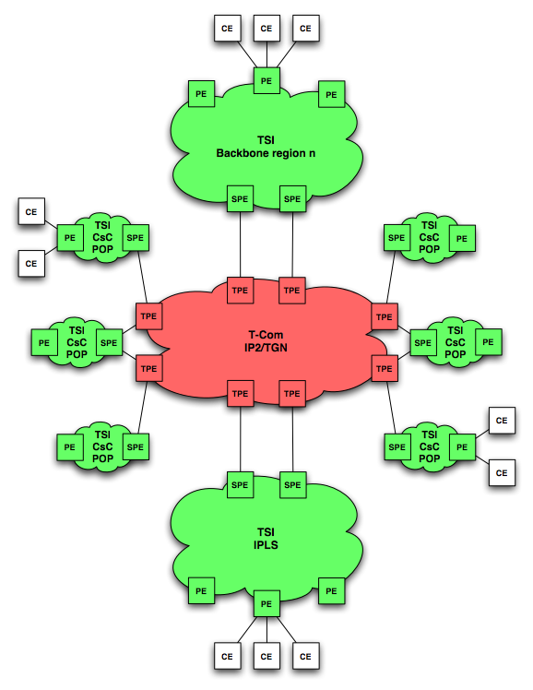

Traffic capacity and flow details for the existing network
<Please provide a description of traffic capacity and flow details per POP or for the entire network. Also mention any on going deployments>

Customer distribution per POP and per PE router
<Please provide a description of customer distribution details per POP or per PE router. Also mention any on going deployments>

Hardware/Software Matrix
<Please provide a description of Hardware platforms, their roles and the Software/Firmware. Also mention any on going deployments>
<The sample below is for a specific customer. Do not use this sample. Please put your customer’s details>

Hardware Platform | Device Purpose | Software Version | Firmware Version
GSR 12000 series | P | 12.0(26)S
Cisco 7500 series | PE | 12.0(26)S of 12.2(13)T8
Cisco 7200 VXR | PE, RR | 12.0(26)S of 12.2(13)T8
Juniper M40e Series | SPE/PE | JunOS

Layer 2 and 3 protocols
<Please provide information about the customer’s existing Layer 2 and Layer 3 information. Also mention any on going deployments>

<The sample below is for a specific customer. Do not use this sample. Please put your customer’s details>
Proposed L2 protocols (including multicast) = FR, PPP, ETH;
Proposed L3 protocols (both IGP, EGP, and multicast) = IP (MPLS)
Addressing (IP, ATM, etc.) = IP
Quality of Service (QoS) = Yes up to 6 classes
MPLS = Yes
Security policies> = Yes

Voice Specific Information
<If Voice is being proposed, please provide the following>
What signaling will the customer use for call control (i.e. PRI, ISUP, MF, etc)?
Traffic scalability: BHCA, AHT, CCS, and Erlangs. This information should be broken down as far as possible into city, and/or PoP, and/or Interconnect Switch(s).
Number of trunks
What are the uses/purposes of the network nodes (local, transit, Int’l gateway, private network, tandem etc.) for interconnecting PSTN?
Dial plan. Blacklist/Whitelist, number translation, alternate routing, resilience, etc.>

Lab and Field Trial Requirements
<Please list lab and field trials in progress. Specify additional lab/field trials or lab/field verification requirements.>
<The sample below is for a specific customer. Do not use this sample. Please put your customer’s details>
The customer had successful test the Cisco76k in his labs.
We don’t have a running System at the moment in the Backbone

Potential Risks
<Please identify potential risks associated with schedule delays and feature delivery.>
<The sample below is for a specific customer. Do not use this sample. Please put your customer’s details>

- Software Problems / Quality
- Performance with QoS (CHOC3)
- Label Space limitation on the M40e
- Rack Space in the different PoP Locations
- Certification time line for the PA-MC-STM1
- Juniper get the project

Network Management and Operation Management Requirements

Existing NMS/OSS Systems
<Please describe all the existing NMS or OSS systems that will be used partially or fully to management the solution proposed to the customer. Details on the following topics are required:
Versions of NMS/OSS applications
Provisioning & configuration
Fault & performance
Billing & accounting systems
Trouble ticket
Inventory systems
The hardware and OS (Operating Systems) used to operate these systems.>

Modification to Existing NMS/OSS Systems
<Please describe any modifications to the existing NMS/OSS systems that are required to meet the solution proposed to the customer. This includes version upgrades, input of new network elements, changes to operational aspects of the systems.>

New NMS/OSS Requirements
<Please list the new Network Management products to be installed and commissioned to support the solution proposed to the customer. These may include:
Versions of NMS/OSS applications
Provisioning & configuration
Fault & performance
Billing & accounting systems
Trouble ticketing
Inventory systems
The hardware and OS (Operating Systems) used to operate these systems
Details of any NOC installation required
Details of know hardware or IOS/CatOS software dependencies for NMS applications>

NMS Transport Network
<Please describe the data network being used to provide connection to the network elements for management purposes.
In band (using the data backbone) => Yes, No
Out of band (separate management network) => Yes, No

NMS/OSS Integration with Other Vendors
<Please state whether the new NMS/OSS system will interconnect or integrate with any non-Cisco NMS/OSS applications.>

Interoperability

Interoperability Requirements

<Please describe any expected interoperability requirements for connecting this network to other networks. <The sample below is for a specific customer. Do not use this sample. Please put your customer’s details>

For the migration time line is it necessary to interoperate with M40e in the same AS.
Interoperability needs to be provided to the following devices:
- 72xx VxR
- Cisco76xx (IOS)
- Juniper ERX 1440
- GSRs (during migration)
For the following protocols interoperability needs to work:
- ISIS
- LDP
- BFD
- Gigabit and 10 Gigabit Ethernet (w/o VLANs)

Interconnection/Integration with Other Networks
<Please state whether this network will interconnect or integrate with any third-party voice or data network.>
<The sample below is for a specific customer. Do not use this sample. Please put your customer’s details>

The IPLS Network is connected over CsC with the ABC Network.
At the moment have the ABC 4 Inter AS Gateways with RFC2547bis 10b. All this Networks are international Backbones from subsidiary of ABC

OSS/Management Components of Other Vendors
<Please describe OSS/Management interactions with non-Cisco equipment.>

Appendices
<Please provide additional Appendices as required.>

CISCO CONFIDENTIAL INFORMATION
THIS DOCUMENT CONTAINS VALUABLE TRADE SECRETS AND CONFIDENTIAL INFORMATION OF CISCO SYSTEMS, INC. AND IT’S SUPPLIERS, AND SHALL NOT BE DISCLOSED TO ANY PERSON, ORGANIZATION, OR ENTITY UNLESS SUCH DISCLOSURE IS SUBJECT TO THE PROVISIONS OF A WRITTEN NON-DISCLOSURE AND PROPRIETARY RIGHTS AGREEMENT OR INTELLECTUAL PROPERTY LICENSE AGREEMENT APPROVED BY CISCO SYSTEMS, INC. THE DISTRIBUTION OF THIS DOCUMENT DOES NOT GRANT ANY LICENSE IN OR RIGHTS, IN WHOLE OR IN PART, TO THE CONTENT, THE PRODUCT(S), TECHNOLOGY OF INTELLECTUAL PROPERTY DESCRIBED HEREIN.
Doc Name Here
Copyright © 2004, Cisco Systems, Inc.
All rights reserved. . Cisco, Cisco Systems, and the Cisco Systems logo are registered trademarks or trademarks of Cisco Systems, Inc. and/or its affiliates in the U.S. and certain other countries
CISCO CONFIDENTIAL INFORMATION

