Simple Nature - engineering physics

1. Conservation of Mass
You are viewing the html version of Simple Nature, by Benjamin Crowell. This version is only designed for casual browsing, and may have some formatting problems. For serious reading, you want the printer-friendly Adobe Acrobat version.

Table of Contents

Contents
Section 1.1 - Mass
Section 1.2 - Equivalence of Gravitational and Inertial Mass
Section 1.3 - Galilean Relativity
Section 1.4 - A Preview of Some Modern Physics

Chapter 1. Conservation of Mass
It took just a moment for that head to fall, but a hundred years might not produce another like it. -- Joseph-Louis Lagrange, referring to the execution of Lavoisier on May 8, 1794
The Republic has no need of scientists. -- Judge Pierre-André Coffinhal's reply to Lavoisier's request for a fifteen-day delay of his execution, so that he could complete some experiments that might be of value to the Republic. Coffinhal was himself executed August 6, 1794. As a scientific experiment, Lavoisier decided to try to determine how long his consciousness would continue after he was guillotined, by blinking his eyes for as long as possible. He blinked twelve times after his head was chopped off.

1.1 Mass

a / Portrait of Monsieur Lavoisier and His Wife, by Jacques-Louis David, 1788. Lavoisier invented the concept of conservation of mass. The husband is depicted with his scientific apparatus, while in the background on the left is the portfolio belonging to Madame Lavoisier, who is thought to have been a student of David's.
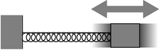
b / The time for one cycle of vibration is related to the object's inertial mass.
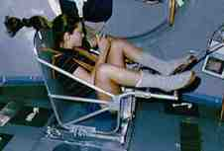
c / Astronaut Tamara Jernigan measures her inertial mass aboard the Space Shuttle.
Change is impossible, claimed the ancient Greek philosopher Parmenides. His work was nonscientific, since he didn't state his ideas in a form that would allow them to be tested experimentally, but modern science nevertheless has a strong Parmenidean flavor. His main argument that change is an illusion was that something can't be turned into nothing, and likewise if you have nothing, you can't turn it into something. To make this into a scientific theory, we have to decide on a way to measure what “something” is, and we can then check by measurements whether the total amount of “something” in the universe really stays constant. How much “something” is there in a rock? Does a sunbeam count as “something?” Does heat count? Motion? Thoughts and feelings?
If you look at the table of contents of this book, you'll see that the first four chapters have the word “conservation” in them. In physics, a conservation law is a statement that the total amount of a certain physical quantity always stays the same. This chapter is about conservation of mass. The metric system is designed around a unit of distance, the meter, a unit of mass, the kilogram, and a time unit, the second.¹ Numerical measurement of distance and time probably date back almost as far into prehistory as counting money, but mass is a more modern concept. Until scientists figured out that mass was conserved, it wasn't obvious that there could be a single, consistent way of measuring an amount of matter, hence jiggers of whiskey and cords of wood. You may wonder why conservation of mass wasn't discovered until relatively modern times, but it wasn't obvious, for example, that gases had mass, and that the apparent loss of mass when wood was burned was exactly matched by the mass of the escaping gases.
Once scientists were on the track of the conservation of mass concept, they began looking for a way to define mass in terms of a definite measuring procedure. If they tried such a procedure, and the result was that it led to nonconservation of mass, then they would throw it out and try a different procedure. For instance, we might be tempted to define mass using kitchen measuring cups, i.e. as a measure of volume. Mass would then be perfectly conserved for a process like mixing marbles with peanut butter, but there would be processes like freezing water that led to a net increase in mass, and others like soaking up water with a sponge that caused a decrease. If, with the benefit of hindsight, it seems like the measuring cup definition was just plain silly, then here's a more subtle example of a wrong definition of mass. Suppose we define it using a bathroom scale, or a more precise device such as a postal scale that works on the same principle of using gravity to compress or twist a spring. The trouble is that gravity is not equally strong all over the surface of the earth, so for instance there would be nonconservation of mass when you brought an object up to the top of a mountain, where gravity is a little weaker.
There are, however, at least two approaches to defining mass that lead to its being a conserved quantity, so we consider these definitions to be “right” in the pragmatic sense that what's correct is what's useful.
One definition that works is to use balances, but compensate for the local strength of gravity. This is the method that is used by scientists who actually specialize in ultraprecise measurements. A standard kilogram, in the form of a platinum-iridium cylinder, is kept in a special shrine in Paris. Copies are made that balance against the standard kilogram in Parisian gravity, and they are then transported to laboratories in other parts of the world, where they are compared with other masses in the local gravity. The quantity defined in this way is called gravitational mass.
A second and completely different approach is to measure how hard it is to change an object's state of motion. This tells us its inertial mass. For example, I'd be more willing to stand in the way of an oncoming poodle than in the path of a freight train, because my body will have a harder time convincing the freight train to stop. This is a dictionary-style conceptual definition, but in physics we need to back up a conceptual definition with an operational definition, which is one that spells out the operations required in order to measure the quantity being defined. We can operationalize our definition of inertial mass by throwing a standard kilogram at an object at a speed of 1 m/s (one meter per second) and measuring the recoiling object's velocity. Suppose we want to measure the mass of a particular block of cement. We put the block in a toy wagon on the sidewalk, and throw a standard kilogram at it. Suppose the standard kilogram hits the wagon, and then drops straight down to the sidewalk, having lost all its velocity, and the wagon and the block inside recoil at a velocity of 0.23 m/s. We then repeat the experiment with the block replaced by various numbers of standard kilograms, and find that we can reproduce the recoil velocity of 0.23 m/s with four standard kilograms in the wagon. We have determined the mass of the block to be four kilograms.² Although this definition of inertial mass has an appealing conceptual simplicity, it is obviously not very practical, at least in this crude form. Nevertheless, this method of collision is very much like the methods used for measuring the masses of subatomic particles, which, after all, can't be put on little postal scales!
Astronauts spending long periods of time in space need to monitor their loss of bone and muscle mass, and here as well, it's impossible to measure gravitational mass. Since they don't want to have standard kilograms thrown at them, they use a slightly different technique (figures b and c). They strap themselves to a chair which is attached to a large spring, and measure the time it takes for one cycle of vibration.
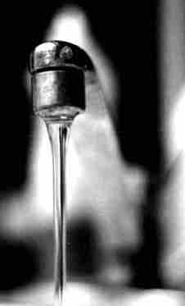
d / Example 1.

Problem-solving techniques
How do we use a conservation law, such as conservation of mass, to solve problems? There are two basic techniques.
As an analogy, consider conservation of money, which makes it illegal for you to create dollar bills using your own laser printer. (Most people don't intentionally destroy their dollar bills, either!) Suppose the police notice that a particular store doesn't seem to have any customers, but the owner wears lots of gold jewelry and drives a BMW. They suspect that the store is a front for some kind of crime, perhaps counterfeiting. With intensive surveillance, there are two basic approaches they could use in their investigation. One method would be to have undercover agents try to find out how much money goes in the door, and how much money comes back out at the end of the day, perhaps by arranging through some trick to get access to the owner's briefcase in the morning and evening. If the amount of money that comes out every day is greater than the amount that went in, and if they're convinced there is no safe on the premises holding a large reservoir of money, then the owner must be counterfeiting. This inflow-equals-outflow technique is useful if we are sure that there is a region of space within which there is no supply of mass that is being built up or depleted.

Example 1: A stream of water
If you watch water flowing out of the end of a hose, you'll see that the stream of water is fatter near the mouth of the hose, and skinnier lower down. This is because the water speeds up as it falls. If the cross-sectional area of the stream was equal all along its length, then the rate of flow (kilograms per second) through a lower cross-section would be greater than the rate of flow through a cross-section higher up. Since the flow is steady, the amount of water between the two cross-sections stays constant. Conservation of mass therefore requires that the cross-sectional area of the stream shrink in inverse proportion to the increasing speed of the falling water.
self-check: Suppose the you point the hose straight up, so that the water is rising rather than falling. What happens as the velocity gets smaller? What happens when the velocity becomes zero? (answer in the back of the PDF version of the book)
How can we apply a conservation law, such as conservation of mass, in a situation where mass might be stored up somewhere? To use a crime analogy again, a prison could contain a certain number of prisoners, who are not allowed to flow in or out at will. In physics, this is known as a closed system. A guard might notice that a certain prisoner's cell is empty, but that doesn't mean he's escaped. He could be sick in the infirmary, or hard at work in the shop earning cigarette money. What prisons actually do is to count all their prisoners every day, and make sure today's total is the same as yesterday's. One way of stating a conservation law is that for a closed system, the total amount of stuff (mass, in this chapter) stays constant.

Example 2: Lavoisier and chemical reactions in a closed system
The French chemist Antoine-Laurent Lavoisier is considered the inventor of the concept of conservation of mass. Before Lavoisier, chemists had never systematically weighed their chemicals to quantify the amount of each substance that was undergoing reactions. They also didn't completely understand that gases were just another state of matter, and hadn't tried performing reactions in sealed chambers to determine whether gases were being consumed from or released into the air. For this they had at least one practical excuse, which is that if you perform a gas-releasing reaction in a sealed chamber with no room for expansion, you get an explosion! Lavoisier invented a balance that was capable of measuring milligram masses, and figured out how to do reactions in an upside-down bowl in a basin of water, so that the gases could expand by pushing out some of the water. In a crucial experiment, Lavoisier heated a red mercury compound, which we would now describe as mercury oxide (HgO), in such a sealed chamber. A gas was produced (Lavoisier later named it “oxygen”), driving out some of the water, and the red compound was transformed into silvery liquid mercury metal. The crucial point was that the total mass of the entire apparatus was exactly the same before and after the reaction. Based on many observations of this type, Lavoisier proposed a general law of nature, that mass is always conserved. (In earlier experiments, in which closed systems were not used, chemists had become convinced that there was a mysterious substance, phlogiston, involved in combustion and oxidation reactions, and that phlogiston's mass could be positive, negative, or zero depending on the situation!)

Delta notation
A convenient notation used throughout physics is Δ, the uppercase Greek letter delta, which indicates “change in” or “after minus before.” For example, if b represents how much money you have in the bank, then a deposit of $100 could be represented as $\Delta{}b=$100$. That is, the change in your balance was $100, or the balance after the transaction minus the balance before the transaction equals $100. A withdrawal would be indicated by Δb<0. We represent “before” and “after” using the subscripts i (initial) and f (final), e.g. Δb=b_{f}-b_{i}. Often the delta notation allows more precision than English words. For instance, “time” can be used to mean a point in time (“now's the time”), t, or it could mean a period of time (“the whole time, he had spit on his chin”), Δt.
This notation is particularly convenient for discussing conserved quantities. The law of conservation of mass can be stated simply as Δm=0, where m is the total mass of any closed system.
self-check: If x represents the location of an object moving in one dimension, then how would positive and negative signs of Δx be interpreted? (answer in the back of the PDF version of the book)

Discussion Questions
◊ If an object had a straight-line x-t graph with Δ x=0 and Δ t≠0, what would be true about its velocity? What would this look like on a graph? What about Δ t=0 and Δ x≠0?

1.2 Equivalence of Gravitational and Inertial Mass

a / The two pendulum bobs are constructed with equal gravitational masses. If their inertial masses are also equal, then each pendulum should take exactly the same amount of time per swing.
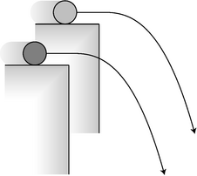
b / If the cylinders have slightly unequal ratios of inertial to gravitational mass, their trajectories will be a little different.
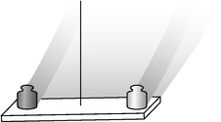
c / A simplified drawing of an E\"otv\"os-style experiment. If the two masses, made out of two different substances, have slightly different ratios of inertial to gravitational mass, then the apparatus will twist slightly as the earth spins.
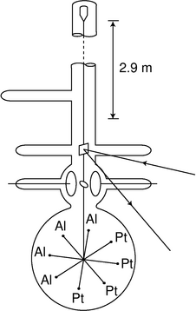
d / A more realistic drawing of Braginskii and Panov's experiment. The whole thing was encased in a tall vacuum tube, which was placed in a sealed basement whose temperature was controlled to within 0.02°C. The total mass of the platinum and aluminum test masses, plus the tungsten wire and the balance arms, was only 4.4 g. To detect tiny motions, a laser beam was bounced off of a mirror attached to the wire. There was so little friction that the balance would have taken on the order of several years to calm down completely after being put in place; to stop these vibrations, static electrical forces were applied through the two circular plates to provide very gentle twists on the ellipsoidal mass between them. After Braginskii and Panov.
We find experimentally that both gravitational and inertial mass are conserved to a high degree of precision for a great number of processes, including chemical reactions, melting, boiling, soaking up water with a sponge, and rotting of meat and vegetables. Now it's logically possible that both gravitational and inertial mass are conserved, but that there is no particular relationship between them, in which case we would say that they are separately conserved. On the other hand, the two conservation laws may be redundant, like having one law against murder and another law against killing people!
Here's an experiment that gets at the issue: stand up now and drop a coin and one of your shoes side by side. I used a 400-gram shoe and a 2-gram penny, and they hit the floor at the same time as far as I could tell by eye. This is an interesting result, but a physicist and an ordinary person will find it interesting for different reasons.
The layperson is surprised, since it would seem logical that heaver objects would always fall faster than light ones. However, it's fairly easy to prove that if air friction is negligible, any two objects made of the same substance must have identical motion when they fall. For instance, a 2-kg copper mass must exhibit the same falling motion as a 1-kg copper mass, because nothing would be changed by physically joining together two 1-kg copper masses to make a single 2-kg copper mass. Suppose, for example, that they are joined with a dab of glue; the glue isn't under any strain, because the two masses are doing the same thing side by side. Since the glue isn't really doing anything, it makes no difference whether the masses fall separately or side by side.³
What a physicist finds remarkable about the shoe-and-penny experiment is that it came out the way it did even though the shoe and the penny are made of different substances. There is absolutely no theoretical reason why this should be true. We could say that it happens because the greater gravitational mass of the shoe is exactly counteracted by its greater inertial mass, which makes it harder for gravity to get it moving, but that just begs the question of why inertial mass and gravitational mass are always in proportion to each other. It's possible that they are only approximately equivalent. Most of the mass of ordinary matter comes from neutrons and protons, and we could imagine, for instance, that neutrons and protons do not have exactly the same ratio of gravitational to inertial mass. This would show up as a different ratio of gravitational to inertial mass for substances containing different proportions of neutrons and protons.
Galileo did the first numerical experiments on this issue in the seventeenth century by rolling balls down inclined planes, although he didn't think about his results in these terms. A fairly easy way to improve on Galileo's accuracy is to use pendulums with bobs made of different materials. Suppose, for example, that we construct an aluminum bob and a brass bob, and use a double-pan balance to verify to good precision that their gravitational masses are equal. If we then measure the time required for each pendulum to perform a hundred cycles, we can check whether the results are the same. If their inertial masses are unequal, then the one with a smaller inertial mass will go through each cycle faster, since gravity has an easier time accelerating and decelerating it. With this type of experiment, one can easily verify that gravitational and inertial mass are proportional to each other to an accuracy of 10⁻³ or 10⁻⁴.
In 1889, the Hungarian physicist Roland E\"otv\"os used a slightly different approach to verify the equivalence of gravitational and inertial mass for various substances to an accuracy of about 10⁻⁸, and the best such experiment, figure d, improved on even this phenomenal accuracy, bringing it to the 10⁻¹² level.⁴ In all the experiments described so far, the two objects move along similar trajectories: straight lines in the penny-and-shoe and inclined plane experiments, and circular arcs in the pendulum version. The E\"otv\"os-style experiment looks for differences in the objects' trajectories. The concept can be understood by imagining the following simplified version. Suppose, as in figure b, we roll a brass cylinder off of a tabletop and measure where it hits the floor, and then do the same with an aluminum cylinder, making sure that both of them go over the edge with precisely the same velocity. An object with zero gravitational mass would fly off straight and hit the wall, while an object with zero inertial mass would make a sudden 90-degree turn and drop straight to the floor. If the aluminum and brass cylinders have ordinary, but slightly unequal, ratios of gravitational to inertial mass, then they will follow trajectories that are just slightly different. In other words, if inertial and gravitational mass are not exactly proportional to each other for all substances, then objects made of different substances will have different trajectories in the presence of gravity.
A simplified drawing of a practical, high-precision experiment is shown in figure c. Two objects made of different substances are balanced on the ends of a bar, which is suspended at the center from a thin fiber. The whole apparatus moves through space on a complicated, looping trajectory arising from the rotation of the earth superimposed on the earth's orbital motion around the sun. Both the earth's gravity and the sun's gravity act on the two objects. If their inertial masses are not exactly in proportion to their gravitational masses, then they will follow slightly different trajectories through space, which will result in a very slight twisting of the fiber between the daytime, when the sun's gravity is pulling upward, and the night, when the sun's gravity is downward. Figure d shows a more realistic picture of the apparatus.
This type of experiment, in which one expects a null result, is a tough way to make a career as a scientist. If your measurement comes out as expected, but with better accuracy than other people had previously achieved, your result is publishable, but won't be considered earthshattering. On the other hand, if you build the most sensitive experiment ever, and the result comes out contrary to expectations, you're in a scary situation. You could be right, and earn a place in history, but if the result turns out to be due to a defect in your experiment, then you've made a fool of yourself.

1.3 Galilean Relativity
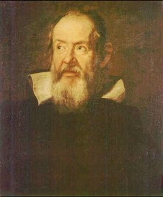
a / Portrait of Galileo Galilei, by Justus Sustermans, 1636.
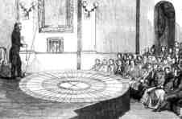
c / Foucault demonstrates his pendulum to an audience at a lecture in 1851.
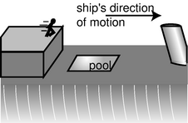
d / Discussion question C.
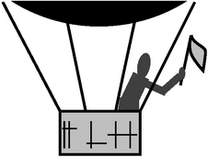
e / Discussion question D.
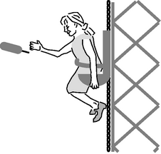
f / Discussion question E.
I defined inertial mass conceptually as a measure of how hard it is to change an object's state of motion, the implication being that if you don't interfere, the object's motion won't change. Most people, however, believe that objects in motion have a natural tendency to slow down. Suppose I push my refrigerator to the west for a while at 0.1 m/s, and then stop pushing. The average person would say fridge just naturally stopped moving, but let's imagine how someone in China would describe the fridge experiment carried out in my house here in California. Due to the rotation of the earth, California is moving to the east at about 400 m/s. A point in China at the same latitude has the same speed, but since China is on the other side of the planet, China's east is my west. (If you're finding the three-dimensional visualization difficult, just think of China and California as two freight trains that go past each other, each traveling at 400 m/s.) If I insist on thinking of my dirt as being stationary, then China and its dirt are moving at 800 m/s to my west. From China's point of view, however, it's California that is moving 800 m/s in the opposite direction (my east). When I'm pushing the fridge to the west at 0.1 m/s, the observer in China describes its speed as 799.9 m/s. Once I stop pushing, the fridge speeds back up to 800 m/s. From my point of view, the fridge “naturally” slowed down when I stopped pushing, but according to the observer in China, it “naturally” sped up!
What's really happening here is that there's a tendency, due to friction, for the fridge to stop moving relative to the floor. In general, only relative motion has physical significance in physics, not absolute motion. It's not even possible to define absolute motion, since there is no special reference point in the universe that everyone can agree is at rest. Of course if we want to measure motion, we do have to pick some arbitrary reference point which we will say is standing still, and we can then define x, y, and z coordinates extending out from that point, which we can define as having x=0, y=0, z=0. Setting up such a system is known as choosing a frame of reference. The local dirt is a natural frame of reference for describing a game of basketball, but if the game was taking place on the deck of a moving ocean liner, we would probably pick a frame of reference in which the deck was at rest, and the land was moving. 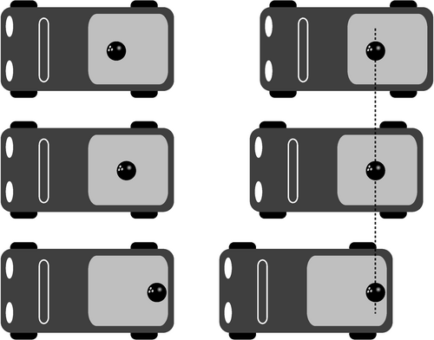
b / Left: In a frame of reference that speeds up with the truck, the bowling ball appears to change its state of motion for no reason. Right: In an inertial frame of reference, which the surface of the earth approximately is, the bowling ball stands still, which makes sense because there is nothing that would cause it to change its state of motion.
Galileo was the first scientist to reason along these lines, and we now use the term Galilean relativity to refer to a somewhat modernized version of his principle. Roughly speaking, the principle of Galilean relativity states that the same laws of physics apply in any frame of reference that is moving in a straight line at constant speed. We need to refine this statement, however, since it is not necessarily obvious which frames of reference are going in a straight line at constant speed. A person in a pickup truck pulling away from a stoplight could admit that the car's velocity is changing, or she could insist that the truck is at rest, and the meter on the dashboard is going up because the asphalt picked that moment to start moving faster and faster backward! Frames of reference are not all created equal, however, and the accelerating truck's frame of reference is not as good as the asphalt's. We can tell, because a bowling ball in the back of the truck appears to behave strangely in the driver's frame of reference: in her rear-view mirror, she sees the ball, initially at rest, start moving faster and faster toward the back of the truck. This goofy behavior is evidence that there is something wrong with her frame of reference. A person on the sidewalk, however, sees the ball as standing still. In the sidewalk's frame of reference, the truck pulls away from the ball, and this makes sense, because the truck is burning gas and using up energy to change its state of motion.
We therefore define an inertial frame of reference as one in which we never see objects change their state of motion without any apparent reason. The sidewalk is a pretty good inertial frame, and a car moving relative to the sidewalk at constant speed in a straight line defines a pretty good inertial frame, but a car that is accelerating or turning is not a inertial frame.
The principle of Galilean relativity states that inertial frames exist, and that the same laws of physics apply in all inertial frames of reference, regardless of one frame's straight-line, constant-speed motion relative to another.⁵
Another way of putting it is that all inertial frames are created equal. We can say whether one inertial frame is in motion or at rest relative to another, but there is no privileged “rest frame.” There is no experiment that comes out any different in laboratories in different inertial frames, so there is no experiment that could tell us which inertial frame is really, truly at rest.

Example 3: The speed of sound
◊ The speed of sound in air is only 340 m/s, so unless you live at a near-polar latitude, you're moving at greater than the speed of sound right now due to the Earth's rotation. In that case, why don't we experience exciting phenomena like sonic booms all the time? ◊ It might seem as though you're unprepared to deal with this question right now, since the only law of physics you know is conservation of mass, and conservation of mass doesn't tell you anything obviously useful about the speed of sound or sonic booms. Galilean relativity, however, is a blanket statement about all the laws of physics, so in a situation like this, it may let you predict the results of the laws of physics without actually knowing what all the laws are! If the laws of physics predict a certain value for the speed of sound, then they had better predict the speed of the sound relative to the air, not their speed relative to some special “rest frame.” Since the air is moving along with the rotation of the earth, we don't detect any special phenomena. To get a sonic boom, the source of the sound would have to be moving relative to the air.
self-check: Galileo got in a bet with some rich noblemen about the following experiment. Suppose a ship is sailing across a calm harbor at constant speed in a straight line. A sailor is assigned to carry a rock up to the top of one of the masts and then drop it to the deck. Does the rock land at the base of the mast, or behind it due to the motion of the ship? (Galileo was never able to collect on his bet, because the noblemen didn't think an actual experiment was a valid way of deciding who was right.) (answer in the back of the PDF version of the book)

Example 4: The Foucault pendulum
Note that in the example of the bowling ball in the truck, I didn't claim the sidewalk was exactly a Galilean frame of reference. This is because the sidewalk is moving in a circle due to the rotation of the Earth, and is therefore changing the direction of its motion continuously on a 24-hour cycle. However, the curve of the motion is so gentle that under ordinary conditions we don't notice that the local dirt's frame of reference isn't quite inertial. The first demonstration of the noninertial nature of the earth-fixed frame of reference was by Foucault using a very massive pendulum (figure c) whose oscillations would persist for many hours without becoming imperceptible. Although Foucault did his demonstration in Paris, it's easier to imagine what would happen at the north pole: the pendulum would keep swinging in the same plane, but the earth would spin underneath it once every 24 hours. To someone standing in the snow, it would appear that the pendulum's plane of motion was twisting. The effect at latitudes less than 90 degrees turns out to be slower, but otherwise similar. The Foucault pendulum was the first definitive experimental proof that the earth really did spin on its axis, although scientists had been convinced of its rotation for a century based on more indirect evidence about the structure of the solar system.
Although popular belief has Galileo being prosecuted by the Catholic Church for saying the earth rotated on its axis and also orbited the sun, Foucault's pendulum was still centuries in the future, so Galileo had no hard proof; Galileo's insights into relative versus absolute motion simply made it more plausible that the world could be spinning without producing dramatic effects, but didn't disprove the contrary hypothesis that the sun, moon, and stars went around the earth every 24 hours. Furthermore, the Church was much more liberal and enlightened than most people believe. It didn't (and still doesn't) require a literal interpretation of the Bible, and one of the Church officials involved in the Galileo affair wrote that “the Bible tells us how to go to heaven, not how the heavens go.” In other words, religion and science should be separate. The actual reason Galileo got in trouble is shrouded in mystery, since Italy in the age of the Medicis was a secretive place where unscrupulous people might settle a score with poison or a false accusation of heresy. What is certain is that Galileo's satirical style of scientific writing made many enemies among the powerful Jesuit scholars who were his intellectual opponents --- he compared one to a snake that doesn't know its own back is broken. It's also possible that the Church was far less upset by his astronomical work than by his support for atomism (discussed further in the next section). Some theologians perceived atomism as contradicting transubstantiation, the Church's doctrine that the holy bread and wine were literally transformed into the flesh and blood of Christ by the priest's blessing.

Discussion Questions
◊ Aristotle stated that all objects naturally wanted to come to rest, with the unspoken implication that “rest” would be interpreted relative to the surface of the earth. Suppose we could transport Aristotle to the moon, put him in a space suit, and kick him out the door of the spaceship and into the lunar landscape. What would he expect his fate to be in this situation? If intelligent creatures inhabited the moon, and one of them independently came up with the equivalent of Aristotelian physics, what would they think about objects coming to rest?
◊ A passenger on a cruise ship finds, while the ship is docked, that he can leap off of the upper deck and just barely make it into the pool on the lower deck. If the ship leaves dock and is cruising rapidly, will this adrenaline junkie still be able to make it?
◊ You are a passenger in the open basket hanging under a helium balloon. The balloon is being carried along by the wind at a constant velocity. If you are holding a flag in your hand, will the flag wave? If so, which way? [Based on a question from PSSC Physics.]
◊ Sally is on an amusement park ride which begins with her chair being hoisted straight up a tower at a constant speed of 60 miles/hour. Despite stern warnings from her father that he'll take her home the next time she misbehaves, she decides that as a scientific experiment she really needs to release her corndog over the side as she's on the way up. She does not throw it. She simply sticks it out of the car, lets it go, and watches it against the background of the sky, with no trees or buildings as reference points. What does the corndog's motion look like as observed by Sally? Does its speed ever appear to her to be zero? What acceleration does she observe it to have: is it ever positive? negative? zero? What would her enraged father answer if asked for a similar description of its motion as it appears to him, standing on the ground?

h / self-check

Applications of calculus
Let's see how this relates to calculus. If an object is moving in one dimension, we can describe its position with a function x(t). The derivative v=dx/dt is called the velocity, and the second derivative a=dv/dt=d²x/dt² is the acceleration. Galilean relativity tells us that there is no detectable effect due to an object's absolute velocity, since in some other frame of reference, the object's velocity might be zero. However, an acceleration does have physical consequences.
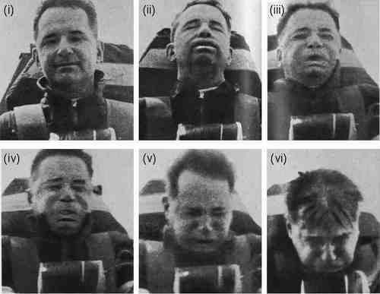
g / This Air Force doctor volunteered to ride a rocket sled as a medical experiment. The obvious effects on his head and face are not because of the sled's speed but because of its rapid changes in speed: increasing in (ii) and (iii), and decreasing in (v) and (vi). In (iv) his speed is greatest, but because his speed is not increasing or decreasing very much at this moment, there is little effect on him. (U.S. Air Force)
Observers in different inertial frames of reference will disagree on velocities, but agree on accelerations. Let's keep it simple by continuing to work in one dimension. One frame of reference uses a coordinate system x₁, and the other we label x₂. If the positive x₁ and x₂ axes point in the same direction, then in general two inertial frames could be related by an equation of the form x₂=x₁+b+ut, where u is the constant velocity of one frame relative to the other, and the constant b tells us how far apart the origins of the two coordinate systems were at t=0. The velocities are different in the two frames of reference:
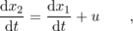
Suppose, for example, frame 1 is defined from the sidewalk, and frame 2 is fixed to a float in a parade that is moving to our left at a velocity u=1 m/s. A dog that is moving to the right with a velocity v₁=dx₁/dt=3 m/s in the sidewalk's frame will appear to be moving at a velocity of v₂=d x₂/d t=d x₁/d t+u=4 m/s in the float's frame.
For acceleration, however, we have
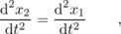
since the derivative of the constant u is zero. Thus an acceleration, unlike a velocity, can have a definite physical significance to all observers in all frames of reference. If this wasn't true, then there would be no particular reason to define a quantity called acceleration in the first place.
self-check: Figure h shows a bottle of beer sitting on a table in the dining car of a train. Does the tilting of the surface tell us about the train's velocity, or its acceleration? What would a person in the train say about the bottle's velocity? What about a person standing in a field outside and looking in through the window? What about the acceleration? (answer in the back of the PDF version of the book)

1.4 A Preview of Some Modern Physics
“Mommy, why do you and Daddy have to go to work?” “To make money, sweetie-pie.” “Why do we need money?” “To buy food.” “Why does food cost money?” When small children ask a chain of “why” questions like this, it usually isn't too long before their parents end up saying something like, “Because that's just the way it is,” or, more honestly, “I don't know the answer.”
The same happens in physics. We may gradually learn to explain things more and more deeply, but there's always the possibility that a certain observed fact, such as conservation of mass, will never be understood on any deeper level. Science, after all, uses limited methods to achieve limited goals, so the ultimate reason for all existence will always be the province of religion. There is, however, an appealing explanation for conservation of mass, which is atomism, the theory that matter is made of tiny, unchanging particles. The atomic hypothesis dates back to ancient Greece, but the first solid evidence to support it didn't come until around the eighteenth century, and individual atoms were never detected until about 1900. The atomic theory implies not only conservation of mass, but a couple of other things as well.
First, it implies that the total mass of one particular element is conserved. For instance, lead and gold are both elements, and if we assume that lead atoms can't be turned into gold atoms, then the total mass of lead and the total mass of gold are separately conserved. It's as though there was not just a law against pickpocketing, but also a law against surreptitiously moving money from one of the victim's pockets to the other. It turns out, however, that although chemical reactions never change one type of atom into another, transmutation can happen in nuclear reactions, such as the ones that created most of the elements in your body out of the primordial hydrogen and helium that condensed out of the aftermath of the Big Bang.
Second, atomism implies that mass is quantized, meaning that only certain values of mass are possible and the ones in between can't exist. We can have three atoms of gold or four atoms of gold, but not three an a half. Although quantization of mass is a natural consequence of any theory in which matter is made up of tiny particles, it was discovered in the twentieth century that other quantities, such as energy, are quantized as well, which had previously not been suspected.
self-check: Is money quantized? (answer in the back of the PDF version of the book)
If atomism is starting to make conservation of mass seem inevitable to you, then it may disturb you to know that Einstein discovered it isn't really conserved. If you put a 50-gram iron nail in some water, seal the whole thing up, and let it sit on a fantastically precise balance while the nail rusts, you'll find that the system loses about 6x×10⁻¹² kg of mass by the time the nail has turned completely to rust. This has to do with Einstein's famous equation E=mc². Rusting releases heat energy, which then escapes out into the room. Einstein's equation states that this amount of heat, E, is equivalent to a certain amount of mass, m. The c in the c² is the speed of light, which is a large number, and a large amount of energy is therefore equivalent to a very small amount of mass, so you don't notice nonconservation of mass under ordinary conditions. What is really conserved is not the mass, m, but the mass-plus-energy, E+mc². The point of this discussion is not to get you to do numerical exercises with E=mc² (at this point you don't even know what units are used to measure energy), but simply to point out to you the empirical nature of the laws of physics. If a previously accepted theory is contradicted by an experiment, then the theory needs to be changed. This is also a good example of something called the correspondence principle, which is a historical observation about how scientific theories change: when a new scientific theory replaces an old one, the old theory is always contained within the new one as an approximation that works within a certain restricted range of situations. Conservation of mass is an extremely good approximation for all chemical reactions, since chemical reactions never release or consume enough energy to change the total mass by a large percentage. Conservation of mass would not have been accepted for 110 years as a fundamental principle of physics if it hadn't been verified over and over again by a huge number of accurate experiments.
\backofchapterboilerplate{1}

Homework Problems
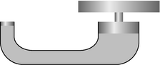
a / Problem 12.
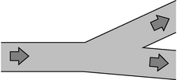
b / Problem 14.
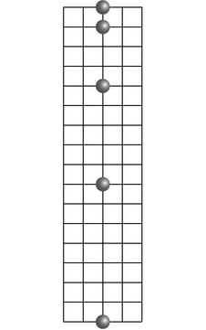
c / Problem 17.
Problems 1-6 are intended to help you check up on your mathematical skills. In my experience, most students can do most of these problems when they start a physics course, but very few students can do all of them. I've written a complete introduction to these skills in ch. 0 and 1 of my book Newtonian Physics, which is available as a free download from www.lightandmatter.com. Rather than duplicating that material in this book, I've decided simply to steer students to it if they need it.
1. [0] Express each of the following quantities in micrograms: (a) \hbox{10 mg}, (b) 10⁴ g, (c) 10 kg, (d) 100×10³ g, (e) 1000 ng. (answer check available at lightandmatter.com)
2. [0] The speed of light is 3.0× 10⁸ m/s. Convert this to furlongs per fortnight. A furlong is 220 yards, and a fortnight is 14 days. An inch is 2.54 cm. (answer check available at lightandmatter.com)
3. [0] How many significant figures are there in each of the following measurements? (a) 9.937 m, (b) 4.0 s, (c) 0.0000037 kg.
4. [0] How many cubic mm are there in a cubic meter? The answer is not 1000.
5. [0] Assume that dogs' and cats' brains are the same shape, and that their brain cells are also the same size and shape, but that a dog's brain is twice as large as a cat's in all its linear dimensions, i.e. any two points in a dog's brain are twice as far apart as the corresponding two points in a cat's. How many times more brain cells does a dog have compared to a cat? The answer is not 2.
6. Make an order-of-magnitude estimate of the number of blades of grass on a football field.
7. [0] Thermometers normally use either mercury or alcohol as their working fluid. If the level of the fluid rises or falls, does this violate conservation of mass?
8. The ratios of the masses of different types of atoms were determined a century before anyone knew any actual atomic masses in units of kg. One finds, for example, that when ordinary table salt, NaCl, is melted, the chlorine atoms bubble off as a gas, leaving liquid sodium metal. Suppose the chlorine is allowed to escape, so that its mass cannot be directly determined by weighing. Experiments show that when 1.00000 kg of NaCl is treated in this way, the mass of the remaining sodium metal is 0.39337 kg. Based on this information, determine the ratio of the mass of a chlorine atom to that of a sodium atom.
9. An atom of the most common naturally occurring uranium isotope breaks up spontaneously into a thorium atom plus a helium atom. The masses are as follows:
uranium | 395292849times 1025 kgunit
thorium | 388638748times 1025 kgunit
helium | 6646481times 1027 kgunit
{}Each of these experimentally determined masses is uncertain in its last decimal place. Is mass conserved in this process to within the accuracy of the experimental data? How would you interpret this?
10. If two spherical water droplets of radius b combine to make a single droplet, what is its radius? (Assume that water has constant density.)
11. Make up an experiment that would test whether mass is conserved in an animal's metabolic processes.
12. The figure shows a hydraulic jack. What is the relationship between the distance traveled by the plunger and the distance traveled by the object being lifted, in terms of the cross-sectional areas?
13. In an example in this chapter, I argued that a stream of water must change its cross-sectional area as it rises or falls. Suppose that the stream of water is confined to a constant-diameter pipe. Which assumption breaks down in this situation?
14. A river with a certain width and depth splits into two parts, each of which has the same width and depth as the original river. What can you say about the speed of the current after the split?
15. The diagram shows a cross-section of a wind tunnel of the kind used, for example, to test designs of airplanes. Under normal conditions of use, the density of the air remains nearly constant throughout the whole wind tunnel. How can the speed of the air be controlled and calculated? (Diagram by NASA, Glenn Research Center.)
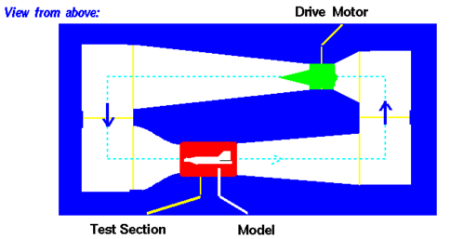
16. A water wave is in a tank that extends horizontally from x=0 to x=a, and from z=0 to z=b. We assume for simplicity that at a certain moment in time the height y of the water's surface only depends on x, not z, so that we can effectively ignore the z coordinate. Under these assumptions, the total volume of the water in the tank is \begin{displaymath}V = b \int_0^a{y(x) \der{}x} .\end{displaymath}
Since the density of the water is essentially constant, conservation of mass requires that V is always the same. When the water is calm, we have y=h, where h=V/ab. If two different wave patterns move into each other, we might imagine that they would add in the sense that y_{total}-h. Show that this type of addition is consistent with conservation of mass.
17. The figure shows the position of a falling ball at equal time intervals, depicted in a certain frame of reference. On a similar grid, show how the ball's motion would appear in a frame of reference that was moving horizontally at a speed of one box per unit time relative to the first frame.

Footnotes
[1] If you haven't already, you should now go ahead and memorize the common metric prefixes, which are summarized on page 767.
[2] You might think intuitively that the recoil velocity should be exactly one fourth of a meter per second, and you'd be right except that the wagon has some mass as well. Our present approach, however, only requires that we give a way to test for equality of masses. To predict the recoil velocity from scratch, we'd need to use conservation of momentum, which is discussed in a later chapter.
[3] The argument only fails for objects light enough to be affected appreciably by air friction: a bunch of feathers falls differently if you wad them up because the pattern of air flow is altered by putting them together.
[4] V.B. Braginskii and V.I. Panov, Soviet Physics JETP 34, 463 (1972).
[5] The principle of Galilean relativity is extended on page 147.

2. Conservation of Energy
Table of Contents

Contents
Section 2.1 - Energy
Section 2.2 - Numerical Techniques
Section 2.3 - Gravitational Phenomena
Section 2.4 - Atomic Phenomena
Section 2.5 - Oscillations

Chapter 2. Conservation of Energy
Do you pronounce it Joule's to rhyme with schools,
Joule's to rhyme with Bowls,
or Joule's to rhyme with Scowls?
Whatever you call it, by Joule's,
or Joule's,
or Joule's, it's good! -- Advertising slogan of the Joule brewery. The name, and the corresponding unit of energy, are now usually pronounced so as to rhyme with “school.”

2.1 Energy
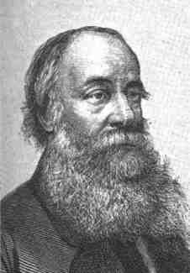
a / James Joule, 1818-1889. The son of a wealthy brewer, Joule was tutored as a young man by the famous scientist John Dalton. Fascinated by electricity, he and his brother experimented by giving electric shocks to each other and to the family's servants. Joule ran the brewery as an adult, and science was merely a serious hobby. His work on energy can be traced to his attempt to build an electric motor that would replace steam engines. His ideas were not accepted at first, partly because they contradicted the widespread belief that heat was a fluid, and partly because they depended on extremely precise measurements, which had not previously been common in physics.
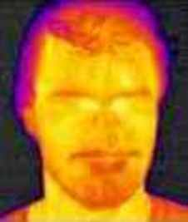
b / Heat energy can be converted to light energy. Very hot objects glow visibly, and even objects that aren't so hot give off infrared light, a color of light that lies beyond the red end of the visible rainbow. This photo was made with a special camera that records infrared light. The man's warm skin emits quite a bit of infrared light energy, while his hair, at a lower temperature, emits less.

The energy concept
You'd probably like to be able to drive your car and light your apartment without having to pay money for gas and electricity, and if you do a little websurfing, you can easily find people who say they have the solution to your problem. This kind of scam has been around for centuries. It used to be known as a perpetual motion machine, but nowadays the con artists' preferred phrase is “free energy.”¹ A typical “free-energy” machine would be a sealed box that heats your house without needing to be plugged into a wall socket or a gas pipe. Heat comes out, but nothing goes in, and this can go on indefinitely. But an interesting thing happens if you try to check on the advertised performance of the machine. Typically, you'll find out that either the device is still in development, or it's back-ordered because so many people have already taken advantage of this Fantastic Opportunity! In a few cases, the magic box exists, but the inventor is only willing to demonstrate very small levels of heat output for short periods of time, in which case there's probably a tiny hearing-aid battery hidden in there somewhere, or some other trick.
Since nobody has ever succeeded in building a device that creates heat out of nothing, we might also wonder whether any device exists that can do the opposite, turning heat into nothing. You might think that a refrigerator was such a device, but actually your refrigerator doesn't destroy the heat in the food. What it really does is to extract some of the heat and bring it out into the room. That's why it has big radiator coils on the back, which get hot when it's in operation.
If it's not possible to destroy or create heat outright, then you might start to suspect that heat was a conserved quantity. This would be a successful rule for explaining certain processes, such as the transfer of heat between a cold Martini and a room-temperature olive: if the olive loses a little heat, then the drink must gain the same amount. It would fail in general, however.
Sunlight can heat your skin, for example, and a hot lightbulb filament can cool off by emitting light. Based on these observations, we could revise our proposed conservation law, and say that there is something called heatpluslight, which is conserved. Even this, however, needs to be generalized in order to explain why you can get a painful burn playing baseball when you slide into a base. Now we could call it heatpluslightplusmotion. The word is getting pretty long, and we haven't even finished the list.
Rather than making the word longer and longer, physicists have hijacked the word “energy” from ordinary usage, and give it a new, specific technical meaning. Just as the Parisian platinum-iridium kilogram defines a specific unit of mass, we need to pick something that defines a definite unit of energy. The metric unit of energy is the joule (J), and we'll define it as the amount of energy required to heat 0.24 grams of water from 20 to 21 degrees Celsius. (Don't memorize the numbers.)²

Example 1: Temperature of a mixture
◊ If 1.0 kg of water at 20°C{} is mixed with 4.0 kg of water at 30°C, what is the temperature of the mixture?
◊ Let's assume as an approximation that each degree of temperature change corresponds to the same amount of energy. In other words, we assume , regardless of whether, as in the definition of the joule, we have or, as in the present example, some other combination of initial and final temperatures. To be consistent with the definition of the joule, we must have = 4.2×10³ C, which is referred to as the specific heat of water.
Conservation of energy tells us Δ E=0, so
m₁cΔ T₁+ m₂cΔ T₂ = 0
{}or
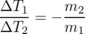
{}If T₁ has to change four times as much as T₂, and the two final temperatures are equal, then the final temperature must be 28°C{}.
Note how only differences in temperature and energy appeared in the preceding example. In other words, we don't have to make any assumptions about whether there is a temperature at which all an object's heat energy is removed. Historically, the energy and temperature units were invented before it was shown that there is such a temperature, called absolute zero. There is a scale of temperature, the Kelvin scale, in which the unit of temperature is the same as the Celsius degree, but the zero point is defined as absolute zero. But as long as we only deal with temperature differences, it doesn't matter whether we use Kelvin or Celsius. Likewise, as long as we deal with differences in heat energy, we don't normally have to worry about the total amount of heat energy the object has. In standard physics terminology, “heat” is used only to refer to differences, while the total amount is called the object's “thermal energy.”This distinction is often ignored by scientists in casual speech, and in this book I'll usually use “heat” for either quantity.
We're defining energy by adding up things from a list, which we lengthen as needed: heat, light, motion, etc. One objection to this approach is aesthetic: physicists tend to regard complication as a synonym for ugliness. If we have to keep on adding more and more forms of energy to our laundry list, then it's starting to sound like energy is distressingly complicated. Luckily it turns out that energy is simpler than it seems. Many forms of energy that are apparently unrelated turn out to be manifestations of a small number of forms at the atomic level, and this is the topic of section 2.4.

Discussion Questions
◊ The ancient Greek philosopher Aristotle said that objects “naturally” tended to slow down, unless there was something pushing on them to keep them moving. What important insight was he missing?
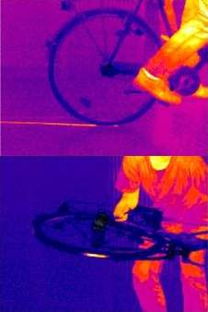
c / As in figure b, an infrared camera distinguishes hot and cold areas. As the bike skids to a stop with its brakes locked, the kinetic energy of the bike and rider is converted into heat in both the floor (top) and the tire (bottom).

Logical issues
Another possible objection is that the open-ended approach to defining energy might seem like a kind of cheat, since we keep on inventing new forms whenever we need them. If a certain experiment seems to violate conservation of energy, can't we just invent a new form of invisible “mystery energy” that patches things up? This would be like balancing your checkbook by putting in a fake transaction that makes your calculation of the balance agree with your bank's. If we could fudge this way, then conservation of energy would be untestable --- impossible to prove or disprove.
Actually all scientific theories are unprovable. A theory can never be proved, because the experiments can only cover a finite number out of the infinitely many situations in which the theory is supposed to apply. Even a million experiments won't suffice to prove it in the same sense of the word “proof” that is used in mathematics. However, even one experiment that contradicts a theory is sufficient to show that the theory is wrong. A theory that is immune to disproof is a bad theory, because there is no way to test it. For instance, if I say that 23 is the maximum number of angels that can dance on the head of a pin, I haven't made a properly falsifiable scientific theory, since there's no method by which anyone could even attempt to prove me wrong based on observations or experiments.
Conservation of energy is testable because new forms of energy are expected to show regular mathematical behavior, and are supposed to be related in a measurable way to observable phenomena. As an example, let's see how to extend the energy concept to include motion.
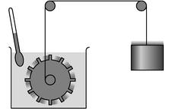
d / A simplified drawing of Joule's paddlewheel experiment.
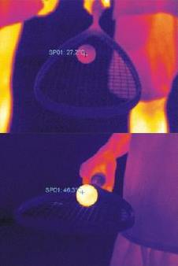
e / The heating of the tire and floor in figure c is something that the average person might have predicted in advance, but there are other situations where it's not so obvious. When a ball slams into a wall, it doesn't rebound with the same amount of kinetic energy. Was some energy destroyed? No. The ball and the wall heat up. These infrared photos show a squash ball at room temperature (top), and after it has been played with for several minutes (bottom), causing it to heat up detectably.

Kinetic energy
Energy of motion is called kinetic energy. (The root of the word is the same as the word “cinema” -- in French, kinetic energy is “énergie cinétique.”) How does an object's kinetic energy depend on its mass and velocity? Joule attempted a conceptually simple experiment on his honeymoon in the French-Swiss Alps near Mt. Chamonix, in which he measured the difference in temperature between the top and bottom of a waterfall. The water at the top of the falls has some gravitational energy, which isn't our subject right now, but as it drops, that gravitational energy is converted into kinetic energy, and then into heat energy due to internal friction in the churning pool at the bottom:
In the logical framework of this book's presentation of energy, the significance of the experiment is that it provides a way to find out how an object's kinetic energy depends on its mass and velocity. The increase in heat energy should equal the kinetic energy of the water just before impact, so in principle we could measure the water's mass, velocity, and kinetic energy, and see how they relate to one another.³
Although the story is picturesque and memorable, most books that mention the experiment fail to note that it was a failure! The problem was that heat wasn't the only form of energy being released. In reality, the situation was more like this:
The successful version of the experiment, shown in figures d and f, used a paddlewheel spun by a dropping weight. As with the waterfall experiment, this one involves several types of energy, but the difference is that in this case, they can all be determined and taken into account. (Joule even took the precaution of putting a screen between himself and the can of water, so that the infrared light emitted by his warm body wouldn't warm it up at all!) The result⁴ is
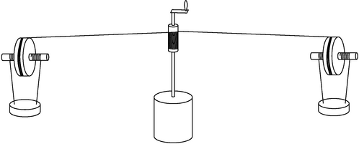
f / A realistic drawing of Joule's apparatus, based on the illustration in his original paper. The paddlewheel is sealed inside the can in the middle. Joule wound up the two 13-kg lead weights and dropped them 1.6 meters, repeating this 20 times to produce a temperature change of only about half a degree Fahrenheit in the water inside the sealed can. He claimed in his paper to be able to measure temperatures to an accuracy of 1/200 of a degree.
Whenever you encounter an equation like this for the first time, you should get in the habit of interpreting it. First off, we can tell that by making the mass or velocity greater, we'd get more kinetic energy. That makes sense. Notice, however, that we have mass to the first power, but velocity to the second. Having the whole thing proportional to mass to the first power is necessary on theoretical grounds, since energy is supposed to be additive. The dependence on v² couldn't have been predicted, but it is sensible. For instance, suppose we reverse the direction of motion. This would reverse the sign of v, because in one dimension we use positive and negative signs to indicate the direction of motion. But since v² is what appears in the equation, the resulting kinetic energy is unchanged.
What about the factor of 1/2 in front? It comes out to be exactly 1/2 by the design of the metric system. If we'd been using the old-fashioned British engineering system of units (which is no longer used in the U.K.), the equation would have been . The version of the metric system called the SI,⁵ in which everything is based on units of kilograms, meters, and seconds, not only has the numerical constant equal to 1/2, but makes it unitless as well. In other words, we can think of the joule as simply an abbreviation, 1 J=1 kg⋅m²/s². More familiar examples of this type of abbreviation are 1 minute=60 s, and the metric unit of land area, 1 hectare=10000 m².

Example 2: Ergs and joules
◊ There used to be two commonly used systems of metric units, referred to as mks and cgs. The mks system, now called the SI, is based on the meter, the kilogram, and the second. The cgs system, which is now obsolete, was based on the centimeter, the gram, and the second. In the cgs system, the unit of energy is not the joule but the erg, 1 erg=1 . How many ergs are in one joule?
◊ The simplest approach is to treat the units as if they were algebra symbols.
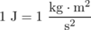
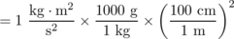
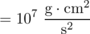
= 10⁷ erg
If you have trouble understanding this example, you should study ch. 0 and 1 of my book Newtonian Physics.

Example 3: Cabin air in a jet airplane
◊ A jet airplane typically cruises at a velocity of 270 m/s. Outside air is continuously pumped into the cabin, but must be cooled off first, both because (1) it heats up due to friction as it enters the engines, and (2) it is heated as a side-effect of being compressed to cabin pressure. Calculate the increase in temperature due to the first effect. The specific heat of dry air is about 1.0×10³ C.
◊ This is easiest to understand in the frame of reference of the plane, in which the air rushing into the engine is stopped, and its kinetic energy converted into heat.⁶ Conservation of energy tells us
0 = Δ E
= Δ K+Δ E_{heat} .
In the plane's frame of reference, the air's initial velocity is v_{i}=270 m/s, and its final velocity is zero, so the change in its kinetic energy is negative,
Δ K = K_{f} - K_{i}
Assuming that the specific heat of air is roughly independent of temperature (which is why the number was stated with the word “about”), we can substitute into 0 = Δ K+Δ E_{heat}, giving
Note how the mass cancels out. This is a big advantage of solving problems algebraically first, and waiting until the end to plug in numbers. With a purely numerical approach, we wouldn't even have known what value of m to pick, or if we'd guessed a value like 1 kg, we wouldn't have known whether our answer depended on that guess.
Solving for Δ T, and writing v instead of v_{i} for simplicity, we find
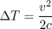
The passengers would be boiled alive if not for the refrigeration. The first stage of cooling happens via heat exchangers in the engine struts, but a second stage, using a refrigerator under the floor of the cabin, is also necessary. Running this refrigerator uses up energy, cutting into the fuel efficiency of the airplane, which is why typically only 50% of the cabin's air is replaced in each pumping cycle of 2-3 minutes. The airlines emphasize that this is a much faster recirculation rate than in the ventilation systems of most buildings, but people are packed more tightly in an airplane.

Power
Power, P, is defined as the rate of change of energy, dE/dt. Power thus has units of joules per second, which are usually abbreviated as watts, 1 W=1 J/s. Since energy is conserved, we would have dE/dt=0 if E was the total energy of a closed system, and that's not very interesting. What's usually more interesting to discuss is either the power flowing in or out of an open system, or the rate at which energy is being transformed from one form into another. The following is an example of energy flowing into an open system.

Example 4: Heating by a lightbulb
◊ The electric company bills you for energy in units of kilowatt-hours (kilowatts multiplied by hours) rather than in SI units of joules. How many joules is a kilowatt-hour?
◊ 1 kilowatt-hour = (1 kW)(1 hour) = (1000 J/s)(3600 s) = 3.6 MJ.
Now here's an example of energy being transformed from one form into another.

Example 5: Human wattage
◊ Food contains chemical energy (discussed in more detail in section 2.4), and for historical reasons, food energy is normally given in non-SI units of Calories. One Calorie with a capital “C” equals 1000 calories, and 1 calorie is defined as 4.18 J. A typical person consumes 2000 Calories of food in a day, and converts nearly all of that directly to body heat. Compare the person's heat production to the rate of energy consumption of a 100-watt lightbulb.
◊ Strictly speaking, we can't really compute the derivative d E/d t, since we don't know how the person's metabolism ebbs and flows over the course of a day. What we can really compute is Δ E/Δ t, which is the power averaged over a one-day period.
Converting to joules, we find Δ E=8×10⁶ J for the amount of energy transformed into heat within our bodies in one day. Converting the time interval likewise into SI units, Δ t=9×10⁴ s. Dividing, we find that our power is 90 J/s = 90 W, about the same as a lightbulb.

g / A skateboarder rises to the edge of an empty pool and then falls back down.
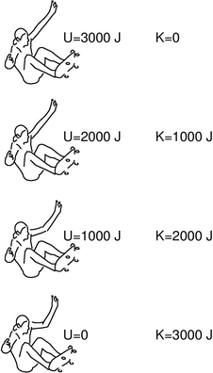
h / The sum of kinetic plus gravitational energy is constant.
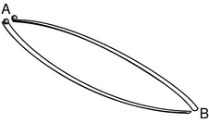
i / Two balls start from rest, and roll from A to B by different paths.
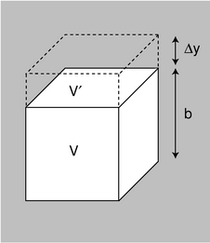
j / How much energy is required to raise the submerged box through a height Δ y?
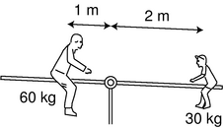
k / A seesaw.
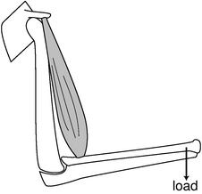
l / The biceps muscle is a reversed lever.
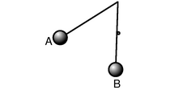
m / Discussion question C.

Gravitational energy
Gravitational energy, to which I've already alluded, is different from heat and kinetic energy in an important way. Heat and kinetic energy are properties of a single object, whereas gravitational energy describes an interaction between two objects. When the skater in figures g and h is at the top, his distance from the bulk of the planet earth is greater. Since we observe his kinetic energy decreasing on the way up, there must be some other form of energy that is increasing. We invent a new form of energy, called gravitational energy, and written U or U_{g}, which depends on the distance between his body and the planet. Where is this energy? It's not in the skater's body, and it's not inside the earth, either, since it takes two to tango. If either object didn't exist, there wouldn't be any interaction or any way to measure a distance, so it wouldn't make sense to talk about a distance-dependent energy. Just as marriage is a relationship between two people, gravitational energy is a relationship between two objects.
There is no precise way to define the distance between the skater and the earth, since both are objects that have finite size. As discussed in more detail in section 2.3, gravity is one of the fundamental forces of nature, a universal attraction between any two particles that have mass. Each atom in the skater's body is at a definite distance from each atom in the earth, but each of these distances is different. An atom in his foot is only a few centimeters from some of the atoms in the plaster side of the pool, but most of the earth's atoms are thousands of kilometers away from him. In theory, we might have to add up the contribution to the gravitational energy for every interaction between an atom in the skater's body and an atom in the earth.
For our present purposes, however, there is a far simpler and more practical way to solve problems. In any region of the earth's surface, there is a direction called “down,” which we can establish by dropping a rock or hanging a plumb bob. In figure h, the skater is moving up and down in one dimension, and if we did measurements of his kinetic energy, like the made-up data in the figure, we could infer his gravitational energy. As long as we stay within a relatively small range of heights, we find that an object's gravitational energy increases at a steady rate with height. In other words, the strength of gravity doesn't change much if you only move up or down a few meters. We also find that the gravitational energy is proportional to the mass of the object we're testing. Writing y for the height, and g for the overall constant of proportionality, we have \begin{array}{cr} U_g=mgy . & \text{[gravitational energy; $y$=height; only ac-} & \text{curate within a small range of heights]} \end{array} The number g, with units of joules per kilogram per meter, is called the gravitational field. It tells us the strength of gravity in a certain region of space. Near the surface of our planet, it has a value of about 9.8 , which is conveniently close to 10 for rough calculations.

Example 6: Velocity at the bottom of a drop
◊ If the skater in figure g drops 3 meters from rest, what is his velocity at the bottom of the pool?
◊ Starting from conservation of energy, we have
0 = Δ E
= Δ K +Δ U
= K_{f} - K_{i} + U_{f} - U_{i}
+ mgy_{f} - mgy_{i}
so
There are a couple of important things to note about this example. First, we were able to massage the equation so that it only involved Δy, rather than y itself. In other words, we don't need to worry about where y=0 is; any coordinate system will work, as long as the positive y axis points up, not down. This is no accident. Gravitational energy can always be changed by adding a constant onto it, with no effect on the final result, as long as you're consistent within a given problem.
The other interesting thing is that the mass canceled out: even if the skater gained weight or strapped lead weights to himself, his velocity at the bottom would still be 8 m/s. This isn't an accident either. This is the same conclusion we reached in section 1.2, based on the equivalence of gravitational and inertial mass. The kinetic energy depends on the inertial mass, while gravitational energy is related to gravitational mass, but since these two quantities are equal, we were able to use a single symbol, m, for them, and cancel them out.
We can see from the equation that a falling object's velocity isn't constant. It increases as the object drops farther and farther. What about its acceleration? If we assume that air friction is negligible, the arguments in section 1.2 show that the acceleration can't depend on the object's mass, so there isn't much else the acceleration can depend on besides g. In fact, the acceleration of a falling object equals -g (in a coordinate system where the positive y axis points up), as we can easily show using the chain rule:
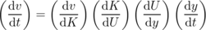
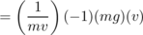
= -g ,
where I've calculated dv/dK as 1/(dK/dv), and dK/dU=-1 can be found by differentiating to give dK+dU=0.
We can also check that the units of g, , are equivalent to the units of acceleration,
{kg⋅m}
and therefore the strength of the gravitational field near the earth's surface can just as well be stated as 10 m/s².

Example 7: Speed after a given time
◊ An object falls from rest. How fast is it moving after two seconds? Assume that the amount of energy converted to heat by air friction is negligible.
◊ Under the stated assumption, we have a=- g, which can be integrated to give v=- gt+constant. If we let t=0 be the beginning of the fall, then the constant of integration is zero, so at we have .

Example 8: The Vomit Comet
◊ The U.S. Air Force has an airplane, affectionately known as the Vomit Comet, in which astronaut trainees can experience simulated weightlessness. The plane climbs up high, and then drops straight down like a rock, and since the people are falling with the same acceleration as the plane, the sensation is just like what you'd experience if you went out of the earth's gravitational field. If the plane can start from 10 km up, what is the maximum amount of time for which the dive can last?
◊ Based on data about acceleration and distance, we want to find time. Acceleration is the second derivative of distance, so if we integrate the acceleration twice with respect to time, we can find how position relates to time. For convenience, let's pick a coordinate system in which the positive y axis is down, so a=g instead of - g.
a = g
Choosing our coordinate system to have y=0 at t=0, we can make the second constant of integration equal zero as well, so
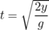
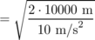
Note that if we hadn't converted the altitude to units of meters, we would have gotten the wrong answer, but we would have been alerted to the problem because the units inside the square root wouldn't have come out to be s². In general, it's a good idea to convert all your data into SI (meter-kilogram-second) units before you do anything with them.

Example 9: High road, low road
◊ In figure i, what can you say based on conservation of energy about the speeds of the balls when the reach point B? What does conservation of energy tell you about which ball will get there first? Assume friction doesn't convert any mechanical energy to heat or sound energy.
◊ Since friction is assumed to be negligible, there are only two forms of energy involved: kinetic and gravitational. Since both balls start from rest, and both lose the same amount of gravitational energy, they must have the same kinetic energy at the end, and therefore they're rolling at the same speed when they reach B. (A subtle point is that the balls have kinetic energy both because they're moving through space and because they're spinning as they roll. These two types of energy must be in fixed proportion to one another, so this has no effect on the conclusion.)
Conservation of energy does not, however, tell us anything obvious about which ball gets there first. This is a general problem with applying conservation laws: conservation laws don't refer directly to time, since they are statements that something stays the same at all moments in time. We expect on intuitive grounds that the ball that goes by the lower ramp gets to B first, since it builds up speed early on.
\myeqnspacing

Example 10: Buoyancy
◊ A cubical box with mass m and volume V= b³ is submerged in a fluid of density ρ. How much energy is required to raise it through a height Δ y?
◊ As the box moves up, it invades a volume V'= b²Δ y previously occupied by some of the fluid, and fluid flows into an equal volume that it has vacated on the bottom. Lowering this amount of fluid by a height b reduces the fluid's gravitational energy by ρ V' gb=ρ g b³Δ y, so the net change in energy is
Δ E = mgΔ y-ρ g b³Δ y
= ( m-ρ V) gΔ y .
In other words, it's as if the mass of the box had been reduced by an amount equal to the fluid that otherwise would have occupied that volume. This is known as Archimedes' principle, and it is true even if the box is not a cube, although we'll defer the more general proof until page 158 in the following chapter. If the box is less dense than the fluid, then it will float.

Example 11: A simple machine
◊ If the father and son on the seesaw in figure k start from rest, what will happen?
◊ Note that although the father is twice as massive, he is at half the distance from the fulcrum. If the seesaw was going to start rotating, it would have to be losing gravitational energy in order to gain some kinetic energy. However, there is no way for it to gain or lose gravitational energy by rotating in either direction. The change in gravitational energy would be
Δ U = Δ U₁ + Δ U₂
= g( m₁Δ y₁ + m₂Δ y₂ )
but Δ y₁ and Δ y₂ have opposite signs and are in the proportion of two to one, since the son moves along a circular arc that covers the same angle as the father's but has half the radius. Therefore Δ U=0, and there is no way for the seesaw to trade gravitational energy for kinetic.
The seesaw example demonstrates the principle of the lever, which is one of the basic mechanical building blocks known as simple machines. As discussed in more detail in chapters 3 and 4, the principle applies even when the forces involved aren't gravitational. (A rigorous definition of “force” is given in chapter 3.)
Note that although a lever makes it easier to lift a heavy weight, it also decreases the distance traveled by the load. By reversing the lever, we can make the load travel a greater distance, at the expense of increasing the amount of force required. The human muscular-skeletal system uses reversed levers of this kind, which allows us to move more rapidly, and also makes our bodies more compact, at the expense of brute strength. A piano uses reversed levers so that a small amount of motion of the key produces a longer swing of the hammer. Another interesting example is the hydraulic jack shown in figure n. The analysis in terms of gravitational energy is exactly the same as for the seesaw, except that the relationship between Δy₁ and Δy₂ is now determined not by geometry but by conservation of mass: since water is highly incompressible, conservation of mass is approximately the same as a requirement of constant volume, which can only be satisfied if the distance traveled by each piston is in inverse proportion to its cross-sectional area.

Discussion Questions
◊ Hydroelectric power (water flowing over a dam to spin turbines) appears to be completely free. Does this violate conservation of energy? If not, then what is the ultimate source of the electrical energy produced by a hydroelectric plant?
◊ You throw a steel ball up in the air. How can you prove based on conservation of energy that it has the same speed when it falls back into your hand? What if you threw a feather up? Is energy not conserved in this case?
◊ The figure shows a pendulum that is released at A and caught by a peg as it passes through the vertical, B. To what height will the bob rise on the right?
◊ What is wrong with the following definitions of g?
(a) “g is gravity.”
(b) “g is the speed of a falling object.”
(c) “g is how hard gravity pulls on things.”
◊ Two people stand on the edge of a cliff. As they lean over the edge, one person throws a rock down, while the other throws one straight up with an exactly opposite initial velocity. Compare the accelerations of the two rocks, and compare the speeds of the rocks on impact at the bottom of the cliff.
n / A hydraulic jack.
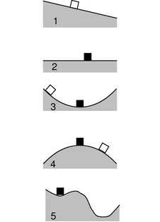
o / The surfaces are frictionless. The black blocks are in equilibrium.
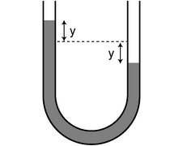
p / Water in a U-shaped tube.

Equilibrium and stability
The seesaw in figure k is in equilibrium, meaning that if it starts out being at rest, it will stay put. This is known as a neutral equilibrium, since the seesaw has no preferred position to which it will return if we disturb it. If we move it to a different position and release it, it will stay at rest there as well. If we put it in motion, it will simply continue in motion until one person's feet hit the ground.
Most objects around you are in stable equilibria, like the black block in figure o/3. Even if the block is moved or set in motion, it will oscillate about the equilibrium position. The pictures are like graphs of y versus x, but since the gravitational energy U=mgy is proportional to y, we can just as well think of them as graphs of U versus x. The block's stable equilibrium position is where the function U(x) has a local minimum. The book you're reading right now is in equilibrium, but gravitational energy isn't the only form of energy involved. To move it upward, we'd have to supply gravitational energy, but downward motion would require a different kind of energy, in order to compress the table more. (As we'll see in section 2.4, this is electrical energy due to interactions between atoms within the table.)
A differentiable function's local extrema occur where its derivative is zero. A position where dU/dx is zero can be a stable (3), neutral (2), or unstable equilibrium, (4). An unstable equilibrium is like a pencil balanced on its tip. Although it could theoretically remain balanced there forever, in reality it will topple due to any tiny perturbation, such as an air current or a vibration from a passing truck. This is a technical, mathematical definition of instability, which is more restrictive than the way the word is used in ordinary speech. Most people would describe a domino standing upright as being unstable, but in technical usage it would be considered stable, because a certain finite amount of energy is required to tip it over, and perturbations smaller than that would only cause it to oscillate around its equilibrium position.
The domino is also an interesting example because it has two local minima, one in which it is upright, and another in which it is lying flat. A local minimum that is not the global minimum, as in figure o/5, is referred to as a metastable equilibrium.

Example 12: Water in a U-shaped tube
◊ The U-shaped tube in figure p has cross-sectional area A, and the density of the water inside is ρ. Find the gravitational energy as a function of the quantity y shown in the figure, and show that there is an equilibrium at y=0.
◊ The question is a little ambiguous, since gravitational energy is only well defined up to an additive constant. To fix this constant, let's define U to be zero when y=0. The difference between U( y) and U(0) is the energy that would be required to lift a water column of height y out of the right side, and place it above the dashed line, on the left side, raising it through a height y. This water column has height y and cross-sectional area A, so its volume is Ay, its mass is ρ Ay, and the energy required is mgy=(ρ Ay) gy=ρ gAy². We then have U( y)= U(0)+ρ gAy²=ρ gAy².
To find equilibria, we look for places where the derivative d U/d y=2ρ gAy equals 0. As we'd expect intuitively, the only equilibrium occurs at y=0. The second derivative test shows that this is a local minimum (not a maximum or a point of inflection), so this is a stable equilibrium.
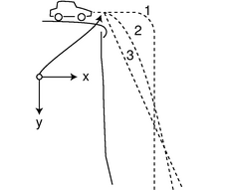
q / A car drives over a cliff.

Predicting the direction of motion
Kinetic energy doesn't depend on the direction of motion. Sometimes this is helpful, as in the high road-low road example (p. 45, example 9), where we were able to predict that the balls would have the same final speeds, even though they followed different paths and were moving in different directions at the end. In general, however, the two conservation laws we've encountered so far aren't enough to predict an object's path through space, for which we need conservation of momentum (chapter 3), and the mathematical technique of vectors. Before we develop those ideas in their full generality, however, it will be helpful to do a couple of simple examples, including one that we'll get a lot of mileage out of in section 2.3.
Suppose we observe an air hockey puck gliding frictionlessly to the right at a velocity v, and we want to predict its future motion. Since there is no friction, no kinetic energy is converted to heat. The only form of energy involved is kinetic energy, so conservation of energy, ΔE=0, becomes simply ΔK=0. There's no particular reason for the puck to do anything but continue moving to the right at constant speed, but it would be equally consistent with conservation of energy if it spontaneously decided to reverse its direction of motion, changing its velocity to -v. Either way, we'd have ΔK=0. There is, however, a way to tell which motion is physical and which is unphysical. Suppose we consider the whole thing again in the frame of reference that is initially moving right along with the puck. In this frame, the puck starts out with K=0. What we originally described as a reversal of its velocity from v to -v is, in this new frame of reference, a change from zero velocity to -2v, which would violate conservation of energy. In other words, the physically possible motion conserves energy in all frames of reference, but the unphysical motion only conserves energy in one special frame of reference.
For our second example, we consider a car driving off the edge of a cliff (q). For simplicity, we assume that air friction is negligible, so only kinetic and gravitational energy are involved. Does the car follow trajectory 1, familiar from Road Runner cartoons, trajectory 2, a parabola, or 3, a diagonal line? All three could be consistent with conservation of energy, in the ground's frame of reference. For instance, the car would have constant gravitational energy along the initial horizontal segment of trajectory 1, so during that time it would have to maintain constant kinetic energy as well. Only a parabola, however, is consistent with conservation of energy combined with Galilean relativity. Consider the frame of reference that is moving horizontally at the same speed as that with which the car went over the edge. In this frame of reference, the cliff slides out from under the initially motionless car. The car can't just hover for a while, so trajectory 1 is out. Repeating the same math as in example 8 on p. 44, we have
in this frame of reference, where the stars indicate coordinates measured in the moving frame of reference. These coordinates are related to the ground-fixed coordinates (x,y) by the equations
where v is the velocity of one frame with respect to the other. We therefore have
x=vt , y=(1/2)gt² ,
in our original frame of reference. Eliminating t, we can see that this has the form of a parabola:
y=(g/2v²)x² .
self-check: What would the car's motion be like in the * frame of reference if it followed trajectory 3? (answer in the back of the PDF version of the book)

2.2 Numerical Techniques
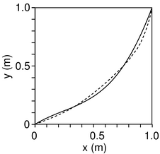
a / Approximations to the brachistochrone curve using a third-order polynomial (solid line), and a seventh-order polynomial (dashed). The latter only improves the time by four milliseconds.
Engineering majors are a majority of the students in the kind of physics course for which this book is designed, so most likely you fall into that category. Although you surely recognize that physics is an important part of your training, if you've had any exposure to how engineers really work, you're probably skeptical about the flavor of problem-solving taught in most science courses. You realize that not very many practical engineering calculations fall into the narrow range of problems for which an exact solution can be calculated with a piece of paper and a sharp pencil. Real-life problems are usually complicated, and typically they need to be solved by number-crunching on a computer, although we can often gain insight by working simple approximations that have algebraic solutions. Not only is numerical problem-solving more useful in real life, it's also educational; as a beginning physics student, I really only felt like I understood projectile motion after I had worked it both ways, using algebra and then a computer program. (This was back in the days when 64 kilobytes of memory was considered a lot.)
In this section, we'll start by seeing how to apply numerical techniques to some simple problems for which we know the answer in “closed form,” i.e. a single algebraic expression without any calculus or infinite sums. After that, we'll solve a problem that would have made you world-famous if you could have done it in the seventeenth century using paper and a quill pen! Before you continue, you should read Appendix 1 on page 739 that introduces you to the Python programming language.
First let's solve the trivial problem of finding how much time it takes an object moving at speed \verb-v- to travel a straight-line distance \verb-dist-. This closed-form answer is, of course, \verb-dist/v-, but the point is to introduce the techniques we can use to solve other problems of this type. The basic idea is to divide the distance up into \verb-n- equal parts, and add up the times required to traverse all the parts. The following Python function does the job. Note that you shouldn't type in the line numbers on the left, and you don't need to type in the comments, either. I've omitted the prompts \verb->>>- and \verb-...- in order to save space.
import math
def time1(dist,v,n):
x=0 # Initialize the position.
dx = dist/n # Divide dist into n equal parts.
t=0 # Initialize the time.
for i in range(n):
x = x+dx # Change x.
dt=dx/v # time=distance/speed
t=t+dt # Keep track of elapsed time.
return t
How long does it take to move 1 meter at a constant speed of 1 m/s? If we do this,
>>> time1(1.0,1.0,10) # dist, v, n
0.99999999999999989
{}Python produces the expected answer by dividing the distance into ten equal 0.1-meter segments, and adding up the ten 0.1-second times required to traverse each one. Since the object moves at constant speed, it doesn't even matter whether we set \verb-n- to 10, 1, or a million:
>>> time1(1.0,1.0,1) # dist, v, n
1.0
Now let's do an example where the answer isn't obvious to people who don't know calculus: how long does it take an object to fall through a height \verb-h-, starting from rest? We know from example 8 on page 44 that the exact answer, found using calculus, is . Let's see if we can reproduce that answer numerically. The main difference between this program and the previous one is that now the velocity isn't constant, so we need to update it as we go along. Conservation of energy gives mgh=(1/2)mv²+mgy for the velocity v at height y, so . (We choose the negative root because the object is moving down, and our coordinate system has the positive y axis pointing up.)
import math
def time2(h,n):
g=9.8 # gravitational field
y=h # Initialize the height.
v=0 # Initialize the velocity.
dy = -h/n # Divide h into n equal parts.
t=0 # Initialize the time.
for i in range(n):
y = y+dy # Change y. (Note dy<0.)
v = -math.sqrt(2*g*(h-y)) # from cons. of energy
dt=dy/v # dy and v are <0, so dt is >0
t=t+dt # Keep track of elapsed time.
return t
For \verb-h-=1.0 m, the closed-form result is . With the drop split up into only 10 equal height intervals, the numerical technique provides a pretty lousy approximation:
>>> time2(1.0,10) # h, n
0.35864270709233342
But by increasing \verb-n- to ten thousand, we get an answer that's as close as we need, given the limited accuracy of the raw data:
>>> time2(1.0,10000) # h, n
0.44846664060793945
A subtle point is that we changed \verb-y- in line 9, and then we calculated \verb-v- in line 10, which depends on \verb-y-. Since \verb-y- is only changing by a ten-thousandth of a meter with each step, you might think this wouldn't make much of a difference, and you'd be almost right, except for one small problem: if we swapped lines 9 and 10, then the very first time through the loop, we'd have \verb-v-=0, which would produce a division-by-zero error when we calculated \verb-dt-! Actually what would make the most sense would be to calculate the velocity at height \verb-y- and the velocity at height \verb-y+dy- (recalling that \verb-dy- is negative), average them together, and use that value of \verb-y- to calculate the best estimate of the velocity between those two points. Since the acceleration is constant in the present example, this modification results in a program that gives an exact result even for \verb-n-=1:
import math
def time3(h,n):
g=9.8
y=h
v=0
dy = -h/n
t=0
for i in range(n):
y_old = y
y = y+dy
v_avg = -(math.sqrt(2*g*(h-y_old))+math.sqrt(2*g*(h-y)))/2.
dt=dy/v_avg
t=t+dt
return t
>>> time3(1.0,1) # h, n
0.45175395145262565
Now we're ready to attack a problem that challenged the best minds of Europe back in the days when there were no computers. In 1696, the mathematician Johann Bernoulli posed the following famous question. Starting from rest, an object slides frictionlessly over a curve joining the point (a,b) to the point (0,0). Of all the possible shapes that such a curve could have, which one gets the object to its destination in the least possible time, and how much time does it take? The optimal curve is called the brachistochrone, from the Greek “short time.” The solution to the brachistochrone problem evaded Bernoulli himself, as well as Leibniz, who had been one of the inventors of calculus. The English physicist Isaac Newton, however, stayed up late one night after a day's work running the royal mint, and, according to legend, produced an algebraic solution at four in the morning. He then published it anonymously, but Bernoulli is said to have remarked that when he read it, he knew instantly from the style that it was Newton --- he could “tell the lion from the mark of his claw.”
Rather than attempting an exact algebraic solution, as Newton did, we'll produce a numerical result for the shape of the curve and the minimum time, in the special case of a=1.0 m and b=1.0 m. Intuitively, we want to start with a fairly steep drop, since any speed we can build up at the start will help us throughout the rest of the motion. On the other hand, it's possible to go too far with this idea: if we drop straight down for the whole vertical distance, and then do a right-angle turn to cover the horizontal distance, the resulting time of 0.68 s is quite a bit longer than the optimal result, the reason being that the path is unnecessarily long. There are infinitely many possible curves for which we could calculate the time, but let's look at third-order polynomials,
y = c₁x+c₂x²+c₃x³ ,
where we require c₃=(b-c₁a-c₂a²)/a³ in order to make the curve pass through the point (a,b). The Python program, below, is not much different from what we've done before. The function only asks for c₁ and c₂, and calculates c₃ internally at line 4. Since the motion is two-dimensional, we have to calculate the distance between one point and the next using the Pythagorean theorem, at line 16.
import math
def timeb(a,b,c1,c2,n):
g=9.8
c3 = (b-c1*a-c2*a**2)/(a**3)
x=a
y=b
v=0
dx = -a/n
t=0
for i in range(n):
y_old = y
x = x+dx
y = c1*x+c2*x**2+c3*x**3
dy = y-y_old
v_avg = (math.sqrt(2*g*(b-y_old))+math.sqrt(2*g*(b-y)))/2.
ds = math.sqrt(dx**2+dy**2) # Pythagorean thm.
dt=ds/v_avg
t=t+dt
return t
As a first guess, we could try a straight diagonal line, y=x, which corresponds to setting c₁=1, and all the other coefficients to zero. The result is a fairly long time:
>>> b=1.
>>> n=10000
>>> c1=1.
>>> c2=0.
>>> timeb(a,b,c1,c2,n)
0.63887656499994161
What we really need is a curve that's very steep on the right, and flatter on the left, so it would actually make more sense to try y=x³:
>>> c1=0.
>>> c2=0.
>>> timeb(a,b,c1,c2,n)
0.59458339947087069
This is a significant improvement, and turns out to be only a hundredth of a second off of the shortest possible time! It's possible, although not very educational or entertaining, to find better approximations to the brachistochrone curve by fiddling around with the coefficients of the polynomial by hand. The real point of this discussion was to give an example of a nontrivial problem that can be attacked successfully with numerical techniques. I found the first approximation shown in figure a,
y = (0.62)x+(-0.93)x²+(1.31)x³
by using the program listed in appendix 2 on page 741 to search automatically for the optimal curve. The seventh-order approximation shown in the figure came from a straightforward extension of the same program.

2.3 Gravitational Phenomena
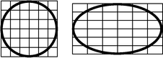
a / An ellipse is circle that has been distorted by shrinking and stretching along perpendicular axes.
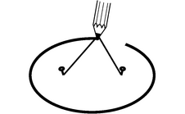
b / An ellipse can be constructed by tying a string to two pins and drawing like this with a pencil stretching the string taut. Each pin constitutes one focus of the ellipse.
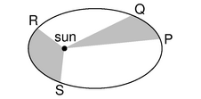
c / If the time interval taken by the planet to move from P to Q is equal to the time interval from R to S, then according to Kepler's equal-area law, the two shaded areas are equal. The planet is moving faster during time interval RS than it was during PQ, because gravitational energy has been transformed into kinetic energy.
Cruise your radio dial today and try to find any popular song that would have been imaginable without Louis Armstrong. By introducing solo improvisation into jazz, Armstrong took apart the jigsaw puzzle of popular music and fit the pieces back together in a different way. In the same way, Newton reassembled our view of the universe. Consider the titles of some recent physics books written for the general reader: The God Particle, Dreams of a Final Theory. When the subatomic particle called the neutrino was recently proven for the first time to have mass, specialists in cosmology began discussing seriously what effect this would have on calculations of the evolution of the universe from the Big Bang to its present state. Without the English physicist Isaac Newton, such attempts at universal understanding would not merely have seemed ambitious, they simply would not have occurred to anyone.
This section is about Newton's theory of gravity, which he used to explain the motion of the planets as they orbited the sun. Newton tosses off a general treatment of motion in the first 20 pages of his Mathematical Principles of Natural Philosophy, and then spends the next 130 discussing the motion of the planets. Clearly he saw this as the crucial scientific focus of his work. Why? Because in it he showed that the same laws of nature applied to the heavens as to the earth, and that the gravitational interaction that made an apple fall was the same as the as the one that kept the earth's motion from carrying it away from the sun.

Kepler's laws
Newton wouldn't have been able to figure out why the planets move the way they do if it hadn't been for the astronomer Tycho Brahe (1546-1601) and his protege Johannes Kepler (1571-1630), who together came up with the first simple and accurate description of how the planets actually do move. The difficulty of their task is suggested by the figure below, which shows how the relatively simple orbital motions of the earth and Mars combine so that as seen from earth Mars appears to be staggering in loops like a drunken sailor.
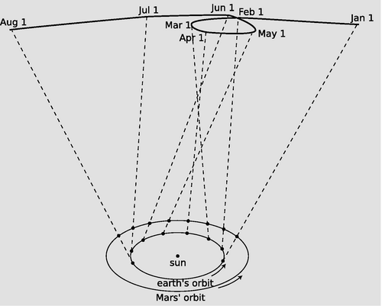
d / As the earth and Mars revolve around the sun at different rates, the combined effect of their motions makes Mars appear to trace a strange, looped path across the background of the distant stars.
Brahe, the last of the great naked-eye astronomers, collected extensive data on the motions of the planets over a period of many years, taking the giant step from the previous observations' accuracy of about 10 minutes of arc (10/60 of a degree) to an unprecedented 1 minute. The quality of his work is all the more remarkable considering that his observatory consisted of four giant brass protractors mounted upright in his castle in Denmark. Four different observers would simultaneously measure the position of a planet in order to check for mistakes and reduce random errors.
With Brahe's death, it fell to his former assistant Kepler to try to make some sense out of the volumes of data. After 900 pages of calculations and many false starts and dead-end ideas, Kepler finally synthesized the data into the following three laws:
\myindented{4mm}{ Kepler's elliptical orbit law: The planets orbit the sun in elliptical orbits with the sun at one focus.
Kepler's equal-area law: The line connecting a planet to the sun sweeps out equal areas in equal amounts of time.
Kepler's law of periods: The time required for a planet to orbit the sun, called its period, T, is proportional to the long axis of the ellipse raised to the 3/2 power. The constant of proportionality is the same for all the planets.}
Although the planets' orbits are ellipses rather than circles, most are very close to being circular. The earth's orbit, for instance, is only flattened by 1.7% relative to a circle. In the special case of a planet in a circular orbit, the two foci (plural of “focus”) coincide at the center of the circle, and Kepler's elliptical orbit law thus says that the circle is centered on the sun. The equal-area law implies that a planet in a circular orbit moves around the sun with constant speed. For a circular orbit, the law of periods then amounts to a statement that the time for one orbit is proportional to r^{3/2}, where r is the radius. If all the planets were moving in their orbits at the same speed, then the time for one orbit would simply depend on the circumference of the circle, so it would only be proportional to r to the first power. The more drastic dependence on r^{3/2} means that the outer planets must be moving more slowly than the inner planets.
Our main focus in this section will be to use the law of periods to deduce the general equation for gravitational energy. The equal-area law turns out to be a statement on conservation of angular momentum, which is discussed in chapter 4. We'll demonstrate the elliptical orbit law numerically in chapter 3, and analytically in chapter 4.
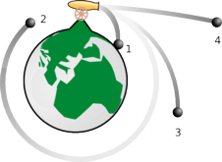
e / A cannon fires cannonballs at different velocities, from the top of an imaginary mountain that rises above the earth's atmosphere. This is almost the same as a figure Newton included in his Mathematical Principles.

Circular orbits
Kepler's laws say that planets move along elliptical paths (with circles as a special case), which would seem to contradict the proof on page 51 that objects moving under the influence of gravity have parabolic trajectories. Kepler was right. The parabolic path was really only an approximation, based on the assumption that the gravitational field is constant, and that vertical lines are all parallel. In figure e, trajectory A is an ellipse, but it gets chopped off when the cannonball hits the earth, and the small piece of it that is above ground is nearly indistinguishable from a parabola. Our goal is to connect the previous calculation of parabolic trajectories, y=(g/2v²)x², with Kepler's data for planets orbiting the sun in nearly circular orbits. Let's start by thinking in terms of an orbit that circles the earth, like orbit C in figure e. It's more natural now to choose a coordinate system with its origin at the center of the earth, so the parabolic approximation becomes y=r-(g/2v²)x², where r is the distance from the center of the earth. For small values of x, i.e. when the cannonball hasn't traveled very far from the muzzle of the gun, the parabola is still a good approximation to the actual circular orbit, defined by the Pythagorean theorem, r²=x²+y², or . For small values of x, we can use the approximation to find y≈r-(1/2r)x². Setting this equal to the equation of the parabola, we have g/2v²=(1/2r), or

Example 13: Low-earth orbit
To get a feel for what this all means, let's calculate the velocity required for a satellite in a circular low-earth orbit. Real low-earth-orbit satellites are only a few hundred km up, so for purposes of rough estimation we can take r to be the radius of the earth, and g is not much less than its value on the earth's surface, 10 . Taking numerical data from Appendix 5, we have
(about twenty times the speed of sound).
In one second, the satellite moves 8000 m horizontally. During this time, it drops the same distance any other object would: about 5 m. But a drop of 5 m over a horizontal distance of 8000 m is just enough to keep it at the same altitude above the earth's curved surface.

The sun's gravitational field
We can now use the circular orbit condition , combined with Kepler's law of periods, T∝r^{3/2} for circular orbits, to determine how the sun's gravitational field falls off with distance.⁷ From there, it will be just a hop, skip, and a jump to get to a universal description of gravitational interactions.
The velocity of a planet in a circular orbit is proportional to r/T, so
If gravity behaves systematically, then we can expect the same to be true for the gravitational field created by any object, not just the sun.
There is a subtle point here, which is that so far, r has just meant the radius of a circular orbit, but what we have come up with smells more like an equation that tells us the strength of the gravitational field made by some object (the sun) if we know how far we are from the object. In other words, we could reinterpret r as the distance from the sun.
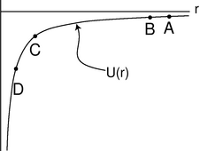
f / The gravitational energy U=-Gm₁m₂/r graphed as a function of r.
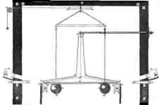
g / Cavendish's original drawing of the apparatus for his experiment, discussed in example 14. The room was sealed to exclude air currents, and the motion was observed through telescopes sticking through holes in the walls.
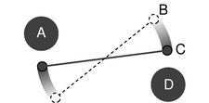
h / A simplified drawing of the Cavendish experiment, viewed from above. The rod with the two small masses on the ends hangs from a thin fiber, and is free to rotate.
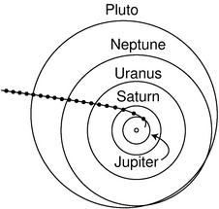
i / The Pioneer 10 space probe's trajectory from 1974 to 1992, with circles marking its position at one-year intervals. After its 1974 slingshot maneuver around Jupiter, the probe's motion was determined almost exclusively by the sun's gravity.

Gravitational energy in general
We now want to find an equation for the gravitational energy of any two masses that attract each other from a distance r. We assume that r is large enough compared to the distance between the objects so that we don't really have to worry about whether r is measured from center to center or in some other way. This would be a good approximation for describing the solar system, for example, since the sun and planets are small compared to the distances between them --- that's why you see Venus (the “evening star”) with your bare eyes as a dot, not a disk.
The equation we seek is going to give the gravitational energy, U, as a function of m₁, m₂, and r. We already know from experience with gravity near the earth's surface that U is proportional to the mass of the object that interacts with the earth gravitationally, so it makes sense to assume the relationship is symmetric: U is presumably proportional to the product m₁m₂. We can no longer assume ΔU∝Δr, as in the earth's-surface equation ΔU=mgΔy, since we are trying to construct an equation that would be valid for all values of r, and g depends on r. We can, however, consider an infinitesimally small change in distance dr, for which we'll have dU=m₂g₁dr, where g₁ is the gravitational field created by m₁. (We could just as well have written this as dU=m₁g₂dr, since we're not assuming either mass is “special” or “active.”) Integrating this equation, we have
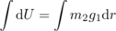
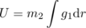
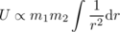
where we're free to take the constant of integration to be equal to zero, since gravitational energy is never a well-defined quantity in absolute terms. Writing G for the constant of proportionality, we have the following fundamental description of gravitational interactions:
Let's interpret this. First, don't get hung up on the fact that it's negative, since it's only differences in gravitational energy that have physical significance. The graph in figure f could be shifted up or down without having any physical effect. The slope of this graph relates to the strength of the gravitational field. For instance, suppose figure f is a graph of the gravitational energy of an asteroid interacting with the sun. If the asteroid drops straight toward the sun, from A to B, the decrease in gravitational energy is very small, so it won't speed up very much during that motion. Points C and D, however, are in a region where the graph's slope is much greater.
As the asteroid moves from C to D, it loses a lot of gravitational energy, and therefore speeds up considerably.

Example 14: Determining G
The constant G is not easy to determine, and Newton went to his grave without knowing an accurate value for it. If we knew the mass of the earth, then we could easily determine G from experiments with terrestrial gravity, but the only way to determine the mass of the earth accurately in units of kilograms is by finding G and reasoning the other way around! (If you estimate the average density of the earth, you can make at least a rough estimate of G.) Figures g and h show how G was first measured by Henry Cavendish in the nineteenth century.The rotating arm is released from rest, and the kinetic energy of the two moving balls is measured when they pass position C. Conservation of energy gives
+ 2 K ,
where M is the mass of one of the large balls, m is the mass of one of the small ones, and the factors of two, which will cancel, occur because every energy is mirrored on the opposite side of the apparatus. (As discussed on page 68, it turns out that we get the right result by measuring all the distances from the center of one sphere to the center of the other.) This can easily be solved for G. The best modern value of G, from modern versions of the same experiment, is 6.67×10⁻¹¹ J⋅m/kg².

Example 15: Escape velocity
◊ The Pioneer 10 space probe was launched in 1972, and continued sending back signals for 30 years. In the year 2001, not long before contact with the probe was lost, it was about 1.2×10¹³ m from the sun, and was moving almost directly away from the sun at a velocity of 1.21×10⁴ m. The mass of the sun is 1.99×10³⁰ kg. Will Pioneer 10 escape permanently, or will it fall back into the solar system?
◊ We want to know whether there will be a point where the probe will turn around. If so, then it will have zero kinetic energy at the turnaround point:
K_{i}+ U_{i} = U_{f}
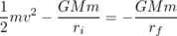
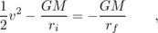
where M is the mass of the sun, m is the (irrelevant) mass of the probe, and r_{f} is the distance from the sun of the hypothetical turnaround point. Plugging in numbers on the left, we get a positive result. There can therefore be no solution, since the right side is negative. There won't be any turnaround point, and Pioneer 10 is never coming back.
The minimum velocity required for this to happen is called escape velocity. For speeds above escape velocity, the orbits are open-ended hyperbolas, rather than repeating elliptical orbits. In figure i, Pioneer's hyperbolic trajectory becomes almost indistinguishable from a line at large distances from the sun. The motion slows perceptibly in the first few years after 1974, but later the speed becomes nearly constant, as shown by the nearly constant spacing of the dots.
Pioneer 10, by the way, is at the center of a remarkable mystery about the nature of gravity.⁸
The probe is still being tracked by the worldwide Deep Space Network of radio dishes, and the precision of these measurements is so good that the acceleration caused by the sun's gravity can be determined to an accuracy of 10⁻¹¹ m/s². After accounting for all known nongravitational effects, the measured deceleration is stronger than predicted by 9×10⁻¹⁰ m/s². The same effect is being observed with Pioneer 10's sister probe, Pioneer 11, which is headed out of the solar system in the opposite direction. Some physicists have interpreted this as evidence that gravitational energy behaves just slightly differently than -Gm₁m₂/r, but it may be due instead to some behavior of the probes that is not completely understood --- after all, we can't inspect them now!

The gravitational field
We got the energy equation U = -Gm₁m₂/r by integrating g∝ 1/r² and then inserting a constant of proportionality to make the proportionality into an equation. The opposite of an integral is a derivative, so we can now go backwards and insert a constant of proportionality in g∝ 1/r² that will be consistent with the energy equation:
d U = m₂ g₁ d r
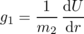
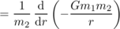
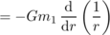
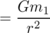
This kind of inverse-square law occurs all the time in nature. For instance, if you go twice as far away from a lightbulb, you receive 1/4 as much light from it, because as the light spreads out, it is like an expanding sphere, and a sphere with twice the radius has four times the surface area. It's like spreading the same amount of peanut butter on four pieces of bread instead of one --- we have to spread it thinner.

Discussion Questions
◊ A bowling ball interacts gravitationally with the earth. Would it make sense for the gravitational energy to be inversely proportional to the distance between their surfaces rather than their centers?
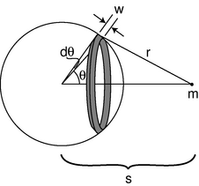
j / A spherical shell of mass M interacts with a pointlike mass m.
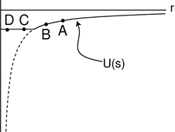
k / The gravitational energy of a mass m at a distance s from the center of a hollow spherical shell of mass.
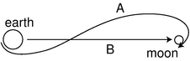
l / The actual trajectory of the Apollo 11 spacecraft, A, and the straight-line trajectory, B, assumed in the example.

The shell theorem
Newton's great insight was that gravity near the earth's surface was the same kind of interaction as the one that kept the planets from flying away from the sun. He told his niece that the idea came to him when he saw an apple fall from a tree, which made him wonder whether the earth might be affecting the apple and the moon in the same way. Up until now, we've generally been dealing with gravitational interactions between objects that are small compared to the distances between them, but that assumption doesn't apply to the apple. A kilogram of dirt a few feet under his garden in England would interact much more strongly with the apple than a kilogram of molten rock deep under Australia, thousands of miles away. Also, we know that the earth has some parts that are more dense, and some parts that are less dense. The solid crust, on which we live, is considerably less dense than the molten rock on which it floats. By all rights, the computation of the total gravitational energy of the apple should be a horrendous mess. Surprisingly, it turns out to be fairly simple in the end. First, we note that although the earth doesn't have the same density throughout, it does have spherical symmetry: if we imagine dividing it up into thin concentric shells, the density of each shell is uniform.
Second, it turns out that a uniform spherical shell interacts with external masses as if all its mass was concentrated at its center.
\mythmhdr{The shell theorem} The gravitational energy of a uniform spherical shell of mass M interacting with a pointlike mass m outside it equals -GMm/s, where s is the center-to-center distance. If mass m is inside the shell, then the energy is constant, i.e. the shell's interior gravitational field is zero.
\mythmhdr{Proof} Let b be the radius of the shell, h its thickness, and ρ its density. Its volume is then V=(area)(thickness)=4πb²h, and its mass is M=ρV=4πρb²h. The strategy is to divide the shell up into rings as shown in figure j, with each ring extending from θ to θ+dθ. Since the ring is infinitesimally skinny, its entire mass lies at the same distance, r, from mass m. The width of such a ring is found by the definition of radian measure to be w=bdθ, and its mass is dM=(ρ)(circumference)(thickness)(width)= (ρ)(2πb sin θ)(h)(bdθ)=2πb²hsinθdθ. The gravitational energy of the ring interacting with mass m is therefore
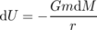
The integral has a mixture of the variables r and θ, which are related by the law of cosines,
r² = b² + s² - 2bscosθ ,
and to evaluate the integral, we need to get everything in terms of either r and dr or θ and dθ. The relationship between the differentials is found by differentiating the law of cosines,
2rdr = 2bssinθdθ ,
and since sinθdθ occurs in the integral, the easiest path is to substitute for it, and get everything in terms of r and dr:
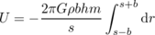
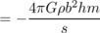
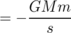
This was all under the assumption that mass m was on the outside of the shell. To complete the proof, we consider the case where it's inside. In this case, the only change is that the limits of integration are different:
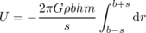
= -4πGρbhm
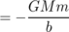
The two results are equal at the surface of the sphere, s=b, so the constant-energy part joins continuously onto the 1/s part, and the effect is to chop off the steepest part of the graph that we would have had if the whole mass M had been concentrated at its center. Dropping a mass m from A to B in figure k releases the same amount of energy as if mass M had been concentrated at its center, but there is no release of gravitational energy at all when moving between two interior points like C and D. In other words, the internal gravitational field is zero. Moving from C to D brings mass m farther away from the nearby side of the shell, but closer to the far side, and the cancellation between these two effects turns out to be perfect. Although the gravitational field has to be zero at the center due to symmetry, it's much more surprising that it cancels out perfectly in the whole interior region; this is a special mathematical characteristic of a 1/r interaction like gravity.

Example 16: Newton's apple
Over a period of 27.3 days, the moon travels the circumference of its orbit, so using data from Appendix 5, we can calculate its speed, and solve the circular orbit condition to determine the strength of the earth's gravitational field at the moon's distance from the earth, g= v²/ r= 2.72×10⁻³ m/s², which is 3600 times smaller than the gravitational field at the earth's surface. The center-to-center distance from the moon to the earth is 60 times greater than the radius of the earth. The earth is, to a very good approximation, a sphere made up of concentric shells, each with uniform density, so the shell theorem tells us that its external gravitational field is the same as if all its mass was concentrated at its center. We already know that a gravitational energy that varies as -1/ r is equivalent to a gravitational field proportional to 1/ r², so it makes sense that a distance that is greater by a factor of 60 corresponds to a gravitational field that is 60×60=3600 times weaker. Note that the calculation didn't require knowledge of the earth's mass or the gravitational constant, which Newton didn't know.
In 1665, shortly after Newton graduated from Cambridge, the Great Plague forced the college to close for two years, and Newton returned to the family farm and worked intensely on scientific problems. During this productive period, he carried out this calculation, but it came out wrong, causing him to doubt his new theory of gravity. The problem was that during the plague years, he was unable to use the university's library, so he had to use a figure for the radius of the moon's orbit that he had memorized, and he forgot that the memorized value was in units of nautical miles rather than statute miles. Once he realized his mistake, he found that the calculation came out just right, and became confident that his theory was right after all. ⁹

Example 17: Weighing the earth
◊ Once Cavendish had found G= 6.67×10⁻¹¹ J⋅m/kg² (p. 65, example 14), it became possible to determine the mass of the earth. By the shell theorem, the gravitational energy of a mass m at a distance r from the center of the earth is U=- GMm/ r, where M is the mass of the earth. The gravitational field is related to this by mgd r=d U, or g=(1/ m)d U/d r= GM/ r². Solving for M, we have
M = gr²/ G
{ 6.67×10⁻¹¹ J⋅m/kg²}
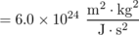

Example 18: Gravity inside the earth
◊ The earth is somewhat more dense at greater depths, but as an approximation let's assume it has a constant density throughout. How does its internal gravitational field vary with the distance r from the center?
◊ Let's write b for the radius of the earth. The shell theorem tell us that at a given location r, we only need to consider the mass M{< r} that is deeper than r. Under the assumption of constant density, this mass is related to the total mass of the earth by
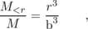
and by the same reasoning as in example 17,
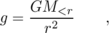
so
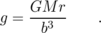
In other words, the gravitational field interpolates linearly between zero at r=0 and its ordinary surface value at r= b.
The following example applies the numerical techniques of section 2.2.

Example 19: From the earth to the moon
The Apollo 11 mission landed the first humans on the moon in 1969. In this example, we'll estimate the time it took to get to the moon, and compare our estimate with the actual time, which was 73.0708 hours from the engine burn that took the ship out of earth orbit to the engine burn that inserted it into lunar orbit. During this time, the ship was coasting with the engines off, except for a small course-correction burn, which we neglect. More importantly, we do the calculation for a straight-line trajectory rather than the real S-shaped one, so the result can only be expected to agree roughly with what really happened. The following data come from the original press kit, which NASA has scanned and posted on the Web:
initial altitude | 3363times105 zum
initial velocity | 1083times104 zums
The endpoint of the the straight-line trajectory is a free-fall impact on the lunar surface, which is also unrealistic (luckily for the astronauts).
The ship's energy is
we can divide it out}
and the energy variables in the program with names like \verb-e-, \verb-k-, and \verb-u- are actually energies per unit mass. The program is a straightforward modification of the function \verb-time3- on page 55.
import math
def tmoon(vi,ri,rf,n):
bigg=6.67e-11 # gravitational constant
me=5.97e24 # mass of earth
mm=7.35e22 # mass of moon
rm=3.84e8 # earth-moon distance
r=ri
v=vi
dr = (rf-ri)/n
e=-bigg*me/ri-bigg*mm/(rm-ri)+.5*vi**2
t=0
for i in range(n):
u_old = -bigg*me/r-bigg*mm/(rm-r)
k_old = e - u_old
v_old = math.sqrt(2.*k_old)
r = r+dr
u = -bigg*me/r-bigg*mm/(rm-r)
k = e - u
v = math.sqrt(2.*k)
v_avg = .5*(v_old+v)
dt=dr/v_avg
t=t+dt
return t
>>> re=6.378e6 # radius of earth
>>> rm=1.74e6 # radius of moon
>>> ri=re+3.363e5 # re+initial altitude
>>> rf=3.8e8-rm # earth-moon distance minus rm
>>> vi=1.083e4 # initial velocity
>>> tmoon(vi,ri,rf,1000)/3600. # convert seconds to hours
59.654047441976552
This is pretty decent agreement, considering the wildly inaccurate trajectory assumed. It's interesting to see how much the duration of the trip changes if we increase the initial velocity by only ten percent:
>>> vi=1.2e4
>>> tmoon(vi,ri,rf,1000)/3600.
18.177752636111677
{}The most important reason for using the lower speed was that if something had gone wrong, the ship would have been able to whip around the moon and take a “free return” trajectory back to the earth, without having to do any further burns. At a higher speed, the ship would have had so much kinetic energy that in the absence of any further engine burns, it would have escaped from the earth-moon system. The Apollo 13 mission had to take a free return trajectory after an explosion crippled the spacecraft.

2.4 Atomic Phenomena
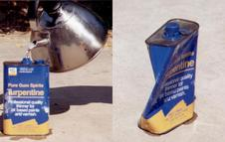
a / A vivid demonstration that heat is a form of motion. A small amount of boiling water is poured into the empty can, which rapidly fills up with hot steam. The can is then sealed tightly, and soon crumples.
Variety is the spice of life, not of science. So far this chapter has focused on heat energy, kinetic energy, and gravitational energy, but it might seem that in addition to these there is a bewildering array of other forms of energy. Gasoline, chocolate bars, batteries, melting water --- in each case there seems to be a whole new type of energy. The physicist's psyche rebels against the prospect of a long laundry list of types of energy, each of which would require its own equations, concepts, notation, and terminology. The point at which we've arrived in the study of energy is analogous to the period in the 1960's when a half a dozen new subatomic particles were being discovered every year in particle accelerators. It was an embarrassment. Physicists began to speak of the “particle zoo,” and it seemed that the subatomic world was distressingly complex. The particle zoo was simplified by the realization that most of the new particles being whipped up were simply clusters of a previously unsuspected set of fundamental particles (which were whimsically dubbed quarks, a made-up word from a line of poetry by James Joyce, “Three quarks for Master Mark.”) The energy zoo can also be simplified, and it's the purpose of this section to demonstrate the hidden similarities between forms of energy as seemingly different as heat and motion.
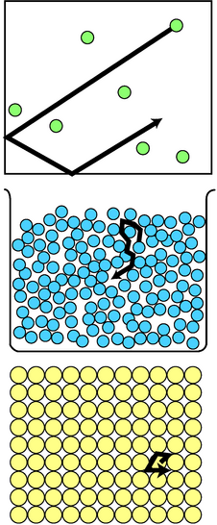
b / Random motion of atoms in a gas, a liquid, and a solid.

c / The spring's energy is really due to electrical interactions among atoms.

Heat is kinetic energy.
What is heat really? Is it an invisible fluid that your bare feet soak up from a hot sidewalk? Can one ever remove all the heat from an object? Is there a maximum to the temperature scale?
The theory of heat as a fluid seemed to explain why colder objects absorbed heat from hotter ones, but once it became clear that heat was a form of energy, it began to seem unlikely that a material substance could transform itself into and out of all those other forms of energy like motion or light. For instance, a compost pile gets hot, and we describe this as a case where, through the action of bacteria, chemical energy stored in the plant cuttings is transformed into heat energy. The heating occurs even if there is no nearby warmer object that could have been leaking Ҩeat fluidӠinto the pile.
An alternative interpretation of heat was suggested by the theory that matter is made of atoms. Since gases are thousands of times less dense than solids or liquids, the atoms (or clusters of atoms called molecules) in a gas must be far apart. In that case, what is keeping all the air molecules from settling into a thin film on the floor of the room in which you are reading this book? The simplest explanation is that they are moving very rapidly, continually ricocheting off of the floor, walls, and ceiling. Though bizarre, the cloud-of-bullets image of a gas did give a natural explanation for the surprising ability of something as tenuous as a gas to exert huge forces.
The experiment shown in figure a, for instance, can be explained as follows. The high temperature of the steam is interpreted as a high average speed of random motions of its molecules. Before the lid was put on the can, the rapidly moving steam molecules pushed their way out of the can, forcing the slower air molecules out of the way. As the steam inside the can thinned out, a stable situation was soon achieved, in which the force from the less dense steam molecules moving at high speed balanced against the force from the more dense but slower air molecules outside. The cap was put on, and after a while the steam inside the can began to cool off. The force from the cooler, thin steam no longer matched the force from the cool, dense air outside, and the imbalance of forces crushed the can.
This type of observation leads naturally to the conclusion that hotter matter differs from colder in that its atoms' random motion is more rapid. In a liquid, the motion could be visualized as people in a milling crowd shoving past each other more quickly. In a solid, where the atoms are packed together, the motion is a random vibration of each atom as it knocks against its neighbors.
We thus achieve a great simplification in the theory of heat. Heat is simply a form of kinetic energy, the total kinetic energy of random motion of all the atoms in an object. With this new understanding, it becomes possible to answer at one stroke the questions posed at the beginning of the section. Yes, it is at least theoretically possible to remove all the heat from an object. The coldest possible temperature, known as absolute zero, is that at which all the atoms have zero velocity, so that their kinetic energies, K=(1/2)mv², are all zero. No, there is no maximum amount of heat that a certain quantity of matter can have, and no maximum to the temperature scale, since arbitrarily large values of v can create arbitrarily large amounts of kinetic energy per atom.
The kinetic theory of heat also provides a simple explanation of the true nature of temperature. Temperature is a measure of the amount of energy per molecule, whereas heat is the total amount of energy possessed by all the molecules in an object.
There is an entire branch of physics, called thermodynamics, that deals with heat and temperature and forms the basis for technologies such as refrigeration. Thermodynamics is discussed in more detail in chapter 5, and I've provided here only a brief overview of the thermodynamic concepts that relate directly to energy.
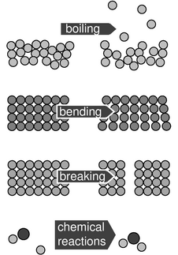
d / All these energy transformations turn out at the atomic level to be due to changes in the distances between atoms that interact electrically.
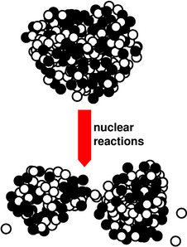
e / This figure looks similar to the previous ones, but the scale is a million times smaller. The little balls are the neutrons and protons that make up the tiny nucleus at the center of a uranium atom. When the nucleus splits (fissions), the source of the kinetic energy is partly electrical and partly nuclear.

All energy comes from particles moving or interacting.
If I stretch the spring in figure c and then release it, it snaps taut again. The creation of some kinetic energy shows that there must have been some other form of energy that was destroyed. What was it?
We could just invent a new type of energy called “spring energy,” study its behavior, and call it quits, but that would be ugly. Are we going to have to invent a new forms of energy like this, over and over? No: the title of this book doesn't lie, and physics really is fundamentally simple. As shown in figure d, when we bend or stretch an object, we're really changing the distances between the atoms, resulting in a change in electrical energy. Electrical energy isn't really our topic right now --- that's what most of the second half of this book is about --- but conceptually it's very similar to gravitational energy. Like gravitational energy, it depends on 1/r, although there are some interesting new phenomena, such as the existence of both attraction and repulsion, which doesn't occur with gravity because gravitational mass can't be negative. The real point is that all the apparently dissimilar forms of energy in figure d turn out to be due to electrical interactions among atoms. Even if we wish to include nuclear reactions (figure e) in the picture, there still turn out to be only four fundamental types of energy:
\myindented{6mm}{ kinetic energy (including heat)
gravitational energy
electrical and magnetic energy
nuclear energy }
Astute students have often asked me how light fits into this picture. This is a very good question, and in fact it could be argued that it is the basic question that led to Einstein's theory of relativity as well as the modern quantum picture of nature. Since these are topics for the second half of the book, we'll have to be content with half an answer at this point. For now, we may think of light energy as a form of kinetic energy, but one calculated not according to (1/2)mv² but by some other equation. (We know that (1/2)mv² would not make sense, because light has no mass, and furthermore, high-energy beams of light do not differ in speed from low-energy ones.)

Example 20: Temperature during boiling
◊ If you stick a thermometer in a pan of water, and watch the temperature as you bring the water to a boil, you'll notice an interesting fact. The temperature goes up until the boiling point is reached, but then stays at 100°C during the whole time the water is being boiled off. The temperature of the steam is also 100°C. Why does the temperature “stick” like this? What's happening to all the energy that the stove's burner is putting into the pan?
◊ As shown in figure d, boiling requires an increase in electrical energy, because the atoms coming out as gas are moving away from the other atoms, which attract them electrically. It is only this electrical energy that is increasing, not the atoms' kinetic energy, which is what the thermometer can measure.

Example 21: Diffusion
◊ A drop of food coloring in a cup of water will gradually spread out, even if you don't do any mixing with a spoon. This is called diffusion. Why would this happen, and what effect would temperature have? What would happen with solids or gases?
◊ Figure b shows that the atoms in a liquid mingle because of their random thermal motion. Diffusion is slow (typically on the order of a centimeter a minute), despite the high speeds of the atoms (typically hundreds of miles per hour). This is due to the randomness of the motion: a particular atom will take a long time to travel any significant distance, because it doesn't travel in a straight line.
Based on this picture, we expect that the speed of diffusion should increase as a function of temperature, and experiments show that this is true.
Diffusion also occurs in gases, which is why you can smell things even when the air is still. The speeds are much faster, because the typical distance between collisions is much longer than in a liquid.
We can see from figure b that diffusion won't occur in solids, because each atom vibrates around an equilibrium position.

Discussion Questions
◊ I'm not making this up. XS Energy Drink has ads that read like this: All the “Energy” ... Without the Sugar! Only 8 Calories!” Comment on this.

2.5 Oscillations
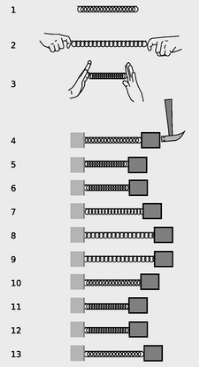
a / The spring has a minimum-energy length, 1, and energy is required in order to compress or stretch it, 2 and 3. A mass attached to the spring will oscillate around the equilibrium, 4-13.
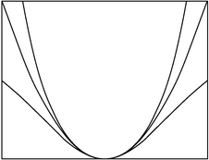
b / Three functions with the same curvature at x=0.
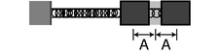
c / The amplitude would usually be defined as the distance from equilibrium to one extreme of the motion, i.e. half the total travel.
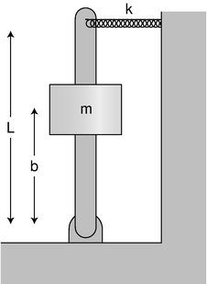
d / Example 22.
e / Water in a U-shaped tube.
Let's revisit the example of the stretched spring from the previous section. We know that its energy is a form of electrical energy of interacting atoms, which is nice conceptually but doesn't help us to solve problems, since we don't know how the energy, U, depends on the length of the spring. All we know is that there's an equilibrium (figure a/1), which is a local minimum of the function U. An extremely important problem which arises in this connection is how to calculate oscillatory motion around an equilibrium, as in a/4-13. Even if we did special experiments to find out how the spring's energy worked, it might seem like we'd have to go through just as much work to deal with any other kind of oscillation, such as a sapling swinging back and forth in the breeze.
Surprisingly, it's possible to analyze this type of oscillation in a very general and elegant manner, as long as the analysis is limited to small oscillations. We'll talk about the mass on the spring for concreteness, but there will be nothing in the discussion at all that is restricted to that particular physical system. First, let's choose a coordinate system in which x=0 corresponds to the position of the mass where the spring is in equilibrium, and since interaction energies like U are only well defined up to an additive constant, we'll simply define it to be zero at equilibrium:
U(0) = 0
Since x=0 is an equilibrium, U(x) must have a local minimum there, and a differentiable function (which we assume U is) has a zero derivative at a local minimum:
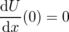
There are still infinitely many functions that could satisfy these criteria, including the three shown in figure b, which are x²/2, x²/2(1+x²), and (e^{3x}+e^{-3x}-2)/18. Note, however, how all three functions are virtually identical right near the minimum. That's because they all have the same curvature. More specifically, each function has its second derivative equal to 1 at x=0, and the second derivative is a measure of curvature. We write k for the second derivative of the energy at an equilibrium point,
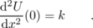
Physically, k is a measure of stiffness. For example, the heavy-duty springs in a car's shock absorbers would have a high value of k. It is often referred to as the spring constant, but we're only using a spring as an example here. As shown in figure b, any two functions that have U(0)=0, dU/dx=0, and d²U/dx²=k, with the same value of k, are virtually indistinguishable for small values of x, so if we want to analyze small oscillations, it doesn't even matter which function we assume. For simplicity, we'll just use U(x)=(1/2)kx² from now on.
Now we're ready to analyze the mass-on-a-spring system, while keeping in mind that it's really only a representative example of a whole class of similar oscillating systems. We expect that the motion is going to repeat itself over and over again, and since we're not going to include frictional heating in our model, that repetition should go on forever without dying out. The most interesting thing to know about the motion would be the period, T, which is the amount of time required for one complete cycle of the motion. We might expect that the period would depend on the spring constant, k, the mass, m, and and the amplitude, A, defined in figure c.¹⁰
In examples like the brachistochrone and the Apollo 11 mission, it was generally necessary to use numerical techniques to determine the amount of time required for a certain motion. Once again, let's dust off the \verb-time3- function from page 55 and modify it for our purposes. For flexibility, we'll define the function U(x) as a separate Python function. We really want to calculate the time required for the mass to come back to its starting point, but that would be awkward to set up, since our function works by dividing up the distance to be traveled into tiny segments. By symmetry, the time required to go from one end to the other equals the time required to come back to the start, so we'll just calculate the time for half a cycle and then double it when we return the result at the end of the function. The test at lines 16-19 is necessary because otherwise at the very end of the motion we can end up trying to take the square root of a negative number due to rounding errors.
import math
def u(k,x):
return .5*k*x**2

def osc(m,k,a,n):
x=a
v=0
dx = -2.*a/n
t=0
e = u(k,x)+.5*m*v**2
for i in range(n):
x_old = x
v_old = v
x = x+dx
kinetic = e-u(k,x)
if kinetic<0. :
v=0.
print "warning, K=",kinetic,"<0"
else :
v = -math.sqrt(2.*kinetic/m)
v_avg = (v+v_old)/2.
dt=dx/v_avg
t=t+dt
return 2.*t
>>> osc(1.,1.,1.,100000)
warning, K= -1.43707268307e-12 <0
6.2831854132667919
The first thing to notice is that with this particular set of inputs (m=1 kg, k=1 J/m², and A=1 m), the program has done an excellent job of computing 2π=6.2831853…. This is Mother Nature giving us a strong hint that the problem has an algebraic solution, not just a numerical one. The next interesting thing happens when we change the amplitude from 1 m to 2 m:
>>> osc(1.,1.,2.,100000)
warning, K= -5.7482907323e-12 <0
6.2831854132667919
{}Even though the mass had to travel double the distance in each direction, the period is the same to within the numerical accuracy of the calculation!
With these hints, it seems like we start looking for an algebraic solution. For guidance, here's a graph of x as a function of t, as calculated by the \verb-osc- function with \verb-n-=10.
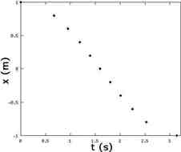This looks like a cosine function, so let's see if a x=Acos(ωt+δ) is a solution to the conservation of energy equation --- it's not uncommon to try to “reverse-engineer” the cryptic results of a numerical calculation like this. The symbol ω=2π/T (Greek omega) is a standard symbol for the number of radians per second of oscillation, and the phase angle δ is to allow for the possibility that t=0 doesn't coincide with the beginning of the motion. The energy is
E = K + U
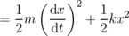
According to conservation of energy, this has to be a constant. Using the identity sin²+cos²=1, we can see that it will be a constant if we have mω²=k, or , i.e. . Note that the period is independent of amplitude.

Example 22: A spring and a lever
◊ What is the period of small oscillations of the system shown in the figure? Neglect the mass of the lever and the spring. Assume that the spring is so stiff that gravity is not an important effect. The spring is relaxed when the lever is vertical.
◊ This is a little tricky, because the spring constant k, although it is relevant, is not the k we should be putting into the equation . The k that goes in there has to be the second derivative of U with respect to the position, x, of the thing that's moving. The energy U stored in the spring depends on how far the tip of the lever is from the center. This distance equals (L/b)x, so the energy in the spring is
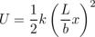
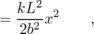
and the k we have to put in is
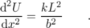
The result is
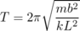
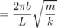
The leverage of the lever makes it as if the spring was stronger, and decreases the period of the oscillations by a factor of b/L.

Example 23: Water in a U-shaped tube
◊ What is the period of oscillation of the water in figure e?
◊ In example 12 on p. 49, we found U( y)=ρ gAy², so the “spring constant,” which really isn't a spring constant here at all, is
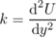
= 2ρ gA .
This is an interesting example, because k can be calculated without any approximations, but the kinetic energy requires an approximation, because we don't know the details of the pattern of flow of the water. It could be very complicated. There will be a tendency for the water near the walls to flow more slowly due to friction, and there may also be swirling, turbulent motion. However, if we make the approximation that all the water moves with the same velocity as the surface, d y/d t, then the mass-on-a-spring analysis applies. Letting L be the total length of the filled part of the tube, the mass is ρ LA, and we have
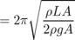
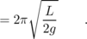
\backofchapterboilerplate{2}

Homework Problems
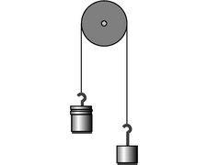
b / Problem 16.
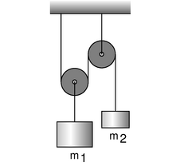
c / Problem 17.
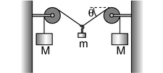
d / Problem 18.
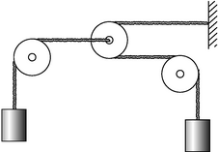
e / Problem 19.
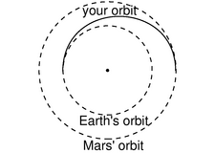
f / Problem 27.
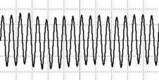
g / Problem 32.
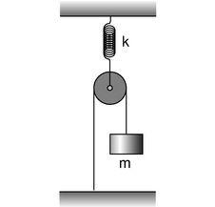
h / Problem 35.
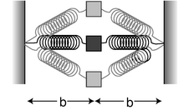
i / Problem 36.
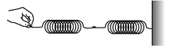
j / Problem 37.
1. [0]{boatpower} Experiments show that the power consumed by a boat's engine is approximately proportional to the third power of its speed. (We assume that it is moving at constant speed.)
(a) When a boat is cruising at constant speed, what type of energy transformation do you think is being performed?
(b) If you upgrade to a motor with double the power, by what factor is your boat's maximum cruising speed increased? (solution in the pdf version of the book){hwsoln:boatpower}
2. [0]{ratioke} Object A has a kinetic energy of 13.4 J. Object B has a mass that is greater by a factor of 3.77, but is moving more slowly by a factor of 2.34. What is object B's kinetic energy? (solution in the pdf version of the book){hwsoln:ratioke}
3. My 1.25 kW microwave oven takes 126 seconds to bring 250 g of water from room temperature to a boil. What percentage of the power is being wasted? Where might the rest of the energy be going? (solution in the pdf version of the book){hwsoln:microwaveeff}
4. [0]{psscballs} The multiflash photograph below shows a collision between two pool balls. The ball that was initially at rest shows up as a dark image in its initial position, because its image was exposed several times before it was struck and began moving. By making measurements on the figure, determine whether or not energy appears to have been conserved in the collision. What systematic effects would limit the accuracy of your test? [From an example in PSSC Physics.]
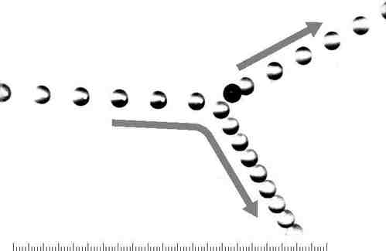
a / Problem 4.
5. A grasshopper with a mass of 110 mg falls from rest from a height of 310 cm. On the way down, it dissipates 1.1 mJ of heat due to air resistance. At what speed, in m/s, does it hit the ground? (solution in the pdf version of the book){hwsoln:grasshopper}
6. [0] You jump up straight up in the air. When do you have the greatest gravitational energy? The greatest kinetic energy? (Based on a problem by Serway and Faughn.)
7. (a) You release a magnet on a tabletop near a big piece of iron, and the magnet leaps across the table to the iron. Does the magnetic energy increase or decrease? Explain. (b) Suppose instead that you have two repelling magnets. You give them an initial push towards each other, so they decelerate while approaching each other. Does the magnetic energy increase or decrease? Explain.
8. [0] Estimate the kinetic energy of an Olympic sprinter.
9. [0] You are driving your car, and you hit a brick wall head on, at full speed. The car has a mass of 1500 kg. The kinetic energy released is a measure of how much destruction will be done to the car and to your body. Calculate the energy released if you are traveling at (a) 40 mi/hr, and again (b) if you're going 80 mi/hr. (c) What is counterintuitive about this, and what implication does this have for driving at high speeds? (answer check available at lightandmatter.com)
10. A closed system can be a bad thing --- for an astronaut sealed inside a space suit, getting rid of body heat can be difficult. Suppose a 60-kg astronaut is performing vigorous physical activity, expending 200 W of power. If none of the heat can escape from her space suit, how long will it take before her body temperature rises by 6°{}C (11°{}F), an amount sufficient to kill her? Assume that the amount of heat required to raise her body temperature by 1°{}C is the same as it would be for an equal mass of water. Express your answer in units of minutes. (answer check available at lightandmatter.com)
11. The following table gives the amount of energy required in order to heat, melt, or boil a gram of water.
heat 1 g of ice by1degcunit | 2.05 J
melt 1 g of ice | 333 J
heat 1 g of liquid by1degcunit | 4.19 J
boil 1 g of water | 2500 J
heat 1 g of steam by1degcunit | 2.01 J
(a) How much energy is required in order to convert 1.00 g of ice at -20 °C into steam at 137 °C? (answer check available at lightandmatter.com)
(b) What is the minimum amount of hot water that could melt 1 g of ice? (answer check available at lightandmatter.com)
12. Anya climbs to the top of a tree, while Ivan climbs half-way to the top. They both drop pennies to the ground. Compare the kinetic energies and velocities of the pennies on impact, using ratios.
13. [0] Anya and Ivan lean over a balcony side by side. Anya throws a penny downward with an initial speed of 5 m/s. Ivan throws a penny upward with the same speed. Both pennies end up on the ground below. Compare their kinetic energies and velocities on impact.
14. [2] (a) A circular hoop of mass m and radius r spins like a wheel while its center remains at rest. Let ω be the number of radians it covers per unit time, i.e. ω=2π/T, where the period, T, is the time for one revolution. Show that its kinetic energy equals (1/2)mω²r².
(b) Show that the answer to part a has the right units. (Note that radians aren't really units, since the definition of a radian is a unitless ratio of two lengths.)
(c) If such a hoop rolls with its center moving at velocity v, its kinetic energy equals (1/2)mv², plus the amount of kinetic energy found in part a. Show that a hoop rolls down an inclined plane with half the acceleration that a frictionless sliding block would have.
15. On page 44, I used the chain rule to prove that the acceleration of a free-falling object is given by a=-g. In this problem, you'll use a different technique to prove the same thing. Assume that the acceleration is a constant, a, and then integrate to find v and y, including appropriate constants of integration. Plug your expressions for v and y into the equation for the total energy, and show that a=-g is the only value that results in constant energy.
16. The figure shows two unequal masses, m₁ and m₂, connected by a string running over a pulley. Find the acceleration. \hwhint{hwhint:atwood}
17. What ratio of masses will balance the pulley system shown in the figure? \hwhint{hwhint:pulley}
18. (a) For the apparatus shown in the figure, find the equilibrium angle θ in terms of the two masses.
(b) Interpret your result in the case of M>> m (M much greater than m). Does it make sense physically?
(c) For what combinations of masses would your result give nonsense? Interpret this physically. \hwhint{hwhint:tightropish}
19. In the system shown in the figure, the pulleys on the left and right are fixed, but the pulley in the center can move to the left or right. The two hanging masses are identical, and the pulleys and ropes are all massless. Find the upward acceleration of the mass on the left, in terms of g only. \hwhint{hwhint:funkyatwood}
20. Two atoms will interact via electrical forces between their protons and electrons. One fairly good approximation to the electrical energy is the Lenard-Jones formula,
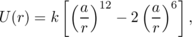
where r is the center-to-center distance between the atoms. Show that (a) there is an equilibrium point at r=a,
(b) the equilibrium is stable, and
(c) the energy required to bring the atoms from their equilibrium separation to infinity is k. \hwhint{hwhint:lennardjones}
21. [0]{gspacestation} The International Space Station orbits at an altitude of about 360 to 400 km. What is the gravitational field of the earth at this altitude?
22. (a) A geosynchronous orbit is one in which the satellite orbits above the equator, and has an orbital period of 24 hours, so that it is always above the same point on the spinning earth. Calculate the altitude of such a satellite.
(b) What is the gravitational field experienced by the satellite? Give your answer as a percentage in relation to the gravitational field at the earth's surface.\hwhint{hwhint:geosynch}
23. Astronomers calculating orbits of planets often work in a nonmetric system of units, in which the unit of time is the year, the unit of mass is the sun's mass, and the unit of distance is the astronomical unit (A.U.), defined as half the long axis of the earth's orbit. In these units, find an exact expression for the gravitational constant, G.
24. The star Lalande 21185 was found in 1996 to have two planets in roughly circular orbits, with periods of 6 and 30 years. What is the ratio of the two planets' orbital radii?
25. A projectile is moving directly away from a planet of mass M at exactly escape velocity. Find r, the distance from the projectile to the center of the planet, as a function of time, t, and also find v(t). Does v show the correct behavior as t approaches infinity? \hwhint{hwhint:escape}
26. [3]{tides} The purpose of this problem is to estimate the height of the tides. The main reason for the tides is the moon's gravity, and we'll neglect the effect of the sun. Also, real tides are heavily influenced by landforms that channel the flow of water, but we'll think of the earth as if it was completely covered with oceans. Under these assumptions, the ocean surface should be a surface of constant U/m. That is, a thimbleful of water, m, should not be able to gain or lose any gravitational energy by moving from one point on the ocean surface to another. If only the spherical earth's gravity was present, then we'd have U/m=-GM_{e}/r, and a surface of constant U/m would be a surface of constant r, i.e. the ocean's surface would be spherical. Taking into account the moon's gravity, the main effect is to shift the center of the sphere, but the sphere also becomes slightly distorted into an approximately ellipsoidal shape. (The shift of the center is not physically related to the tides, since the solid part of the earth tends to be centered within the oceans; really, this effect has to do with the motion of the whole earth through space, and the way that it wobbles due to the moon's gravity.) Determine the amount by which the long axis of the ellipsoid exceeds the short axis. \hwhint{hwhint:tides}
27. You are considering going on a space voyage to Mars, in which your route would be half an ellipse, tangent to the Earth's orbit at one end and tangent to Mars' orbit at the other. Your spacecraft's engines will only be used at the beginning and end, not during the voyage. How long would the outward leg of your trip last? (Assume the orbits of Earth and Mars are circular.) (answer check available at lightandmatter.com)
28. When you buy a helium-filled balloon, the seller has to inflate it from a large metal cylinder of the compressed gas. The helium inside the cylinder has energy, as can be demonstrated for example by releasing a little of it into the air: you hear a hissing sound, and that sound energy must have come from somewhere. The total amount of energy in the cylinder is very large, and if the valve is inadvertently damaged or broken off, the cylinder can behave like bomb or a rocket.
Suppose the company that puts the gas in the cylinders prepares cylinder A with half the normal amount of pure helium, and cylinder B with the normal amount. Cylinder B has twice as much energy, and yet the temperatures of both cylinders are the same. Explain, at the atomic level, what form of energy is involved, and why cylinder B has twice as much.
29. Energy is consumed in melting and evaporation. Explain in terms of conservation of energy why sweating cools your body, even though the sweat is at the same temperature as your body.
30. A microwave oven works by twisting molecules one way and then the other, counterclockwise and then clockwise about their own centers, millions of times a second. If you put an ice cube or a stick of butter in a microwave, you'll observe that the oven doesn't heat the solid very quickly, although eventually melting begins in one small spot. Once a melted spot forms, it grows rapidly, while the more distant solid parts remain solid. In other words, it appears based on this experiment that a microwave oven heats a liquid much more rapidly than a solid. Explain why this should happen, based on the atomic-level description of heat, solids, and liquids.
31. All stars, including our sun, show variations in their light output to some degree. Some stars vary their brightness by a factor of two or even more, but our sun has remained relatively steady during the hundred years or so that accurate data have been collected. Nevertheless, it is possible that climate variations such as ice ages are related to long-term irregularities in the sun's light output. If the sun was to increase its light output even slightly, it could melt enough ice at the polar icecaps to flood all the world's coastal cities. The total sunlight that falls on the ice caps amounts to about 1×10¹⁶ watts. Presently, this heat input to the poles is balanced by the loss of heat via winds, ocean currents, and emission of infrared light, so that there is no net melting or freezing of ice at the poles from year to year. Suppose that the sun changes its light output by some small percentage, but there is no change in the rate of heat loss by the polar caps. Estimate the percentage by which the sun's light output would have to increase in order to melt enough ice to raise the level of the oceans by 10 meters over a period of 10 years. (This would be enough to flood New York, London, and many other cities.) Melting 1 kg of ice requires 3×10³ J.
32. [0]{whistle} The figure shows the oscillation of a microphone in response to the author whistling the musical note “A.” The horizontal axis, representing time, has a scale of 1.0 ms per square. Find T, the period, f, the frequency, and ω, the angular frequency.
33. (a) A mass m is hung from a spring whose spring constant is k. Write down an expression for the total interaction energy of the system, U, and find its equilibrium position.\hwhint{hwhint:hangfromspring}
(b) Explain how you could use your result from part a to determine an unknown spring constant.
34. A certain mass, when hung from a certain spring, causes the spring to stretch by an amount h compared to its equilibrium length. If the mass is displaced vertically from this equilibrium, it will oscillate up and down with a period T_{osc}. Give a numerical comparison between T_{osc} and T_{fall}, the time required for the mass to fall from rest through a height h, when it isn't attached to the spring. (You will need the result of problem 33).
35. Find the period of vertical oscillations of the mass m. The spring, pulley, and ropes have negligible mass.\hwhint{hwhint:pulleyandspring}
36. The equilibrium length of each spring in the figure is b, so when the mass m is at the center, neither spring exerts any force on it. When the mass is displaced to the side, the springs stretch; their spring constants are both k.
(a) Find the energy, U, stored in the springs, as a function of y, the distance of the mass up or down from the center.
(b) Show that the frequency of small up-down oscillations is infinite. \hwans{hwans:vibtransverse}
37. Two springs with spring constants k₁ and k₂ are put together end-to-end. Let x₁ be the amount by which the first spring is stretched relative to its equilibrium length, and similarly for x₂. If the combined double spring is stretched by an amount b relative to its equilibrium length, then b=x₁+x₂. Find the spring constant, K, of the combined spring in terms of k₁ and k₂. \hwhint{hwhint:springsseries}\hwans{hwans:springsseries}
38. A mass m on a spring oscillates around an equilibrium at x=0. If the energy is symmetric with respect to positive and negative values of x, then the next level of improvement beyond U(x)=(1/2)kx² would be U(x)=(1/2)kx²+bx⁴. Do a numerical simulation with an energy that behaves in this way. Is the period still independent of amplitude? Is the amplitude-independent equation for the period still approximately valid for small enough amplitudes? Does the addition of a positive x⁴ term tend to increase or decrease the period?
39. An idealized pendulum consists of a pointlike mass m on the end of a massless, rigid rod of length L. Its amplitude, θ, is the angle the rod makes with the vertical when the pendulum is at the end of its swing. Write a numerical simulation to determine the period of the pendulum for any combination of m, L, and θ. Examine the effect of changing each variable while manipulating the others.
\begin{exsection} \extitle{A}{Reasoning with Ratios and Powers}
Equipment:
ping-pong balls and paddles
two-meter sticks
You have probably bounced a ping pong ball straight up and down in the air. The time between hits is related to the height to which you hit the ball. If you take twice as much time between hits, how many times higher do you think you will have to hit the ball? Write down your hypothesis:\_\_\_\_\_\_\_\_\_\_\_\_\_
Your instructor will first beat out a tempo of 240 beats per minute (four beats per second), which you should try to match with the ping-pong ball. Measure the height to which the ball rises:\_\_\_\_\_\_\_
Now try it at 120 beats per minute:\_\_\_\_\_\_\_\_
Compare your hypothesis and your results with the rest of the class.
\extitle{B}{The Shell Theorem}
This exercise is an approximate numerical test of the shell theorem. There are seven masses A-G, each being one kilogram. Masses A-E, each one meter from the center, form a shape like two Egyptian pyramids joined at their bases; this is a rough approximation to a six-kilogram spherical shell of mass. Mass G is five meters from the center of the main group. The class will divide into six groups and split up the work required in order to calculate the vector sum of the six gravitational forces exerted on mass G. Depending on the size of the class, more than one group may be assigned to deal with the contribution of the same mass to the total force, and the redundant groups can check each other's results.
\includegraphics[width=78mm]{\chapdir/figs/ex-octahedron}
1. Discuss as a class what can be done to simplify the task of calculating the vector sum, and how to organize things so that each group can work in parallel with the others.
2. Each group should write its results on the board in units of piconewtons, retaining six significant figures of precision.
3. The class will determine the vector sum and compare with the result that would be obtained with the shell theorem.
\end{exsection}

Footnotes
[1] An entertaining account of this form of quackery is given in Voodoo Science: The Road from Foolishness to Fraud, Robert Park, Oxford University Press, 2000. Until reading this book, I hadn't realized the degree to which pseudoscience had penetrated otherwise respectable scientific organizations like NASA.
[2] Although the definition refers to the Celsius scale of temperature, it's not necessary to give an operational definition of the temperature concept in general (which turns out to be quite a tricky thing to do completely rigorously); we only need to establish two specific temperatures that can be reproduced on thermometers that have been calibrated in a standard way. Heat and temperature are discussed in more detail in section 2.4, and in chapter 5. Conceptually, heat is a measure of energy, whereas temperature relates to how concentrated that energy is.
[3] From Joule's point of view, the point of the experiment was different. At that time, most physicists believed that heat was a quantity that was conserved separately from the rest of the things to which we now refer as energy, i.e. mechanical\ energy. Separate units of measurement had been constructed for heat and mechanical of energy, but Joule was trying to show that one could convert back and forth between them, and that it was actually their sum that was conserved, if they were both expressed in consistent units. His main result was the conversion factor that would allow the two sets of units to be reconciled. By showing that the conversion factor came out the same in different types of experiments, he was supporting his assertion that heat was not separately conserved. From Joule's perspective or from ours, the result is to connect the mysterious, invisible phenomenon of heat with forms of energy that are visible properties of objects, i.e. mechanical energy.
[4] If you've had a previous course in physics, you may have seen this presented not as an empirical result but as a theoretical one, derived from Newton's laws, and in that case you might feel you're being cheated here. However, I'm going to reverse that reasoning and derive Newton's laws from the conservation laws in chapter 3. From the modern perspective, conservation laws are more fundamental, because they apply in cases where Newton's laws don't.
[5] Système International
[6] It's not at all obvious that the solution would work out in the earth's frame of reference, although Galilean relativity states that it doesn't matter which frame we use. Chapter 3 discusses the relationship between conservation of energy and Galilean relativity.
[7] There is a hidden assumption here, which is that the sun doesn't move. Actually the sun wobbles a little because of the planets' gravitational interactions with it, but the wobble is small due to the sun's large mass, so it's a pretty good approximation to assume the sun is stationary. Chapter 3 provides the tools to analyze this sort of thing completely correctly --- see p. 107.
[8] J.D. Anderson et al., http://arxiv.org/abs/gr-qc/0104064
[9] Some historians are suspicious that the story of the apple and the mistake in conversions may have been fabricated by Newton later in life. The conversion incident may have been a way of explaining his long delay in publishing his work, which led to a conflict with Leibniz over priority in the invention of calculus.
[10] Many kinds of oscillations are possible, so there is no standard definition of the amplitude. For a pendulum, the natural definition would be in terms of an angle. For a radio transmitter, we'd use some kind of electrical units.

3. Conservation of Momentum
Table of Contents

Contents
Section 3.1 - Momentum in One Dimension
Section 3.2 - Force in One Dimension
Section 3.3 - Resonance
Section 3.4 - Motion in Three Dimensions

Chapter 3. Conservation of Momentum
I think, therefore I am.\par{}I hope that posterity will judge me kindly, not only as to the things which I have explained, but also to those which I have intentionally omitted so as to leave to others the pleasure of discovery. -- René Descartes

3.1 Momentum in One Dimension
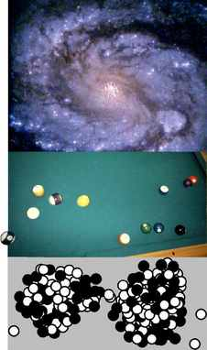
a / Systems consisting of material particles that interact through an energy U(r). Top: The galaxy M100. Here the “particles” are stars. Middle: The pool balls don't interact until they come together and become compressed; the energy U(r) has a sharp upturn when the center-to-center distance r gets small enough for the balls to be in contact. Bottom: A uranium nucleus undergoing fission. The energy U(r) has a repulsive contribution from the electrical interactions of the protons, plus an attractive one due to the strong nuclear interaction. (M100: Hubble Space Telescope image.)
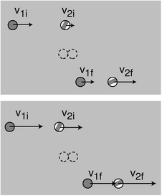
b / A collision between two pool balls is seen in two different frames of reference. The solid ball catches up with the striped ball. Velocities are shown with arrows. The second observer is moving to the left at velocity u compared to the first observer, so all the velocities in the second frame have u added onto them. The two observers must agree on conservation of energy.
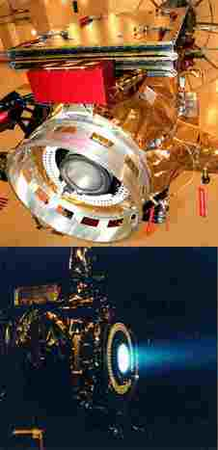
c / The ion drive engine of the NASA Deep Space 1 probe, shown under construction (top) and being tested in a vacuum chamber (bottom) prior to its October 1998 launch. Intended mainly as a test vehicle for new technologies, the craft nevertheless also carried out a scientific program that included a rendezvous with a comet in 2004. (NASA)

Mechanical momentum
In the martial arts movie Crouching Tiger, Hidden Dragon, those who had received mystical enlightenment are able to violate the laws of physics. Some of the violations are obvious, such as their ability to fly, but others are a little more subtle. The rebellious young heroine/antiheroine Jen Yu gets into an argument while sitting at a table in a restaurant. A young tough, Iron Arm Lu, comes running toward her at full speed, and she puts up one arm and effortlessly makes him bounce back, without even getting out of her seat or bracing herself against anything. She does all this between bites.
Although kinetic energy doesn't depend on the direction of motion, we've already seen on page 51 how conservation of energy combined with Galilean relativity allows us to make some predictions about the direction of motion. One of the examples was a demonstration that it isn't possible for a hockey puck to spontaneously reverse its direction of motion. In the scene from the movie, however, the woman's assailant isn't just gliding through space. He's interacting with her, so the previous argument doesn't apply here, and we need to generalize it to more than one object. We consider the case of a physical system composed of pointlike material particles, in which every particle interacts with every other particle through an energy U(r) that depends only on the distance r between them. This still allows for a fairly general mechanical system, by which I mean roughly a system made of matter, not light. The characters in the movie are made of protons, neutrons, and electrons, so they would constitute such a system if the interactions among all these particles were of the form U(r).¹ We might even be able to get away with thinking of each person as one big particle, if it's a good approximation to say that every part of each person's whole body moves in the same direction at the same speed.
The basic insight can be extracted from the special case where there are only two particles interacting, and they only move in one dimension, as in the example shown in figure b. Conservation of energy says
K_{1i}+K_{2i}+U_{i} = K_{1f}+K_{2f}+U_{f} .
For simplicity, let's assume that the interactions start after the time we're calling initial, and end before the instant we choose as final. This is true in figure b, for example. Then U_{i}=U_{f}, and we can subtract the interaction energies from both sides, giving.
K_{1i}+K_{2i} = K_{1f}+K_{2f}
As in the one-particle argument on page 51, the trick is to require conservation of energy not just in one particular frame of reference, but in every frame of reference. In a frame of reference moving at velocity u relative to the first one, the velocities all have u added onto them:²
When we square a quantity like (v_{1i}+u)², we get the same v_{1i}² that occurred in the original frame of reference, plus two u-dependent terms, 2v_{1i}u+u². Subtracting the original conservation of energy equation from the version in the new frame of reference, we have
m₁v_{1i}u+m₂v_{2i}u = m₁v_{1f}u+m₂v_{2f}u ,
or, dividing by u,
m₁v_{1i}+m₂v_{2i} = m₁v_{1f}+m₂v_{2f} .
This is a statement that when you add up mv for the whole system, that total remains constant over time. In other words, this is a conservation law. The quantity mv is called momentum, notated p for obscure historical reasons. Its units are kg⋅m/s.
Unlike kinetic energy, momentum depends on the direction of motion, since the velocity is not squared. In one dimension, motion in the same direction as the positive x axis is represented with positive values of v and p. Motion in the opposite direction has negative v and p.

Example 1: Jen Yu meets Iron Arm Lu
◊ Initially, Jen Yu is at rest, and Iron Arm Lu is charging to the left, toward her, at 5 m/s. Jen Yu's mass is 50 kg, and Lu's is 100 kg. After the collision, the movie shows Jen Yu still at rest, and Lu rebounding at 5 m/s to the right. Is this consistent with the laws of physics, or would it be impossible in real life?
◊ This is perfectly consistent with conservation of mass (50 kg+100 kg=50 kg+100 kg), and also with conservation of energy, since neither person's kinetic energy changes, and there is therefore no change in the total energy. (We don't have to worry about interaction energies, because the two points in time we're considering are ones at which the two people aren't interacting.) To analyze whether the scene violates conservation of momentum, we have to pick a coordinate system. Let's define positive as being to the right. The initial momentum is (50 kg)(0 m/s)+(100 kg)(-5 m/s)=-500 kg⋅m/s, and the final momentum is (50 kg)(0 m/s)+(100 kg)(5 m/s)=500 kg⋅m/s. This is a change of 1000 kg⋅m/s, which is impossible if the two people constitute a closed system.
One could argue that they're not a closed system, since Lu might be exchanging momentum with the floor, and Jen Yu might be exchanging momentum with the seat of her chair. This is a reasonable objection, but in the following section we'll see that there are physical reasons why, in this situation, the force of friction would be relatively weak, and would not be able to transfer that much momentum in a fraction of a second.
This example points to an intuitive interpretation of conservation of momentum, which is that interactions are always mutual. That is, Jen Yu can't change Lu's momentum without having her own momentum changed as well.

Example 2: A cannon
◊ A cannon of mass 1000 kg fires a 10-kg shell at a velocity of 200 m/s. At what speed does the cannon recoil?
◊ The law of conservation of momentum tells us that
p_{cannon,i} + p_{shell,i}
Choosing a coordinate system in which the cannon points in the positive direction, the given information is
p_{cannon,i} = 0
p_{s}hell,i = 0
We must have , so the recoil velocity of the cannon is 2 m/s.

Example 3: Ion drive
◊ The experimental solar-powered ion drive of the Deep Space 1 space probe expels its xenon gas exhaust at a speed of 30,000 m/s, ten times faster than the exhaust velocity for a typical chemical-fuel rocket engine. Roughly how many times greater is the maximum speed this spacecraft can reach, compared with a chemical-fueled probe with the same mass of fuel (“reaction mass”) available for pushing out the back as exhaust?
◊ Momentum equals mass multiplied by velocity. Both spacecraft are assumed to have the same amount of reaction mass, and the ion drive's exhaust has a velocity ten times greater, so the momentum of its exhaust is ten times greater. Before the engine starts firing, neither the probe nor the exhaust has any momentum, so the total momentum of the system is zero. By conservation of momentum, the total momentum must also be zero after all the exhaust has been expelled. If we define the positive direction as the direction the spacecraft is going, then the negative momentum of the exhaust is canceled by the positive momentum of the spacecraft. The ion drive allows a final speed that is ten times greater. (This simplified analysis ignores the fact that the reaction mass expelled later in the burn is not moving backward as fast, because of the forward speed of the already-moving spacecraft.)
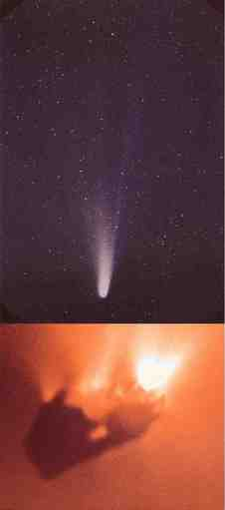
d / Halley's comet. Top: A photograph made from earth. Bottom: A view of the nucleus from the Giotto space probe. (W. Liller and European Space Agency)

Nonmechanical momentum
So far, it sounds as though conservation of momentum can be proved mathematically, unlike conservation of mass and energy, which are entirely based on observations. The proof, however, was only for a mechanical system, with interactions of the form U(r). Conservation of momentum can be extended to other systems as well, but this generalization is based on experiments, not mathematical proof. Light is the most important example of momentum that doesn't equal mv --- light doesn't have mass at all, but it does have momentum. For example, a flashlight left on for an hour would absorb about 10⁻⁵ kg⋅m/s of momentum as it recoiled.

Example 4: Halley's comet
Momentum is not always equal to mv. Halley's comet, shown in figure d, has a very elongated elliptical orbit, like those of many other comets. About once per century, its orbit brings it close to the sun. The comet's head, or nucleus, is composed of dirty ice, so the energy deposited by the intense sunlight gradually removes ice from the surface and turns it into water vapor. The bottom photo shows a view of the water coming off of the nucleus from the European Giotto space probe, which passed within 596 km of the comet's head on March 13, 1986.
The sunlight does not just carry energy, however. It also carries momentum. Once the steam comes off, the momentum of the sunlight impacting on it pushes it away from the sun, forming a tail as shown in in the top image. The tail always points away from the sun, so when the comet is receding from the sun, the tail is in front. By analogy with matter, for which momentum equals mv, you would expect that massless light would have zero momentum, but the equation p= mv is not the correct one for light, and light does have momentum. (Some comets also have a second tail, which is propelled by electrical forces rather than by the momentum of sunlight.)
The reason for bringing this up is not so that you can plug numbers into formulas in these exotic situations. The point is that the conservation laws have proven so sturdy exactly because they can easily be amended to fit new circumstances. The momentum of light will be a natural consequence of the discussion of the theory of relativity in chapter 6.
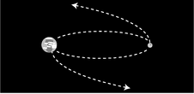
e / Example 8.

Momentum compared to kinetic energy
Momentum and kinetic energy are both measures of the quantity of motion, and a sideshow in the Newton-Leibniz controversy over who invented calculus was an argument over whether mv (i.e. momentum) or mv² (i.e. kinetic energy without the 1/2 in front) was the “true” measure of motion. The modern student can certainly be excused for wondering why we need both quantities, when their complementary nature was not evident to the greatest minds of the 1700s. The following table highlights their differences.
Kinetic energy... & Momentum...
\hline\hline doesn't depend on direction. & depends on direction.
\hline
is always positive, and cannot cancel out. & cancels with momentum in the opposite direction.
\hline
can be traded for forms of energy that do not involve motion. Kinetic energy is not a conserved quantity by itself. & is always conserved in a closed system.
\hline
is quadrupled if the velocity is doubled. & is doubled if the velocity is doubled.
\hline
Here are some examples that show the different behaviors of the two quantities.

Example 5: A spinning top
A spinning top has zero total momentum, because for every moving point, there is another point on the opposite side that cancels its momentum. It does, however, have kinetic energy.

Example 6: Momentum and kinetic energy in firing a rifle
The rifle and bullet have zero momentum and zero kinetic energy to start with. When the trigger is pulled, the bullet gains some momentum in the forward direction, but this is canceled by the rifle's backward momentum, so the total momentum is still zero. The kinetic energies of the gun and bullet are both positive numbers, however, and do not cancel. The total kinetic energy is allowed to increase, because kinetic energy is being traded for other forms of energy. Initially there is chemical energy in the gunpowder. This chemical energy is converted into heat, sound, and kinetic energy. The gun's “backward” kinetic energy does not refrigerate the shooter's shoulder!

Example 7: The wobbly earth
As the moon completes half a circle around the earth, its motion reverses direction. This does not involve any change in kinetic energy. The reversed velocity does, however, imply a reversed momentum, so conservation of momentum in the closed earth-moon system tells us that the earth must also reverse its momentum. In fact, the earth wobbles in a little “orbit” about a point below its surface on the line connecting it and the moon. The two bodies' momenta always point in opposite directions and cancel each other out.

Example 8: The earth and moon get a divorce
Why can't the moon suddenly decide to fly off one way and the earth the other way? It is not forbidden by conservation of momentum, because the moon's newly acquired momentum in one direction could be canceled out by the change in the momentum of the earth, supposing the earth headed off in the opposite direction at the appropriate, slower speed. The catastrophe is forbidden by conservation of energy, because their energies would have to increase greatly.

Example 9: Momentum and kinetic energy of a glacier
A cubic-kilometer glacier would have a mass of about 10¹² kg. If it moves at a speed of 10⁻⁵ m/s, then its momentum is 10⁷ kg⋅m/s. This is the kind of heroic-scale result we expect, perhaps the equivalent of the space shuttle taking off, or all the cars in LA driving in the same direction at freeway speed. Its kinetic energy, however, is only 50 J, the equivalent of the calories contained in a poppy seed or the energy in a drop of gasoline too small to be seen without a microscope. The surprisingly small kinetic energy is because kinetic energy is proportional to the square of the velocity, and the square of a small number is an even smaller number.

Discussion Questions
◊ If all the air molecules in the room settled down in a thin film on the floor, would that violate conservation of momentum as well as conservation of energy?
◊ A refrigerator has coils in back that get hot, and heat is molecular motion. These moving molecules have both energy and momentum. Why doesn't the refrigerator need to be tied to the wall to keep it from recoiling from the momentum it loses out the back?
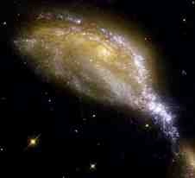
f / This Hubble Space Telescope photo shows a small galaxy (yellow blob in the lower right) that has collided with a larger galaxy (spiral near the center), producing a wave of star formation (blue track) due to the shock waves passing through the galaxies' clouds of gas. This is considered a collision in the physics sense, even though it is statistically certain that no star in either galaxy ever struck a star in the other --- the stars are very small compared to the distances between them. (NASA)

Collisions in one dimension
Physicists employ the term “collision” in a broader sense than in ordinary usage, applying it to any situation where objects interact for a certain period of time. A bat hitting a baseball, a cosmic ray damaging DNA, and a gun and a bullet going their separate ways are all examples of collisions in this sense. Physical contact is not even required. A comet swinging past the sun on a hyperbolic orbit is considered to undergo a collision, even though it never touches the sun. All that matters is that the comet and the sun interacted gravitationally with each other.
The reason for broadening the term “collision” in this way is that all of these situations can be attacked mathematically using the same conservation laws in similar ways. In our first example, conservation of momentum is all that is required.

Example 10: Getting rear-ended
◊ Ms. Chang is rear-ended at a stop light by Mr. Nelson, and sues to make him pay her medical bills. He testifies that he was only going 55 km per hour when he hit Ms. Chang. She thinks he was going much faster than that. The cars skidded together after the impact, and measurements of the length of the skid marks and the coefficient of friction show that their joint velocity immediately after the impact was 30 km per hour. Mr.\ Nelson's Nissan has a mass of 1400 kg, and Ms. Chang 's Cadillac is 2400 kg. Is Mr. Nelson telling the truth?
◊ Since the cars skidded together, we can write down the equation for conservation of momentum using only two velocities, v for Mr. Nelson's velocity before the crash, and v' for their joint velocity afterward:
m_{N} v = m_{N} v' + m_{C} v' .
Solving for the unknown, v, we find
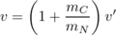
He is lying.
The above example was simple because both cars had the same velocity afterward. In many one-dimensional collisions, however, the two objects do not stick. If we wish to predict the result of such a collision, conservation of momentum does not suffice, because both velocities after the collision are unknown, so we have one equation in two unknowns.
Conservation of energy can provide a second equation, but its application is not as straightforward, because kinetic energy is only the particular form of energy that has to do with motion. In many collisions, part of the kinetic energy that was present before the collision is used to create heat or sound, or to break the objects or permanently bend them. Cars, in fact, are carefully designed to crumple in a collision. Crumpling the car uses up energy, and that's good because the goal is to get rid of all that kinetic energy in a relatively safe and controlled way. At the opposite extreme, a superball is “super” because it emerges from a collision with almost all its original kinetic energy, having only stored it briefly as interatomic electrical energy while it was being squashed by the impact.
Collisions of the superball type, in which almost no kinetic energy is converted to other forms of energy, can thus be analyzed more thoroughly, because they have K_{f}=K_{i}, as opposed to the less useful inequality K_{f}<K_{i} for a case like a tennis ball bouncing on grass.

Example 11: Pool balls colliding head-on
◊ Two pool balls collide head-on, so that the collision is restricted to one dimension. Pool balls are constructed so as to lose as little kinetic energy as possible in a collision, so under the assumption that no kinetic energy is converted to any other form of energy, what can we predict about the results of such a collision?
◊ Pool balls have identical masses, so we use the same symbol m for both. Conservation of energy and no loss of kinetic energy give us the two equations
mv_{1i}+ mv_{2i} = mv_{1f}+ mv_{2f}
The masses and the factors of 1/2 can be divided out, giving
v_{1i}+ v_{2i} = v_{1f}+ v_{2f}
v_{1i}²+v_{2i}² =v_{1f}²+v_{2f}² .
A little experimentation with numbers shows that given values of v_{1i} and v_{2i}, it is impossible to find v_{1f} and v_{1f} that satisfy these equations unless the final velocities equal the initial ones, or the final velocities are the same as the initial ones but swapped around. (An algebraic proof is not difficult, but I won't bother here.) In the special case where ball 2 is initially at rest, this tells us that ball 1 is stopped dead by the collision, and ball 2 heads off at the velocity originally possessed by ball 1. Pool players are familiar with this behavior.
Often, as in the example above, the details of the algebra are the least interesting part of the problem, and considerable physical insight can be gained simply by counting the number of unknowns and comparing to the number of equations. Suppose a beginner at pool notices a case where her cue ball hits an initially stationary ball and stops dead. “Wow, what a good trick,” she thinks. “I bet I could never do that again in a million years.” But she tries again, and finds that she can't help doing it even if she doesn't want to. Luckily she has just learned about collisions in her physics course. Once she has written down the equations for conservation of energy and no loss of kinetic energy, she really doesn't have to complete the algebra. She knows that she has two equations in two unknowns, so there must be a well-defined solution. Once she has seen the result of one such collision, she knows that the same thing must happen every time. The same thing would happen with colliding marbles or croquet balls. It doesn't matter if the masses or velocities are different, because that just multiplies both equations by some constant factor.

The discovery of the neutron
This was the type of reasoning employed by James Chadwick in his 1932 discovery of the neutron. At the time, the atom was imagined to be made out of two types of fundamental particles, protons and electrons. The protons were far more massive, and clustered together in the atom's core, or nucleus. Electrical attraction caused the electrons to orbit the nucleus in circles, in much the same way that gravity kept the planets from cruising out of the solar system. Experiments showed, for example, that twice as much energy was required to strip the last electron off of a helium atom as was needed to remove the single electron from a hydrogen atom, and this was explained by saying that helium had two protons to hydrogen's one. The trouble was that according to this model, helium would have two electrons and two protons, giving it precisely twice the mass of a hydrogen atom with one of each. In fact, helium has about four times the mass of hydrogen.
Chadwick suspected that the helium nucleus possessed two additional particles of a new type, which did not participate in electrical interactions at all, i.e. were electrically neutral. If these particles had very nearly the same mass as protons, then the four-to-one mass ratio of helium and hydrogen could be explained. In 1930, a new type of radiation was discovered that seemed to fit this description. It was electrically neutral, and seemed to be coming from the nuclei of light elements that had been exposed to other types of radiation. At this time, however, reports of new types of particles were a dime a dozen, and most of them turned out to be either clusters made of previously known particles or else previously known particles with higher energies. Many physicists believed that the “new” particle that had attracted Chadwick's interest was really a previously known particle called a gamma ray, which was electrically neutral. Since gamma rays have no mass, Chadwick decided to try to determine the new particle's mass and see if it was nonzero and approximately equal to the mass of a proton.
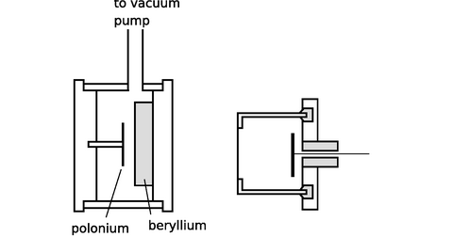
g / Chadwick's subatomic pool table. A disk of the naturally occurring metal polonium provides a source of radiation capable of kicking neutrons out of the beryllium nuclei. The type of radiation emitted by the polonium is easily absorbed by a few mm of air, so the air has to be pumped out of the left-hand chamber. The neutrons, Chadwick's mystery particles, penetrate matter far more readily, and fly out through the wall and into the chamber on the right, which is filled with nitrogen or hydrogen gas. When a neutron collides with a nitrogen or hydrogen nucleus, it kicks it out of its atom at high speed, and this recoiling nucleus then rips apart thousands of other atoms of the gas. The result is an electrical pulse that can be detected in the wire on the right. Physicists had already calibrated this type of apparatus so that they could translate the strength of the electrical pulse into the velocity of the recoiling nucleus. The whole apparatus shown in the figure would fit in the palm of your hand, in dramatic contrast to today's giant particle accelerators.
Unfortunately a subatomic particle is not something you can just put on a scale and weigh. Chadwick came up with an ingenious solution. The masses of the nuclei of the various chemical elements were already known, and techniques had already been developed for measuring the speed of a rapidly moving nucleus. He therefore set out to bombard samples of selected elements with the mysterious new particles. When a direct, head-on collision occurred between a mystery particle and the nucleus of one of the target atoms, the nucleus would be knocked out of the atom, and he would measure its velocity.
Suppose, for instance, that we bombard a sample of hydrogen atoms with the mystery particles. Since the participants in the collision are fundamental particles, there is no way for kinetic energy to be converted into heat or any other form of energy, and Chadwick thus had two equations in three unknowns:
equation #1: conservation of momentum
equation #2: no loss of kinetic energy
unknown #1: mass of the mystery particle
unknown #2: initial velocity of the mystery particle
unknown #3: final velocity of the mystery particle
The number of unknowns is greater than the number of equations, so there is no unique solution. But by creating collisions with nuclei of another element, nitrogen, he gained two more equations at the expense of only one more unknown:
equation #3: conservation of momentum in the new collision
equation #4: no loss of kinetic energy in the new collision
unknown #4: final velocity of the mystery particle in the new collision
He was thus able to solve for all the unknowns, including the mass of the mystery particle, which was indeed within 1% of the mass of a proton. He named the new particle the neutron, since it is electrically neutral.

Discussion Questions
◊ Good pool players learn to make the cue ball spin, which can cause it not to stop dead in a head-on collision with a stationary ball. If this does not violate the laws of physics, what hidden assumption was there in the example in the text where it was proved that the cue ball must stop?
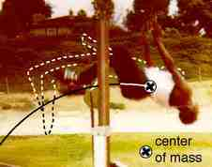
h / The highjumper's body passes over the bar, but his center of mass passes under it. (Dunia Young)
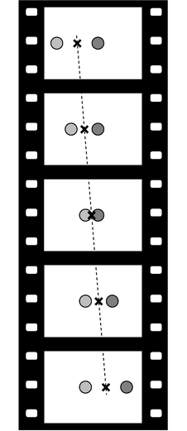
i / Two pool balls collide.

The center of mass
Figures h and j show two examples where a motion that appears complicated actually has a very simple feature. In both cases, there is a particular point, called the center of mass, whose motion is surprisingly simple. The highjumper flexes his body as he passes over the bar, so his motion is intrinsically very complicated, and yet his center of mass's motion is a simple parabola, just like the parabolic arc of a pointlike particle. The wrench's center of mass travels in a straight line as seen from above, which is what we'd expect for a pointlike particle flying through the air.
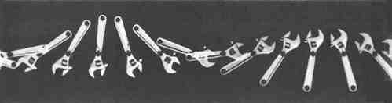
j / In this multiple-flash photograph, we see the wrench from above as it flies through the air, rotating as it goes. Its center of mass, marked with the black cross, travels along a straight line, unlike the other points on the wrench, which execute loops. (PSSC Physics)
The highjumper and the wrench are both complicated systems, each consisting of zillions of subatomic particles. To understand what's going on, let's instead look at a nice simple system, two pool balls colliding. We assume the balls are a closed system (i.e. their interaction with the felt surface is not important) and that their rotation is unimportant, so that we'll be able to treat each one as a single particle. By symmetry, the only place their center of mass can be is half-way in between, at an x coordinate equal to the average of the two balls' positions, x_{cm}=(x₁+x₂)/2.
Figure i makes it appear that the center of mass, marked with an ×, moves with constant velocity to the right, regardless of the collision, and we can easily prove this using conservation of momentum:
v_{cm} = dx_{cm}/dt
Since momentum is conserved, the last expression is constant, which proves that v_{cm} is constant.
Rearranging this a little, we have p_{total}=m_{total}v_{cm}. In other words, the total momentum of the system is the same as if all its mass was concentrated at the center of mass point.

Sigma notation
When there is a large, potentially unknown number of particles, we can write sums like the ones occurring above using symbols like “+…,” but that gets awkward. It's more convenient to use the Greek uppercase sigma, Σ, to indicate addition. For example, the sum 1²+2²+3²+4²=30 could be written as
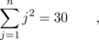
read “the sum from j=1 to n of j².” The variable j is a dummy variable, just like the dx in an integral that tells you you're integrating with respect to x, but has no significance outside the integral. The j below the sigma tells you what variable is changing from one term of the sum to the next, but j has no significance outside the sum.
As an example, let's generalize the proof of p_{total}=m_{total}v_{cm} to the case of an arbitrary number n of identical particles moving in one dimension, rather than just two particles. The center of mass is at
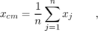
where x₁ is the mass of the first particle, and so on. The velocity of the center of mass is
v_{cm} = dx_{cm}/dt
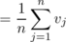
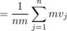
What about a system containing objects with unequal masses, or containing more than two objects? The reasoning above can be generalized to a weighted average:
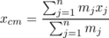

Example 12: The solar system's center of mass
In the discussion of the sun's gravitational field on page 63, I mentioned in a footnote that the sun doesn't really stay in one place while the planets orbit around it. Actually, motion is relative, so it's meaningless to ask whether the sun is absolutely at rest, but it is meaningful to ask whether it moves in a straight line at constant velocity. We can now see that since the solar system is a closed system, its total momentum must be constant, and p_{total}= m_{total}v_{cm} then tells us that it's the solar system's center of mass that has constant velocity, not the sun. The sun wobbles around this point irregularly due to its interactions with the planets, Jupiter in particular.

Example 13: The earth-moon system
The earth-moon system is much simpler than the solar system because it contains only two objects. Where is the center of mass of this system? Let x=0 be the earth's center, so that the moon lies at x=3.8×10⁵ km. Then
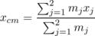
{ m₁+ m₂} ,
and letting 1 be the earth and 2 the moon, we have
x_{cm}
= 4600 km ,
or about three quarters of the way from the earth's center to its surface.

Example 14: Momentum and Galilean relativity
The principle of Galilean relativity states that the laws of physics are supposed to be equally valid in all inertial frames of reference. If we first calculate some momenta in one frame of reference and find that momentum is conserved, and then rework the whole problem in some other frame of reference that is moving with respect to the first, the numerical values of the momenta will all be different. Even so, momentum will still be conserved. All that matters is that we work a single problem in one consistent frame of reference.
One way of proving this is to apply the equation p_{total}=m_{total}v_{cm}. If the velocity of one frame relative to the other is u, then the only effect of changing frames of reference is to change v_{cm} from its original value to v_{cm}+u. This adds a constant onto the momentum, which has no effect on conservation of momentum.
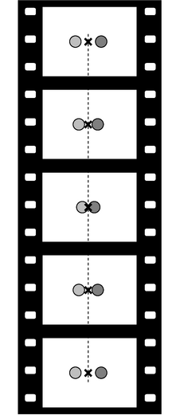
k / The same collision of two pools balls, but now seen in the center of mass frame of reference.
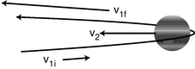
l / The sun's frame of reference.
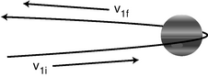
m / The c.m. frame.

The center of mass frame of reference
A particularly useful frame of reference in many cases is the frame that moves along with the center of mass, called the center of mass (c.m.) frame. In this frame, the total momentum is zero. The following examples show how the center of mass frame can be a powerful tool for simplifying our understanding of collisions.

Example 15: A collision of pool balls viewed in the c.m. frame
If you move your head so that your eye is always above the point halfway in between the two pool balls, as in figure k, you are viewing things in the center of mass frame. In this frame, the balls come toward the center of mass at equal speeds. By symmetry, they must therefore recoil at equal speeds along the lines on which they entered. Since the balls have essentially swapped paths in the center of mass frame, the same must also be true in any other frame. This is the same result that required laborious algebra to prove previously without the concept of the center of mass frame.

Example 16: The slingshot effect
It is a counterintuitive fact that a spacecraft can pick up speed by swinging around a planet, if it arrives in the opposite direction compared to the planet's motion. Although there is no physical contact, we treat the encounter as a one-dimensional collision, and analyze it in the center of mass frame. Since Jupiter is so much more massive than the spacecraft, the center of mass is essentially fixed at Jupiter's center, and Jupiter has zero velocity in the center of mass frame, as shown in figure 3.1.6. The c.m. frame is moving to the left compared to the sun-fixed frame used in figure 3.1.6, so the spacecraft's initial velocity is greater in this frame than in the sun's frame.
Things are simpler in the center of mass frame, because it is more symmetric. In the sun-fixed frame, the incoming leg of the encounter is rapid, because the two bodies are rushing toward each other, while their separation on the outbound leg is more gradual, because Jupiter is trying to catch up. In the c.m. frame, Jupiter is sitting still, and there is perfect symmetry between the incoming and outgoing legs, so by symmetry we have v₁f=- v_{1i}. Going back to the sun-fixed frame, the spacecraft's final velocity is increased by the frames' motion relative to each other. In the sun-fixed frame, the spacecraft's velocity has increased greatly.

Example 17: Einstein's motorcycle
We've assumed we were dealing with a system of material objects, for which the equation p=mv was true. What if our system contains only light rays, or a mixture of light and matter? As a college student, Einstein kept worrying about was what a beam of light would look like if you could ride alongside it on a motorcycle. In other words, he imagined putting himself in the light beam's center of mass frame. Chapter 6 discusses Einstein's resolution of this problem, but the basic point is that you can't ride the motorcycle alongside the light beam, because material objects can't go as fast as the speed of light. A beam of light has no center of mass frame of reference.
◊ Make up a numerical example of two unequal masses moving in one dimension at constant velocity, and verify the equation p_{total}=m_{total}v_{cm} over a time interval of one second.
◊ A more massive tennis racquet or baseball bat makes the ball fly off faster. Explain why this is true, using the center of mass frame. For simplicity, assume that the racquet or bat is simply sitting still before the collision, and that the hitter's hands do not make any force large enough to have a significant effect over the short duration of the impact.

3.2 Force in One Dimension

Momentum transfer
For every conserved quantity, we can define an associated rate of flow. An open system can have mass transferred in or out of it, and we can measure the rate of mass flow, dm/dt in units of kg/s. Energy can flow in or out, and the rate of energy transfer is the power, P=dE/dt, measured in watts.³ The rate of momentum transfer is called force,
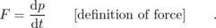
The units of force are kg⋅m/s², which can be abbreviated as newtons, 1 N=kg⋅m/s². Newtons are unfortunately not as familiar as watts. A newton is about how much force you'd use to pet a dog. The most powerful rocket engine ever built, the first stage of the Saturn V that sent astronauts to the moon, had a thrust of about 30 million newtons. In one dimension, positive and negative signs indicate the direction of the force --- a positive force is one that pushes or pulls in the direction of the positive x axis.

Example 18: Walking into a lamppost
◊ Starting from rest, you begin walking, bringing your momentum up to 100 . You walk straight into a lamppost. Why is the momentum change of so much more painful than the change of when you started walking?
◊ The forces are not really constant, but for this type of qualitative discussion we can pretend they are, and approximate d p/d t as Δ p/Δ t. It probably takes you about 1 s to speed up initially, so the ground's force on you is F=Δ p/Δ t≈100 N. Your impact with the lamppost, however, is over in the blink of an eye, say 1/10 s or less. Dividing by this much smaller Δ t gives a much larger force, perhaps thousands of newtons (with a negative sign).
This is also the principle of airbags in cars. The time required for the airbag to decelerate your head is fairly long: the time it takes your face to travel 20 or 30 cm. Without an airbag, your face would have hit the dashboard, and the time interval would have been the much shorter time taken by your skull to move a couple of centimeters while your face compressed. Note that either way, the same amount of momentum is transferred: the entire momentum of your head.
Force is defined as a derivative, and the derivative of a sum is the sum of the derivatives. Therefore force is additive: when more than one force acts on an object, you add the forces to find out what happens. An important special case is that forces can cancel. Consider your body sitting in a chair as you read this book. Let the positive x axis be upward. The chair's upward force on you is represented with a positive number, which cancels out with the earth's downward gravitational force, which is negative. The total rate of momentum transfer into your body is zero, and your body doesn't change its momentum.
◊ Many collisions, like the collision of a bat with a baseball, appear to be instantaneous. Most people also would not imagine the bat and ball as bending or being compressed during the collision. Consider the following possibilities:
(1) The collision is instantaneous.
(2) The collision takes a finite amount of time, during which the ball and bat retain their shapes and remain in contact.
(3) The collision takes a finite amount of time, during which the ball and bat are bending or being compressed.
How can two of these be ruled out based on energy or momentum considerations?
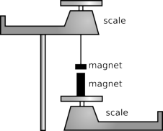
a / Two magnets exert forces on each other.

b / It doesn't make sense for the man to talk about the woman's money canceling out his bar tab, because there is no good reason to combine his debts and her assets.
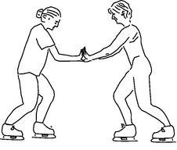
c / Newton's third law does not mean that forces always cancel out so that nothing can ever move. If these two ice skaters, initially at rest, push against each other, they will both move.

Newton's laws
Although momentum is the third conserved quantity we've encountered, historically it was the first to be discovered. Isaac Newton formulated a complete treatment of mechanical systems in terms of force and momentum. Newton's theory was based on three laws of motion, which we now think of as consequences of conservation of mass, energy, and momentum.
Newton’s laws in one dimension:
Newton’s first law: If there is no force acting on an object, it stays in the same state of motion.
Newton’s second law:Fderpdert.
Newton’s third law: Forces occur in opposite pairs. If object A interacts with object B, then A’s force on B and B’s force on A are related byF_{AB} = − F_{BA}.
{}The second law is the definition of force, which we've already encountered.⁴ The first law is a special case of the second law⁵ --- if dp/dt is zero, then p=mv is a constant, and since mass is conserved, constant p implies constant v. The third law is a restatement of conservation of momentum: for two objects interacting, we have constant total momentum, so =F_{BA}+F_{AB}.

Example 19: a=F/m
Many modern textbooks restate Newton's second law as a= F/ m, i.e. as an equation that predicts an object's acceleration based on the force exerted on it. This is easily derived from Newton's original form as follows: a=d v/d t=(d p/d t)/ m= F/ m.

Example 20: Gravitational force related to g
As a special case of the previous example, consider an object in free fall, and let the x axis point down, so that g is positive. Then a=g, and F= ma= mg. For example, the gravitational force on a 1 kg mass at the earth's surface is about 9.8 N. Even if other forces act on the object, and it isn't in free fall, the gravitational force on it is still the same, and can still be calculated as mg.
If you've already accepted Galilean relativity in your heart, then there is nothing really difficult about the first and second laws. The third law, however, is more of a conceptual challenge. The first hurdle is that it is counterintuitive. Is it really true that if a speeding cement truck hits an old lady who is crossing the street, the old lady's force on the cement truck is just as strong as the truck's force on her? Yes, it is true, but it is hard to believe at first. That amount of force simply has more of an effect on the old lady, because she is less massive and not as tough.
A more humane and practical experiment is shown in figure a. A large magnet and a small magnet are weighed separately, and then one magnet is hung from the pan of the top balance so that it is directly above the other magnet. There is an attraction between the two magnets, causing the reading on the top scale to increase and the reading on the bottom scale to decrease. The large magnet is more “powerful” in the sense that it can pick up a heavier paperclip from the same distance, so many people have a strong expectation that one scale's reading will change by a far different amount than the other. Instead, we find that the two changes are equal in magnitude but opposite in direction, so the upward force of the top magnet on the bottom magnet is of the same magnitude as the downward force of the bottom magnet on the top magnet.
To students, it often sounds as though Newton's third law implies nothing could ever change its motion, since the two equal and opposite forces would always cancel. As illustrated in figure b, the fallacy arises from assuming that we can add things that it doesn't make sense to add. It only makes sense to add up forces that are acting on the same object, whereas two forces related to each other by Newton's third law are always acting on two different objects. If two objects are interacting via a force and no other forces are involved, then both objects will accelerate --- in opposite directions, as shown in figure c!

Discussion Questions
◊ Criticize the following incorrect statement:
“If an object is at rest and the total force on it is zero, it stays at rest. There can also be cases where an object is moving and keeps on moving without having any total force on it, but that can only happen when there's no friction, like in outer space.”
◊ The table gives laser timing data for Ben Johnson's 100 m dash at the 1987 World Championship in Rome. (His world record was later revoked because he tested positive for steroids.) How does the total force on him change over the duration of the race?
x (m) | t (s)
10 | 1.84
20 | 2.86
30 | 3.80
40 | 4.67
50 | 5.53
60 | 6.38
70 | 7.23
80 | 8.10
90 | 8.96
100 | 9.83
◊ Criticize the following incorrect statement: “If you shove a book across a table, friction takes away more and more of its force, until finally it stops.”
◊ You hit a tennis ball against a wall. Explain any and all incorrect ideas in the following description of the physics involved: “The ball gets some force from you when you hit it, and when it hits the wall, it loses part of that force, so it doesn't bounce back as fast. The muscles in your arm are the only things that a force can come from.”
◊ When you fire a gun, the exploding gases push outward in all directions, causing the bullet to accelerate down the barrel. What Newton's-third-law pairs are involved? [Hint: Remember that the gases themselves are an object.]
◊ Tam Anh grabs Sarah by the hand and tries to pull her. She tries to remain standing without moving. A student analyzes the situation as follows. “If Tam Anh's force on Sarah is greater than her force on him, he can get her to move. Otherwise, she'll be able to stay where she is.” What's wrong with this analysis?
◊ You hit a tennis ball against a wall. Explain any and all incorrect ideas in the following description of the physics involved: “According to Newton's third law, there has to be a force opposite to your force on the ball. The opposite force is the ball's mass, which resists acceleration, and also air resistance.”
◊ The earth's gravitational force on you, i.e. your weight, is always equal to mg, where m is your mass. So why can you get a shovel to go deeper into the ground by jumping onto it? Just because you're jumping, that doesn't mean your mass or weight is any greater, does it?

Forces between solids
Conservation laws are more fundamental than Newton's laws, and they apply where Newton's laws don't, e.g. to light and to the internal structure of atoms. However, there are certain problems that are much easier to solve using Newton's laws. As a trivial example, if you drop a rock, it could conserve momentum and energy by levitating, or by falling in the usual manner. With Newton's laws, however, we can reason that a=F/m, so the rock must respond to the gravitational force by accelerating.
Less trivially, suppose a person is hanging onto a rope, and we want to know if she will slip. Unlike the case of the levitating rock, here the no-motion solution could be perfectly reasonable if her grip is strong enough. We know that her hand's interaction with the rope is fundamentally an electrical interaction between the atoms in the surface of her palm and the nearby atoms in the surface of the rope. For practical problem-solving, however, this is a case where we're better off forgetting the fundamental classification of interactions at the atomic level and working with a more practical, everyday classification of forces. In this practical scheme, we have three types of forces that can occur between solid objects in contact:
A normal force,F_{n}, | is perpendicular to the surface of contact, and prevents objects from passing through each other by becoming as strong as necessary (up to the point where the objects break). “Normal” means perpendicular.
Static friction,F_{s}, | is parallel to the surface of contact, and prevents the surfaces from starting to slip by becoming as strong as necessary, up to a maximum value ofF_{s,max}. “Static” means not moving, i.e. not slipping.
Kinetic friction,F_{k}, | is parallel to the surface of contact, and tends to slow down any slippage once it starts. “Kinetic” means moving, i.e. slipping.
If you put a coin on this page, which is horizontal, gravity pulls down on the coin, but the atoms in the paper and the coin repel each other electrically, and the atoms are compressed until the repulsion becomes strong enough to stop the downward motion of the coin. We describe this complicated and invisible atomic process by saying that the paper makes an upward normal force on the coin, and the coin makes a downward normal force on the paper. (The two normal forces are related by Newton's third law. In fact, Newton's third law only relates forces that are of the same type.)
If you now tilt the book a little, static friction keeps the coin from slipping. The picture at the microscopic level is even more complicated than the previous description of the normal force. One model is to think of the tiny bumps and depressions in the coin as settling into the similar irregularities in the paper. This model predicts that rougher surfaces should have more friction, which is sometimes true but not always. Two very smooth, clean glass surfaces or very well finished machined metal surfaces may actually stick better than rougher surfaces would, the probable explanation being that there is some kind of chemical bonding going on, and the smoother surfaces allow more atoms to be in contact.
Finally, as you tilt the book more and more, there comes a point where static friction reaches its maximum value. The surfaces become unstuck, and the coin begins to slide over the paper. Kinetic friction slows down this slipping motion significantly. In terms of energy, kinetic friction is converting mechanical energy into heat, just like when you rub your hands together to keep warm. One model of kinetic friction is that the tiny irregularities in the two surfaces bump against each other, causing vibrations whose energy rapidly converts to heat and sound --- you can hear this sound if you rub your fingers together near your ear.
For dry surfaces, experiments show that the following equations usually work fairly well:
F_{s,max} ≈ μ_{s}F_{n} ,
and
F_{k} ≈ μ_{k}F_{n} ,
where μ_{s}, the coefficient of static friction, and μ_{k}, the coefficient of kinetic friction, are constants that depend on the properties of the two surfaces, such as what they're made of and how rough they are.

Example 21: Maximum acceleration of a car
◊ Rubber on asphalt gives μ_{k}≈0.4 and μ_{s}≈ 0.6. What is the upper limit on a car's acceleration on a flat road, assuming that the engine has plenty of power and that air friction is negligible?
◊ The earth makes a downward gravitational force on the car whose absolute value is mg, and since the car doesn't accelerate vertically, the road apparently makes an upward normal force of the same magnitude, F_{n}= mg. As is always true, the coefficient of static friction is greater than the coefficient of kinetic friction, so the maximum acceleration is obtained with static friction, i.e. the driver should try not to burn rubber. The maximum force of static friction is F_{s},max=μ_{s} F_{n}. The maximum acceleration is a= F_{s}/ m=μ_{s} g≈6 m/s². This is true regardless of how big the tires are, since the experimentally determined relationship F_{s,max}=μ_{s} F_{n} is independent of surface area.
self-check: Can a frictionless surface exert a normal force? Can a frictional force exist without a normal force? (answer in the back of the PDF version of the book)
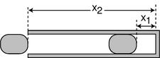
d / A simplified drawing of an airgun.
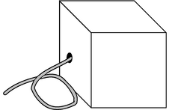
e / The black box does work by reeling in its cable.
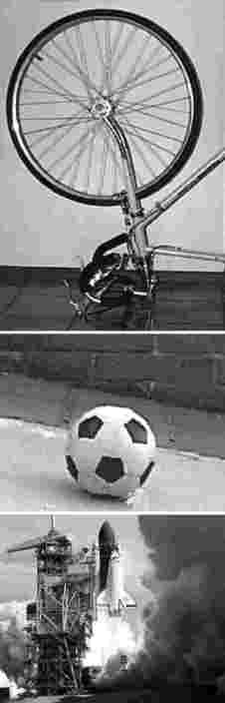
f / The wheel spinning in the air has K_{cm}=0. The space shuttle has all its kinetic energy in the form of center of mass motion, K=K_{cm}. The rolling ball has some, but not all, of its energy in the form of center of mass motion, K_{cm}<K. (Space Shuttle photo by NASA)

Work

Energy transferred to a particle
To change the kinetic energy, K=(1/2)mv², of a particle moving in one dimension, we must change its velocity. That will entail a change in its momentum, p=mv, as well, and since force is the rate of transfer of momentum, we conclude that the only way to change a particle's kinetic energy is to apply a force.⁶ A force in the same direction as the motion speeds it up, increasing the kinetic energy, while a force in the opposite direction slows it down.
Consider an infinitesimal time interval during which the particle moves an infinitesimal distance dx, and its kinetic energy changes by dK. In one dimension, we represent the direction of the force and the direction of the motion with positive and negative signs for F and dx, so the relationship among the signs can be summarized as follows: \begin{center}
F > 0 | derx0 | derK0
F < 0 | derx0 | derK0
F > 0 | derx0 | derK0
F < 0 | derx0 | derK0
\end{center} This looks exactly like the rule for determining the sign of a product, and we can easily show using the chain rule that this is indeed a multiplicative relationship:
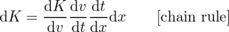
= (mv)(a)(1/v)dx
= kg⋅m²/s²
= J

Example 22: A TV picture tube
◊ At the back of a typical TV's picture tube, electrical forces accelerate each electron to an energy of 5×10⁻¹⁶ J over a distance of about 1 cm. How much force is applied to a single electron? (Assume the force is constant.) What is the corresponding acceleration?
◊ Integrating
d K = Fd x ,
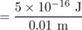
an electron with a spectacular acceleration. Looking up the mass of an
= 5×10¹⁶ m/s² .

Example 23: An air gun
◊ An airgun, figure d, uses compressed air to accelerate a pellet. As the pellet moves from x₁ to x₂, the air decompresses, so the force is not constant. Using methods from chapter 5, one can show that the air's force on the pellet is given by . A typical high-end airgun used for competitive target shooting has
x₁ = 0.046 m ,
x₂ = 0.41 m ,
and
What is the kinetic energy of the pellet when it leaves the muzzle? (Assume friction is negligible.)
◊ Since the force isn't constant, it would be incorrect to do F = Δ K/Δ x. Integrating both sides of the equation d K= Fd x, we have
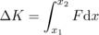
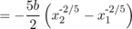
= 22 J
In general, when energy is transferred by a force,⁷ we use the term work to refer to the amount of energy transferred. This is different from the way the word is used in ordinary speech. If you stand for a long time holding a bag of cement, you get tired, and everyone will agree that you've worked hard, but you haven't changed the energy of the cement, so according to the definition of the physics term, you haven't done any work on the bag. There has been an energy transformation inside your body, of chemical energy into heat, but this just means that one part of your body did positive work (lost energy) while another part did a corresponding amount of negative work (gained energy).

Work in general
I derived the expression Fdx for one particular type of kinetic-energy transfer, the work done in accelerating a particle, and then defined work as a more general term. Is the equation correct for other types of work as well? For example, if a force lifts a mass m against the resistance of gravity at constant velocity, the increase in the mass's gravitational energy is d(mgy)=mgdy=Fdy, so again the equation works, but this still doesn't prove that the equation is always correct as a way of calculating energy transfers.
Imagine a black box⁸, containing a gasoline-powered engine, which is designed to reel in a steel cable, exerting a certain force F. For simplicity, we imagine that this force is always constant, so we can talk about Δx rather than an infinitesimal dx. If this black box is used to accelerate a particle (or any mass without internal structure), and no other forces act on the particle, then the original derivation applies, and the work done by the box is W=FΔx. Since F is constant, the box will run out of gas after reeling in a certain amount of cable Δx. The chemical energy inside the box has decreased by -W, while the mass being accelerated has gained W worth of kinetic energy.⁹
Now what if we use the black box to pull a plow? The energy increase in the outside world is of a different type than before; it takes the forms of (1) the gravitational energy of the dirt that has been lifted out to the sides of the furrow, (2) frictional heating of the dirt and the plowshare, and (3) the energy needed to break up the dirt clods (a form of electrical energy involving the attractions among the atoms in the clod). The box, however, only communicates with the outside world via the hole through which its cable passes. The amount of chemical energy lost by the gasoline can therefore only depend on F and Δx, so it is the same -W as when the box was being used to accelerate a mass, and thus by conservation of energy, the work done on the outside world is again W.
This is starting to sound like a proof that the force-times-distance method is always correct, but there was one subtle assumption involved, which was that the force was exerted at one point (the end of the cable, in the black box example). Real life often isn't like that. For example, a cyclist exerts forces on both pedals at once. Serious cyclists use toe-clips, and the conventional wisdom is that one should use equal amounts of force on the upstroke and downstroke, to make full use of both sets of muscles. This is a two-dimensional example, since the pedals go in circles. We're only discussing one-dimensional motion right now, so let's just pretend that the upstroke and downstroke are both executed in straight lines. Since the forces are in opposite directions, one is positive and one is negative. The cyclist's total force on the crank set is zero, but the work done isn't zero. We have to add the work done by each stroke, W=F₁Δx₁+F₂Δx₂. (I'm pretending that both forces are constant, so we don't have to do integrals.) Both terms are positive; one is a positive number multiplied by a positive number, while the other is a negative times a negative.
This might not seem like a big deal --- just remember not to use the total force --- but there are many situations where the total force is all we can measure. The ultimate example is heat conduction. Heat conduction is not supposed to be counted as a form of work, since it occurs without a force. But at the atomic level, there are forces, and work is done by one atom on another. When you hold a hot potato in your hand, the transfer of heat energy through your skin takes place with a total force that's extremely close to zero. At the atomic level, atoms in your skin are interacting electrically with atoms in the potato, but the attractions and repulsions add up to zero total force. It's just like the cyclist's feet acting on the pedals, but with zillions of forces involved instead of two. There is no practical way to measure all the individual forces, and therefore we can't calculate the total energy transferred.
To summarize, is a correct way of calculating work, where F_{j} is the individual force acting on particle j, which moves a distance dx_{j}. However, this is only useful if you can identify all the individual forces and determine the distance moved at each point of contact. For convenience, I'll refer to this as the work theorem. (It doesn't have a standard name.)
There is, however, something useful we can do with the total force. We can use it to calculate the part of the work done on an object that consists of a change in the kinetic energy it has due to the motion of its center of mass. The proof is essentially the same as the proof on 117, except that now we don't assume the force is acting on a single particle, so we have to be a little more delicate. Let the object consist of n particles. Its total kinetic energy is 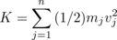, but this is what we've already realized can't be calculated using the total force. The kinetic energy it has due to motion of its center of mass is
Figure f shows some examples of the distinction between K_{cm} and K. Differentiating K_{cm}, we have
dK_{cm} = m_{total}v_{cm}dv_{cm}
= m_{total}v_{cm}
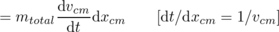
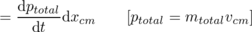
= F_{total}dx_{cm}
I'll call this the kinetic energy theorem --- like the work theorem, it has no standard name.

Example 24: An ice skater pushing off from a wall
The kinetic energy theorem tells us how to calculate the skater's kinetic energy if we know the amount of force and the distance her center of mass travels while she is pushing off.
The work theorem tells us that the wall does no work on the skater, since the point of contact isn't moving. This makes sense, because the wall does not have any source of energy.

Example 25: Absorbing an impact without recoiling?
◊ Is it possible to absorb an impact without recoiling? For instance, if a ping-pong ball hits a brick wall, does the wall “give” at all?
◊ There will always be a recoil. In the example proposed, the wall will surely have some energy transferred to it in the form of heat and vibration. The work theorem tells us that we can only have an energy transfer if the distance traveled by the point of contact is nonzero.

Example 26: Dragging a refrigerator at constant velocity
The fridge's momentum is constant, so there is no net momentum transfer, and the total force on it must be zero: your force is canceling the floor's kinetic frictional force. The kinetic energy theorem is therefore true but useless. It tells us that there is zero total force on the refrigerator, and that the refrigerator's kinetic energy doesn't change.
The work theorem tells us that the work you do equals your hand's force on the refrigerator multiplied by the distance traveled. Since we know the floor has no source of energy, the only way for the floor and refrigerator to gain energy is from the work you do. We can thus calculate the total heat dissipated by friction in the refrigerator and the floor.
Note that there is no way to find how much of the heat is dissipated in the floor and how much in the refrigerator.

Example 27: Accelerating a cart
If you push on a cart and accelerate it, there are two forces acting on the cart: your hand's force, and the static frictional force of the ground pushing on the wheels in the opposite direction.
Applying the work theorem to your force tells us how to calculate the work you do.
Applying the work theorem to the floor's force tells us that the floor does no work on the cart. There is no motion at the point of contact, because the atoms in the floor are not moving. (The atoms in the surface of the wheel are also momentarily at rest when they touch the floor.) This makes sense, because the floor does not have any source of energy.
The kinetic energy theorem refers to the total force, and because the floor's backward force cancels part of your force, the total force is less than your force. This tells us that only part of your work goes into the kinetic energy associated with the forward motion of the cart's center of mass. The rest goes into rotation of the wheels.

Discussion Questions
◊ Criticize the following incorrect statement: “A force doesn't do any work unless it's causing the object to move.”
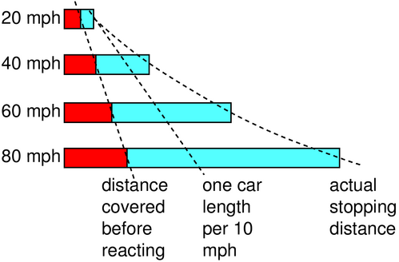
g / Discussion question B.
◊ To stop your car, you must first have time to react, and then it takes some time for the car to slow down. Both of these times contribute to the distance you will travel before you can stop. The figure shows how the average stopping distance increases with speed. Because the stopping distance increases more and more rapidly as you go faster, the rule of one car length per 10 m.p.h. of speed is not conservative enough at high speeds. In terms of work and kinetic energy, what is the reason for the more rapid increase at high speeds?

h / The force is transmitted to the block.

i / A mechanical advantage of 2.
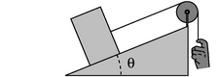
j / An inclined plane.
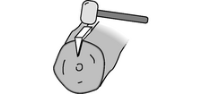
k / A wedge.
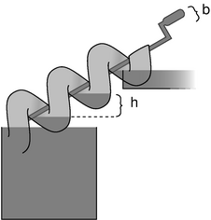
l / Archimedes' screw

Simple machines
Conservation of energy provided the necessary tools for analyzing some mechanical systems, such as the seesaw on page 46 and the pulley arrangements of the homework problems on page 86, but we could only analyze those machines by computing the total energy of the system. That approach wouldn't work for systems like the biceps/forearm machine on page 46, or the one in figure h, where the energy content of the person's body is impossible to compute directly. Even though the seesaw and the biceps/forearm system were clearly just two different forms of the lever, we had no way to treat them both on the same footing. We can now successfully attack such problems using the work and kinetic energy theorems.

Example 28: Constant tension around a pulley
◊ In figure h, what is the relationship between the force applied by the person's hand and the force exerted on the block?
◊ If we assume the rope and the pulley are ideal, i.e. frictionless and massless, then there is no way for them to absorb or release energy, so the work done by the hand must be the same as the work done on the block. Since the hand and the block move the same distance, the work theorem tells us the two forces are the same.
Similar arguments show that an idealized rope exerts the same force anywhere it's attached to something, and the same amount of force is also exerted by each segment of the rope on the neighboring segments. This amount of force is called the tension in the rope. Going around an ideal pulley has no effect on the tension.
This is an example of a simple machine, which is any mechanical system that manipulates forces to do work. This particular machine reverses the direction of the motion, but doesn't change the force or the speed of motion.

Example 29: A mechanical advantage
The idealized pulley in figure i has negligible mass, so its kinetic energy is zero, and the kinetic energy theorem tells us that the total force on it is zero. We know, as in the preceding example, that the two forces pulling it to the right are equal to each other, so the force on the left must be twice as strong. This simple machine doubles the applied force, and we refer to this ratio as a mechanical advantage (M.A.) of 2. There's no such thing as a free lunch, however; the distance traveled by the load is cut in half, and there is no increase in the amount of work done.

Example 30: Inclined plane and wedge
In figure j, the force applied by the hand is equal to the one applied to the load, but there is a mechanical advantage compared to the force that would have been required to lift the load straight up. The distance traveled up the inclined plane is greater by a factor of 1/sin θ, so by the work theorem, the force is smaller by a factor of sin θ, and we have M.A.=1/sin θ. The wedge, k, is similar.

Example 31: Archimedes' screw
In one revolution, the crank travels a distance 2π b, and the water rises by a height h. The mechanical advantage is 2π b/ h.

Force related to interaction energy
In section 2.3, we saw that there were two equivalent ways of looking at gravity, the gravitational field and the gravitational energy. They were related by the equation dU=mgdr, so if we knew the field, we could find the energy by integration, 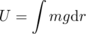, and if we knew the energy, we could find the field by differentiation, g=(1/m)dU/dr.
The same approach can be applied to other interactions, for example a mass on a spring. The main difference is that only in gravitational interactions does the strength of the interaction depend on the mass of the object, so in general, it doesn't make sense to separate out the factor of m as in the equation dU=mgdr. Since F=mg is the gravitational force, we can rewrite the equation in the more suggestive form dU=Fdr. This form no longer refers to gravity specifically, and can be applied much more generally. The only remaining detail is that I've been fairly cavalier about positive and negative signs up until now. That wasn't such a big problem for gravitational interactions, since gravity is always attractive, but it requires more careful treatment for nongravitational forces, where we don't necessarily know the direction of the force in advance, and we need to use positive and negative signs carefully for the direction of the force.
In general, suppose that forces are acting on a particle --- we can think of them as coming from other objects that are “off stage” --- and that the interaction between the particle and the off-stage objects can be characterized by an interaction energy, U, which depends only on the particle's position, x. Using the kinetic energy theorem, we have dK=Fdx. (It's not necessary to write K_{cm}, since a particle can't have any other kind of kinetic energy.) Conservation of energy tells us dK+dU=0, so the relationship between force and interaction energy is dU=-Fdx, or

Example 32: Force exerted by a spring
◊ A mass is attached to the end of a spring, and the energy of the spring is U=(1/2) kx², where x is the position of the mass, and x=0 is defined to be the equilibrium position. What is the force the spring exerts on the mass? Interpret the sign of the result.
◊ Differentiating, we find
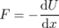
= - kx .
If x is positive, then the force is negative, i.e. it acts so as to bring the mass back to equilibrium, and similarly for x<0 we have F>0.
Most books do the F=- kx form before the U=(1/2) kx² form, and call it Hooke's law. Neither form is really more fundamental than the other --- we can always get from one to the other by integrating or differentiating.

Example 33: Newton's law of gravity
◊ Given the equation U=- Gm₁ m₂/ r for the energy of gravitational interactions, find the corresponding equation for the gravitational force on mass m₂. Interpret the positive and negative signs.
◊ We have to be a little careful here, because we've been taking r to be positive by definition, whereas the position, x, of mass m₂ could be positive or negative, depending on which side of m₁ it's on.
For positive x, we have r= x, and differentiation gives
= - Gm₁ m₂/ x² .
As in the preceding example, we have F<0 when x is positive, because the object is being attracted back toward x=0.
When x is negative, the relationship between r and x becomes r=- x, and the result for the force is the same as before, but with a minus sign. We can combine the two equations by writing
| F| = Gm₁ m₂/ r² ,
and this is the form traditionally known as Newton's law of gravity. As in the preceding example, the U and F equations contain equivalent information, and neither is more fundamental than the other.

Example 34: Equilibrium
I previously described the condition for equilibrium as a local maximum or minimum of U. A differentiable function has a zero derivative at its extrema, and we can now relate this directly to force: zero force acts on an object when it is at equilibrium.

3.3 Resonance
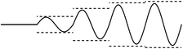
a / An x-versus-t graph for a swing pushed at resonance.
b / A swing pushed at twice its resonant frequency.
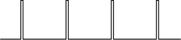
c / The F-versus-t graph for an impulsive driving force.
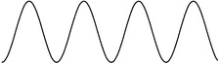
d / A sinusoidal driving force.
Resonance is a phenomenon in which an oscillator responds most strongly to a driving force that matches its own natural frequency of vibration. For example, suppose a child is on a playground swing with a natural frequency of 1 Hz. That is, if you pull the child away from equilibrium, release her, and then stop doing anything for a while, she'll oscillate at 1 Hz. If there was no friction, as we assumed in section 2.5, then the sum of her gravitational and kinetic energy would remain constant, and the amplitude would be exactly the same from one oscillation to the next. However, friction is going to convert these forms of energy into heat, so her oscillations would gradually die out. To keep this from happening, you might give her a push once per cycle, i.e. the frequency of your pushes would be 1 Hz, which is the same as the swing's natural frequency. As long as you stay in rhythm, the swing responds quite well. If you start the swing from rest, figure a, and then give pushes at 1 Hz, the swing's amplitude rapidly builds up, until after a while it reaches a steady state in which friction removes just as much energy as you put in over the course of one cycle.
What will happen if you try pushing at 2 Hz? Your first push puts in some momentum, p, but your second push happens after only half a cycle, when the swing is coming right back at you, with momentum -p! The momentum transfer from the second push is exactly enough to stop the swing. The result is a very weak, and not very sinusoidal, motion, b.

Making the math easy
This is a simple and physically transparent example of resonance: the swing responds most strongly if you match its natural rhythm. However, it has some characteristics that are mathematically ugly and possibly unrealistic. The quick, hard pushes are known as impulse forces, c, and they lead to an x-t graph that has nondifferentiable kinks. Impulsive forces like this are not only badly behaved mathematically, they are usually undesirable in practical terms. In a car engine, for example, the engineers work very hard to make the force on the pistons change smoothly, to avoid excessive vibration. Throughout the rest of this section, we'll assume a driving force that is sinusoidal, d, i.e. one whose F-t graph is either a sine function or a function that differs from a sine wave in phase, such as a cosine. The force is positive for half of each cycle and negative for the other half, i.e. there is both pushing and pulling. Sinusoidal functions have many nice mathematical characteristics (we can differentiate and integrate them, and the sum of sinusoidal functions that have the same frequency is a sinusoidal function), and they are also used in many practical situations. For instance, my garage door zapper sends out a sinusoidal radio wave, and the receiver is tuned to resonance with it.
A second mathematical issue that I glossed over in the swing example was how friction behaves. In section 3.2.3, about forces between solids, the empirical equation for kinetic friction was independent of velocity. If the only type of friction operating on the playground swing was one that behaved in this way, the consequences for the child would be unfortunate: the amplitude, rather than approaching a limiting value as suggested in figure a, would grow without bound, and she would find herself falling out of the swing as it flew up higher than the bar! The main source of friction on the playground swing is air friction, which increases with velocity. In practical machines, moving parts are normally lubricated, and friction at a lubricated surface is not just weaker than dry friction but also, unlike dry friction, displays velocity dependence. How exactly does friction work when liquids and gases are involved? We could imagine that as the child on the swing moves through the air, her body would experience continual collisions with air molecules. In these collisions she would tend to transfer momentum to the air, and force is the rate of momentum transfer. The number of collisions per second would be proportional to her velocity, and we would therefore expect air friction to be proportional to her velocity,
F = -bv ,
where the minus sign is because the frictional force opposes her motion. In reality, experiments show that friction involving gases and liquids only behaves according to this equation at extremely low velocities, or for a gas that has a very low density. At more ordinary velocities, the relationship is not a straight proportionality, because turbulent eddies are stirred up. Nevertheless, we'll assume throughout the rest of this section that F=-bv is true, because it ends up giving mathematically simple results!
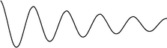
e / A damped sine wave, of the form x = Ae^{- ct}sin (ω_{f} t+δ).

Damped, free motion

Numerical treatment
An oscillator that has friction is referred to as damped. Let's use numerical techniques to find the motion of a damped oscillator that is released away from equilibrium, but experiences no driving force after that. We can expect that the motion will consist of oscillations that gradually die out. In section 2.5, we simulated the undamped case using our tried and true Python function based on conservation of energy. Now, however, that approach becomes a little awkward, because it involves splitting up the path to be traveled into n tiny segments, but in the presence of damping, each swing is a little shorter than the last one, and we don't know in advance exactly how far the oscillation will get before turning around. An easier technique here is to use force rather than energy. Newton's second law, a=F/m, gives a=(-kx-bv)/m, where we've made use of the result of example 32 for the force exerted by the spring. This becomes a little prettier if we rewrite it in the form
ma+bv+kx = 0 ,
which gives symmetric treatment to three terms involving x and its first and second derivatives, v and a. Now instead of calculating the time Δt=Δx/v required to move a predetermined distance Δx, we pick Δt and determine the distance traveled in that time, Δx=vΔt. Also, we can no longer update v based on conservation of energy, since we don't have any easy way to keep track of how much mechanical energy has been changed into heat energy. Instead, we recalculate the velocity using Δv=aΔt.
import math
k=39.4784 # chosen to give a period of 1 second
m=1.
b=0.211 # chosen to make the results simple
x=1.
v=0.
t=0.
dt=.01
n=1000
for j in range(n):
x=x+v*dt
a=(-k*x-b*v)/m
if (v>0) and (v+a*dt<0) :
print "turnaround at t=",t,", x=",x
v=v+a*dt
t=t+dt
turnaround at t= 0.99 , x= 0.899919262445
turnaround at t= 1.99 , x= 0.809844934046
turnaround at t= 2.99 , x= 0.728777519477
turnaround at t= 3.99 , x= 0.655817260033
turnaround at t= 4.99 , x= 0.590154191135
turnaround at t= 5.99 , x= 0.531059189965
turnaround at t= 6.99 , x= 0.477875914756
turnaround at t= 7.99 , x= 0.430013546991
turnaround at t= 8.99 , x= 0.386940256644
turnaround at t= 9.99 , x= 0.348177318484
The spring constant, k=4π=39.4784, is designed so that if the undamped equation was still true, the frequency would be 1 Hz. We start by noting that the addition of a small amount of damping doesn't seem to have changed the period at all, or at least not to within the accuracy of the calculation.¹⁰ You can check for yourself, however, that a large value of b, say 5 N⋅s/m, does change the period significantly.
We release the mass from x=1 m, and after one cycle, it only comes back to about x=0.9 m. I chose b=0.211 N⋅s/m by fiddling around until I got this result, since a decrease of exactly 10% is easy to discuss. Notice how the amplitude after two cycles is about 0.81 m, i.e. 1 m times 0.9²: the amplitude has again dropped by exactly 10%. This pattern continues for as long as the simulation runs, e.g. for the last two cycles, we have 0.34818/0.38694=0.89982, or almost exactly 0.9 again. It might have seemed capricious when I chose to use the unrealistic equation F=-bv, but this is the payoff. Only with -bv friction do we get this kind of mathematically simple exponential decay.

Analytic treatment
Taking advantage of this unexpectedly simple result, let's find an analytic solution for the motion. The numerical output suggests that we assume a solution of the form
x = Ae^{-ct}sin (ω_{f} t+δ) .
where the unknown constants ω_{f} and c will presumably be related to m, b, and k. The constant c indicates how quickly the oscillations die out. The constant ω_{f} is, as before, defined as 2π times the frequency, with the subscript f to indicate a free (undriven) solution. All our equations will come out much simpler if we use ωs everywhere instead of s from now on, and, as physicists often do, I'll generally use the word “frequency” to refer to ω when the context makes it clear what I'm talking about. The phase angle δ has no real physical significance, since we can define t=0 to be any moment in time we like. The factor A for the initial amplitude can also be omitted without loss of generality, since the equation we're trying to solve, ma+bv+kx = 0 is linear. That is, v and a are the first and second derivatives of x, and the derivative of Ax is simply A times the derivative of x. Thus, if x(t) is a solution of the equation, then multiplying it by a constant gives an equally valid solution. For the purpose of determining ω_{f} and c, the most general form we need to consider is therefore x = e^{-ct}sin ω_{f} t , whose first and second derivatives are and a = e^{-ct}≤ft(c² sin ω_{f} t. Plugging these into the equation ma+bv+kx = 0 and setting the sine and cosine parts equal to zero gives, after some tedious algebra,
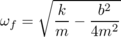
and
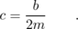
The first of these two equations is like the undamped equation , except for the second term, which is often negligible for small b. The second equation says that c, which indicates how quickly the oscillations damp out, is directly related to b, the strength of the damping.

The quality factor
It's usually impractical to measure b directly and determine c from the equation c=b/2m. For a child on a swing, measuring b would require putting the child in a wind tunnel! It's usually much easier to characterize the amount of damping by observing the actual damped oscillations and seeing how many cycles it takes for the mechanical energy to decrease by a certain factor. The unitless quality factor, Q, is defined as Q=ω_{o}/2c, and in the limit of weak damping, where ω≈ω_{o}, this can be interpreted as the number of cycles required for the mechanical energy to fall off by a factor of e^{2π}=535.49…. Using this new quantity, we can rewrite the equation for the frequency of damped oscillations in the slightly more elegant form .

Example 35: Exponential decay in a trumpet
◊ The vibrations of the air column inside a trumpet have a Q of about 10. This means that even after the trumpet player stops blowing, the note will keep sounding for a short time. If the player suddenly stops blowing, how will the sound intensity 20 cycles later compare with the sound intensity while she was still blowing?
◊ The trumpet's Q is 10, so after 10 cycles the energy will have fallen off by a factor of 535. After another 10 cycles we lose another factor of 535, so the sound intensity is reduced by a factor of 535×535= 2.9×10⁵.
The decay of a musical sound is part of what gives it its character, and a good musical instrument should have the right Q, but the Q that is considered desirable is different for different instruments. A guitar is meant to keep on sounding for a long time after a string has been plucked, and might have a Q of 1000 or 10000. One of the reasons why a cheap synthesizer sounds so bad is that the sound suddenly cuts off after a key is released.
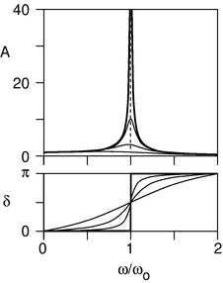
g / Dependence of the amplitude and phase angle on the driving frequency. The undamped case, Q=∞, is shown with heavy lines, and the other curves represent Q=1, 3, and 10. The amplitudes were calculated with F_{m}, m, and ω_{o}, all set to 1.
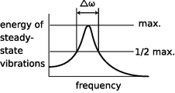
h / The definition of Δω, the full width at half maximum.
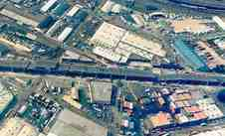
i / The collapsed section of the Nimitz Freeway
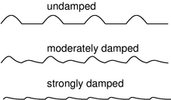
j / An x-versus-t graph of the steady-state motion of a swing being pushed at twice its resonant frequency by an impulsive force.

Driven motion
The driven case is both simpler and more interesting than the undriven one. We have an external driving force F=F_{m} sin ω t, where the constant F_{m} indicates the maximum strength of the force in either direction. The equation of motion is now
ma+bv+kx = F_{m} sin ω t
After the driving force has been applied for a while, we expect that the amplitude of the oscillations will approach some constant value. This motion is known as the steady state, and it's the most interesting thing to find out; as we'll see later, the most general type of motion is only a minor variation on the steady-state motion. For the steady-state motion, we're going to look for a solution of the form
x = A sin (ωt+δ) .
In contrast to the undriven case, here it's not possible to sweep A and δ under the rug. The amplitude of the steady-state motion, A, is actually the most interesting thing to know about the steady-state motion, and it's not true that we still have a solution no matter how we fiddle with A; if we have a solution for a certain value of A, then multiplying A by some constant would break the equality between the two sides of the equation of motion. It's also no longer true that we can get rid of δ simply be redefining when we start the clock; here δ represents a difference in time between the start of one cycle of the driving force and the start of the corresponding cycle of the motion.
The velocity and acceleration are v=ωAsin(ω t+δ) and a=-ω²Acos(ω t+δ), and if we plug these into the equation of motion, \eqref{eqn:resonancemotion}, and simplify a little, we find
(k-mω²)sin (ω t+δ)
The sum of any two sinusoidal functions with the same frequency is also a sinusoidal, so the whole left side adds up to a sinusoidal. By fiddling with A and δ we can make the amplitudes and phases of the two sides of the equation match up.

Steady state, no damping
A and δ are easy to find in the case where there is no damping at all. There are now no cosines in equation \eqref{eqn:steadystate} above, only sines, so if we wish we can set δ to zero, and we find A=F_{m}/(k-mω²)=F_{m}/m(ω_{o}²-ω²). This, however, makes A negative for ω>ω_{o}. The variable δ was designed to represent this kind of phase relationship, so we prefer to keep A positive and set δ=π for ω>ω_{o}. Our results are then
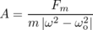
and \delta = \left\{\begin{array}{ll} 0, & \omega<\omega_\zu{o} \pi, & \omega>\omega_\zu{o}\end{array}\right. .
The most important feature of the result is that there is a resonance: the amplitude becomes greater and greater, and approaches infinity, as ω approaches the resonant frequency ω_{o}. The interpretation of the infinite amplitude is that there really isn't any steady state if we drive the system exactly at resonance --- the amplitude will just keep on increasing indefinitely. In real life, there is always some damping, and there will always be some difference, however small, between ω and ω_{o}.
There is a simple interpretation for the surprising behavior of the phase angle δ. The system's mechanical energy can only change due to work done by the driving force, since there is no damping to convert mechanical energy to heat. In the steady state, then, the power transmitted by the driving force over a full cycle of motion must average out to zero. In general, the work theorem dE=Fdx can always be divided by dt on both sides to give the useful relation P=Fv. If Fv is to average out to zero, then F and v must be out of phase by ±π/2, and since v is ahead of x by a phase angle of π/2, the phase angle between x and F must be zero or π.

Example 36: A practice mute for a violin
The amplitude of the driven vibrations, A=F_{m}/(m|ω²-ω_{o}²|), contains an inverse proportionality to the mass of the vibrating object. This is simply because a given force will produce less acceleration when applied to a more massive object. An application is shown in figure 36.
In a stringed instrument, the strings themselves don't have enough surface area to excite sound waves very efficiently. In instruments of the violin family, as the strings vibrate from left to right, they cause the bridge (the piece of wood they pass over) to wiggle clockwise and counterclockwise, and this motion is transmitted to the top panel of the instrument, which vibrates and creates sound waves in the air.
A string player who wants to practice at night without bothering the neighbors can add some mass to the bridge. Adding mass to the bridge causes the amplitude of the vibrations to be smaller, and the sound to be much softer. A similar effect is seen when an electric guitar is used without an amp. The body of an electric guitar is so much more massive than the body of an acoustic guitar that the amplitude of its vibrations is very small.
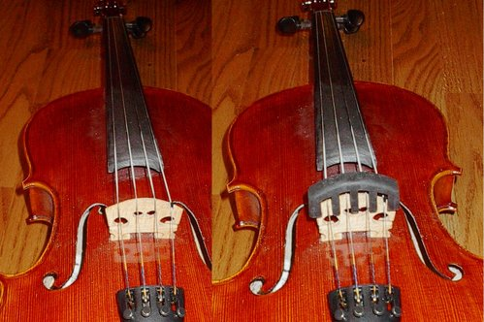
f / Example 36: a viola without a mute (left), and with a mute (right). The mute doesn't touch the strings themselves.

Steady state, with damping
The extension of the analysis to the damped case involves some lengthy algebra, which I've outlined on page 741 in appendix 2. The results are shown in figure g. It's not surprising that the steady state response is weaker when there is more damping, since the steady state is reached when the power extracted by damping matches the power input by the driving force. What is surprising is that the amplitude is strongly affected by damping close to resonance, but only weakly affected far from it. In other words, the shape of the resonance curve is broader with more damping, and even if we were to scale up a high-damping curve so that its maximum was the same as that of a low-damping curve, it would still have a different shape. The standard way of describing the shape numerically is to give the quantity Δω, called the full width at half-maximum, or FWHM, which is defined in figure h. Note that the y axis is energy, which is proportional to the square of the amplitude. Our previous observations amount to a statement that Δω is greater when the damping is stronger, i.e. when the Q is lower. It's not hard to show from the equations on page 741 that for large Q, the FWHM is given approximately by
Δω ≈ ω_{o}/Q .
(It's clear that this can't be a good approximation for small values of Q, since for very small Q the resonance curve doesn't even have a maximum near ω=ω_{o}.)

Example 37: An opera singer breaking a wineglass
In order to break a wineglass by singing, an opera singer must first tap the glass to find its natural frequency of vibration, and then sing the same note back, so that her driving force will produce a response with the greatest possible amplitude. If she's shopping for the right glass to use for this display of her prowess, she should look for one that has the greatest possible Q, since the resonance curve has a higher maximum for higher values of Q.

Example 38: Collapse of the Nimitz Freeway
Figure i shows a section of the Nimitz Freeway in Oakland, CA, that collapsed during an earthquake in 1989. An earthquake consists of many low-frequency vibrations that occur simultaneously, which is why it sounds like a rumble of indeterminate pitch rather than a low hum. The frequencies that we can hear are not even the strongest ones; most of the energy is in the form of vibrations in the range of frequencies from about 1 Hz to 10 Hz.
All the structures we build are resting on geological layers of dirt, mud, sand, or rock. When an earthquake wave comes along, the topmost layer acts like a system with a certain natural frequency of vibration, sort of like a cube of jello on a plate being shaken from side to side. The resonant frequency of the layer depends on how stiff it is and also on how deep it is. The ill-fated section of the Nimitz freeway was built on a layer of mud, and analysis by geologist Susan E. Hough of the U.S. Geological Survey shows that the mud layer's resonance was centered on about 2.5 Hz, and had a width covering a range from about 1 Hz to 4 Hz.
When the earthquake wave came along with its mixture of frequencies, the mud responded strongly to those that were close to its own natural 2.5 Hz frequency. Unfortunately, an engineering analysis after the quake showed that the overpass itself had a resonant frequency of 2.5 Hz as well! The mud responded strongly to the earthquake waves with frequencies close to 2.5 Hz, and the bridge responded strongly to the 2.5 Hz vibrations of the mud, causing sections of it to collapse.

Physical reason for the relationship between Q and the FWHM
What is the reason for this surprising relationship between the damping and the width of the resonance? Fundamentally, it has to do with the fact that friction causes a system to lose its “memory” of its previous state. If the Pioneer 10 space probe, coasting through the frictionless vacuum of interplanetary space, is detected by aliens a million years from now, they will be able to trace its trajectory backwards and infer that it came from our solar system. On the other hand, imagine that I shove a book along a tabletop, it comes to rest, and then someone else walks into the room. There will be no clue as to which direction the book was moving before it stopped --- friction has erased its memory of its motion. Now consider the playground swing driven at twice its natural frequency, figure j, where the undamped case is repeated from figure b on page 128. In the undamped case, the first push starts the swing moving with momentum p, but when the second push comes, if there is no friction at all, it now has a momentum of exactly -p, and the momentum transfer from the second push is exactly enough to stop it dead. With moderate damping, however, the momentum on the rebound is not quite -p, and the second push's effect isn't quite as disastrous. With very strong damping, the swing comes essentially to rest long before the second push. It has lost all its memory, and the second push puts energy into the system rather than taking it out. Although the detailed mathematical results with this kind of impulsive driving force are different,¹¹ the general results are the same as for sinusoidal driving: the less damping there is, the more of a penalty you pay for driving the system off of resonance.

Example 39: High-Q speakers
Most good audio speakers have Q≈1, but the resonance curve for a higher-Q oscillator always lies above the corresponding curve for one with a lower Q, so people who want their car stereos to be able to rattle the windows of the neighboring cars will often choose speakers that have a high Q. Of course they could just use speakers with stronger driving magnets to increase F_{m}, but the speakers might be more expensive, and a high-Q speaker also has less friction, so it wastes less energy as heat.
One problem with this is that whereas the resonance curve of a low-Q speaker (its “response curve” or “frequency response” in audiophile lingo) is fairly flat, a higher-Q speaker tends to emphasize the frequencies that are close to its natural resonance. In audio, a flat response curve gives more realistic reproduction of sound, so a higher quality factor, Q, really corresponds to a lower -quality speaker.
Another problem with high-Q speakers is discussed in example 42 on page 141 .

Example 40: Changing the pitch of a wind instrument
◊ A saxophone player normally selects which note to play by choosing a certain fingering, which gives the saxophone a certain resonant frequency. The musician can also, however, change the pitch significantly by altering the tightness of her lips. This corresponds to driving the horn slightly off of resonance. If the pitch can be altered by about 5% up or down (about one musical half-step) without too much effort, roughly what is the Q of a saxophone?
◊ Five percent is the width on one side of the resonance, so the full width is about 10%, Δ f/f_{o}≈ 0.1. The equation Δω=ω_{o}/ Q is defined in terms of angular frequency, ω=2π f, and we've been given our data in terms of ordinary frequency, f. The factors of 2π end up canceling out, however:
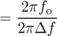
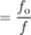
In other words, once the musician stops blowing, the horn will continue sounding for about 10 cycles before its energy falls off by a factor of 535. (Blues and jazz saxophone players will typically choose a mouthpiece that gives a low Q, so that they can produce the bluesy pitch-slides typical of their style. “Legit,” i.e. classically oriented players, use a higher-Q setup because their style only calls for enough pitch variation to produce a vibrato, and the higher Q makes it easier to play in tune.)

Example 41: Q of a radio receiver
◊ A radio receiver used in the FM band needs to be tuned in to within about 0.1 MHz for signals at about 100 MHz. What is its Q?
◊ As in the last example, we're given data in terms of fs, not ωs, but the factors of 2π cancel. The resulting Q is about 1000, which is extremely high compared to the Q values of most mechanical systems.

Transients
What about the motion before the steady state is achieved? When we computed the undriven motion numerically on page 130, the program had to initialize the position and velocity. By changing these two variables, we could have gotten any of an infinite number of simulations.¹² The same is true when we have an equation of motion with a driving term, ma+bv+kx = F_{m} sin ωt (p. , equation \eqref{eqn:resonancemotion}). The steady-state solutions, however, have no adjustable parameters at all --- A and δ are uniquely determined by the parameters of the driving force and the oscillator itself. If the oscillator isn't initially in the steady state, then it will not have the steady-state motion at first. What kind of motion will it have?
The answer comes from realizing that if we start with the solution to the driven equation of motion, and then add to it any solution to the free equation of motion, the result,
x = A sin (ω t+δ) + A' e^{-ct}sin (ω_{f} t+δ') ,
is also a solution of the driven equation. Here, as before, ω_{f} is the frequency of the free oscillations (ω_{f}≈ω_{o} for small Q), ω is the frequency of the driving force, A and δ are related as usual to the parameters of the driving force, and A' and δ' can have any values at all. Given the initial position and velocity, we can always choose A' and δ' to reproduce them, but this is not something one often has to do in real life. What's more important is to realize that the second term dies out exponentially over time, decaying at the same rate at which a free vibration would. For this reason, the A' term is called a transient. A high-Q oscillator's transients take a long time to die out, while a low-Q oscillator always settles down to its steady state very quickly.

Example 42: Boomy bass
In example 39 on page 139, I've already discussed one of the drawbacks of a high-Q speaker, which is an uneven response curve. Another problem is that in a high-Q speaker, transients take a long time to die out. The bleeding-eardrums crowd tend to focus mostly on making their bass loud, so it's usually their woofers that have high Qs. The result is that bass notes, “ring” after the onset of the note, a phenomenon referred to as “boomy bass.”

Overdamped motion
The treatment of free, damped motion on page 131 skipped over a subtle point: in the equation , Q<1/2 results in an answer that is the square root of a negative number. For example, suppose we had k=0, which corresponds to a neutral equilibrium. A physical example would be a mass sitting in a tub of syrup. If we set it in motion, it won't oscillate --- it will simply slow to a stop. This system has Q=0. The equation of motion in this case is ma+bv=0, or, more suggestively,
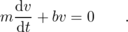
One can easily verify that this has the solution , and integrating, we find . In other words, the reason ω_{f} comes out to be mathematical nonsense¹³ is that we were incorrect in assuming a solution that oscillated at a frequency ω_{f}. The actual motion is not oscillatory at all.
In general, systems with Q<1/2, called overdamped systems, do not display oscillatory motion. Most cars' shock absorbers are designed with Q≈1/2, since it's undesirable for the car to undulate up and down for a while after you go over a bump. (Shocks with extremely low values of Q are not good either, because such a system takes a very long time to come back to equilibrium.) It's not particularly important for our purposes, but for completeness I'll note, as you can easily verify, that the general solution to the equation of motion for 0<Q<1/2 is of the form x=Ae^{-ct}+Be^{-dt}, while Q=1/2, called the critically dampedcase, gives x=(A+Bt)e^{-ct}.

3.4 Motion in Three Dimensions
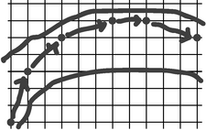
a / The car can change its x and y motions by one square every turn.
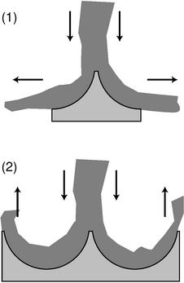
d / Two surfaces that could be used to extract energy from a stream of water.
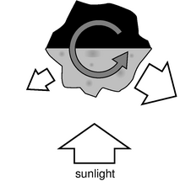
e / An asteroid absorbs visible light from the sun, and gets rid of the energy by radiating infrared light.

The Cartesian perspective
When my friends and I were bored in high school, we used to play a paper-and-pencil game which, although we never knew it, was Very Educational --- in fact, it pretty much embodies the entire world-view of classical physics. To play the game, you draw a racetrack on graph paper, and try to get your car around the track before anyone else. The default is for your car to continue at constant speed in a straight line, so if it moved three squares to the right and one square up last turn, it will do the same this turn. You can also control the car's motion by changing its Δ x and Δ y by up to one unit. If it moved three squares to the right last turn, you can have it move anywhere from two to four squares to the right this turn.
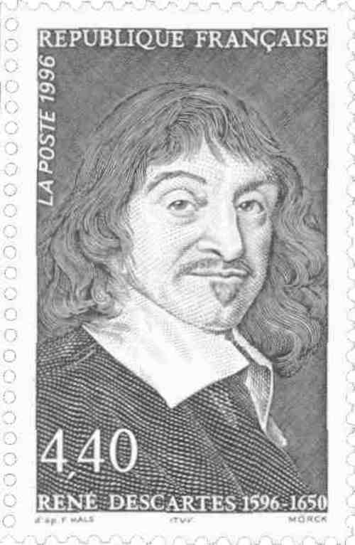
b / French mathematician René Descartes invented analytic geometry; Cartesian (xyz) coordinates are named after him. He did work in philosophy, and was particularly interested in the mind-body problem. He was a skeptic and an antiaristotelian, and, probably for fear of religious persecution, spent his adult life in the Netherlands, where he fathered a daughter with a Protestant peasant whom he could not marry. He kept his daughter's existence secret from his enemies in France to avoid giving them ammunition, but he was crushed when she died of scarlatina at age 5. A pious Catholic, he was widely expected to be sainted. His body was buried in Sweden but then reburied several times in France, and along the way everything but a few fingerbones was stolen by peasants who expected the body parts to become holy relics.
The fundamental way of dealing with the direction of an object's motion in physics is to use conservation of momentum, since momentum depends on direction. Up until now, we've only done momentum in one dimension. How does this relate to the racetrack game? In the game, the motion of a car from one turn to the next is represented by its Δ x and Δ y. In one dimension, we would only need Δ x, which could be related to the velocity, Δ x/Δ t, and the momentum, mΔ x/Δ t. In two dimensions, the rules of the game amount to a statement that if there is no momentum transfer, then both mΔ x/Δ t and mΔ y/Δ t stay the same. In other words, there are two flavors of momentum, and they are separately conserved. All of this so far has been done with an artificial division of time into “turns,” but we can fix that by redefining everything in terms of derivatives, and for motion in three dimensions rather than two, we augment x and y with z:
and
We call these the x, y, and z components of the velocity and the momentum.
There is both experimental and theoretical evidence that the x, y, and z momentum components are separately conserved, and that a momentum transfer (force) along one axis has no effect on the momentum components along the other two axes. On page 51, for example, I argued that it was impossible for an air hockey puck to make a 180-degree turn spontaneously, because then in the frame moving along with the puck, it would have begun moving after starting from rest. Now that we're working in two dimensions, we might wonder whether the puck could spontaneously make a 90-degree turn, but exactly the same line of reasoning shows that this would be impossible as well, which proves that the puck can't trade x-momentum for y-momentum. A more general proof of separate conservation will be given on page 170, after some of the appropriate mathematical techniques have been introduced.
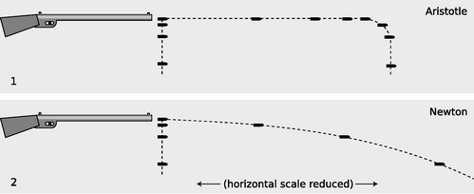
c / Bullets are dropped and shot at the same time.
As an example of the experimental evidence for separate conservation of the momentum components, figure c shows correct and incorrect predictions of what happens if you shoot a rifle and arrange for a second bullet to be dropped from the same height at exactly the same moment when the first one left the barrel. Nearly everyone expects that the dropped bullet will reach the dirt first, and Aristotle would have agreed, since he believed that the bullet had to lose its horizontal motion before it could start moving vertically. In reality, we find that the vertical momentum transfer between the earth and the bullet is completely unrelated to the horizontal momentum. The bullet ends up with p_{y}<0, while the planet picks up an upward momentum p_{y}>0, and the total momentum in the y direction remains zero. Both bullets hit the ground at the same time. This is much simpler than the Aristotelian version!

Example 43: The Pelton waterwheel
◊ There is a general class of machines that either do work on a gas or liquid, like a boat's propeller, or have work done on them by a gas or liquid, like the turbine in a hydroelectric power plant. Figure d shows two types of surfaces that could be attached to the circumference of an old-fashioned waterwheel. Compare the force exerted by the water in the two cases.
◊ Let the x axis point to the right, and the y axis up. In both cases, the stream of water rushes down onto the surface with momentum p_{y,i}=- p_{o}, where the subscript i stands for “initial,” i.e. before the collision.
In the case of surface 1, the streams of water leaving the surface have no momentum in the y direction, and their momenta in the x direction cancel. The final momentum of the water is zero along both axes, so its entire momentum, - p_{o}, has been transferred to the waterwheel.
When the water leaves surface 2, however, its momentum isn't zero. If we assume there is no friction, it's p_{y,f}= p_{o}, with the positive sign indicating upward momentum. The change in the water's momentum is p_{y,f}- p_{y,i}=2 p_{o}, and the momentum transferred to the waterwheel is -2 p_{o}.
Force is defined as the rate of transfer of momentum, so surface 2 experiences double the force. A waterwheel constructed in this way is known as a Pelton waterwheel.

Example 44: The Yarkovsky effect
We think of the planets and asteroids as inhabiting their orbits permanently, but it is possible for an orbit to change over periods of millions or billions of years, due to a variety of effects. For asteroids with diameters of a few meters or less, an important mechanism is the Yarkovsky effect, which is easiest to understand if we consider an asteroid spinning about an axis that is exactly perpendicular to its orbital plane.
The illuminated side of the asteroid is relatively hot, and radiates more infrared light than the dark (night) side. Light has momentum, and a total force away from the sun is produced by combined effect of the sunlight hitting the asteroid and the imbalance between the momentum radiated away on the two sides. This force, however, doesn't cause the asteroid's orbit to change over time, since it simply cancels a tiny fraction of the sun's gravitational attraction. The result is merely a tiny, undetectable violation of Kepler's law of periods.
Consider the sideways momentum transfers, however. In figure e, the part of the asteroid on the right has been illuminated for half a spin-period (half a “day”) by the sun, and is hot. It radiates more light than the morning side on the left. This imbalance produces a total force in the x direction which points to the left. If the asteroid's orbital motion is to the left, then this is a force in the same direction as the motion, which will do positive work, increasing the asteroid's energy and boosting it into an orbit with a greater radius. On the other hand, if the asteroid's spin and orbital motion are in opposite directions, the Yarkovsky push brings the asteroid spiraling in closer to the sun.
Calculations show that it takes on the order of 10⁷ to 10⁸ years for the Yarkovsky effect to move an asteroid out of the asteroid belt and into the vicinity of earth's orbit, and this is about the same as the typical age of a meteorite as estimated by its exposure to cosmic rays. The Yarkovsky effect doesn't remove all the asteroids from the asteroid belt, because many of them have orbits that are stabilized by gravitational interactions with Jupiter. However, when collisions occur, the fragments can end up in orbits which are not stabilized in this way, and they may then end up reaching the earth due to the Yarkovsky effect. The cosmic-ray technique is really telling us how long it has been since the fragment was broken out of its parent.

Discussion Questions
◊ The following is an incorrect explanation of a fact about target shooting:
“Shooting a high-powered rifle with a high muzzle velocity is different from shooting a less powerful gun. With a less powerful gun, you have to aim quite a bit above your target, but with a more powerful one you don't have to aim so high because the bullet doesn't drop as fast.”
What is the correct explanation?
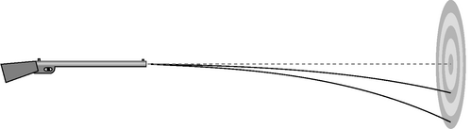
f / Discussion question A.
◊ You have thrown a rock, and it is flying through the air in an arc. If the earth's gravitational force on it is always straight down, why doesn't it just go straight down once it leaves your hand?
◊ Consider the example of the bullet that is dropped at the same moment another bullet is fired from a gun. What would the motion of the two bullets look like to a jet pilot flying alongside in the same direction as the shot bullet and at the same horizontal speed?
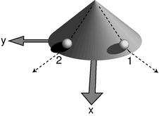
g / Two balls roll down a cone and onto a plane.

Rotational invariance
The Cartesian approach requires that we choose x, y, and z axes. How do we choose them correctly? The answer is that it had better not matter which directions the axes point (provided they're perpendicular to each other), or where we put the origin, because if it did matter, it would mean that space was asymmetric. If there was a certain point in the universe that was the right place to put the origin, where would it be? The top of Mount Olympus? The United Nations headquarters? We find that experiments come out the same no matter where we do them, and regardless of which way the laboratory is oriented, which indicates that no location in space or direction in space is special in any way.¹⁴
This is closely related to the idea of Galilean relativity stated on page 22, from which we already know that the absolute motion of a frame of reference is irrelevant and undetectable. Observers using frames of reference that are in motion relative to each other will not even agree on the permanent identity of a particular point in space, so it's not possible for the laws of physics to depend on where you are in space. For instance, if gravitational energies were proportional to m₁m₂ in one location but to (m₁m₂)^{1.00001} in another, then it would be possible to determine when you were in a state of absolute motion, because the behavior of gravitational interactions would change as you moved from one region to the other.
Because of this close relationship, we restate the principle of Galilean relativity in a more general form. This extended principle of Galilean relativity states that the laws of physics are no different in one time and place than in another, and that they also don't depend on your orientation or your motion, provided that your motion is in a straight line and at constant speed.
The irrelevance of time and place could have been stated in chapter 1, but since this section is the first one in which we're dealing with three-dimensional physics in full generality, the irrelevance of orientation is what we really care about right now. This property of the laws of physics is called rotational invariance. The word “invariance” means a lack of change, i.e. the laws of physics don't change when we reorient our frame of reference.

Example 45: Rotational invariance of gravitational interactions
Gravitational energies depend on the quantity 1/r, which by the Pythagorean theorem equals
.
Rotating a line segment doesn't change its length, so this expression comes out the same regardless of which way we orient our coordinate axes. Even though Δ x, Δ y, and Δ z are different in differently oriented coordinate systems, r is the same.

Example 46: Kinetic energy
Kinetic energy equals , but what does that mean in three dimensions, where we have v_{x}, v_{y}, and v_{z}? If you were tempted to add the components and calculate K=(1/2) m( v_{x}+ v_{y}+ v_{z})², figure g should convince you otherwise. Using that method, we'd have to assign a kinetic energy of zero to ball number 1, since its negative v_{y} would exactly cancel its positive v_{x}, whereas ball number 2's kinetic energy wouldn't be zero. This would violate rotational invariance, since the balls would behave differently.
The only possible way to generalize kinetic energy to three dimensions, without violating rotational invariance, is to use an expression that resembles the Pythagorean theorem,
which results in
.
Since the velocity components are squared, the positive and negative signs don't matter, and the two balls in the example behave the same way.
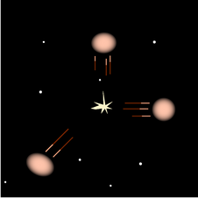
h / Example 47.
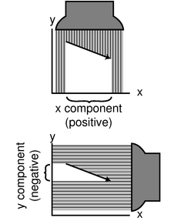
i / The geometric interpretation of a vector's components.
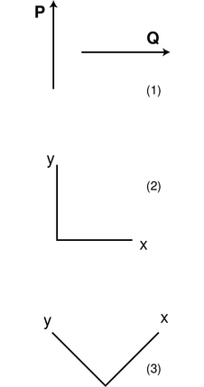
j / Two vectors, 1, to which we apply the same operation in two different frames of reference, 2 and 3.
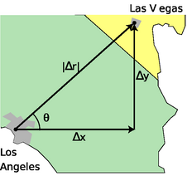
k / Example 49.
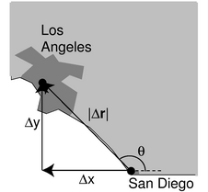
l / Example 51.
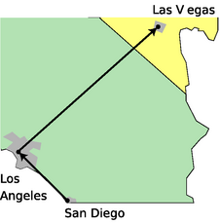
m / Example 52.
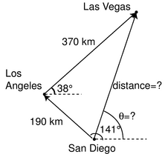
n / Example 53.
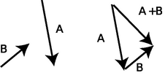
o / Adding vectors graphically by placing them tip-to-tail, like a train.
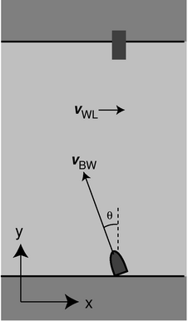
p / Example 54
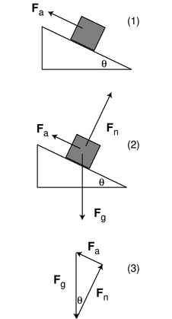
q / Example 56.
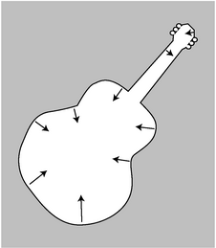
r / Archimedes' principle works regardless of whether the object is a cube. The fluid makes a force on every square millimeter of the object's surface.
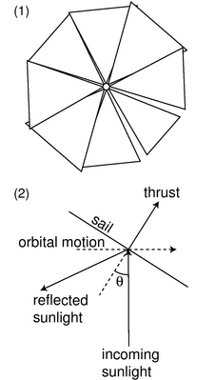
s / Example 58.
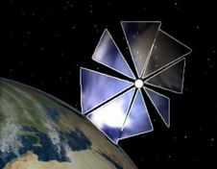
t / An artist's rendering of what Cosmos 1 would have looked like in orbit.
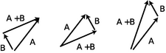
u / Discussion question E.
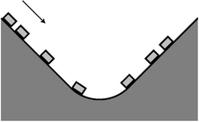
v / Discussion question H.

Vectors
Remember the title of this book? It would have been possible to obtain the result of example 46 by applying the Pythagorean theorem to d x, d y, and d z, and then dividing by d t, but the rotational invariance approach is simpler, and is useful in a much broader context. Even with a quantity you presently know nothing about, say the magnetic field, you can infer that if the components of the magnetic field are B_{x}, B_{y}, and B_{z}, then the physically useful way to talk about the strength of the magnetic field is to define it as . Nature knows your brain cells are precious, and doesn't want you to have to waste them by memorizing mathematical rules that are different for magnetic fields than for velocities.
When mathematicians see that the same set of techniques is useful in many different contexts, that's when they start making definitions that allow them to stop reinventing the wheel. The ancient Greeks, for example, had no general concept of fractions. They couldn't say that a circle's radius divided by its diameter was equal to the number 1/2. They had to say that the radius and the diameter were in the ratio of one to two. With this limited number concept, they couldn't have said that water was dripping out of a tank at a rate of 3/4 of a barrel per day; instead, they would have had to say that over four days, three barrels worth of water would be lost. Once enough of these situations came up, some clever mathematician finally realized that it would make sense to define something called a fraction, and that one could think of these fraction thingies as numbers that lay in the gaps between the traditionally recognized numbers like zero, one, and two. Later generations of mathematicians introduced further subversive generalizations of the number concepts, inventing mathematical creatures like negative numbers, and the square root of two, which can't be expressed as a fraction.
In this spirit, we define a vector as any quantity that has both an amount and a direction in space. In contradistinction, a scalar has an amount, but no direction. Time and temperature are scalars. Velocity, acceleration, momentum, and force are vectors. In one dimension, there are only two possible directions, and we can use positive and negative numbers to indicate the two directions. In more than one dimension, there are infinitely many possible directions, so we can't use the two symbols + and - to indicate the direction of a vector. Instead, we can specify the three components of the vector, each of which can be either negative or positive. We represent vector quantities in handwriting by writing an arrow above them, so for example the momentum vector looks like this, , but the arrow looks ugly in print, so in books vectors are usually shown in bold-face type: p. A straightforward way of thinking about vectors is that a vector equation really represents three different equations. For instance, conservation of momentum could be written in terms of the three components,
Δ p_{x} = 0
Δ p_{y} = 0
Δ p_{z} = 0 ,
or as a single vector equation,¹⁵
Δ p = 0 .
The following table summarizes some vector operations.
operation | definition
mathbfvector | sqrtvectorx2vectory2vectorz2
mathbfvectormathbfvector | Add component by component.
mathbfvectormathbfvector | Subtract component by component.
mathbfvector cdot scalar | Multiply each component by the scalar.
mathbfvector scalar | Divide each component by the scalar.
{}The first of these is called the magnitude of the vector; in one dimension, where a vector only has one component, it amounts to taking the absolute value, hence the similar notation.
self-check: Translate the equations , , and into a single equation in vector notation. (answer in the back of the PDF version of the book)

Example 47: An explosion
◊ Astronomers observe the planet Mars as the Martians fight a nuclear war. The Martian bombs are so powerful that they rip the planet into three separate pieces of liquefied rock, all having the same mass. If one fragment flies off with velocity components v_{1 x}=0, km/hr, and the second with km/hr, v_{2 y}=0, what is the magnitude of the third one's velocity?
◊ We work the problem in the center of mass frame, in which the planet initially had zero momentum. After the explosion, the vector sum of the momenta must still be zero. Vector addition can be done by adding components, so
mv_{1 x} + mv_{2 x} + mv_{3 x} = 0
and
mv_{1 y} + mv_{2 y} + mv_{3 y} = 0 ,
where we have used the same symbol m for all the terms, because the fragments all have the same mass. The masses can be eliminated by dividing each equation by m, and we find
which gives a magnitude of

Geometric representation of vectors
A vector in two dimensions can be easily visualized by drawing an arrow whose length represents its magnitude and whose direction represents its direction. The x component of a vector can then be visualized, i, as the length of the shadow it would cast in a beam of light projected onto the x axis, and similarly for the y component. Shadows with arrowheads pointing back against the direction of the positive axis correspond to negative components.
In this type of diagram, the negative of a vector is the vector with the same magnitude but in the opposite direction. Multiplying a vector by a scalar is represented by lengthening the arrow by that factor, and similarly for division.
self-check: Given vector Q represented by an arrow below, draw arrows representing the vectors 1.5Q and -Q.
\begin{center}\end{center} (answer in the back of the PDF version of the book)
[3]{A useless vector operation} The way I've defined the various vector operations above aren't as arbitrary as they seem. There are many different vector operations that we could define, but only some of the possible definitions are mathematically useful. Consider the operation of multiplying two vectors component by component to produce a third vector:
As a simple example, we choose vectors P and Q to have length 1, and make them perpendicular to each other, as shown in figure j/1. If we compute the result of our new vector operation using the coordinate system shown in j/2, we find:
R_{x} = 0
R_{y} = 0
R_{z} = 0
The x component is zero because P_{x} =0, the y component is zero because Q_{y}=0, and the z component is of course zero because both vectors are in the x-y plane. However, if we carry out the same operations in coordinate system j/3, rotated 45 degrees with respect to the previous one, we find
R_{z} = 0
The operation's result depends on what coordinate system we use, and since the two versions of R have different lengths (one being zero and the other nonzero), they don't just represent the same answer expressed in two different coordinate systems. Such an operation will never be useful in physics, because experiments show physics works the same regardless of which way we orient the laboratory building! The useful vector operations, such as addition and scalar multiplication, are rotationally invariant, i.e. come out the same regardless of the orientation of the coordinate system.
All the vector techniques can be applied to any kind of vector, but the graphical representation of vectors as arrows is particularly natural for vectors that represent lengths and distances. We define a vector called r whose components are the coordinates of a particular point in space, x, y, and z. The Δr vector, whose components are Δ x, Δ y, and Δ z, can then be used to represent motion that starts at one point and ends at another. Adding two Δ r vectors is interpreted as a trip with two legs: by computing the Δ r vector going from point A to point B plus the vector from B to C, we find the vector that would have taken us directly from A to C.

Calculations with magnitude and direction
If you ask someone where Las Vegas is compared to Los Angeles, she is unlikely to say that the Δ x is 290 km and the Δ y is 230 km, in a coordinate system where the positive x axis is east and the y axis points north. She will probably say instead that it's 370 km to the northeast. If she was being precise, she might specify the direction as 38° counterclockwise from east. In two dimensions, we can always specify a vector's direction like this, using a single angle. A magnitude plus an angle suffice to specify everything about the vector. The following two examples show how we use trigonometry and the Pythagorean theorem to go back and forth between the x-y and magnitude-angle descriptions of vectors.

Example 48: Finding the magnitude and angle from the components
◊ Given that the Δr vector from LA to Las Vegas has Δ x=290 km and Δ y=230 km, how would we find the magnitude and direction of Δr?
◊ We find the magnitude of Δr from the Pythagorean theorem:
= 370 km
We know all three sides of the triangle, so the angle θ can be found using any of the inverse trig functions. For example, we know the opposite and adjacent sides, so
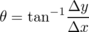
= 38° .

Example 49: Finding the components from the magnitude and angle
◊ Given that the straight-line distance from Los Angeles to Las Vegas is 370 \zu{km}, and that the angle θ in the figure is 38°, how can the x and y components of the Δr vector be found?
◊ The sine and cosine of θ relate the given information to the information we wish to find:
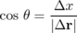
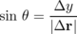
Solving for the unknowns gives
Δ x = |Δr| cos θ
= 290 km
Δ y = |Δr| sin θ
= 230 km
The following example shows the correct handling of the plus and minus signs, which is usually the main cause of mistakes by students.

Example 50: Negative components
◊ San Diego is 120 km east and 150 km south of Los Angeles. An airplane pilot is setting course from San Diego to Los Angeles. At what angle should she set her course, measured counterclockwise from east, as shown in the figure?
◊ If we make the traditional choice of coordinate axes, with x pointing to the right and y pointing up on the map, then her Δ x is negative, because her final x value is less than her initial x value. Her Δ y is positive, so we have
Δ x = -120 km
Δ y = 150 km .
If we work by analogy with the example 49, we get
= -51° .
According to the usual way of defining angles in trigonometry, a negative result means an angle that lies clockwise from the x axis, which would have her heading for the Baja California. What went wrong? The answer is that when you ask your calculator to take the arctangent of a number, there are always two valid possibilities differing by 180°. That is, there are two possible angles whose tangents equal -1.25:
tan 129° = - 1.25
You calculator doesn't know which is the correct one, so it just picks one. In this case, the one it picked was the wrong one, and it was up to you to add 180° to it to find the right answer.

Addition of vectors given their components
The easiest type of vector addition is when you are in possession of the components, and want to find the components of their sum.

Example 51: San Diego to Las Vegas
◊ Given the Δ x and Δ y values from the previous examples, find the Δ x and Δ y from San Diego to Las Vegas.
◊
Δ x_{total} = Δ x₁ + Δ x₂
= -120 km + 290 km
= 170 km
Δ y_{total} = Δ y₁ + Δ y₂
= 150 km + 230 km
= 380

Addition of vectors given their magnitudes and directions
In this case, you must first translate the magnitudes and directions into components, and the add the components.

Graphical addition of vectors
Often the easiest way to add vectors is by making a scale drawing on a piece of paper. This is known as graphical addition, as opposed to the analytic techniques discussed previously.

Example 52: From San Diego to Las Vegas, graphically
◊ Given the magnitudes and angles of the Δr vectors from San Diego to Los Angeles and from Los Angeles to Las Vegas, find the magnitude and angle of the Δr vector from San Diego to Las Vegas.
◊ Using a protractor and a ruler, we make a careful scale drawing, as shown in the figure. A scale of 1 cm≤ftrightarrow10 \zu{km} was chosen for this solution. With a ruler, we measure the distance from San Diego to Las Vegas to be 3.8 cm, which corresponds to 380 \zu{km}. With a protractor, we measure the angle θ to be 71°.
Even when we don't intend to do an actual graphical calculation with a ruler and protractor, it can be convenient to diagram the addition of vectors in this way. With Δr vectors, it intuitively makes sense to lay the vectors tip-to-tail and draw the sum vector from the tail of the first vector to the tip of the second vector. We can do the same when adding other vectors such as force vectors.

Unit vector notation
When we want to specify a vector by its components, it can be cumbersome to have to write the algebra symbol for each component:
Δ x = 290 km, Δ y = 230 km
A more compact notation is to write
where the vectors , , and , called the unit vectors, are defined as the vectors that have magnitude equal to 1 and directions lying along the x, y, and z axes. In speech, they are referred to as “x-hat,” “y-hat,” and “z-hat.”
A slightly different, and harder to remember, version of this notation is unfortunately more prevalent. In this version, the unit vectors are called , , and :

Applications to relative motion, momentum, and force
Vector addition is the correct way to generalize the one-dimensional concept of adding velocities in relative motion, as shown in the following example:

Example 53: Velocity vectors in relative motion
◊ You wish to cross a river and arrive at a dock that is directly across from you, but the river's current will tend to carry you downstream. To compensate, you must steer the boat at an angle. Find the angle θ, given the magnitude, |v_{WL}|, of the water's velocity relative to the land, and the maximum speed, |v_{BW}|, of which the boat is capable relative to the water.
◊ The boat's velocity relative to the land equals the vector sum of its velocity with respect to the water and the water's velocity with respect to the land,
v_{BL} = v_{BW}+ v_{W}L .
If the boat is to travel straight across the river, i.e., along the y axis, then we need to have v_{BL,x}=0. This x component equals the sum of the x components of the other two vectors,
v_{B}L,x = v_{B}W,x + v_{W}L,x ,
or
0 = -|v_{BW}| sin θ + |v_{WL}| .
Solving for θ, we find
sin θ = |v_{WL}|/|v_{BW}| ,
so
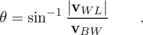

Example 54: How to generalize one-dimensional equations
◊ How can the one-dimensional relationships
p_{total} = m_{total} v_{cm}
be generalized to three dimensions?
◊ Momentum and velocity are vectors, since they have directions in space. Mass is a scalar. If we rewrite the first equation to show the appropriate quantities notated as vectors,
p_{total} = m_{total} v_{cm} ,
we get a valid mathematical operation, the multiplication of a vector by a scalar. Similarly, the second equation becomes
,
which is also valid. Each term in the sum on top contains a vector multiplied by a scalar, which gives a vector. Adding up all these vectors gives a vector, and dividing by the scalar sum on the bottom gives another vector.
This kind of wave-the-magic-wand-and-write-it-all-in-bold-face technique will always give the right generalization from one dimension to three, provided that the result makes sense mathematically --- if you find yourself doing something nonsensical, such as adding a scalar to a vector, then you haven't found the generalization correctly.
Force is a vector, and we add force vectors when more than one force acts on the same object.

Example 55: Pushing a block up a ramp
◊ Figure q/1 shows a block being pushed up a frictionless ramp at constant speed by an applied force F_{a}. How much force is required, in terms of the block's mass, m, and the angle of the ramp, θ?
◊ We analyzed this simple machine in example 30 on page 124 using the concept of work. Here we'll do it using vector addition of forces. Figure q/2 shows the other two forces acting on the block: a normal force, F_{n}, created by the ramp, and the gravitational force, F_{g}. Because the block is being pushed up at constant speed, it has zero acceleration, and the total force on it must be zero. In figure q/3, we position all the force vectors tip-to-tail for addition. Since they have to add up to zero, they must join up without leaving a gap, so they form a triangle. Using trigonometry we find
F_{a} = F_{g} sin θ
= mg sin θ .

Example 56: Buoyancy, again
In example 10 on page 46, we found that the energy required to raise a cube immersed in a fluid is as if the cube's mass had been reduced by an amount equal to the mass of the fluid that otherwise would have been in the volume it occupies (Archimedes' principle). From the energy perspective, this effect occurs because raising the cube allows a certain amount of fluid to move downward, and the decreased gravitational energy of the fluid tends to offset the increased gravitational energy of the cube. The proof given there, however, could not easily be extended to other shapes.
Thinking in terms of force rather than energy, it becomes easier to give a proof that works for any shape. A certain upward force is needed to support the object in figure r. If this force was applied, then the object would be in equilibrium: the vector sum of all the forces acting on it would be zero. These forces are F_{a}, the upward force just mentioned, F_{g}, the downward force of gravity, and F_{f}, the total force from the fluid:
F_{a}+F_{g}+F_{f} = 0
Since the fluid is under more pressure at a greater depth, the part of the fluid underneath the object tends to make more force than the part above, so the fluid tends to help support the object.
Now suppose the object was removed, and instantly replaced with an equal volume of fluid. The new fluid would be in equilibrium without any force applied to hold it up, so
F_{gf}+F_{f} = 0 ,
where F_{gf}, the weight of the fluid, is not the same as F_{g}, the weight of the object, but F_{f} is the same as before, since the pressure of the surrounding fluid is the same as before at any particular depth. We therefore have
which is Archimedes' principle in terms of force: the force required to support the object is lessened by an amount equal to the weight of the fluid that would have occupied its volume.
By the way, the word “pressure” that I threw around casually in the preceding example has a precise technical definition: force per unit area. The SI units of pressure are N/m², which can be abbreviated as pascals, 1 Pa = 1 N/m². Atmospheric pressure is about 100 kPa. By applying the equation F_{g}+F_{f} = 0 to the top and bottom surfaces of a cubical volume of fluid, one can easily prove that the difference in pressure between two different depths is Δ P=ρ gΔ y. (In physics, “fluid” can refer to either a gas or a liquid.)
Pressure is discussed in more detail in chapter 5.

Example 57: A solar sail
A solar sail, figure s/1, allows a spacecraft to get its thrust without using internal stores of energy or having to carry along mass that it can shove out the back like a rocket. Sunlight strikes the sail and bounces off, transferring momentum to the sail. A working 30-meter-diameter solar sail, Cosmos 1, was built by an American company, and was supposed to be launched into orbit aboard a Russian booster launched from a submarine, but launch attempts in 2001 and 2005 both failed.
In this example, we will calculate the optimal orientation of the sail, assuming that “optimal” means changing the vehicle's energy as rapidly as possible. For simplicity, we model the complicated shape of the sail's surface as a disk, seen edge-on in figure s/2, and we assume that the craft is in a nearly circular orbit around the sun, hence the 90-degree angle between the direction of motion and the incoming sunlight. We assume that the sail is 100% reflective. The orientation of the sail is specified using the angle θ between the incoming rays of sunlight and the perpendicular to the sail. In other words, if the sail is catching the sunlight full-on, while means that the sail is edge-on to the sun.
Conservation of momentum gives
p_{light,i} = p_{light,f}+Δp_{sail} ,
where Δp_{sail} is the change in momentum picked up by the sail. Breaking this down into components, we have
0 = p_{light,f,x}+Δ p_{sail,x} and
p_{light,i,y} = p_{light,f,y}+Δ p_{sail,y} .
As in example 44 on page 145, the component of the force that is directly away from the sun (up in figure s/2) doesn't change the energy of the craft, so we only care about Δ p_{sail,x}, which equals - p_{light,f,x}. The outgoing light ray forms an angle of 2θ with the negative y axis, or 270°-2θ measured counterclockwise from the x axis, so the useful thrust depends on -cos(270°-2θ).
However, this is all assuming a given amount of light strikes the sail. During a certain time period, the amount of sunlight striking the sail depends on the cross-sectional area the sail presents to the sun, which is proportional to cos θ. For , cos θ equals zero, since the sail is edge-on to the sun.
Putting together these two factors, the useful thrust is proportional to sin 2θ cos θ, and this quantity is maximized for θ≈35°. A counterintuitive fact about this maneuver is that as the spacecraft spirals outward, its total energy (kinetic plus gravitational) increases, but its kinetic energy actually decreases!

Discussion Questions
◊ An object goes from one point in space to another. After it arrives at its destination, how does the magnitude of its vector compare with the distance it traveled?
◊ In several examples, I've dealt with vectors having negative components. Does it make sense as well to talk about negative and positive vectors?
◊ If you're doing graphical addition of vectors, does it matter which vector you start with and which vector you start from the other vector's tip?
◊ If you add a vector with magnitude 1 to a vector of magnitude 2, what magnitudes are possible for the vector sum?
◊ Which of these examples of vector addition are correct, and which are incorrect?
◊ Is it possible for an airplane to maintain a constant velocity vector but not a constant ? How about the opposite -- a constant but not a constant velocity vector? Explain.
◊ New York and Rome are at about the same latitude, so the earth's rotation carries them both around nearly the same circle. Do the two cities have the same velocity vector (relative to the center of the earth)? If not, is there any way for two cities to have the same velocity vector?
◊ The figure shows a roller coaster car rolling down and then up under the influence of gravity. Sketch the car's velocity vectors and acceleration vectors. Pick an interesting point in the motion and sketch a set of force vectors acting on the car whose vector sum could have resulted in the right acceleration vector.
◊ The following is a question commonly asked by students:
“Why does the force vector always have to point in the same direction as the acceleration vector? What if you suddenly decide to change your force on an object, so that your force is no longer pointing in the same direction that the object is accelerating?”
What misunderstanding is demonstrated by this question? Suppose, for example, a spacecraft is blasting its rear main engines while moving forward, then suddenly begins firing its sideways maneuvering rocket as well. What does the student think Newton's laws are predicting?
◊ Debug the following incorrect solutions to this vector addition problem.
Problem: Freddi Fish^{T}EXTu0002TM swims 5.0 km northeast, and then 12.0 km in the direction 55 degrees west of south. How far does she end up from her starting point, and in what direction is she from her starting point?
Incorrect solution #1:
5.0 km+12.0 km=17.0 km
Incorrect solution #2:
=13.0 km
Incorrect solution #3:
Let \zb{A} and \zb{B} be her two vectors, and let . Then
A_{x} = (5.0 km) cos 45° = 3.5 km
B_{x} = (12.0 km) cos 55° = 6.9 km
A_{y} = (5.0 km) sin 45° = 3.5 km
B_{y} = (12.0 km) sin 55° = 9.8 km
C_{x} = A_{x}+B_{x}
= 10.4 km
C_{y} = A_{y}+B_{y}
= 13.3 km
= 16.9 km
direction = tan⁻¹ (13.3/10.4)
Incorrect solution #4:
(same notation as above)
A_{x} = (5.0 km) cos 45° = 3.5 km
B_{x} = -(12.0 km) cos 55° = -6.9 km
A_{y} = (5.0 km) sin 45° = 3.5 km
B_{y} = -(12.0 km) sin 55° = -9.8 km
C_{x} = A_{x}+B_{x}
= -3.4 km
C_{y} = A_{y}+B_{y}
= -6.3 km
= 7.2 km
direction = tan⁻¹ (-6.3/-3.4)
(continued)
Incorrect solution #5:
(same notation as above)
A_{x} = (5.0 km) cos 45° = 3.5 km
B_{x} = -(12.0 km) sin 55° = -9.8 km
A_{y} = (5.0 km) sin 45° = 3.5 km
B_{y} = -(12.0 km) cos 55° = -6.9 km
C_{x} = A_{x}+B_{x}
= -6.3 km
C_{y} = A_{y}+B_{y}
= -3.4 km
= 7.2 km
direction = tan⁻¹ (-3.4/-6.3)
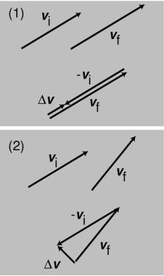
w / Visualizing the acceleration vector.
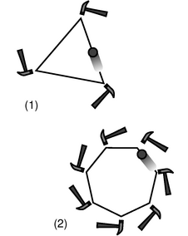
x / The heptagon, 2, is a better approximation to a circle than the triangle, 1. To make an infinitely good approximation to circular motion, we would need to use an infinitely large number of infinitesimal taps, which would amount to a steady inward force.
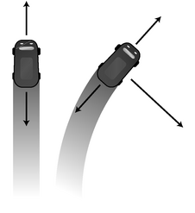
y / The total force in the forward-backward direction is zero in both cases.
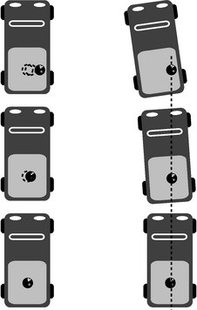
z / There is no outward force on the bowling ball, but in the noninertial frame it seems like one exists.
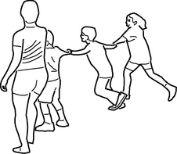
aa / Discussion question A.
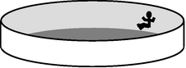
ab / Discussion question E.

Calculus with vectors

Differentiation
In one dimension, we define the velocity as the derivative of the position with respect to time, and we can think of the derivative as what we get when we calculate Δ x/Δ t for very short time intervals. The quantity Δ x=x_{f}-x_{i} is calculated by subtraction. In three dimensions, x becomes r, and the Δr vector is calculated by vector subtraction, Δr=r_{f}-r_{i}. Vector subtraction is defined component by component, so when we take the derivative of a vector, this means we end up taking the derivative component by component,
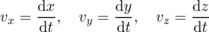
or
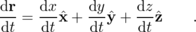
All of this reasoning applies equally well to any derivative of a vector, so for instance we can take the second derivative,
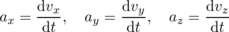
or
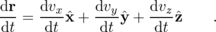
A counterintuitive consequence of this is that the acceleration vector does not need to be in the same direction as the motion. The velocity vector points in the direction of motion, but by Newton's second law, a=F/m, the acceleration vector points in the same direction as the force, not the motion. This is easiest to understand if we take velocity vectors from two different moments in the motion, and visualize subtracting them graphically to make a Δv vector. The direction of the Δv vector tells us the direction of the acceleration vector as well, since the derivative dv/d t can be approximated as Δv/Δ t. As shown in figure w/1, a change in the magnitude of the velocity vector implies an acceleration that is in the direction of motion. A change in the direction of the velocity vector produces an acceleration perpendicular to the motion, w/2.

Example 58: Circular motion
◊ An object moving in a circle of radius r in the x-y plane has
x = r cos ω t and
y = r sin ω t ,
where ω is the number of radians traveled per second, and the positive or negative sign indicates whether the motion is clockwise or counterclockwise. What is its acceleration?
◊ The components of the velocity are
v_{x} = -ω r sin ω t and
v_{y} = ω r cos ω t ,
and for the acceleration we have
a_{x} = -ω² r cos ω t and
a_{y} = -ω² r sin ω t .
The acceleration vector has cosines and sines in the same places as the r vector, but with minus signs in front, so it points in the opposite direction, i.e. toward the center of the circle. By Newton's second law, a=F/m, this shows that the force must be inward as well; without this force, the object would fly off straight.
The magnitude of the acceleration is
= ω² r .
It makes sense that ω is squared, since reversing the sign of ω corresponds to reversing the direction of motion, but the acceleration is toward the center of the circle, regardless of whether the motion is clockwise or counterclockwise. This result can also be rewritten in the form
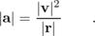
The results of example 59 are important and useful, but counterintuitive as well. Until Newton, physicists and laypeople alike had assumed that the planets would need a force to push them forward in their orbits. Figure x may help to make it more plausible that only an inward force is required. A forward force might be needed in order to cancel out a backward force such as friction, y, but the total force in the forward-backward direction needs to be exactly zero for constant-speed motion.
When you are in a car undergoing circular motion, there is also a strong illusion of an outward force. But what object could be making such a force? The car's seat makes an inward force on you, not an outward one. There is no object that could be exerting an outward force on your body. In reality, this force is an illusion that comes from our brain's intuitive efforts to interpret the situation within a noninertial frame of reference. As shown in figure z, we can describe everything perfectly well in an inertial frame of reference, such as the frame attached to the sidewalk. In such a frame, the bowling ball goes straight because there is no force on it. The wall of the truck's bed hits the ball, not the other way around.

Integration
An integral is really just a sum of many infinitesimally small terms. Since vector addition is defined in terms of addition of the components, an integral of a vector quantity is found by doing integrals component by component.

Example 59: Projectile motion
◊ Find the motion of an object whose acceleration vector is constant, for instance a projectile moving under the influence of gravity.
◊ We integrate the acceleration to get the velocity, and then integrate the velocity to get the position as a function of time. Doing this to the x component of the acceleration, we find
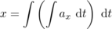
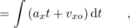
+ v_{xo}t + x_{o} .
Similarly, and . Once one has gained a little confidence, it becomes natural to do the whole thing as a single vector integral,
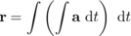
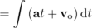
where now the constants of integration are vectors.

Discussion Questions
◊ In the game of crack the whip, a line of people stand holding hands, and then they start sweeping out a circle. One person is at the center, and rotates without changing location. At the opposite end is the person who is running the fastest, in a wide circle. In this game, someone always ends up losing their grip and flying off. Suppose the person on the end loses her grip. What path does she follow as she goes flying off? (Assume she is going so fast that she is really just trying to put one foot in front of the other fast enough to keep from falling; she is not able to get any significant horizontal force between her feet and the ground.)
◊ Suppose the person on the outside is still holding on, but feels that she may loose her grip at any moment. What force or forces are acting on her, and in what directions are they? (We are not interested in the vertical forces, which are the earth's gravitational force pulling down, and the ground's normal force pushing up.)
◊ Suppose the person on the outside is still holding on, but feels that she may loose her grip at any moment. What is wrong with the following analysis of the situation? “The person whose hand she's holding exerts an inward force on her, and because of Newton's third law, there's an equal and opposite force acting outward. That outward force is the one she feels throwing her outward, and the outward force is what might make her go flying off, if it's strong enough.”
◊ If the only force felt by the person on the outside is an inward force, why doesn't she go straight in?
◊ In the amusement park ride shown in the figure, the cylinder spins faster and faster until the customer can pick her feet up off the floor without falling. In the old Coney Island version of the ride, the floor actually dropped out like a trap door, showing the ocean below. (There is also a version in which the whole thing tilts up diagonally, but we're discussing the version that stays flat.) If there is no outward force acting on her, why does she stick to the wall? Analyze all the forces on her.
◊ What is an example of circular motion where the inward force is a normal force? What is an example of circular motion where the inward force is friction? What is an example of circular motion where the inward force is the sum of more than one force?
◊ Does the acceleration vector always change continuously in circular motion? The velocity vector?
◊ A certain amount of force is needed to provide the acceleration of circular motion. What if were are exerting a force perpendicular to the direction of motion in an attempt to make an object trace a circle of radius r, but the force isn't as big as ?
◊ Suppose a rotating space station is built that gives its occupants the illusion of ordinary gravity. What happens when a person in the station lets go of a ball? What happens when she throws a ball straight “up” in the air (i.e. towards the center)?
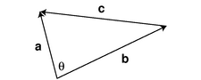
ac / The geometric interpretation of the dot product.
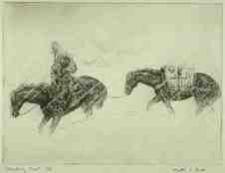
ad / Breaking trail, by Walter E. Bohl. The pack horse is not doing any work on the pack, because the pack is moving in a horizontal line at constant speed, and therefore there is no kinetic or gravitational energy being transferred into or out of it.

The dot product
How would we generalize the mechanical work equation d E=F d x to three dimensions? Energy is a scalar, but force and distance are vectors, so it might seem at first that the kind of “magic-wand” generalization discussed on page 157 failed here, since we don't know of any way to multiply two vectors together to get a scalar. Actually, this is Nature giving us a hint that there is such a multiplication operation waiting for us to invent it, and since Nature is simple, we can be assured that this operation will work just fine in any situation where a similar generalization is required.
How should this operation be defined? Let's consider what we would get by performing this operation on various combinations of the unit vectors , , and . The conventional notation for the operation is to put a dot, ⋅, between the two vectors, and the operation is therefore called the dot product. Rotational invariance requires that we handle the three coordinate axes in the same way, without giving special treatment to any of them, so we must have and . This is supposed to be a way of generalizing ordinary multiplication, so for consistency with the property 1×1=1 of ordinary numbers, the result of multiplying a magnitude-one vector by itself had better be the scalar 1, so . Furthermore, there is no way to satisfy rotational invariance unless we define the mixed products to be zero, ; for example, a 90-degree rotation of our frame of reference about the z axis reverses the sign of , but rotational invariance requires that produce the same result either way, and zero is the only number that stays the same when we reverse its sign. Establishing these six products of unit vectors suffices to define the operation in general, since any two vectors that we want to multiply can be broken down into components, e.g. . Thus by requiring rotational invariance and consistency with multiplication of ordinary numbers, we find that there is only one possible way to define a multiplication operation on two vectors that gives a scalar as the result.¹⁶ The dot product has all of the properties we normally associate with multiplication, except that there is no “dot division.”

Example 60: Dot product in terms of components
If we know the components of any two vectors b and c, we can find their dot product:
= b_{x} c_{x}+ b_{y} c_{y}+ b_{z} c_{z} .

Example 61: Magnitude expressed with a dot product
If we take the dot product of any vector b with itself, we find
= b_{x}²+ b_{y}²+ b_{z}² ,
so its magnitude can be expressed as
We will often write b² to mean b⋅b, when the context makes it clear what is intended. For example, we could express kinetic energy as , , or . In the third version, nothing but context tells us that v really stands for the magnitude of some vector v.

Example 62: Geometric interpretation
In figure ac, vectors a, b, and c represent the sides of a triangle, and a=b+c. The law of cosines gives
|c|² = |a|²+|b|²-2|a||b| cos θ .
Using the result of example 62, we can also write this as
|c|² = c⋅c
= (a-b)⋅(a-b)
= a⋅a+b⋅b-2a⋅b .
Matching up terms in these two expressions, we find
a⋅b = |a||b| cos θ ,
which is a geometric interpretation for the dot product.
The result of the preceding example is very useful. It gives us a way to find the angle between two vectors if we know their components. It can be used to show that the dot product of any two perpendicular vectors is zero. It also leads to a nifty proof that the dot product is rotationally invariant --- up until now I've only proved that if a rotationally invariant product exists, the dot product is it --- because angles and lengths aren't affected by a rotation, so the right side of the equation is rotationally invariant, and therefore so is the left side.
I introduced the whole discussion of the dot product by way of generalizing the equation d E=Fd x to three dimensions. In terms of a dot product, we have
d E = F⋅dr .
If F is a constant, integrating both sides gives
Δ E = F⋅Δr .
(If that step seemed like black magic, try writing it out in terms of components.) If the force is perpendicular to the motion, as in figure ad, then the work done is zero. The pack horse is doing work within its own body, but is not doing work on the pack.

Example 63: Pushing a lawnmower
◊ I push a lawnmower with a force , and the total distance I travel is . How much work do I do?
◊ The dot product is 11000 N⋅m = 11000 J.
A good application of the dot product is to allow us to write a simple, streamlined proof of separate conservation of the momentum components. (You can skip the proof without losing the continuity of the text.) The argument is a generalization of the one-dimensional proof on page 93, and makes the same assumption about the type of system of particles we're dealing with. The kinetic energy of one of the particles is (1/2)mv⋅v, and when we transform into a different frame of reference moving with velocity u relative to the original frame, the one-dimensional rule v→ v+u turns into vector addition, v→ v+u. In the new frame of reference, the kinetic energy is (1/2)m(v+u)⋅(v+u). For a system of n particles, we have
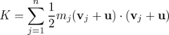
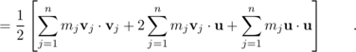
As in the proof on page 93, the first sum is simply the total kinetic energy in the original frame of reference, and the last sum is a constant, which has no effect on the validity of the conservation law. The middle sum can be rewritten as
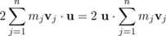
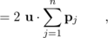
so the only way energy can be conserved for all values of u is if the vector sum of the momenta is conserved as well.
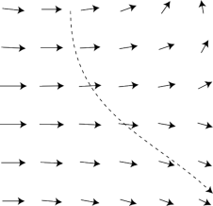
ae / An object moves through a field of force.

Gradients and line integrals (optional)
This subsection introduces a little bit of vector calculus. It can be omitted without loss of continuity, but the techniques will be needed in our study of electricity and magnetism, and it may be helpful to be exposed to them in easy-to-visualize mechanical contexts before applying them to invisible electrical and magnetic phenomena.
In physics we often deal with fields of force, meaning situations where the force on an object depends on its position. For instance, figure ae could represent a map of the trade winds affecting a sailing ship, or a chart of the gravitational forces experienced by a space probe entering a double-star system. An object moving under the influence of this force will not necessarily be moving in the same direction as the force at every moment. The sailing ship can tack against the wind, due to the force from the water on the keel. The space probe, if it entered from the top of the diagram at high speed, would start to curve around to the right, but its inertia would carry it forward, and it wouldn't instantly swerve to match the direction of the gravitational force. For convenience, we've defined the gravitational field, g, as the force per unit mass, but that trick only leads to a simplification because the gravitational force on an object is proportional to its mass. Since this subsection is meant to apply to any kind of force, we'll discuss everything in terms of the actual force vector, F, in units of newtons.
If an object moves through the field of force along some curved path from point r₁ to point r₂, the force will do a certain amount of work on it. To calculate this work, we can break the path up into infinitesimally short segments, find the work done along each segment, and add them all up. For an object traveling along a nice straight x axis, we use the symbol d x to indicate the length of any infinitesimally short segment. In three dimensions, moving along a curve, each segment is a tiny vector . The work theorem can be expressed as a dot product, so the work done along a segment is F⋅dr. We want to integrate this, but we don't know how to integrate with respect to a variable that's a vector, so let's define a variable s that indicates the distance traveled so far along the curve, and integrate with respect to it instead. The expression F⋅dr can be rewritten as |F| |dr| cosθ, where θ is the angle between F and dr. But |dr| is simply d s, so the amount of work done becomes
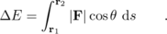
Both F and θ are functions of s. As a matter of notation, it's cumbersome to have to write the integral like this. Vector notation was designed to eliminate this kind of drudgery. We therefore define the line integral
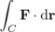
as a way of notating this type of integral. The `C' refers to the curve along which the object travels. If we don't know this curve then we typically can't evaluate the line integral just by knowing the initial and final positions r₁ and r₂.
The basic idea of calculus is that integration undoes differentiation, and vice-versa. In one dimension, we could describe an interaction either in terms of a force or in terms of an interaction energy. We could integrate force with respect to position to find minus the energy, or we could find the force by taking minus the derivative of the energy. In the line integral, position is represented by a vector. What would it mean to take a derivative with respect to a vector? The correct way to generalize the derivative d U/d x to three dimensions is to replace it with the following vector,
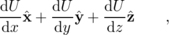
called the gradient of U, and written with an upside-down delta¹⁷ like this, ∇ U. Each of these three derivatives is really what's known as a partial derivative. What that means is that when you're differentiating U with respect to x, you're supposed to treat y and z and constants, and similarly when you do the other two derivatives. To emphasize that a derivative is a partial derivative, it's customary to write it using the symbol ∂ in place of the differential d's. Putting all this notation together, we have
The gradient looks scary, but it has a very simple physical interpretation. It's a vector that points in the direction in which U is increasing most rapidly, and it tells you how rapidly U is increasing in that direction. For instance, sperm cells in plants and animals find the egg cells by traveling in the direction of the gradient of the concentration of certain hormones. When they reach the location of the strongest hormone concentration, they find their destiny. In terms of the gradient, the force corresponding to a given interaction energy is F=-∇ U.

Example 64: Force exerted by a spring
In one dimension, Hooke's law is . Suppose we tether one end of a spring to a post, but it's free to stretch and swing around in a plane. Let's say its equilibrium length is zero, and let's choose the origin of our coordinate system to be at the post. Rotational invariance requires that its energy only depend on the magnitude of the r vector, not its direction, so in two dimensions we have . The force exerted by the spring is then
F = -∇ U
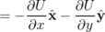
The magnitude of this force vector is k|r|, and its direction is toward the origin.
\backofchapterboilerplate{3}

Homework Problems
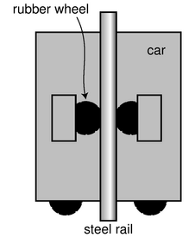
a / Problem 14.
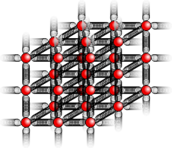
b / Problem 18
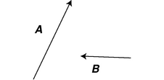
d / Problem 30.
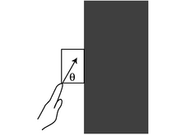
f / Problem 36
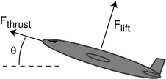
g / Problem 40
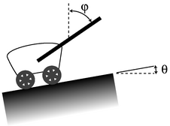
h / Problem 41
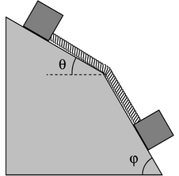
i / Problem 47.
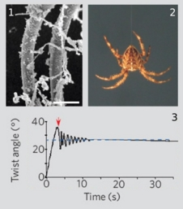
j / Problem 48.
1. [0] Derive a formula expressing the kinetic energy of an object in terms of its momentum and mass.(answer check available at lightandmatter.com)
2. Two people in a rowboat wish to move around without causing the boat to move. What should be true about their total momentum? Explain.
3. A bullet leaves the barrel of a gun with a kinetic energy of 90 J. The gun barrel is 50 cm long. The gun has a mass of 4 kg, the bullet 10 g.
(a) Find the bullet's final velocity. (answer check available at lightandmatter.com)
(b) Find the bullet's final momentum. (answer check available at lightandmatter.com)
(c) Find the momentum of the recoiling gun.
(d) Find the kinetic energy of the recoiling gun, and explain why the recoiling gun does not kill the shooter. (answer check available at lightandmatter.com)
4. A ball of mass 2m collides head-on with an initially stationary ball of mass m. No kinetic energy is transformed into heat or sound. In what direction is the mass-2m ball moving after the collision, and how fast is it going compared to its original velocity? \hwans{hwans:twotoonecollision}
5. An object is observed to be moving at constant speed along a line. Can you conclude that no forces are acting on it? Explain. [Based on a problem by Serway and Faughn.]
6. [0] A car is normally capable of an acceleration of 3 m/s². If it is towing a trailer with half as much mass as the car itself, what acceleration can it achieve? [Based on a problem from PSSC Physics.]
7. (a) Let T be the maximum tension that the elevator's cable can withstand without breaking, i.e. the maximum force it can exert. If the motor is programmed to give the car an acceleration a, what is the maximum mass that the car can have, including passengers, if the cable is not to break?
(b) Interpret the equation you derived in the special cases of a=0 and of a downward acceleration of magnitude g.
8. A helicopter of mass m is taking off vertically. The only forces acting on it are the earth's gravitational force and the force, F_{air}, of the air pushing up on the propeller blades.
(a) If the helicopter lifts off at t=0, what is its vertical speed at time t?
(b) Plug numbers into your equation from part a, using m=2300 kg, F_{air}=27000 N, and t=4.0 s. (answer check available at lightandmatter.com)
9. A blimp is initially at rest, hovering, when at t=0 the pilot turns on the motor of the propeller. The motor cannot instantly get the propeller going, but the propeller speeds up steadily. The steadily increasing force between the air and the propeller is given by the equation F=kt, where k is a constant. If the mass of the blimp is m, find its position as a function of time. (Assume that during the period of time you're dealing with, the blimp is not yet moving fast enough to cause a significant backward force due to air resistance.)
10. A car is accelerating forward along a straight road. If the force of the road on the car's wheels, pushing it forward, is a constant 3.0 kN, and the car's mass is 1000 kg, then how long will the car take to go from 20 m/s to 50 m/s? (answer check available at lightandmatter.com)
11. [0] If a big truck and a VW bug collide head-on, which will be acted on by the greater force? Which will have the greater acceleration?
12. The earth is attracted to an object with a force equal and opposite to the force of the earth on the object. If this is true, why is it that when you drop an object, the earth does not have an acceleration equal and opposite to that of the object?
13. When you stand still, there are two forces acting on you, the force of gravity (your weight) and the normal force of the floor pushing up on your feet. Are these forces equal and opposite? Does Newton's third law relate them to each other? Explain.
14. Today's tallest buildings are really not that much taller than the tallest buildings of the 1940s. The main problem with making an even taller skyscraper is that every elevator needs its own shaft running the whole height of the building. So many elevators are needed to serve the building's thousands of occupants that the elevator shafts start taking up too much of the space within the building. An alternative is to have elevators that can move both horizontally and vertically: with such a design, many elevator cars can share a few shafts, and they don't get in each other's way too much because they can detour around each other. In this design, it becomes impossible to hang the cars from cables, so they would instead have to ride on rails which they grab onto with wheels. Friction would keep them from slipping. The figure shows such a frictional elevator in its vertical travel mode. (The wheels on the bottom are for when it needs to switch to horizontal motion.)
(a) If the coefficient of static friction between rubber and steel is μ_{s}, and the maximum mass of the car plus its passengers is M, how much force must there be pressing each wheel against the rail in order to keep the car from slipping? (Assume the car is not accelerating.)
(b) Show that your result has physically reasonable behavior with respect to μ_{s}. In other words, if there was less friction, would the wheels need to be pressed more firmly or less firmly? Does your equation behave that way?
15. A tugboat of mass m pulls a ship of mass M, accelerating it. Ignore fluid friction acting on their hulls, although there will of course need to be fluid friction acting on the tug's propellers.
(a) If the force acting on the tug's propeller is F, what is the tension, T, in the cable connecting the two ships? \hwhint{hwhint:tugboat}
(b) Interpret your answer in the special cases of M=0 and M=∞.
16. Explain why it wouldn't make sense to have kinetic friction be stronger than static friction.
17. (a) Using the solution of problem 37 on page 89, predict how the spring constant of a fiber will depend on its length and cross-sectional area.
(b) The constant of proportionality is called the Young's modulus, E, and typical values of the Young's modulus are about 10¹⁰ to 10¹¹. What units would the Young's modulus have in the SI system? (solution in the pdf version of the book){hwsoln:youngmodulus}
18. This problem depends on the results of problems problem 37 on page 89 and problem 17 from this chapter. When atoms form chemical bonds, it makes sense to talk about the spring constant of the bond as a measure of how “stiff” it is. Of course, there aren't really little springs --- this is just a mechanical model. The purpose of this problem is to estimate the spring constant, k, for a single bond in a typical piece of solid matter. Suppose we have a fiber, like a hair or a piece of fishing line, and imagine for simplicity that it is made of atoms of a single element stacked in a cubical manner, as shown in the figure, with a center-to-center spacing b. A typical value for b would be about 10⁻¹⁰ m.
(a) Find an equation for k in terms of b, and in terms of the Young's modulus, E, defined in problem 17 and its solution.
(b) Estimate k using the numerical data given in problem 17.
(c) Suppose you could grab one of the atoms in a diatomic molecule like H₂ or O₂, and let the other atom hang vertically below it. Does the bond stretch by any appreciable fraction due to gravity?
19. [0]{swimbladder} Many fish have an organ known as a swim bladder, an air-filled cavity whose main purpose is to control the fish's buoyancy and allow it to keep from rising or sinking without having to use its muscles. In some fish, however, the swim bladder (or a small extension of it) is linked to the ear and serves the additional purpose of amplifying sound waves. For a typical fish having such an anatomy, the bladder has a resonant frequency of 300 Hz, the bladder's Q is 3, and the maximum amplification is about a factor of 100 in energy. Over what range of frequencies would the amplification be at least a factor of 50?
20. An oscillator with sufficiently strong damping has its maximum response at ω=0. Using the result derived on page 741, find the value of Q at which this behavior sets in. \hwhint{hwhint:maxampatdc}\hwans{hwans:maxampatdc}
21. An oscillator has Q=6.00, and, for convenience, let's assume F_{m}=1.00, ω_{o}=1.00, and m=1.00. The usual approximations would give
ω_{res} =ω_{o} ,
A_{res}=6.00 , and
Δω=1/6.00 .
Determine these three quantities numerically using the result derived on page 741, and compare with the approximations.
22. [2]{braginskii} The apparatus in figure d on page 20 had a natural period of oscillation of 5 hours and 20 minutes. The authors estimated, based on calculations of internal friction in the tungsten wire, that its Q was on the order of 10⁶, but they were unable to measure it empirically because it would have taken years for the amplitude to die down by any measurable amount. Although each aluminum or platinum mass was really moving along an arc of a circle, any actual oscillations caused by a violation of the equivalence of gravitational and inertial mass would have been measured in millions of a degree, so it's a good approximation to say that each mass's motion was along a (very short!) straight line segment. We can also treat each mass as if it was oscillating separately from the others. If the principle of equivalence had been violated at the 10⁻¹² level, the limit of their experiment's sensitivity, the sun's gravitational force on one of the 0.4-gram masses would have been about 3×10⁻¹⁹ N, oscillating with a period of 24 hours due to the rotation of the earth. (We ignore the inertia of the arms, whose total mass was only about 25% of the total mass of the rotating assembly.)
(a) Find the amplitude of the resulting oscillations, and determine the angle to which they would have corresponded, given that the radius of the balance arms was 10 cm.\hwans{hwans:braginskii}
(b) Show that even if their estimate of Q was wildly wrong, it wouldn't have affected this result.
23. (a) A ball is thrown straight up with velocity v. Find an equation for the height to which it rises.
(b) Generalize your equation for a ball thrown at an angle θ above horizontal.
24. At the Salinas Lettuce Festival Parade, Miss Lettuce of 1996 drops her bouquet while riding on a float. Compare the shape of its trajectory as seen by her to the shape seen by one of her admirers standing on the sidewalk.
25. Two daredevils, Wendy and Bill, go over Niagara Falls. Wendy sits in an inner tube, and lets the 30 km/hr velocity of the river throw her out horizontally over the falls. Bill paddles a kayak, adding an extra 10 km/hr to his velocity. They go over the edge of the falls at the same moment, side by side. Ignore air friction. Explain your reasoning.
(a) Who hits the bottom first?
(b) What is the horizontal component of Wendy's velocity on impact?
(c) What is the horizontal component of Bill's velocity on impact?
(d) Who is going faster on impact?
26. A baseball pitcher throws a pitch clocked at v_{x}=73.3 mi/h. He throws horizontally. By what amount, d, does the ball drop by the time it reaches home plate, L=60.0 ft away?
(a) First find a symbolic answer in terms of L, v_{x}, and g.
(b) Plug in and find a numerical answer. Express your answer in units of ft. (Note: 1 ft=12 in, 1 mi=5280 ft, and 1 in=2.54 cm) (answer check available at lightandmatter.com)
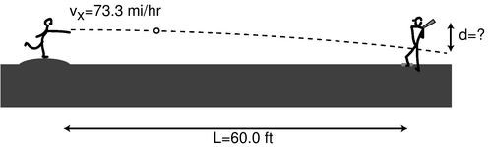
c / Problem 26.
27. A batter hits a baseball at speed v, at an angle θ above horizontal.
(a) Find an equation for the range (horizontal distance to where the ball falls), R, in terms of the relevant variables. Neglect air friction and the height of the ball above the ground when it is hit. \hwans{hwans:baseballrange}
(b) Interpret your equation in the cases of θ=0 and θ=90°.
(c) Find the angle that gives the maximum range.\hwans{hwans:baseballrange}
28. [2]{baseballrangeair} This problem uses numerical methods to extend the analysis in problem 27 to include air friction. For a game played at sea level, the force due to air friction is approximately (5×10⁻³ N⋅s²/m²)v², in the direction opposite to the motion of the ball. The mass of a baseball is 0.146 kg.
(a) For a ball hit at a speed of 45.0 m/s from a height of 1.0 m, find the optimal angle and the resulting range. \hwans{hwans:baseballrangeair}
(b) How much farther would the ball fly at the Colorado Rockies' stadium, where the thinner air gives 18 percent less air friction? \hwans{hwans:baseballrangeair}
29. If you walk 35 km at an angle 25° counterclockwise from east, and then 22 km at 230° counterclockwise from east, find the distance and direction from your starting point to your destination. (answer check available at lightandmatter.com)
30. [0]{addvecs} Here are two vectors. Graphically calculate A+B, A-B, B-A, -2B, and A-2B. No numbers are involved.
31. [0] Phnom Penh is 470 km east and 250 km south of Bangkok. Hanoi is 60 km east and 1030 km north of Phnom Penh.
(a) Choose a coordinate system, and translate these data into Δ x and Δ y values with the proper plus and minus signs.
(b) Find the components of the Δr vector pointing from Bangkok to Hanoi. (answer check available at lightandmatter.com)
32. Is it possible for a helicopter to have an acceleration due east and a velocity due west? If so, what would be going on? If not, why not?
33. A dinosaur fossil is slowly moving down the slope of a glacier under the influence of wind, rain and gravity. At the same time, the glacier is moving relative to the continent underneath. The dashed lines represent the directions but not the magnitudes of the velocities. Pick a scale, and use graphical addition of vectors to find the magnitude and the direction of the fossil's velocity relative to the continent. You will need a ruler and protractor. (answer check available at lightandmatter.com)
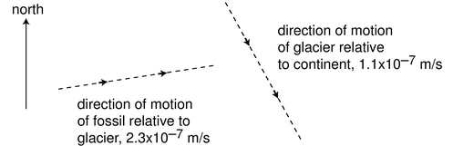
e / Problem 33.
34. A bird is initially flying horizontally east at 21.1 m/s, but one second later it has changed direction so that it is flying horizontally and 7° north of east, at the same speed. What are the magnitude and direction of its acceleration vector during that one second time interval? (Assume its acceleration was roughly constant.) (answer check available at lightandmatter.com)
35. A learjet traveling due east at 300 mi/hr collides with a jumbo jet which was heading southwest at 150 mi/hr. The jumbo jet's mass is five times greater than that of the learjet. When they collide, the learjet sticks into the fuselage of the jumbo jet, and they fall to earth together. Their engines stop functioning immediately after the collision. On a map, what will be the direction from the location of the collision to the place where the wreckage hits the ground? (Give an angle.)
36. Your hand presses a block of mass m against a wall with a force F_{h} acting at an angle θ. Find the minimum and maximum possible values of |F_{h}| that can keep the block stationary, in terms of m, g, θ, and μ_{s}, the coefficient of static friction between the block and the wall.
37. A skier of mass m is coasting down a slope inclined at an angle θ compared to horizontal. Assume for simplicity that the standard treatment of kinetic friction given in the text is appropriate here, although a soft and wet surface actually behaves a little differently. The coefficient of kinetic friction acting between the skis and the snow is μ_{k}, and in addition the skier experiences an air friction force of magnitude bv², where b is a constant. (a) Find the maximum speed that the skier will attain, in terms of the variables m, θ, μ_{k}, and b. (b) For angles below a certain minimum angle θ_{min}, the equation gives a result that is not mathematically meaningful. Find an equation for θ_{min}, and give a physical explanation of what is happening for θ<θ_{min}.
38. A gun is aimed horizontally to the west, and fired at t=0. The bullet's position vector as a function of time is , where b, c, and d are constants.
(a) What units would b, c, and d need to have for the equation to make sense?
(b) Find the bullet's velocity and acceleration as functions of time.
(c) Give physical interpretations of b, c, d, , , and .
39. Annie Oakley, riding north on horseback at 30 mi/hr, shoots her rifle, aiming horizontally and to the northeast. The muzzle speed of the rifle is 140 mi/hr. When the bullet hits a defenseless fuzzy animal, what is its speed of impact? Neglect air resistance, and ignore the vertical motion of the bullet.(solution in the pdf version of the book){hwsoln:annieoakley}
40. A cargo plane has taken off from a tiny airstrip in the Andes, and is climbing at constant speed, at an angle of θ=17° with respect to horizontal. Its engines supply a thrust of F_{thrust}=200 kN, and the lift from its wings is F_{lift}=654 kN. Assume that air resistance (drag) is negligible, so the only forces acting are thrust, lift, and weight. What is its mass, in kg? (solution in the pdf version of the book){hwsoln:annieoakley}
41. A wagon is being pulled at constant speed up a slope θ by a rope that makes an angle φ with the vertical. (a) Assuming negligible friction, show that the tension in the rope is given by the equation
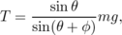
(b) Interpret this equation in the special cases of φ=0 and φ=180°-θ.(solution in the pdf version of the book){hwsoln:wagon}
42. The angle of repose is the maximum slope on which an object will not slide. On airless, geologically inert bodies like the moon or an asteroid, the only thing that determines whether dust or rubble will stay on a slope is whether the slope is less steep than the angle of repose.
(a) Find an equation for the angle of repose, deciding for yourself what are the relevant variables.
(b) On an asteroid, where g can be thousands of times lower than on Earth, would rubble be able to lie at a steeper angle of repose?(solution in the pdf version of the book){hwsoln:reposeasteroid}
43. When you're done using an electric mixer, you can get most of the batter off of the beaters by lifting them out of the batter with the motor running at a high enough speed. Let's imagine, to make things easier to visualize, that we instead have a piece of tape stuck to one of the beaters.
(a) Explain why static friction has no effect on whether or not the tape flies off.
(b) Suppose you find that the tape doesn't fly off when the motor is on a low speed, but speeding it up does cause it to fly off. Why would the greater speed change things?
44. [0] Show that the expression |v|²/r has the units of acceleration.
45. A plane is flown in a loop-the-loop of radius 1.00 km. The plane starts out flying upside-down, straight and level, then begins curving up along the circular loop, and is right-side up when it reaches the top. (The plane may slow down somewhat on the way up.) How fast must the plane be going at the top if the pilot is to experience no force from the seat or the seatbelt while at the top of the loop? (answer check available at lightandmatter.com)
46. [0]{anglebetween} Find the angle between the following two vectors:
\hwhint{hwhint:anglebetween}(answer check available at lightandmatter.com)
47. The two blocks shown in the figure have equal mass, m, and the surface is frictionless. What is the tension in the massless rope?
48. The figure is from Shape memory in Spider draglines, Emile, Le Floch, and Vollrath, Nature 440:621 (2006). Panel 1 shows an electron microscope's image of a thread of spider silk. In 2, a spider is hanging from such a thread. From an evolutionary point of view, it's probably a bad thing for the spider if it twists back and forth while hanging like this. (We're referring to a back-and-forth rotation about the axis of the thread, not a swinging motion like a pendulum.) The authors speculate that such a vibration could make the spider easier for predators to see, and it also seems to me that it would be a bad thing just because the spider wouldn't be able to control its orientation and do what it was trying to do. Panel 3 shows a graph of such an oscillation, which the authors measured using a video camera and a computer, with a 0.1 g mass hung from it in place of a spider. Compared to human-made fibers such as kevlar or copper wire, the spider thread has an unusual set of properties:
- It has a low Q, so the vibrations damp out quickly.
- It doesn't become brittle with repeated twisting as a copper wire would.
- When twisted, it tends to settle in to a new equilibrium angle, rather than insisting on returning to its original angle. You can see this in panel 2, because although the experimenters initially twisted the wire by 35 degrees, the thread only performed oscillations with an amplitude much smaller than ±35 degrees, settling down to a new equilibrium at 27 degrees.
- Over much longer time scales (hours), the thread eventually resets itself to its original equilbrium angle (shown as zero degrees on the graph). (The graph reproduced here only shows the motion over a much shorter time scale.) Some human-made materials have this “memory” property as well, but they typically need to be heated in order to make them go back to their original shapes.
Focusing on property number 1, estimate the Q of spider silk from the graph.
\begin{exsection}
\extitle{A}{Force and Motion}
Equipment:
2-meter pieces of butcher paper
wood blocks with hooks
string
masses to put on top of the blocks to increase friction
spring scales (preferably calibrated in Newtons)
Suppose a person pushes a crate, sliding it across the floor at a certain speed, and then repeats the same thing but at a higher speed. This is essentially the situation you will act out in this exercise. What do you think is different about her force on the crate in the two situations? Discuss this with your group and write down your hypothesis:
\_\_\_\_\_\_\_\_\_\_\_\_\_\_\_\_\_\_\_\_\_\_\_\_\_\_\_\_\_\_\_\_\_\_\_\_
1. First you will measure the amount of friction between the wood block and the butcher paper when the wood and paper surfaces are slipping over each other. The idea is to attach a spring scale to the block and then slide the butcher paper under the block while using the scale to keep the block from moving with it. Depending on the amount of force your spring scale was designed to measure, you may need to put an extra mass on top of the block in order to increase the amount of friction. It is a good idea to use long piece of string to attach the block to the spring scale, since otherwise one tends to pull at an angle instead of directly horizontally.
First measure the amount of friction force when sliding the butcher paper as slowly as possible:\_\_\_\_\_\_\_\_\_
Now measure the amount of friction force at a significantly higher speed, say 1 meter per second. (If you try to go too fast, the motion is jerky, and it is impossible to get an accurate reading.) \_\_\_\_\_\_\_\_\_
Discuss your results. Why are we justified in assuming that the string's force on the block (i.e., the scale reading) is the same amount as the paper's frictional force on the block?
2. Now try the same thing but with the block moving and the paper standing still. Try two different speeds.
Do your results agree with your original hypothesis? If not, discuss what's going on. How does the block “know” how fast to go?
\extitle{B}{Vibrations}
Equipment:
- air track and carts of two different masses
- springs
- spring scales
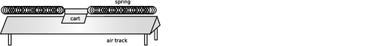Place the cart on the air track and attach springs so that it can vibrate.
1. Test whether the period of vibration depends on amplitude. Try at least two moderate amplitudes, for which the springs do not go slack, and at least one amplitude that is large enough so that they do go slack.
2. Try a cart with a different mass. Does the period change by the expected factor, based on the equation ?
3. Use a spring scale to pull the cart away from equilibrium, and make a graph of force versus position. Is it linear? If so, what is its slope?
4. Test the equation numerically.
\extitle{C}{Worksheet on Resonance}
1. Compare the oscillator's energies at A, B, C, and D.
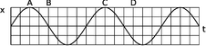2. Compare the Q values of the two oscillators.
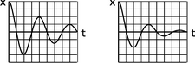3. Match the x-t graphs in #2 with the amplitude-frequency graphs below.
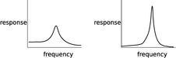
\extitle{D}{Vectors and Motion}
Each diagram on page 187 shows the motion of an object in an x-y plane. Each dot is one location of the object at one moment in time. The time interval from one dot to the next is always the same, so you can think of the vector that connects one dot to the next as a v vector, and subtract to find Δv vectors.
1. Suppose the object in diagram 1 is moving from the top left to the bottom right. Deduce whatever you can about the force acting on it. Does the force always have the same magnitude? The same direction?
Invent a physical situation that this diagram could represent.
What if you reinterpret the diagram, and reverse the object's direction of motion?
2. What can you deduce about the force that is acting in diagram 2?
Invent a physical situation that diagram 2 could represent.
3. What can you deduce about the force that is acting in diagram 3?
Invent a physical situation.
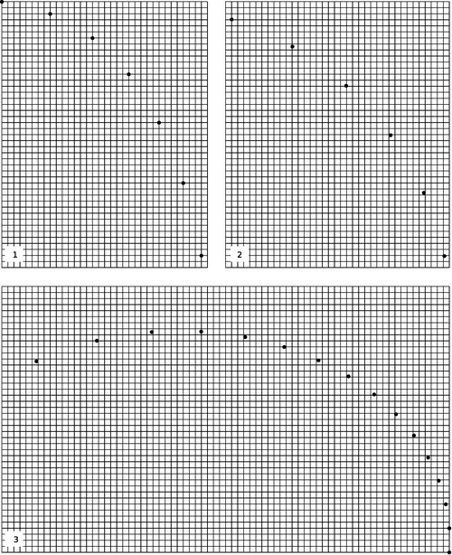
\end{exsection}

Footnotes
[1] Electrical and magnetic interactions don't quite behave like this, which is a point we'll take up later in the book.
[2] We can now see that the derivation would have been equally valid for U_{i}≠ U_{f}. The two observers agree on the distance between the particles, so they also agree on the interaction energies, even though they disagree on the kinetic energies.
[3] Recall that uppercase P is power, while lowercase p is momentum.
[4] This is with the benefit of hindsight. At the time, the word “force” already had certain connotations, and people thought they understood what it meant and how to measure it, e.g. by using a spring scale. From their point of view, F=dp/dt was not a definition but a testable --- and controversial! --- statement.
[5] My own opinion is that Newton stated this special case as a separate law in order to emphasize his commitment to Galilean relativity, as opposed to the prevalent Aristotelian belief that a force was required to keep an object moving. Many modern textbooks, however, present the first law as a statement that inertial frames of reference exist. Newton wrote in Latin and didn't use modern algebra notation in his published work, so any modernized presentation of his work is necessarily not literal. Newton was a notoriously bad communicator (he lectured to an empty hall once a year to fulfill a requirement of his position at Cambridge), so the modern student should be thankful that textbook authors take so many liberties with Newton's laws!
[6] The converse isn't true, because kinetic energy doesn't depend on the direction of motion, but momentum does. We can change a particle's momentum without changing its energy, as when a pool ball bounces off a bumper, reversing the sign of p.
[7] The part of the definition about “by a force” is meant to exclude the transfer of energy by heat conduction, as when a stove heats soup.
[8] “Black box” is a traditional engineering term for a device whose inner workings we don't care about.
[9] For conceptual simplicity, we ignore the transfer of heat energy to the outside world via the exhaust and radiator. In reality, the sum of these energies plus the useful kinetic energy transferred would equal W.
[10] This subroutine isn't as accurate a way of calculating the period as the energy-based one we used in the undamped case, since it only checks whether the mass turned around at some point during the time interval Δt.
[11] For example, the graphs calculated for sinusoidal driving have resonances that are somewhat below the natural frequency, getting lower with increasing damping, until for Q≤1 the maximum response occurs at ω=0. In figure j, however, we can see that impulsive driving at ω=2ω_{o} produces a steady state with more energy than at ω=ω_{o}.
[12] If you've learned about differential equations, you'll know that any second-order differential equation requires the specification of two boundary conditions in order to specify solution uniquely.
[13] Actually, if you know about complex numbers and Euler's theorem, it's not quite so nonsensical.
[14] Of course, you could tell in a sealed laboratory which way was down, but that's because there happens to be a big planet nearby, and the planet's gravitational field reaches into the lab, not because space itself has a special down direction. Similarly, if your experiment was sensitive to magnetic fields, it might matter which way the building was oriented, but that's because the earth makes a magnetic field, not because space itself comes equipped with a north direction.
[15] The zero here is really a zero vector, i.e. a vector whose components are all zero, so we should really represent it with a boldface \vc{0}. There's usually not much danger of confusion, however, so most books, including this one, don't use boldface for the zero vector.
[16] There is, however, a different operation, discussed in the next chapter, which multiplies two vectors to give a vector.
[17] The symbol ∇ is called a “nabla.” Cool word!

4. Conservation of Angular Momentum
Table of Contents

Contents
Section 4.1 - Angular Momentum in Two Dimensions
Section 4.2 - Rigid-Body Rotation
Section 4.3 - Angular Momentum in Three Dimensions

Chapter 4. Conservation of Angular Momentum

4.1 Angular Momentum in Two Dimensions
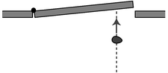
b / An overhead view of a piece of putty being thrown at a door. Even though the putty is neither spinning nor traveling along a curve, we must define it has having some kind of “rotation” because it is able to make the door rotate.
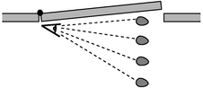
c / As seen by someone standing at the axis, the putty changes its angular position. We therefore define it as having angular momentum.
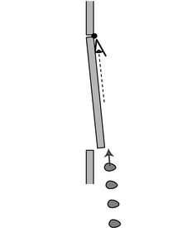
d / A putty blob thrown directly at the axis has no angular motion, and therefore no angular momentum. It will not cause the door to rotate.
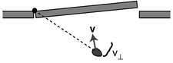
e / Only the component of the velocity vector perpendicular to the line connecting the object to the axis should be counted into the definition of angular momentum.
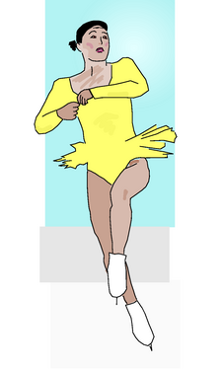
f / A figure skater pulls in her arms so that she can execute a spin more rapidly.
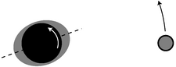
g / A view of the earth-moon system from above the north pole. All distances have been highly distorted for legibility.

Angular momentum
“Sure, and maybe the sun won't come up tomorrow.” Of course, the sun only appears to go up and down because the earth spins, so the cliche should really refer to the unlikelihood of the earth's stopping its rotation abruptly during the night. Why can't it stop? It wouldn't violate conservation of momentum, because the earth's rotation doesn't add anything to its momentum. While California spins in one direction, some equally massive part of India goes the opposite way, canceling its momentum. A halt to Earth's rotation would entail a drop in kinetic energy, but that energy could simply be converted into some other form, such as heat.
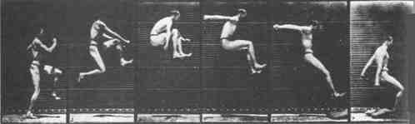
a / The jumper can't move his legs counterclockwise without moving his arms clockwise. (Thomas Eakins.)
Other examples along these lines are not hard to find. An atom spins at the same rate for billions of years. A high-diver who is rotating when he comes off the board does not need to make any physical effort to continue rotating, and indeed would be unable to stop rotating before he hit the water.
These observations have the hallmarks of a conservation law:
A closed system is involved. Nothing is making an effort to twist the earth, the hydrogen atom, or the high-diver. They are isolated from rotation-changing influences, i.e. they are closed systems.
Something remains unchanged. There appears to be a numerical quantity for measuring rotational motion such that the total amount of that quantity remains constant in a closed system.
Something can be transferred back and forth without changing the total amount. In the photo of the old-fashioned high jump, a, the jumper wants to get his feet out in front of him so he can keep from doing a “face plant” when he lands. Bringing his feet forward would involve a certain quantity of counterclockwise rotation, but he didn't start out with any rotation when he left the ground. Suppose we consider counterclockwise as positive and clockwise as negative. The only way his legs can acquire some positive rotation is if some other part of his body picks up an equal amount of negative rotation. This is why he swings his arms up behind him, clockwise.
What numerical measure of rotational motion is conserved? Car engines and old-fashioned LP records have speeds of rotation measured in rotations per minute (r.p.m.), but the number of rotations per minute (or per second) is not a conserved quantity. A twirling figure skater, for instance, can pull her arms in to increase her r.p.m.'s. The first section of this chapter deals with the numerical definition of the quantity of rotation that results in a valid conservation law.
When most people think of rotation, they think of a solid object like a wheel rotating in a circle around a fixed point. Examples of this type of rotation, called rigid rotation or rigid-body rotation, include a spinning top, a seated child's swinging leg, and a helicopter's spinning propeller. Rotation, however, is a much more general phenomenon, and includes noncircular examples such as a comet in an elliptical orbit around the sun, or a cyclone, in which the core completes a circle more quickly than the outer parts.
If there is a numerical measure of rotational motion that is a conserved quantity, then it must include nonrigid cases like these, since nonrigid rotation can be traded back and forth with rigid rotation. For instance, there is a trick for finding out if an egg is raw or hardboiled. If you spin a hardboiled egg and then stop it briefly with your finger, it stops dead. But if you do the same with a raw egg, it springs back into rotation because the soft interior was still swirling around within the momentarily motionless shell. The pattern of flow of the liquid part is presumably very complex and nonuniform due to the asymmetric shape of the egg and the different consistencies of the yolk and the white, but there is apparently some way to describe the liquid's total amount of rotation with a single number, of which some percentage is given back to the shell when you release it.
The best strategy is to devise a way of defining the amount of rotation of a single small part of a system. The amount of rotation of a system such as a cyclone will then be defined as the total of all the contributions from its many small parts.
The quest for a conserved quantity of rotation even requires us to broaden the rotation concept to include cases where the motion doesn't repeat or even curve around. If you throw a piece of putty at a door, b, the door will recoil and start rotating. The putty was traveling straight, not in a circle, but if there is to be a general conservation law that can cover this situation, it appears that we must describe the putty as having had some “rotation,” which it then gave up to the door. The best way of thinking about it is to attribute rotation to any moving object or part of an object that changes its angle in relation to the axis of rotation. In the putty-and-door example, the hinge of the door is the natural point to think of as an axis, and the putty changes its angle as seen by someone standing at the hinge, c. For this reason, the conserved quantity we are investigating is called angular momentum. The symbol for angular momentum can't be “a” or “m,” since those are used for acceleration and mass, so the letter L is arbitrarily chosen instead.
Imagine a 1 kg blob of putty, thrown at the door at a speed of 1 m/s, which hits the door at a distance of 1 m from the hinge. We define this blob to have 1 unit of angular momentum. When it hits the door, the door will recoil and start rotating. We can use the speed at which the door recoils as a measure of the angular momentum the blob brought in.¹
Experiments show, not surprisingly, that a 2 kg blob thrown in the same way makes the door rotate twice as fast, so the angular momentum of the putty blob must be proportional to mass,
L ∝ m .
Similarly, experiments show that doubling the velocity of the blob will have a doubling effect on the result, so its angular momentum must be proportional to its velocity as well,
L ∝ mv .
You have undoubtedly had the experience of approaching a closed door with one of those bar-shaped handles on it and pushing on the wrong side, the side close to the hinges. You feel like an idiot, because you have so little leverage that you can hardly budge the door. The same would be true with the putty blob. Experiments would show that the amount of rotation the blob can give to the door is proportional to the distance, r, from the axis of rotation, so angular momentum must be proportional to r as well,
L ∝ mvr .
We are almost done, but there is one missing ingredient. We know on grounds of symmetry that a putty ball thrown directly inward toward the hinge will have no angular momentum to give to the door. After all, there would not even be any way to decide whether the ball's rotation was clockwise or counterclockwise in this situation. It is therefore only the component of the blob's velocity vector perpendicular to the door that should be counted in its angular momentum,
L = m v⊥ r .
More generally, v⊥ should be thought of as the component of the object's velocity vector that is perpendicular to the line joining the object to the axis of rotation.
We find that this equation agrees with the definition of the original putty blob as having one unit of angular momentum, and we can now see that the units of angular momentum are (kg⋅m/s)⋅m, i.e. kg⋅m²/s. Summarizing, we have
L = m v⊥ r
where m is the particle's mass, v⊥ is the component of its velocity vector perpendicular to the line joining it to the axis of rotation, and r is its distance from the axis. (Note that r is not necessarily the radius of a circle.) Positive and negative signs of angular momentum are used to describe opposite directions of rotation. The angular momentum of a finite-sized object or a system of many objects is found by dividing it up into many small parts, applying the equation to each part, and adding to find the total amount of angular momentum. (As implied by the word “particle,” matter isn't the only thing that can have angular momentum. Light can also have angular momentum, and the above equation would not apply to light.)
Conservation of angular momentum has been verified over and over again by experiment, and is now believed to be one of the most fundamental principles of physics, along with conservation of mass, energy, and momentum.

Example 1: A figure skater pulls her arms in.
When a figure skater is twirling, there is very little friction between her and the ice, so she is essentially a closed system, and her angular momentum is conserved. If she pulls her arms in, she is decreasing r for all the atoms in her arms. It would violate conservation of angular momentum if she then continued rotating at the same speed, i.e. taking the same amount of time for each revolution, because her arms' contributions to her angular momentum would have decreased, and no other part of her would have increased its angular momentum. This is impossible because it would violate conservation of angular momentum. If her total angular momentum is to remain constant, the decrease in r for her arms must be compensated for by an overall increase in her rate of rotation. That is, by pulling her arms in, she substantially reduces the time for each rotation.

Example 2: Earth's slowing rotation and the receding moon
The earth's rotation is actually slowing down very gradually, with the kinetic energy being dissipated as heat by friction between the land and the tidal bulges raised in the seas by the earth's gravity. Does this mean that angular momentum is not really perfectly conserved? No, it just means that the earth is not quite a closed system by itself. If we consider the earth and moon as a system, then the angular momentum lost by the earth must be gained by the moon somehow. In fact very precise measurements of the distance between the earth and the moon have been carried out by bouncing laser beams off of a mirror left there by astronauts, and these measurements show that the moon is receding from the earth at a rate of 2 millimeters per year! The moon's greater value of r means that it has a greater angular momentum, and the increase turns out to be exactly the amount lost by the earth. In the days of the dinosaurs, the days were significantly shorter, and the moon was closer and appeared bigger in the sky.
But what force is causing the moon to speed up, drawing it out into a larger orbit? It is the gravitational forces of the earth's tidal bulges. In figure g, the earth's rotation is counterclockwise (arrow). The moon's gravity creates a bulge on the side near it, because its gravitational pull is stronger there, and an “anti-bulge” on the far side, since its gravity there is weaker. For simplicity, let's focus on the tidal bulge closer to the moon. Its frictional force is trying to slow down the earth's rotation, so its force on the earth's solid crust is toward the bottom of the figure. By Newton's third law, the crust must thus make a force on the bulge which is toward the top of the figure. This causes the bulge to be pulled forward at a slight angle, and the bulge's gravity therefore pulls the moon forward, accelerating its orbital motion about the earth and flinging it outward.
The result would obviously be extremely difficult to calculate directly, and this is one of those situations where a conservation law allows us to make precise quantitative statements about the outcome of a process when the calculation of the process itself would be prohibitively complex.

Restriction to rotation in a plane
Is angular momentum a vector, or a scalar? It does have a direction in space, but it's a direction of rotation, not a straight-line direction like the directions of vectors such as velocity or force. It turns out that there is a way of defining angular momentum as a vector, but in this section the examples will be confined to a single plane of rotation, i.e. effectively two-dimensional situations. In this special case, we can choose to visualize the plane of rotation from one side or the other, and to define clockwise and counterclockwise rotation as having opposite signs of angular momentum. “Effectively” two-dimensional means that we can deal with objects that aren't flat, as long as the velocity vectors of all their parts lie in a plane.

Discussion Questions
◊ Conservation of plain old momentum, p, can be thought of as the greatly expanded and modified descendant of Galileo's original principle of inertia, that no force is required to keep an object in motion. The principle of inertia is counterintuitive, and there are many situations in which it appears superficially that a force is needed to maintain motion, as maintained by Aristotle. Think of a situation in which conservation of angular momentum, L, also seems to be violated, making it seem incorrectly that something external must act on a closed system to keep its angular momentum from “running down.”
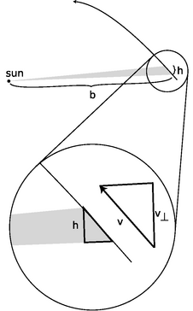
h / The area swept out by a planet in its orbit.
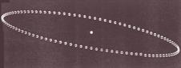
i / Discussion question B.

Application to planetary motion
We now discuss the application of conservation of angular momentum to planetary motion, both because of its intrinsic importance and because it is a good way to develop a visual intuition for angular momentum.
Kepler's law of equal areas states that the area swept out by a planet in a certain length of time is always the same. Angular momentum had not been invented in Kepler's time, and he did not even know the most basic physical facts about the forces at work. He thought of this law as an entirely empirical and unexpectedly simple way of summarizing his data, a rule that succeeded in describing and predicting how the planets sped up and slowed down in their elliptical paths. It is now fairly simple, however, to show that the equal area law amounts to a statement that the planet's angular momentum stays constant.
There is no simple geometrical rule for the area of a pie wedge cut out of an ellipse, but if we consider a very short time interval, as shown in figure h, the shaded shape swept out by the planet is very nearly a triangle. We do know how to compute the area of a triangle. It is one half the product of the base and the height:
We wish to relate this to angular momentum, which contains the variables r and v⊥. If we consider the sun to be the axis of rotation, then the variable r is identical to the base of the triangle, r=b. Referring to the magnified portion of the figure, v⊥ can be related to h, because the two right triangles are similar:
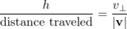
The area can thus be rewritten as
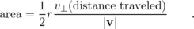
The distance traveled equals |v|Δ t, so this simplifies to
We have found the following relationship between angular momentum and the rate at which area is swept out:
The factor of 2 in front is simply a matter of convention, since any conserved quantity would be an equally valid conserved quantity if you multiplied it by a constant. The factor of m was not relevant to Kepler, who did not know the planets' masses, and who was only describing the motion of one planet at a time.
We thus find that Kepler's equal-area law is equivalent to a statement that the planet's angular momentum remains constant. But wait, why should it remain constant? --- the planet is not a closed system, since it is being acted on by the sun's gravitational force. There are two valid answers. The first is that it is actually the total angular momentum of the sun plus the planet that is conserved. The sun, however, is millions of times more massive than the typical planet, so it accelerates very little in response to the planet's gravitational force. It is thus a good approximation to say that the sun doesn't move at all, so that no angular momentum is transferred between it and the planet.
The second answer is that to change the planet's angular momentum requires not just a force but a force applied in a certain way. Later in this section (starting on page 199) we discuss the transfer of angular momentum by a force, but the basic idea here is that a force directly in toward the axis does not change the angular momentum.

Discussion Questions
◊ Suppose an object is simply traveling in a straight line at constant speed. If we pick some point not on the line and call it the axis of rotation, is area swept out by the object at a constant rate?
◊ The figure is a strobe photo of a pendulum bob, taken from underneath the pendulum looking straight up. The black string can't be seen in the photograph. The bob was given a slight sideways push when it was released, so it did not swing in a plane. The bright spot marks the center, i.e. the position the bob would have if it hung straight down at us. Does the bob's angular momentum appear to remain constant if we consider the center to be the axis of rotation?
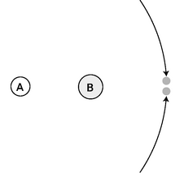
j / Two asteroids collide.
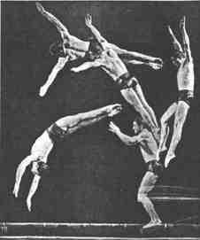
k / Everyone has a strong tendency to think of the diver as rotating about his own center of mass. However, he is flying in an arc, and he also has angular momentum because of this motion.
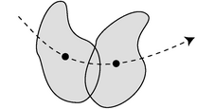
l / This rigid object has angular momentum both because it is spinning about its center of mass and because it is moving through space.

Two Theorems About Angular Momentum
With plain old momentum, p, we had the freedom to work in any inertial frame of reference we liked. The same object could have different values of momentum in two different frames, if the frames were not at rest with respect to each other. Conservation of momentum, however, would be true in either frame. As long as we employed a single frame consistently throughout a calculation, everything would work.
The same is true for angular momentum, and in addition there is an ambiguity that arises from the definition of an axis of rotation. For a wheel, the natural choice of an axis of rotation is obviously the axle, but what about an egg rotating on its side? The egg has an asymmetric shape, and thus no clearly defined geometric center. A similar issue arises for a cyclone, which does not even have a sharply defined shape, or for a complicated machine with many gears. The following theorem, the first of two presented in this section, explains how to deal with this issue. Although I have put descriptive titles above both theorems, they have no generally accepted names. The proofs, given on page 743, use the vector cross-product technique introduced in section 4.3, which greatly simplifies them.
\mythmhdr{The choice of axis theorem} It is entirely arbitrary what point one defines as the axis for purposes of calculating angular momentum. If a closed system's angular momentum is conserved when calculated with one choice of axis, then it will be conserved for any other choice of axis. Likewise, any inertial frame of reference may be used.

Example 3: Colliding asteroids described with different axes
Observers on planets A and B both see the two asteroids colliding. The asteroids are of equal mass and their impact speeds are the same. Astronomers on each planet decide to define their own planet as the axis of rotation. Planet A is twice as far from the collision as planet B. The asteroids collide and stick. For simplicity, assume planets A and B are both at rest.
With planet A as the axis, the two asteroids have the same amount of angular momentum, but one has positive angular momentum and the other has negative. Before the collision, the total angular momentum is therefore zero. After the collision, the two asteroids will have stopped moving, and again the total angular momentum is zero. The total angular momentum both before and after the collision is zero, so angular momentum is conserved if you choose planet A as the axis.
The only difference with planet B as axis is that r is smaller by a factor of two, so all the angular momenta are halved. Even though the angular momenta are different than the ones calculated by planet A, angular momentum is still conserved.
The earth spins on its own axis once a day, but simultaneously travels in its circular one-year orbit around the sun, so any given part of it traces out a complicated loopy path. It would seem difficult to calculate the earth's angular momentum, but it turns out that there is an intuitively appealing shortcut: we can simply add up the angular momentum due to its spin plus that arising from its center of mass's circular motion around the sun. This is a special case of the following general theorem:
\mythmhdr{The spin theorem} An object's angular momentum with respect to some outside axis A can be found by adding up two parts:
(1) The first part is the object's angular momentum found by using its own center of mass as the axis, i.e. the angular momentum the object has because it is spinning.
(2) The other part equals the angular momentum that the object would have with respect to the axis A if it had all its mass concentrated at and moving with its center of mass.

Example 4: A system with its center of mass at rest
In the special case of an object whose center of mass is at rest, the spin theorem implies that the object's angular momentum is the same regardless of what axis we choose. (This is an even stronger statement than the choice of axis theorem, which only guarantees that angular momentum is conserved for any given choice of axis, without specifying that it is the same for all such choices.)

Example 5: Angular momentum of a rigid object
◊ A motorcycle wheel has almost all its mass concentrated at the outside. If the wheel has mass m and radius r, and the time required for one revolution is T, what is the spin part of its angular momentum?
◊ This is an example of the commonly encountered special case of rigid motion, as opposed to the rotation of a system like a hurricane in which the different parts take different amounts of time to go around. We don't really have to go through a laborious process of adding up contributions from all the many parts of a wheel, because they are all at about the same distance from the axis, and are all moving around the axis at about the same speed. The velocity is all perpendicular to the spokes,
v⊥
= 2π r/ T
and the angular momentum of the wheel about its center is
L = mv⊥ r
= m(2π r/ T) r
= 2π mr²/ T .
Note that although the factors of 2π in this expression is peculiar to a wheel with its mass concentrated on the rim, the proportionality to m/T would have been the same for any other rigidly rotating object. Although an object with a noncircular shape does not have a radius, it is also true in general that angular momentum is proportional to the square of the object's size for fixed values of m and T. For instance doubling an object's size doubles both the v⊥ and r factors in the contribution of each of its parts to the total angular momentum, resulting in an overall factor of four increase.
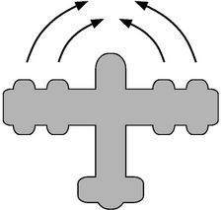
m / The plane's four engines produce zero total torque but not zero total force.
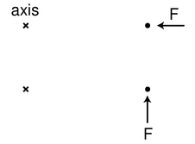
n / The simple physical situation we use to derive an equation for torque. A force that points directly in at or out away from the axis produces neither clockwise nor counterclockwise angular momentum. A force in the perpendicular direction does transfer angular momentum.
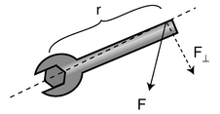
o / The geometric relationships referred to in the relationship between force and torque.
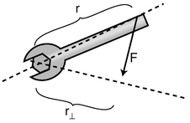
q / Visualizing torque in terms of r⊥.
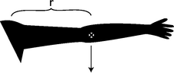
r / Example 7.
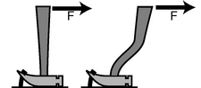
s / Discussion question D.
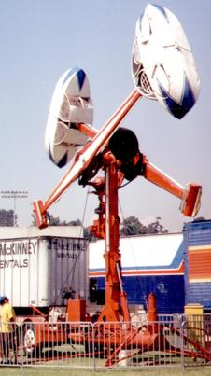
t / Discussion question E.

Torque
Force is the rate of transfer of momentum. The corresponding quantity in the case of angular momentum is called torque (rhymes with “fork”). Where force tells us how hard we are pushing or pulling on something, torque indicates how hard we are twisting on it. Torque is represented by the Greek letter tau, τ, and the rate of change of an object's angular momentum equals the total torque acting on it,
τ_{total} = d L/d t .
As with force and momentum, it often happens that angular momentum recedes into the background and we focus our interest on the torques. The torque-focused point of view is exemplified by the fact that many scientifically untrained but mechanically apt people know all about torque, but none of them have heard of angular momentum. Car enthusiasts eagerly compare engines' torques, and there is a tool called a torque wrench which allows one to apply a desired amount of torque to a screw and avoid overtightening it.

Torque distinguished from force
Of course a force is necessary in order to create a torque --- you can't twist a screw without pushing on the wrench --- but force and torque are two different things. One distinction between them is direction. We use positive and negative signs to represent forces in the two possible directions along a line. The direction of a torque, however, is clockwise or counterclockwise, not a linear direction.
The other difference between torque and force is a matter of leverage. A given force applied at a door's knob will change the door's angular momentum twice as rapidly as the same force applied halfway between the knob and the hinge. The same amount of force produces different amounts of torque in these two cases.
It's possible to have a zero total torque with a nonzero total force. An airplane with four jet engines would be designed so that their forces are balanced on the left and right. Their forces are all in the same direction, but the clockwise torques of two of the engines are canceled by the counterclockwise torques of the other two, giving zero total torque.
Conversely we can have zero total force and nonzero total torque. A merry-go-round's engine needs to supply a nonzero torque on it to bring it up to speed, but there is zero total force on it. If there was not zero total force on it, its center of mass would accelerate!

Relationship between force and torque
How do we calculate the amount of torque produced by a given force? Since it depends on leverage, we should expect it to depend on the distance between the axis and the point of application of the force. I'll work out an equation relating torque to force for a particular very simple situation, and give a more rigorous derivation on page 229, after developing some mathematical techniques that dramatically shorten and simplify the proof.
Consider a pointlike object which is initially at rest at a distance r from the axis we have chosen for defining angular momentum. We first observe that a force directly inward or outward, along the line connecting the axis to the object, does not impart any angular momentum to the object.
A force perpendicular to the line connecting the axis and the object does, however, make the object pick up angular momentum. Newton's second law gives
a = F/m ,
and using a=d v/d t we find the velocity the object acquires after a time d t,
d v = Fd t/m .
We're trying to relate force to a change in angular momentum, so we multiply both sides of the equation by mr to give
m d v r = F d t r
d L = F d t r .
Dividing by d t gives the torque:
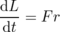
τ = Fr .
If a force acts at an angle other than 0 or 90° with respect to the line joining the object and the axis, it would be only the component of the force perpendicular to the line that would produce a torque,
τ = F⊥r .
Although this result was proved under a simplified set of circumstances, it is more generally valid:²
\mythmhdr{Relationship between force and torque} The rate at which a force transfers angular momentum to an object, i.e. the torque produced by the force, is given by
|τ| = r |F⊥| ,
where r is the distance from the axis to the point of application of the force, and F⊥ is the component of the force that is perpendicular to the line joining the axis to the point of application.
The equation is stated with absolute value signs because the positive and negative signs of force and torque indicate different things, so there is no useful relationship between them. The sign of the torque must be found by physical inspection of the case at hand.
From the equation, we see that the units of torque can be written as newtons multiplied by meters. Metric torque wrenches are calibrated in N⋅m, but American ones use foot-pounds, which is also a unit of distance multiplied by a unit of force. We know from our study of mechanical work that newtons multiplied by meters equal joules, but torque is a completely different quantity from work, and nobody writes torques with units of joules, even though it would be technically correct.
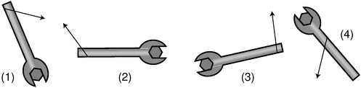
p / Self-check.
self-check: Compare the magnitudes and signs of the four torques shown in figure p. (answer in the back of the PDF version of the book)

Example 6: How torque depends on the direction of the force
◊ How can the torque applied to the wrench in the figure be expressed in terms of r, | F|, and the angle θ?
◊ The force vector and its F⊥ component form the hypotenuse and one leg of a right triangle,
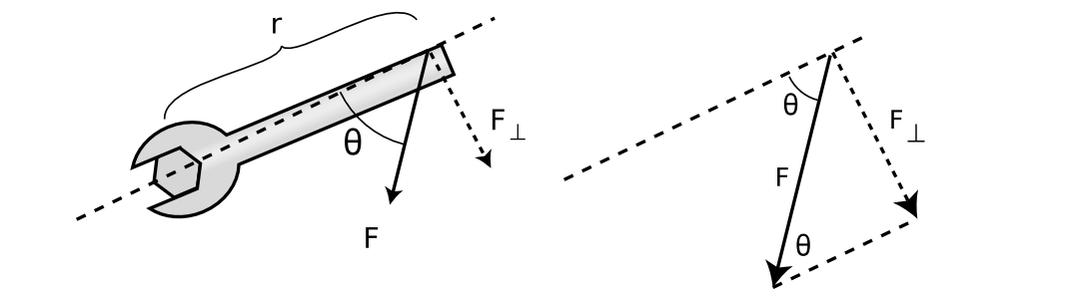
and the interior angle opposite to F⊥ equals θ. The absolute value of F⊥ can thus be expressed as
F⊥ = |F| sin θ ,
leading to
|τ| = r |F| sin θ .
Sometimes torque can be more neatly visualized in terms of the quantity r⊥ shown in the figure on the left, which gives us a third way of expressing the relationship between torque and force:
|τ| = r⊥ |F| .
Of course you wouldn't want to go and memorize all three equations for torque. Starting from any one of them you could easily derive the other two using trigonometry. Familiarizing yourself with them can however clue you in to easier avenues of attack on certain problems.

The torque due to gravity
Up until now we've been thinking in terms of a force that acts at a single point on an object, such as the force of your hand on the wrench. This is of course an approximation, and for an extremely realistic calculation of your hand's torque on the wrench you might need to add up the torques exerted by each square millimeter where your skin touches the wrench. This is seldom necessary. But in the case of a gravitational force, there is never any single point at which the force is applied. Our planet is exerting a separate tug on every brick in the Leaning Tower of Pisa, and the total gravitational torque on the tower is the sum of the torques contributed by all the little forces. Luckily there is a trick that allows us to avoid such a massive calculation. It turns out that for purposes of computing the total gravitational torque on an object, you can get the right answer by just pretending that the whole gravitational force acts at the object's center of mass.

Example 7: Gravitational torque on an outstretched arm
◊ Your arm has a mass of 3.0 kg, and its center of mass is 30 cm from your shoulder. What is the gravitational torque on your arm when it is stretched out horizontally to one side, taking the shoulder to be the axis?
◊ The total gravitational force acting on your arm is
|F| = ( 3.0 kg)( 9.8 m/s²) = 29 N .
For the purpose of calculating the gravitational torque, we can treat the force as if it acted at the arm's center of mass. The force is straight down, which is perpendicular to the line connecting the shoulder to the center of mass, so
F⊥ = |F| = 29 N .
Continuing to pretend that the force acts at the center of the arm, r equals 30 cm = 0.30 m, so the torque is
τ = r F⊥ = 9 N⋅m .

Discussion Questions
◊ This series of discussion questions deals with past students' incorrect reasoning about the following problem.
Suppose a comet is at the point in its orbit shown in the figure. The only force on the comet is the sun's gravitational force. Throughout the question, define all torques and angular momenta using the sun as the axis.
(1) Is the sun producing a nonzero torque on the comet? Explain.
(2) Is the comet's angular momentum increasing, decreasing, or staying the same? Explain.
Explain what is wrong with the following answers. In some cases, the answer is correct, but the reasoning leading up to it is wrong.
(a) Incorrect answer to part (1): “Yes, because the sun is exerting a force on the comet, and the comet is a certain distance from the sun.”
(b) Incorrect answer to part (1): “No, because the torques cancel out.”
(c) Incorrect answer to part (2): “Increasing, because the comet is speeding up.”

u / Discussion question A.
◊ You whirl a rock over your head on the end of a string, and gradually pull in the string, eventually cutting the radius in half. What happens to the rock's angular momentum? What changes occur in its speed, the time required for one revolution, and its acceleration? Why might the string break?
◊ A helicopter has, in addition to the huge fan blades on top, a smaller propeller mounted on the tail that rotates in a vertical plane. Why?
◊ Which claw hammer would make it easier to get the nail out of the wood if the same force was applied in the same direction?
◊ The photo shows an amusement park ride whose two cars rotate in opposite directions. Why is this a good design?
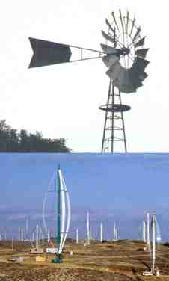
v / The windmills are not closed systems, but angular momentum is being transferred out of them at the same rate it is transferred in, resulting in constant angular momentum. To get an idea of the huge scale of the modern windmill farm, note the sizes of the trucks and trailers.
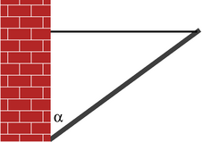
w / Example 8.
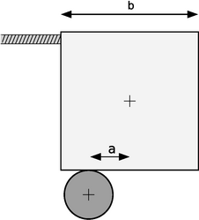
x / Example 9.
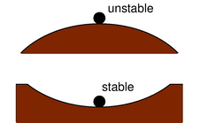
y / Stable and unstable equilibria.

z / The dancer's equilibrium is unstable. If she didn't constantly make tiny adjustments, she would tip over.
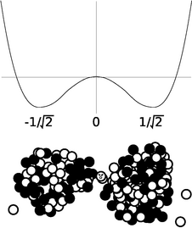
aa / Example 10.

Applications to statics
In chapter 2 I defined equilibrium as a situation where the interaction energy is minimized. This is the same as a condition of zero total force, or constant momentum. Thus a car is in equilibrium not just when it is parked but also when it is cruising down a straight road with constant momentum.
Likewise there are many cases where a system is not closed but maintains constant angular momentum. When a merry-go-round is running at constant angular momentum, the engine's torque is being canceled by the torque due to friction.
It's not enough for a boat not to sink --- we'd also like to avoid having it capsize. For this reason, we now redefine equilibrium as follows.
When an object has constant momentum and constant angular momentum, we say that it is in equilibrium. Again, this is a scientific redefinition of the common English word, since in ordinary speech nobody would describe a car spinning out on an icy road as being in equilibrium.
Very commonly, however, we are interested in cases where an object is not only in equilibrium but also at rest, and this corresponds more closely to the usual meaning of the word. Statics is the branch of physics concerned with problems such as these.
Solving statics problems is now simply a matter of applying and combining some things you already know:
- You know the behaviors of the various types of forces, for example that a frictional force is always parallel to the surface of contact.
- You know about vector addition of forces. It is the vector sum of the forces that must equal zero to produce equilibrium.
- You know about torque. The total torque acting on an object must be zero if it is to be in equilibrium.
- You know that the choice of axis is arbitrary, so you can make a choice of axis that makes the problem easy to solve.
In general, this type of problem could involve four equations in four unknowns: three equations that say the force components add up to zero, and one equation that says the total torque is zero. Most cases you'll encounter will not be this complicated. In the example below, only the equation for zero total torque is required in order to get an answer.

Example 8: A flagpole
◊ A 10-kg flagpole is being held up by a lightweight horizontal cable, and is propped against the foot of a wall as shown in the figure. If the cable is only capable of supporting a tension of 70 N, how great can the angle α be without breaking the cable?
◊ ◊ All three objects in the figure are supposed to be in equilibrium: the pole, the cable, and the wall. Whichever of the three objects we pick to investigate, all the forces and torques on it have to cancel out. It is not particularly helpful to analyze the forces and torques on the wall, since it has forces on it from the ground that are not given and that we don't want to find. We could study the forces and torques on the cable, but that doesn't let us use the given information about the pole. The object we need to analyze is the pole.
The pole has three forces on it, each of which may also result in a torque: (1) the gravitational force, (2) the cable's force, and (3) the wall's force.
We are free to define an axis of rotation at any point we wish, and it is helpful to define it to lie at the bottom end of the pole, since by that definition the wall's force on the pole is applied at r=0 and thus makes no torque on the pole. This is good, because we don't know what the wall's force on the pole is, and we are not trying to find it.
With this choice of axis, there are two nonzero torques on the pole, a counterclockwise torque from the cable and a clockwise torque from gravity. Choosing to represent counterclockwise torques as positive numbers, and using the equation , we have
r_{cable} |F_{cable}| sin θ_{cable} - r_{grav}|F_{grav}|sin θ_{grav} = 0 .
A little geometry gives θ_{cable}=90°-α and θ_{grav}=α, so
r_{cable} |F_{cable}| sin (90°-α) - r_{grav}|F_{grav}| sin α = 0 .
The gravitational force can be considered as acting at the pole's center of mass, i.e., at its geometrical center, so r_{cable} is twice r_{grav}, and we can simplify the equation to read
2 |F_{cable}| sin (90°-α) - |F_{grav}| sin α = 0 .
These are all quantities we were given, except for α, which is the angle we want to find. To solve for α we need to use the trig identity sin (90°-x)= cos x,
2 |F_{cable}| cos α - |F_{grav}| sin α = 0 ,
which allows us to find
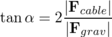
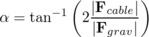
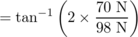
= 55° .

Example 9: Art!
◊ The abstract sculpture shown in figure x contains a cube of mass m and sides of length b. The cube rests on top of a cylinder, which is off-center by a distance a. Find the tension in the cable.
◊ There are four forces on the cube: a gravitational force mg, the force F_{T} from the cable, the upward normal force from the cylinder, F_{N}, and the horizontal static frictional force from the cylinder, F_{s}.
The total force on the cube in the vertical direction is zero:
F_{N}-mg = 0 .
As our axis for defining torques, it's convenient to choose the point of contact between the cube and the cylinder, because then neither F_{s} nor F_{N} makes any torque. The cable's torque is counterclockwise, and the torque due to gravity is clockwise. and the cylinder's torque is clockwise. Letting counterclockwise torques be positive, and using the convenient equation τ=r⊥ F, we find the equation for the total torque:
b F_{T} - F_{N} a = 0 .
We could also write down the equation saying that the total horizontal force is zero, but that would bring in the cylinder's frictional force on the cube, which we don't know and don't need to find. We already have two equations in the two unknowns F_{T} and F_{N}, so there's no need to make it into three equations in three unknowns. Solving the first equation for F_{N}=mg, we then substitute into the second equation to eliminate F_{N}, and solve for F_{T}=(a/b)mg.
Why is one equilibrium stable and another unstable? Try pushing your own nose to the left or the right. If you push it a millimeter to the left, it responds with a gentle force to the right. If you push it a centimeter to the left, its force on your finger becomes much stronger. The defining characteristic of a stable equilibrium is that the farther the object is moved away from equilibrium, the stronger the force is that tries to bring it back.
The opposite is true for an unstable equilibrium. In the top figure, the ball resting on the round hill theoretically has zero total force on it when it is exactly at the top. But in reality the total force will not be exactly zero, and the ball will begin to move off to one side. Once it has moved, the net force on the ball is greater than it was, and it accelerates more rapidly. In an unstable equilibrium, the farther the object gets from equilibrium, the stronger the force that pushes it farther from equilibrium.
This idea can be rephrased in terms of energy. The difference between the stable and unstable equilibria shown in figure y is that in the stable equilibrium, the potential energy is at a minimum, and moving to either side of equilibrium will increase it, whereas the unstable equilibrium represents a maximum.
Note that we are using the term “stable” in a weaker sense than in ordinary speech. A domino standing upright is stable in the sense we are using, since it will not spontaneously fall over in response to a sneeze from across the room or the vibration from a passing truck. We would only call it unstable in the technical sense if it could be toppled by any force, no matter how small. In everyday usage, of course, it would be considered unstable, since the force required to topple it is so small.

Example 10: An application of calculus
◊ Nancy Neutron is living in a uranium nucleus that is undergoing fission. Nancy's potential energy as a function of position can be approximated by PE=x⁴-x², where all the units and numerical constants have been suppressed for simplicity. Use calculus to locate the equilibrium points, and determine whether they are stable or unstable.
◊ The equilibrium points occur where the PE is at a minimum or maximum, and minima and maxima occur where the derivative (which equals minus the force on Nancy) is zero. This derivative is d PE/d x=4x³-2x, and setting it equal to zero, we have . Minima occur where the second derivative is positive, and maxima where it is negative. The second derivative is 12x²-2, which is negative at x=0 (unstable) and positive at (stable). Interpretation: the graph of the PE is shaped like a rounded letter `W,' with the two troughs representing the two halves of the splitting nucleus. Nancy is going to have to decide which half she wants to go with.
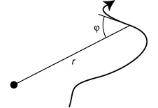
ab / Describing a curve by giving φ as a function of r.
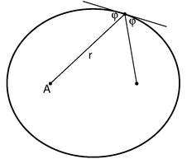
ac / Proof that the two angles labeled φ are in fact equal: The definition of an ellipse is that the sum of the distances from the two foci stays constant. If we move a small distance along the ellipse, then one distance shrinks by an amount , while the other grows by . These are equal, so φ₁=φ₂.
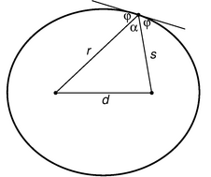
ad / Quantities referred to in the proof of part (3).

Proof of Kepler's elliptical orbit law
Kepler determined purely empirically that the planets' orbits were ellipses, without understanding the underlying reason in terms of physical law. Newton's proof of this fact based on his laws of motion and law of gravity was considered his crowning achievement both by him and by his contemporaries, because it showed that the same physical laws could be used to analyze both the heavens and the earth. Newton's proof was very lengthy, but by applying the more recent concepts of conservation of energy and angular momentum we can carry out the proof quite simply and succinctly. This subsection can be skipped without losing the continuity of the text.
The basic idea of the proof is that we want to describe the shape of the planet's orbit with an equation, and then show that this equation is exactly the one that represents an ellipse. Newton's original proof had to be very complicated because it was based directly on his laws of motion, which include time as a variable. To make any statement about the shape of the orbit, he had to eliminate time from his equations, leaving only space variables. But conservation laws tell us that certain things don't change over time, so they have already had time eliminated from them.
There are many ways of representing a curve by an equation, of which the most familiar is y=ax+b for a line in two dimensions. It would be perfectly possible to describe a planet's orbit using an x-y equation like this, but remember that we are applying conservation of angular momentum, and the space variables that occur in the equation for angular momentum are the distance from the axis, r, and the angle between the velocity vector and the r vector, which we will call φ. The planet will have φ=90° when it is moving perpendicular to the r vector, i.e. at the moments when it is at its smallest or greatest distances from the sun. When φ is less than 90° the planet is approaching the sun, and when it is greater than 90° it is receding from it. Describing a curve with an r-φ equation is like telling a driver in a parking lot a certain rule for what direction to steer based on the distance from a certain streetlight in the middle of the lot.
The proof is broken into the three parts for easier digestion. The first part is a simple and intuitively reasonable geometrical fact about ellipses, whose proof we relegate to the caption of figure ac; you will not be missing much if you merely absorb the result without reading the proof.
(1) If we use one of the two foci of an ellipse as an axis for defining the variables r and φ, then the angle between the tangent line and the line drawn to the other focus is the same as φ, i.e. the two angles labeled φ in the figure are in fact equal.
The other two parts form the meat of our proof. We state the results first and then prove them.
(2) A planet, moving under the influence of the sun's gravity with less then the energy required to escape, obeys an equation of the form
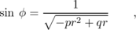
where p and q are positive constants that depend on the planet's energy and angular momentum and p is greater than zero.
(3) A curve is an ellipse if and only if its r-φ equation is of the form
where p and q are positive constants that depend on the size and shape of the ellipse.

Proof of part (2)
The component of the planet's velocity vector that is perpendicular to the r vector is v⊥=v sinφ, so conservation of angular momentum tells us that L = mrv sin φ is a constant. Since the planet's mass is a constant, this is the same as the condition
rv sin φ = constant .
Conservation of energy gives
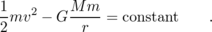
We solve the first equation for v and plug into the second equation to eliminate v. Straightforward algebra then leads to the equation claimed above, with the constant p being positive because of our assumption that the planet's energy is insufficient to escape from the sun, i.e. its total energy is negative.

Proof of part (3)
We define the quantities α, d, and s as shown in figure ad. The law of cosines gives
d² = r² + s² - 2rs cos α .
Using α=180°-2φ and the trigonometric identities cos and cos 2x = 1-2 sin² x, we can rewrite this as
Straightforward algebra transforms this into
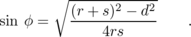
Since r+s is constant, the top of the fraction is constant, and the denominator can be rewritten as 4rs=4r(constant-r), which is equivalent to the desired form.

4.2 Rigid-Body Rotation
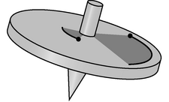
a / The two atoms cover the same angle in a given time interval.
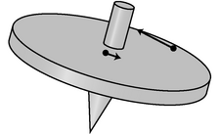
b / Their velocity vectors, however, differ in both magnitude and direction.
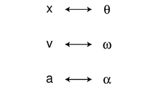
c / Analogies between rotational and linear quantities.

Kinematics
When a rigid object rotates, every part of it (every atom) moves in a circle, covering the same angle in the same amount of time, a. Every atom has a different velocity vector, b. Since all the velocities are different, we can't measure the speed of rotation of the top by giving a single velocity. We can, however, specify its speed of rotation consistently in terms of angle per unit time. Let the position of some reference point on the top be denoted by its angle θ, measured in a circle around the axis. For reasons that will become more apparent shortly, we measure all our angles in radians. Then the change in the angular position of any point on the top can be written as dθ, and all parts of the top have the same value of dθ over a certain time interval d t. We define the angular velocity, ω (Greek omega),
which is similar to, but not the same as, the quantity ω we defined earlier to describe vibrations. The relationship between ω and t is exactly analogous to that between x and t for the motion of a particle through space.
self-check: If two different people chose two different reference points on the top in order to define , how would their θ-t graphs differ? What effect would this have on the angular velocities? (answer in the back of the PDF version of the book)
The angular velocity has units of radians per second, rad/s. However, radians are not really units at all. The radian measure of an angle is defined, as the length of the circular arc it makes, divided by the radius of the circle. Dividing one length by another gives a unitless quantity, so anything with units of radians is really unitless. We can therefore simplify the units of angular velocity, and call them inverse seconds, s⁻¹.

Example 11: A 78-rpm record
◊ In the early 20th century, the standard format for music recordings was a plastic disk that held a single song and rotated at 78 rpm (revolutions per minute). What was the angular velocity of such a disk?
◊ If we measure angles in units of revolutions and time in units of minutes, then 78 rpm is the angular velocity. Using standard physics units of radians/second, however, we have
= 8.2 s⁻¹ .
In the absence of any torque, a rigid body will rotate indefinitely with the same angular velocity. If the angular velocity is changing because of a torque, we define an angular acceleration,
The symbol is the Greek letter alpha. The units of this quantity are rad/s², or simply s⁻².
The mathematical relationship between ω and θ is the same as the one between v and x, and similarly for α and a. We can thus make a system of analogies, c, and recycle all the familiar kinematic equations for constant-acceleration motion.

Example 12: The synodic period
Mars takes nearly twice as long as the Earth to complete an orbit. If the two planets are alongside one another on a certain day, then one year later, Earth will be back at the same place, but Mars will have moved on, and it will take more time for Earth to finish catching up. Angular velocities add and subtract, just as velocity vectors do. If the two planets' angular velocities are ω₁ and ω₂, then the angular velocity of one relative to the other is ω₁-ω₂. The corresponding period, 1/(1/T₁-1/T₂) is known as the synodic period.

Example 13: A neutron star
◊ A neutron star is initially observed to be rotating with an angular velocity of 2.0 s⁻¹, determined via the radio pulses it emits. If its angular acceleration is a constant - 1.0×10⁻⁸ s⁻², how many rotations will it complete before it stops? (In reality, the angular acceleration is not always constant; sudden changes often occur, and are referred to as “starquakes!”)
◊ The equation can be translated into , giving
Δθ = (ω_{f}²-ω_{i}²)/2α
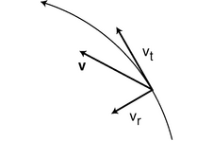
d / We construct a coordinate system that coincides with the location and motion of the moving point of interest at a certain moment.
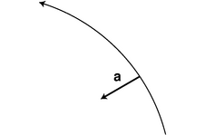
e / Even if the rotating object has zero angular acceleration, every point on it has an acceleration towards the center.

Relations between angular quantities and motion of a point
It is often necessary to be able to relate the angular quantities to the motion of a particular point on the rotating object. As we develop these, we will encounter the first example where the advantages of radians over degrees become apparent.
The speed at which a point on the object moves depends on both the object's angular velocity ω and the point's distance r from the axis. We adopt a coordinate system, d, with an inward (radial) axis and a tangential axis. The length of the infinitesimal circular arc d s traveled by the point in a time interval d t is related to dθ by the definition of radian measure, dθ=d s/r, where positive and negative values of d s represent the two possible directions of motion along the tangential axis. We then have v_{t} = d s/d t = rdθ/d t = ω r, or
The radial component is zero, since the point is not moving inward or outward,
Note that we had to use the definition of radian measure in this derivation. Suppose instead we had used units of degrees for our angles and degrees per second for angular velocities. The relationship between dθ_{degrees} and d s is dθ_{degrees} = (360/2π)s/r, where the extra conversion factor of (360/2π) comes from that fact that there are 360 degrees in a full circle, which is equivalent to 2π radians. The equation for v_{t} would then have been v_{t} =, which would have been much messier. Simplicity, then, is the reason for using radians rather than degrees; by using radians we avoid infecting all our equations with annoying conversion factors.
Since the velocity of a point on the object is directly proportional to the angular velocity, you might expect that its acceleration would be directly proportional to the angular acceleration. This is not true, however. Even if the angular acceleration is zero, i.e. if the object is rotating at constant angular velocity, every point on it will have an acceleration vector directed toward the axis, e. As derived on page 164, the magnitude of this acceleration is
For the tangential component, any change in the angular velocity dω will lead to a change dω⋅ r in the tangential velocity, so it is easily shown that
self-check: Positive and negative signs of ω represent rotation in opposite directions. Why does it therefore make sense physically that ω is raised to the first power in the equation for v_{t} and to the second power in the one for a_{r}? (answer in the back of the PDF version of the book)

Example 14: Radial acceleration at the surface of the Earth
◊ What is your radial acceleration due to the rotation of the earth if you are at the equator?
◊ At the equator, your distance from the Earth's rotation axis is the same as the radius of the spherical Earth, 6.4×10⁶ m. Your angular velocity is
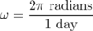
= 7.3×10⁻⁵ s⁻¹ ,
which gives an acceleration of
a_{r} = ω² r
= 0.034 m/s² .
The angular velocity was a very small number, but the radius was a very big number. Squaring a very small number, however, gives a very very small number, so the ω² factor “wins,” and the final result is small.
If you're standing on a bathroom scale, this small acceleration is provided by the imbalance between the downward force of gravity and the slightly weaker upward normal force of the scale on your foot. The scale reading is therefore a little lower than it should be.
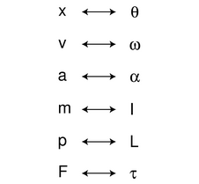
f / Analogies between rotational and linear quantities.
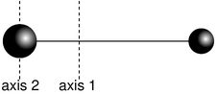
g / Example 15

Dynamics
If we want to connect all this kinematics to anything dynamical, we need to see how it relates to torque and angular momentum. Our strategy will be to tackle angular momentum first, since angular momentum relates to motion, and to use the additive property of angular momentum: the angular momentum of a system of particles equals the sum of the angular momenta of all the individual particles. The angular momentum of one particle within our rigidly rotating object, L=mv⊥ r, can be rewritten as L=r p sin θ, where r and p are the magnitudes of the particle's r and momentum vectors, and θ is the angle between these two vectors. (The r vector points outward perpendicularly from the axis to the particle's position in space.) In rigid-body rotation the angle θ is 90°, so we have simply L=r p. Relating this to angular velocity, we have L=rp=(r)(mv)=(r)(mω r)=mr²ω. The particle's contribution to the total angular momentum is proportional to ω, with a proportionality constant mr². We refer to mr² as the particle's contribution to the object's total moment of inertia, I, where “moment” is used in the sense of “important,” as in “momentous” --- a bigger value of I tells us the particle is more important for determining the total angular momentum. The total moment of inertia is
The angular momentum of a rigidly rotating body is then
Since torque is defined as d L/d t, and a rigid body has a constant moment of inertia, we have τ=d L/d t,
which is analogous to F=ma.
The complete system of analogies between linear motion and rigid-body rotation is given in figure f.

Example 15: A barbell
◊ The barbell shown in figure g consists of two small, dense, massive balls at the ends of a very light rod. The balls have masses of 2.0 kg and 1.0 kg, and the length of the rod is 3.0 m. Find the moment of inertia of the rod (1) for rotation about its center of mass, and (2) for rotation about the center of the more massive ball.
◊ (1) The ball's center of mass lies 1/3 of the way from the greater mass to the lesser mass, i.e. 1.0 m from one and 2.0 m from the other. Since the balls are small, we approximate them as if they were two pointlike particles. The moment of inertia is
= 2.0 kg⋅m²
= 6.0 kg⋅m²
Perhaps counterintuitively, the less massive ball contributes far more to the moment of inertia.
(2) The big ball theoretically contributes a little bit to the moment of inertia, since essentially none of its atoms are exactly at r=0. However, since the balls are said to be small and dense, we assume all the big ball's atoms are so close to the axis that we can ignore their small contributions to the total moment of inertia:
This example shows that the moment of inertia depends on the choice of axis. For example, it is easier to wiggle a pen about its center than about one end.

Example 16: The parallel axis theorem
◊ Generalizing the previous example, suppose we pick any axis parallel to axis 1, but offset from it by a distance h. Part (2) of the previous example then corresponds to the special case of h=- 1.0 m (negative being to the left). What is the moment of inertia about this new axis?
◊ The big ball's distance from the new axis is , and the small one's is . The new moment of inertia is
The constant term is the same as the moment of inertia about the center-of-mass axis, the first-order terms cancel out, and the third term is just the total mass multiplied by h². The interested reader will have no difficulty in generalizing this to any set of particles, resulting in the parallel axis theorem: If an object of total mass M rotates about a line at a distance h from its center of mass, then its moment of inertia equals I_{cm}+ Mh², where I_{cm} is the moment of inertia for rotation about a parallel line through the center of mass.

Example 17: Scaling of the moment of inertia
◊ (1) Suppose two objects have the same mass and the same shape, but one is less dense, and larger by a factor k. How do their moments of inertia compare?
(2) What if the densities are equal rather than the masses?
◊ (1) This is like increasing all the distances between atoms by a factor k. All the r's become greater by this factor, so the moment of inertia is increased by a factor of k².
(2) This introduces an increase in mass by a factor of k³, so the moment of inertia of the bigger object is greater by a factor of k⁵.

Iterated integrals
In various places in this book, starting with subsection 4.2.5, we'll come across integrals stuck inside other integrals. (We'll also use them in subsection 11.2.3.) These are known as iterated integrals, or double integrals, triple integrals, etc. Similar concepts crop up all the time even when you're not doing calculus, so let's start by imagining such an example. Suppose you want to count how many squares there are on a chess board, and you don't know how to multiply eight times eight. You could start from the upper left, count eight squares across, then continue with the second row, and so on, until you how counted every square, giving the result of 64. In slightly more formal mathematical language, we could write the following recipe: for each row, r, from 1 to 8, consider the columns, c, from 1 to 8, and add one to the count for each one of them. Using the sigma notation, this becomes
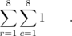
If you're familiar with computer programming, then you can think of this as a sum that could be calculated using a loop nested inside another loop. To evaluate the result (again, assuming we don't know how to multiply, so we have to use brute force), we can first evaluate the inside sum, which equals 8, giving
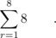
Notice how the “dummy” variable c has disappeared. Finally we do the outside sum, over r, and find the result of 64.
Now imagine doing the same thing with the pixels on a TV screen. The electron beam sweeps across the screen, painting the pixels in each row, one at a time. This is really no different than the example of the chess board, but because the pixels are so small, you normally think of the image on a TV screen as continuous rather than discrete. This is the idea of an integral in calculus. Suppose we want to find the area of a rectangle of width a and height b, and we don't know that we can just multiply to get the area ab. The brute force way to do this is to break up the rectangle into a grid of infinitesimally small squares, each having width d x and height d y, and therefore the infinitesimal area d A = d x d y. For convenience, we'll imagine that the rectangle's lower left corner is at the origin. Then the area is given by this integral:
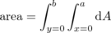
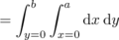
Notice how the leftmost integral sign, over y, and the rightmost differential, d y, act like bookends, or the pieces of bread on a sandwich. Inside them, we have the integral sign that runs over x, and the differential d x that matches it on the right. Finally, on the innermost layer, we'd normally have the thing we're integrating, but here's it's 1, so I've omitted it. Writing the lower limits of the integrals with x= and y= helps to keep it straight which integral goes with with differential. The result is
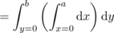
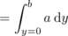
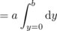
= ab .

Example 18: Area of a triangle
◊ Find the area of a 45-45-90 right triangle having legs a.
◊ Let the triangle's hypotenuse run from the origin to the point (a,a), and let its legs run from the origin to (0,a), and then to (a,a). In other words, the triangle sits on top of its hypotenuse. Then the integral can be set up the same way as the one before, but for a particular value of y, values of x only run from 0 (on the y axis) to y (on the hypotenuse). We then have
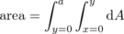
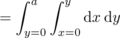
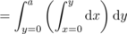
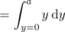
Note that in this example, because the upper end of the x values depends on the value of y, it makes a difference which order we do the integrals in. The x integral has to be on the inside, and we have to do it first.

Example 19: Volume of a cube
◊ Find the volume of a cube with sides of length a.
◊ This is a three-dimensional example, so we'll have integrals nested three deep, and the thing we're integrating is the volume d V = d x d y d z.
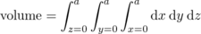
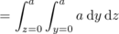
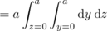
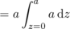
= a³

Example 20: Area of a circle
◊ Find the area of a circle.
◊ To make it easy, let's find the area of a semicircle and then double it. Let the circle's radius be r, and let it be centered on the origin and bounded below by the x axis. Then the curved edge is given by the equation r²=x²+y², or . Since the y integral's limit depends on x, the x integral has to be on the outside. The area is
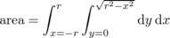
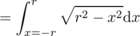
The definite integal equals π, as you can find using a trig substitution or simply by looking it up in a table, and the result is, as expected, π r²/2 for the area of the semicircle.
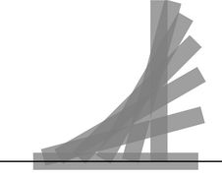
i / Example 22.

Finding moments of inertia by integration
When calculating the moment of inertia of an ordinary-sized object with perhaps 10²⁶ atoms, it would be impossible to do an actual sum over atoms, even with the world's fastest supercomputer. Calculus, however, offers a tool, the integral, for breaking a sum down to infinitely many small parts. If we don't worry about the existence of atoms, then we can use an integral to compute a moment of inertia as if the object was smooth and continuous throughout, rather than granular at the atomic level. Of course this granularity typically has a negligible effect on the result unless the object is itself an individual molecule. This subsection consists of three examples of how to do such a computation, at three distinct levels of mathematical complication.

Moment of inertia of a thin rod
What is the moment of inertia of a thin rod of mass M and length L about a line perpendicular to the rod and passing through its center? We generalize the discrete sum
to a continuous one,
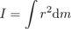
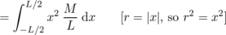
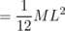
In this example the object was one-dimensional, which made the math simple. The next example shows a strategy that can be used to simplify the math for objects that are three-dimensional, but possess some kind of symmetry.

Moment of inertia of a disk
What is the moment of inertia of a disk of radius b, thickness t, and mass M, for rotation about its central axis?
We break the disk down into concentric circular rings of thickness d r. Since all the mass in a given circular slice has essentially the same value of r (ranging only from r to r+d r), the slice's contribution to the total moment of inertia is simply r²d m. We then have
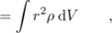
where V=π b² t is the total volume, ρ=M/V=M/π b² t is the density, and the volume of one slice can be calculated as the volume enclosed by its outer surface minus the volume enclosed by its inner surface, d V= π (r+d r)² t - π r² t = 2π tr d r.
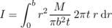
In the most general case where there is no symmetry about the rotation axis, we must use iterated integrals, as discussed in subsection 4.2.4. The example of the disk possessed two types of symmetry with respect to the rotation axis: (1) the disk is the same when rotated through any angle about the axis, and (2) all slices perpendicular to the axis are the same. These two symmetries reduced the number of layers of integrals from three to one. The following example possesses only one symmetry, of type (2), and we simply set it up as a triple integral. You may not have seen multiple integrals yet in a math course. If so, just skim this example.

Moment of inertia of a cube
What is the moment of inertia of a cube of side b, for rotation about an axis that passes through its center and is parallel to four of its faces? Let the origin be at the center of the cube, and let x be the rotation axis.
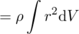
d x d y d z
d y d z
The fact that the last step is a trivial integral results from the symmetry of the problem. The integrand of the remaining double integral breaks down into two terms, each of which depends on only one of the variables, so we break it into two integrals,
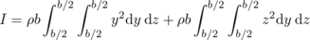
which we know have identical results. We therefore only need to evaluate one of them and double the result:
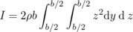
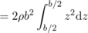
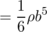
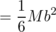
Figure h shows the moments of inertia of some shapes, which were evaluated with techniques like these.
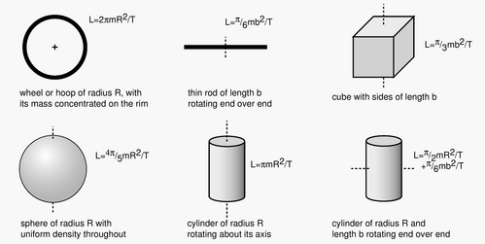
h / Momenta of inertia of some geometric shapes.

Example 21: The hammer throw
◊ In the men's Olympic hammer throw, a steel ball of radius 6.1 cm is swung on the end of a wire of length 1.22 m. What fraction of the ball's angular momentum comes from its rotation, as opposed to its motion through space?
◊ It's always important to solve problems symbolically first, and plug in numbers only at the end, so let the radius of the ball be b, and the length of the wire . If the time the ball takes to go once around the circle is T, then this is also the time it takes to revolve once around its own axis. Its speed is , so its angular momentum due to its motion through space is . Its angular momentum due to its rotation around its own center is (4π/5)mb²/T. The ratio of these two angular momenta is . The angular momentum due to the ball's spin is extremely small.

Example 22: Toppling a rod
◊ A rod of length b and mass m stands upright. We want to strike the rod at the bottom, causing it to fall and land flat. Find the momentum, p, that should be delivered, in terms of m, b, and g. Can this really be done without having the rod scrape on the floor?
◊ This is a nice example of a question that can very nearly be answered based only on units. Since the three variables, m, b, and g, all have different units, they can't be added or subtracted. The only way to combine them mathematically is by multiplication or division. Multiplying one of them by itself is exponentiation, so in general we expect that the answer must be of the form
p = A m^{j} b^{k} g^{l} ,
where A, j, k, and l are unitless constants. The result has to have units of kg⋅m/s. To get kilograms to the first power, we need
j=1 ,
meters to the first power requires
k+l=1 ,
and seconds to the power -1 implies
l=1/2 .
We find j=1, k=1/2, and l=1/2, so the solution must be of the form
Note that no physics was required!
Consideration of units, however, won't help us to find the unitless constant A. Let t be the time the rod takes to fall, so that (1/2)gt²=b/2. If the rod is going to land exactly on its side, then the number of revolutions it completes while in the air must be 1/4, or 3/4, or 5/4, ..., but all the possibilities greater than 1/4 would cause the head of the rod to collide with the floor prematurely. The rod must therefore rotate at a rate that would cause it to complete a full rotation in a time T=4t, and it has angular momentum L=(π/6)mb²/T.
The momentum lost by the object striking the rod is p, and by conservation of momentum, this is the amount of momentum, in the horizontal direction, that the rod acquires. In other words, the rod will fly forward a little. However, this has no effect on the solution to the problem. More importantly, the object striking the rod loses angular momentum bp/2, which is also transferred to the rod. Equating this to the expression above for L, we find .
Finally, we need to know whether this can really be done without having the foot of the rod scrape on the floor. The figure shows that the answer is no for this rod of finite width, but it appears that the answer would be yes for a sufficiently thin rod. This is analyzed further in homework problem 37 on page 239.

4.3 Angular Momentum in Three Dimensions
Conservation of angular momentum produces some surprising phenomena when extended to three dimensions. Try the following experiment, for example. Take off your shoe, and toss it in to the air, making it spin along its long (toe-to-heel) axis. You should observe a nice steady pattern of rotation. The same happens when you spin the shoe about its shortest (top-to-bottom) axis. But something unexpected happens when you spin it about its third (left-to-right) axis, which is intermediate in length between the other two. Instead of a steady pattern of rotation, you will observe something more complicated, with the shoe changing its orientation with respect to the rotation axis.
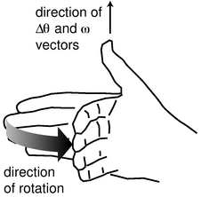
b / The right-hand rule for associating a vector with a direction of rotation.

Rigid-body kinematics in three dimensions
How do we generalize rigid-body kinematics to three dimensions? When we wanted to generalize the kinematics of a moving particle to three dimensions, we made the numbers r, v, and a into vectors r, v, and a. This worked because these quantities all obeyed the same laws of vector addition. For instance, one of the laws of vector addition is that, just like addition of numbers, vector addition gives the same result regardless of the order of the two quantities being added. Thus you can step sideways 1 m to the right and then step forward 1 m, and the end result is the same as if you stepped forward first and then to the side. In order words, it didn't matter whether you took Δr₁+Δr₂ or Δr₂+Δr₁. In math this is called the commutative property of addition.
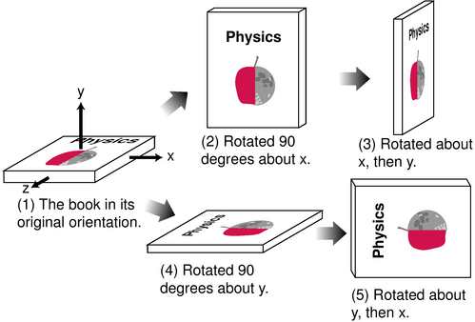
a / Performing the rotations in one order gives one result, 3, while reversing the order gives a different result, 5.
Angular motion, unfortunately doesn't have this property, as shown in figure a. Doing a rotation about the x axis and then about y gives one result, while doing them in the opposite order gives a different result. These operations don't “commute,” i.e. it makes a difference what order you do them in.
This means that there is in general no possible way to construct a vector. However, if you try doing the operations shown in figure a using small rotation, say about 10 degrees instead of 90, you'll find that the result is nearly the same regardless of what order you use; small rotations are very nearly commutative. Not only that, but the result of the two 10-degree rotations is about the same as a single, somewhat larger, rotation about an axis that lies symmetrically at between the x and y axes at 45 degree angles to each one. This is exactly what we would expect if the two small rotations did act like vectors whose directions were along the axis of rotation. We therefore define a vector whose magnitude is the amount of rotation in units of radians, and whose direction is along the axis of rotation. Actually this definition is ambiguous, because there it could point in either direction along the axis. We therefore use a right-hand rule as shown in figure b to define the direction of the vector, and the vector, , based on it. Aliens on planet Tammyfaye may decide to define it using their left hands rather than their right, but as long as they keep their scientific literature separate from ours, there is no problem. When entering a physics exam, always be sure to write a large warning note on your left hand in magic marker so that you won't be tempted to use it for the right-hand rule while keeping your pen in your right.
self-check: Use the right-hand rule to determine the directions of the vectors in each rotation shown in figures a/1 through a/5. (answer in the back of the PDF version of the book)
Because the vector relationships among , , and are strictly analogous to the ones involving dr, v, and a (with the proviso that we avoid describing large rotations using vectors), any operation in r-v-a vector kinematics has an exact analog in -- kinematics.

Example 23: Result of successive 10-degree rotations
◊ What is the result of two successive (positive) 10-degree rotations about the x and y axes? That is, what single rotation about a single axis would be equivalent to executing these in succession?
◊ The result is only going to be approximate, since 10 degrees is not an infinitesimally small angle, and we are not told in what order the rotations occur. To some approximation, however, we can add the vectors in exactly the same way we would add Δ r vectors, so we have
This is a vector with a magnitude of , and it points along an axis midway between the x and y axes.
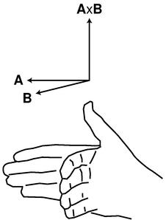
c / The right-hand rule for the direction of the vector cross product.
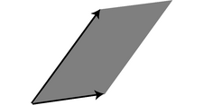
d / The magnitude of the cross product is the area of the shaded parallelogram.
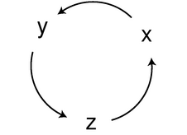
e / A cyclic change in the x, y, and z subscripts.
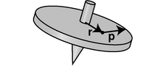
f / The position and momentum vectors of an atom in the spinning top.

g / The right-hand rule for the atom's contribution to the angular momentum.
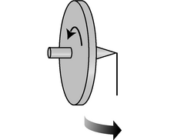
h / A top is supported at its tip by a pinhead. (More practical devices to demonstrate this would use a double bearing.)
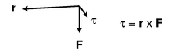
i / The torque made by gravity is in the horizontal plane.

j / The ΔL vector is in the same direction as the torque, out of the page.

k / Example 27.

Angular momentum in three dimensions

The vector cross product
In order to expand our system of three-dimensional kinematics to include dynamics, we will have to generalize equations like v_{t}=ω r, τ=rF sinθ_{rF}, and L=rp sinθ_{rp}, each of which involves three quantities that we have either already defined as vectors or that we want to redefine as vectors. Although the first one appears to differ from the others in its form, it could just as well be rewritten as v_{t}=ω r sinθ_{ω r}, since θ_{ω r}=90°, and sinθ_{ω r}=1.
It thus appears that we have discovered something general about the physically useful way to relate three vectors in a multiplicative way: the magnitude of the result always seems to be proportional to the product of the magnitudes of the two vectors being “multiplied,” and also to the sine of the angle between them.
Is this pattern just an accident? Actually the sine factor has a very important physical property: it goes to zero when the two vectors are parallel. This is a Good Thing. The generalization of angular momentum into a three-dimensional vector, for example, is presumably going to describe not just the clockwise or counterclockwise nature of the motion but also from which direction we would have to view the motion so that it was clockwise or counterclockwise. (A clock's hands go counterclockwise as seen from behind the clock, and don't rotate at all as seen from above or to the side.) Now suppose a particle is moving directly away from the origin, so that its r and p vectors are parallel. It is not going around the origin from any point of view, so its angular momentum vector had better be zero.
Thinking in a slightly more abstract way, we would expect the angular momentum vector to point perpendicular to the plane of motion, just as the angular velocity vector points perpendicular to the plane of motion. The plane of motion is the plane containing both r and p, if we place the two vectors tail-to-tail. But if r and p are parallel and are placed tail-to-tail, then there are infinitely many planes containing them both. To pick one of these planes in preference to the others would violate the symmetry of space, since they should all be equally good. Thus the zero-if-parallel property is a necessary consequence of the underlying symmetry of the laws of physics.
The following definition of a kind of vector multiplication is consistent with everything we've seen so far, and later we'll prove that the definition is unique, i.e. if we believe in the symmetry of space, it is essentially the only way of defining the multiplication of two vectors to produce a third vector:
\mythmhdr{Definition of the vector cross product}
The cross product A×B of two vectors A and B is defined as follows:
(1) Its magnitude is defined by |A×B| = |A| |B| sinθ_{AB}, where θ_{AB} is the angle between A and B when they are placed tail-to-tail.
(2) Its direction is along the line perpendicular to both A and B. Of the two such directions, it is the one that obeys the right-hand rule shown in figure c.
The name “cross product” refers to the symbol, and distinguishes it from the dot product, which acts on two vectors but produces a scalar.
Although the vector cross-product has nearly all the properties of numerical multiplication, e.g. A×(B+C) = A×B+A×C, it lacks the usual property of commutativity. Try applying the right-hand rule to find the direction of the vector cross product B×A using the two vectors shown in the figure. This requires starting with a flattened hand with the four fingers pointing along B, and then curling the hand so that the fingers point along A. The only possible way to do this is to point your thumb toward the floor, in the opposite direction. Thus for the vector cross product we have
A×B = -B×A ,
a property known as anticommutativity. The vector cross product is also not associative, i.e. A×(B×C) is usually not the same as (A×B)×C.
A geometric interpretation of the cross product, d, is that if both A and B are vectors with units of distance, then the magnitude of their cross product can be interpreted as the area of the parallelogram they form when placed tail-to-tail.
A useful expression for the components of the vector cross product in terms of the components of the two vectors being multiplied is as follows:
(A×B)_{x} = A_{y}B_{z} - B_{y}A_{z}
(A×B)_{y} = A_{z}B_{x} - B_{z}A_{x}
(A×B)_{z} = A_{x}B_{y} - B_{x}A_{y}
I'll prove later that these expressions are equivalent to the previous definition of the cross product. Although they may appear formidable, they have a simple structure: the subscripts on the right are the other two besides the one on the left, and each equation is related to the preceding one by a cyclic change in the subscripts, e. If the subscripts were not treated in some completely symmetric manner like this, then the definition would provide some way to distinguish one axis from another, which would violate the symmetry of space.
self-check: Show that the component equations are consistent with the rule A×B = -B×A. (answer in the back of the PDF version of the book)

Angular momentum in three dimensions
In terms of the vector cross product, we have:
L = r × p
But wait, how do we know these equations are even correct? For instance, how do we know that the quantity defined by r×p is in fact conserved? Well, just as we saw on page 168 that the dot product is unique (i.e., can only be defined in one way while observing rotational invariance), the cross product is also unique, as proved on page 742. If r×p was not conserved, then there could not be any generally conserved quantity that would reduce to our old definition of angular momentum in the special case of plane rotation. This doesn't prove conservation of angular momentum --- only experiments can prove that --- but it does prove that if angular momentum is conserved in three dimensions, there is only one possible way to generalize from two dimensions to three.

Example 24: Angular momentum of a spinning top
As an illustration, we consider the angular momentum of a spinning top. Figures f and g show the use of the vector cross product to determine the contribution of a representative atom to the total angular momentum. Since every other atom's angular momentum vector will be in the same direction, this will also be the direction of the total angular momentum of the top. This happens to be rigid-body rotation, and perhaps not surprisingly, the angular momentum vector is along the same direction as the angular velocity vector.
Three important points are illustrated by this example: (1) When we do the full three-dimensional treatment of angular momentum, the “axis” from which we measure the position vectors is just an arbitrarily chosen point. If this had not been rigid-body rotation, we would not even have been able to identify a single line about which every atom circled. (2) Starting from figure f, we had to rearrange the vectors to get them tail-to-tail before applying the right-hand rule. If we had attempted to apply the right-hand rule to figure f, the direction of the result would have been exactly the opposite of the correct answer. (3) The equation L=r×p cannot be applied all at once to an entire system of particles. The total momentum of the top is zero, which would give an erroneous result of zero angular momentum (never mind the fact that r is not well defined for the top as a whole).
Doing the right-hand rule like this requires some practice. I urge you to make models like g out of rolled up pieces of paper and to practice with the model in various orientations until it becomes natural.

Example 25: Precession
Figure h shows a counterintuitive example of the concepts we've been discussing. One expects the torque due to gravity to cause the top to flop down. Instead, the top remains spinning in the horizontal plane, but its axis of rotation starts moving in the direction shown by the shaded arrow. This phenomenon is called precession. Figure i shows that the torque due to gravity is out of the page. (Actually we should add up all the torques on all the atoms in the top, but the qualitative result is the same.) Since torque is the rate of change of angular momentum, , the ΔL vector must be in the same direction as the torque (division by a positive scalar doesn't change the direction of the vector). As shown in j, this causes the angular momentum vector to twist in space without changing its magnitude.
For similar reasons, the Earth's axis precesses once every 26,000 years (although not through a great circle, since the angle between the axis and the force isn't 90 degrees as in figure h). This precession is due to a torque exerted by the moon. If the Earth was a perfect sphere, there could be no precession effect due to symmetry. However, the Earth's own rotation causes it to be slightly flattened (oblate) relative to a perfect sphere, giving it “love handles” on which the moon's gravity can act. The moon's gravity on the nearer side of the equatorial bulge is stronger, so the torques do not cancel out perfectly. Presently the earth's axis very nearly lines up with the star Polaris, but in 12,000 years, the pole star will be Vega instead.

Example 26: The frisbee
The flow of the air over a flying frisbee generates lift, and the lift at the front and back of the frisbee isn't necessarily balanced. If you throw a frisbee without rotating it, as if you were shooting a basketball with two hands, you'll find that it pitches, i.e., its nose goes either up or down. When I do this with my frisbee, it goes nose down, which apparently means that the lift at the back of the disc is greater than the lift at the front. The two torques are unbalanced, resulting in a total torque that points to the left.
The way you actually throw a frisbee is with one hand, putting a lot of spin on it. If you throw backhand, which is how most people first learn to do it, the angular momentum vector points down (assuming you're right-handed). On my frisbee, the aerodynamic torque to the left would therefore tend to make the angular momentum vector precess in the clockwise direction as seen by the thrower. This would cause the disc to roll to the right, and therefore follow a curved trajectory. Some specialized discs, used in the sport of disc golf, are actually designed intentionally to show this behavior; they're known as “understable” discs. However, the typical frisbee that most people play with is designed to be stable: as the disc rolls to one side, the airflow around it is altered in way that tends to bring the disc back into level flight. Such a disc will therefore tend to fly in a straight line, provided that it is thrown with enough angular momentum.

Example 27: Finding a cross product by components
◊ What is the torque produced by a force given by (in units of Newtons) acting on a point whose radius vector is (in meters)?
◊ It's helpful to make a table of the components as shown in the figure. The results are \begin{alignat*}{2} \tau_x = r_{y} F_{z} - F_y r_{z} =& 15 \nunit\unitdotm
\tau_y = r_{z} F_x - F_{z} r_{x} =& - 12 \nunit\unitdotm
\tau_z = r_x F_{y} - F_{x} r_y =& 3 \nunit\unitdotm \end{alignat*}

Example 28: Torque and angular momentum
In this example, we prove explicitly the consistency of the equations involving torque and angular momentum that we proved above based purely on symmetry. The proof uses calculus. Starting from the definition of torque, we have
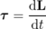
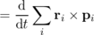
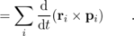
The derivative of a cross product can be evaluated in the same was as the derivative of an ordinary scalar product:
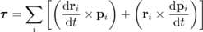
The first term is zero for each particle, since the velocity vector is parallel to the momentum vector. The derivative appearing in the second term is the force acting on the particle, so
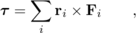
which is the relationship we set out to prove.
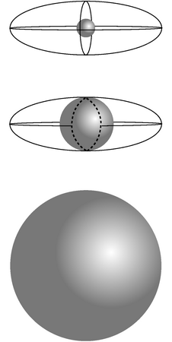
l / Visualizing surfaces of constant energy and angular momentum in L_{x}-L_{y}-L_{z} space.
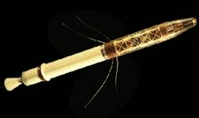
m / The Explorer I satellite.

Rigid-body dynamics in three dimensions
The student who is not madly in love with mathematics may wish to skip the rest of this section after absorbing the statement that, for a typical, asymmetric object, the angular momentum vector and the angular velocity vector need not be parallel. That is, only for a body that possesses symmetry about the rotation axis is it true that (the rotational equivalent of p=mv) for some scalar I.
Let's evaluate the angular momentum of a rigidly rotating system of particles:
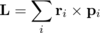
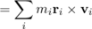
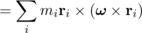
An important mathematical skill is to know when to give up and back off. This is a complicated expression, and there is no reason to expect it to simplify and, for example, take the form of a scalar multiplied by ω. Instead we examine its general characteristics. If we expanded it using the equation that gives the components of a vector cross product, every term would have one of the ω components raised to the first power, multiplied by a bunch of other stuff. The most general possible form for the result is
L_{x} = I_{xx}ω_{x} + I_{xy}ω_{y} + I_{xz}ω_{z}
L_{y} = I_{yx}ω_{x} + I_{yy}ω_{y} + I_{yz}ω_{z}
L_{z} = I_{zx}ω_{x} + I_{zy}ω_{y} + I_{zz}ω_{z} ,
which you may recognize as a case of matrix multiplication. The moment of inertia is not a scalar, and not a three-component vector. It is a matrix specified by nine numbers, called its matrix elements.
The elements of the moment of inertia matrix will depend on our choice of a coordinate system. In general, there will be some special coordinate system, in which the matrix has a simple diagonal form: \begin{alignat*}{2} L_x = I_{xx}\omega_x & &
L_y = & I_{yy}\omega_y &
L_z = & & I_{zz}\omega_z . \end{alignat*}
The three special axes that cause this simplification are called the principal axes of the object, and the corresponding coordinate system is the principal axis system. For symmetric shapes such as a rectangular box or an ellipsoid, the principal axes lie along the intersections of the three symmetry planes, but even an asymmetric body has principal axes.
We can also generalize the plane-rotation equation K=(1/2)Iω² to three dimensions as follows:
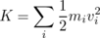
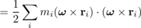
We want an equation involving the moment of inertia, and this has some evident similarities to the sum we originally wrote down for the moment of inertia. To massage it into the right shape, we need the vector identity (A×B)⋅C= (B×C) ⋅ A, which we state without proof. We then write
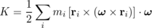
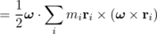
As a reward for all this hard work, let's analyze the problem of the spinning shoe that I posed at the beginning of the chapter. The three rotation axes referred to there are approximately the principal axes of the shoe. While the shoe is in the air, no external torques are acting on it, so its angular momentum vector must be constant in magnitude and direction. Its kinetic energy is also constant. That's in the room's frame of reference, however. The principal axis frame is attached to the shoe, and tumbles madly along with it. In the principal axis frame, the kinetic energy and the magnitude of the angular momentum stay constant, but the actual direction of the angular momentum need not stay fixed (as you saw in the case of rotation that was initially about the intermediate-length axis). Constant |L| gives
L_{x}² + L_{y}²+ L_{z}² = constant .
In the principal axis frame, it's easy to solve for the components of in terms of the components of L, so we eliminate ω from the expression , giving
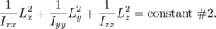
The first equation is the equation of a sphere in the three dimensional space occupied by the angular momentum vector, while the second one is the equation of an ellipsoid. The top figure corresponds to the case of rotation about the shortest axis, which has the greatest moment of inertia element. The intersection of the two surfaces consists only of the two points at the front and back of the sphere. The angular momentum is confined to one of these points, and can't change its direction, i.e. its orientation with respect to the principal axis system, which is another way of saying that the shoe can't change its orientation with respect to the angular momentum vector. In the bottom figure, the shoe is rotating about the longest axis. Now the angular momentum vector is trapped at one of the two points on the right or left. In the case of rotation about the axis with the intermediate moment of inertia element, however, the intersection of the sphere and the ellipsoid is not just a pair of isolated points but the curve shown with the dashed line. The relative orientation of the shoe and the angular momentum vector can and will change.
As an example of this, you can try tossing a box-shaped object up in the air, spinning about one of its principal axes. A book works, if you tape it shut, but I've also used a shoe. If you spin it about its intermediate-moment-of-inertia axis, it tumbles irregularly.
One more exotic example has to do with nuclear physics. Although you have probably visualized atomic nuclei as nothing more than featureless points, or perhaps tiny spheres, they are often ellipsoids with one long axis and two shorter, equal ones. Although a spinning nucleus normally gets rid of its angular momentum via gamma ray emission within a period of time on the order of picoseconds, it may happen that a deformed nucleus gets into a state in which has a large angular momentum is along its long axis, which is a very stable mode of rotation. Such states can live for seconds or even years! (There is more to the story --- this is the topic on which I wrote my Ph.D. thesis --- but the basic insight applies even though the full treatment requires fancy quantum mechanics.)
Our analysis has so far assumed that the kinetic energy of rotation energy can't be converted into other forms of energy such as heat, sound, or vibration. When this assumption fails, then rotation about the axis of least moment of inertia becomes unstable, and will eventually convert itself into rotation about the axis whose moment of inertia is greatest. This happened to the U.S.'s first artificial satellite, Explorer I, launched in 1958. It had long, floppy antennas, Note the long, floppy antennas, which tended to dissipare kinetic energy into vibration. It had been designed to spin about its minimimum-moment-of-inertia axis, but almost immediately, as soon as it was in space, it began spinning end over end. It was nevertheless able to carry out its science mission, which didn't depend on being able to maintain a stable orientation, and it discovered the Van Allen radiation belts.
\backofchapterboilerplate{4}

Homework Problems
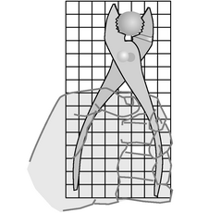
a / Problem 1.
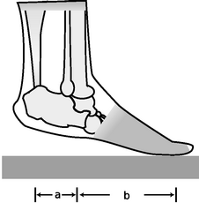
b / Problem 6.
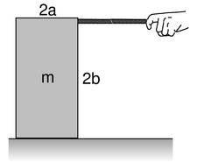
c / Problem 8.
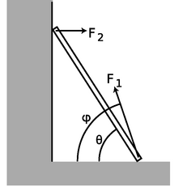
d / Problems 9 and 10.
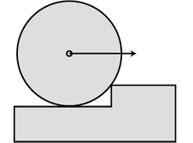
e / Problem 11.
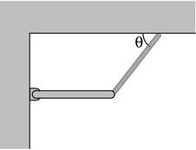
f / Problem 14.
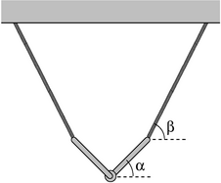
g / Problem 15.
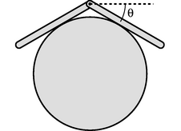
h / Problem 16.
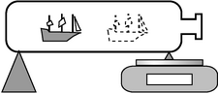
i / Problem 17.

j / Problem 22.
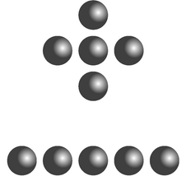
k / Problem 23
1. The figure shows scale drawing of a pair of pliers being used to crack a nut, with an appropriately reduced centimeter grid. Warning: do not attempt this at home; it is bad manners. If the force required to crack the nut is 300 N, estimate the force required of the person's hand. (solution in the pdf version of the book){hwsoln:pliers}
2. [0]{bigwrench} You are trying to loosen a stuck bolt on your RV using a big wrench that is 50 cm long. If you hang from the wrench, and your mass is 55 kg, what is the maximum torque you can exert on the bolt? (answer check available at lightandmatter.com)
3. A physical therapist wants her patient to rehabilitate his injured elbow by laying his arm flat on a table, and then lifting a 2.1 kg mass by bending his elbow. In this situation, the weight is 33 cm from his elbow. He calls her back, complaining that it hurts him to grasp the weight. He asks if he can strap a bigger weight onto his arm, only 17 cm from his elbow. How much mass should she tell him to use so that he will be exerting the same torque? (He is raising his forearm itself, as well as the weight.) (answer check available at lightandmatter.com)
4. An object thrown straight up in the air is momentarily at rest when it reaches the top of its motion. Does that mean that it is in equilibrium at that point? Explain.
5. An object is observed to have constant angular momentum. Can you conclude that no torques are acting on it? Explain. [Based on a problem by Serway and Faughn.]
6. A person of mass m stands on the ball of one foot. Find the tension in the calf muscle and the force exerted by the shinbones on the bones of the foot, in terms of m, g, a, and b. For simplicity, assume that all the forces are at 90-degree angles to the foot, i.e. neglect the angle between the foot and the floor.
7. Two objects have the same momentum vector. Can you conclude that their angular momenta are the same? Explain. [Based on a problem by Serway and Faughn.]
8. The box shown in the figure is being accelerated by pulling on it with the rope.
(a) Assume the floor is frictionless. What is the maximum force that can be applied without causing the box to tip over?
(b) Repeat part a, but now let the coefficient of kinetic friction be μ_{k}.
(c) What happens to your answer to part b when the box is sufficiently tall? How do you interpret this?
9. A uniform ladder of mass m and length leans against a smooth wall, making an angle θ with respect to the ground. The dirt exerts a normal force and a frictional force on the ladder, producing a force vector with magnitude F₁ at an angle φ with respect to the ground. Since the wall is smooth, it exerts only a normal force on the ladder; let its magnitude be F₂.
(a) Explain why φ must be greater than θ. No math is needed.
(b) Choose any numerical values you like for m and , and show that the ladder can be in equilibrium (zero torque and zero total force vector) for θ=45.00° and φ=63.43°.
10. [2]{ladderb} Continuing problem 9, find an equation for φ in terms of θ, and show that m and L do not enter into the equation. Do not assume any numerical values for any of the variables. You will need the trig identity sin(a-b) = sin a. (As a numerical check on your result, you may wish to check that the angles given in problem 9b satisfy your equation.)
11. (a) Find the minimum horizontal force which, applied at the axle, will pull a wheel over a step. Invent algebra symbols for whatever quantities you find to be relevant, and give your answer in symbolic form.
(b) Under what circumstances does your result become infinite? Give a physical interpretation. What happens to your answer when the height of the curb is zero? Does this make sense? \hwhint{hwhint:wheeloverstep}
12. A ball is connected by a string to a vertical post. The ball is set in horizontal motion so that it starts winding the string around the post. Assume that the motion is confined to a horizontal plane, i.e. ignore gravity. Michelle and Astrid are trying to predict the final velocity of the ball when it reaches the post. Michelle says that according to conservation of angular momentum, the ball has to speed up as it approaches the post. Astrid says that according to conservation of energy, the ball has to keep a constant speed. Who is right?
13. In the 1950's, serious articles began appearing in magazines like Life predicting that world domination would be achieved by the nation that could put nuclear bombs in orbiting space stations, from which they could be dropped at will. In fact it can be quite difficult to get an orbiting object to come down. Let the object have energy E=K+U and angular momentum L. Assume that the energy is negative, i.e. the object is moving at less than escape velocity. Show that it can never reach a radius less than
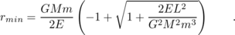
[Note that both factors are negative, giving a positive result.]
14. (a) The bar of mass m is attached at the wall with a hinge, and is supported on the right by a massless cable. Find the tension, T, in the cable in terms of the angle θ.
(b) Interpreting your answer to part a, what would be the best angle to use if we wanted to minimize the strain on the cable?
(c) Again interpreting your answer to part a, for what angles does the result misbehave mathematically? Interpet this physically.
15. (a) The two identical rods are attached to one another with a hinge, and are supported by the two massless cables. Find the angle α in terms of the angle β, and show that the result is a purely geometric one, independent of the other variables involved.
(b) Using your answer to part a, sketch the configurations for β→ 0, β= 45°, and β= 90°. Do your results make sense intuitively?
16. [2]{hingeoncylinder} Two bars of length are connected with a hinge and placed on a frictionless cylinder of radius r. (a) Show that the angle θ shown in the figure is related to the unitless ratio by the equation
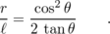
(b) Discuss the physical behavior of this equation for very large and very small values of .
17. You wish to determine the mass of a ship in a bottle without taking it out. Show that this can be done with the setup shown in the figure, with a scale supporting the bottle at one end, provided that it is possible to take readings with the ship slid to two different locations.
18. Suppose that we lived in a universe in which Newton's law of gravity gave forces proportional to r⁻⁷ rather than r⁻². Which, if any, of Kepler's laws would still be true? Which would be completely false? Which would be different, but in a way that could be calculated with straightforward algebra?
19. [0]{anganalogies} Use analogies to find the equivalents of the following equations for rotation in a plane:
K = p²/2m
Δ x = v_{o}Δ t + (1/2)aΔ t²
W = F Δ x
Example: v = Δ x/Δ t → ω = Δθ/Δ t
20. For a one-dimensional harmonic oscillator, the solution to the energy conservation equation,
is an oscillation with frequency .
Now consider an analogous system consisting of a bar magnet hung from a thread, which acts like a magnetic compass. A normal compass is full of water, so its oscillations are strongly damped, but the magnet-on-a-thread compass has very little friction, and will oscillate repeatedly around its equilibrium direction. The magnetic energy of the bar magnet is
U = -Bmcosθ ,
where B is a constant that measures the strength of the earth's magnetic field, m is a constant that parametrizes the strength of the magnet, and θ is the angle, measured in radians, between the bar magnet and magnetic north. The equilibrium occurs at θ=0, which is the minimum of U.
(a) For small θ, the magnetic energy can be approximated by U≈(1/2)κθ². Relate κ to the other quantities. (Assume the thread is so thin that it does not have any significant effect compared to earth's magnetic field.)
(b) Problem 19 gave some examples of how to construct analogies between rotational and linear motion. Use a similar technique to solve for the frequency of the compass's vibrations, stating your result in terms of the variables that will be relevant.
21. [0]{earthangkinematics} (a) Find the angular velocities of the earth's rotation and of the earth's motion around the sun.
(b) Which motion involves the greater acceleration?
22. The sun turns on its axis once every 26.0 days. Its mass is 2.0×10³⁰ kg and its radius is 7.0×10⁸ m. Assume it is a rigid sphere of uniform density.
(a) What is the sun's angular momentum? (answer check available at lightandmatter.com)
In a few billion years, astrophysicists predict that the sun will use up all its sources of nuclear energy, and will collapse into a ball of exotic, dense matter known as a white dwarf. Assume that its radius becomes 5.8×10⁶ m (similar to the size of the Earth.) Assume it does not lose any mass between now and then. (Don't be fooled by the photo, which makes it look like nearly all of the star was thrown off by the explosion. The visually prominent gas cloud is actually thinner than the best laboratory vacuum every produced on earth. Certainly a little bit of mass is actually lost, but it is not at all unreasonable to make an approximation of zero loss of mass as we are doing.
(b) What will its angular momentum be?
(c) How long will it take to turn once on its axis? (answer check available at lightandmatter.com)
23. Give a numerical comparison of the two molecules' moments of inertia for rotation in the plane of the page about their centers of mass.
24. [2]{yoyo} A yo-yo of total mass m consists of two solid cylinders of radius R, connected by a small spindle of negligible mass and radius r. The top of the string is held motionless while the string unrolls from the spindle. Show that the acceleration of the yo-yo is g/(1+R²/2r²).
25. Show that a sphere of radius R that is rolling without slipping has angular momentum and momentum in the ratio L/p=(2/5)R.
26. Suppose a bowling ball is initially thrown so that it has no angular momentum at all, i.e. it is initially just sliding down the lane. Eventually kinetic friction will bring its angular velocity up to the point where it is rolling without slipping. Show that the final velocity of the ball equals 5/7 of its initial velocity. You'll need the result of problem 25.
27. [0]{amcrossprodplugin} Find the angular momentum of a particle whose position is (in meters) and whose momentum is (in kg⋅m/s).
28. [0]{findperp} Find a vector that is perpendicular to both of the following two vectors:
29. Prove property (3) of the vector cross product from the theorem in on page 742.
30. [0]{proveanticommutative} Prove the anticommutative property of the vector cross product, A×B = -B×A, using the expressions for the components of the cross product.
31. Find two vectors with which you can demonstrate that the vector cross product need not be associative, i.e. that A×(B×C) need not be the same as (A×B)×C.
32. [0]{xnonsense} Which of the following expressions make sense, and which are nonsense? For those that make sense, indicate whether the result is a vector or a scalar.
(a) (A×B)×C
(b) (A×B)⋅C
(c) (A⋅B)×C
33. Find the moment of inertia for rotation about its axis of a cone whose mass is M, whose height is h, and whose base has a radius b.
34. Find the moment of inertia of a rectangular box of mass M whose sides are of length a, b, and c, for rotation about an axis through its center parallel to the edges of length a.
35. The nucleus ¹⁶⁸Er (erbium-168) contains 68 protons (which is what makes it a nucleus of the element erbium) and 100 neutrons. It has an ellipsoidal shape like an American football, with one long axis and two short axes that are of equal diameter. Because this is a subatomic system, consisting of only 168 particles, its behavior shows some clear quantum-mechanical properties. It can only have certain energy levels, and it makes quantum leaps between these levels. Also, its angular momentum can only have certain values, which are all multiples of 2.109×10⁻³⁴ kg⋅m²/s. The table shows some of the observed angular momenta and energies of ¹⁶⁸Er, in SI units (kg⋅m²/s and joules).
L×10³⁴ | E×10¹⁷
0 | 0
2.109 | 1.2786
4.218 | 4.2311
6.327 | 8.7919
8.437 | 14.8731
10.546 | 22.3798
12.655 | 31.135
14.764 | 41.206
16.873 | 52.223
(a) These data can be described to a good approximation as a rigid end-over-end rotation. Estimate a single best-fit value for the moment of inertia from the data, and check how well the data agree with the assumption of rigid-body rotation.
(b) Check whether this moment of inertia is on the right order of magnitude. The moment of inertia depends on both the size and the shape of the nucleus. For the sake of this rough check, ignore the fact that the nucleus is not quite spherical. To estimate its size, use the fact that a neutron or proton has a volume of about 1 fm³ (one cubic femtometer, where 1 fm=10⁻¹⁵ m), and assume they are closely packed in the nucleus. \hwhint{hwhint:erbium}
36. [2]{ellipsoidmoi} Find the moment of inertia matrix of an ellipsoid with axes of lengths a, b, and c, in the principal-axis frame, and with the axis at the center. Rather than starting directly from the results given in the text, you'll have an easier time if you us the following reformulation of the moment of inertia matrix: 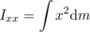, etc.
37. [2]{toppling-rod} (solution in the pdf version of the book){hwsoln:toppling-rod} In example 22 on page 221, prove that if the rod is sufficiently thin, it can be toppled without scraping on the floor.
\begin{exsection}
\extitle{A}{Torque}
Equipment:
- rulers with holes in them
- spring scales (two per group)
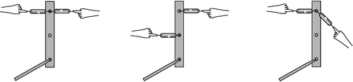While one person holds the pencil which forms the axle for the ruler, the other members of the group pull on the scale and take readings. In each case, calculate the total torque on the ruler, and find out whether it equals zero to roughly within the accuracy of the experiment. \end{exsection}

Footnotes
[1] We assume that the door is much more massive than the blob. Under this assumption, the speed at which the door recoils is much less than the original speed of the blob, so the blob has lost essentially all its angular momentum, and given it to the door.
[2] A proof is given in example 28 on page 229

5. Thermodynamics
Table of Contents

Contents
Section 5.1 - Pressure and Temperature
Section 5.2 - Microscopic Description of an Ideal Gas
Section 5.3 - Entropy as a Macroscopic Quantity
Section 5.4 - Entropy as a Microscopic Quantity (Optional)
Section 5.5 - More about Heat Engines (Optional)

Chapter 5. Thermodynamics
S=k log W -- Inscription on the tomb of Ludwig Boltzmann, 1844-1906. Boltzmann, who originated the microscopic theory of thermodynamics, was driven to suicide by the criticism of his peers, who thought that physical theories shouldn't discuss purely hypothetical objects like atoms.
In a developing country like China, a refrigerator is the mark of a family that has arrived in the middle class, and a car is the ultimate symbol of wealth. Both of these are heat engines: devices for converting between heat and other forms of energy. Unfortunately for the Chinese, neither is a very efficient device. Burning fossil fuels has made China's big cities the most polluted on the planet, and the country's total energy supply isn't sufficient to support American levels of energy consumption by more than a small fraction of China's population. Could we somehow manipulate energy in a more efficient way?
Conservation of energy is a statement that the total amount of energy is constant at all times, which encourages us to believe that any energy transformation can be undone --- indeed, the laws of physics you've learned so far don't even distinguish the past from the future. If you get in a car and drive around the block, the net effect is to consume some of the energy you paid for at the gas station, using it to heat the neighborhood. There would not seem to be any fundamental physical principle to prevent you from recapturing all that heat and using it again the next time you want to go for a drive. More modestly, why don't engineers design a car engine so that it recaptures the heat energy that would otherwise be wasted via the radiator and the exhaust?
Hard experience, however, has shown that designers of more and more efficient engines run into a brick wall at a certain point. The generators that the electric company uses to produce energy at an oil-fueled plant are indeed much more efficient than a car engine, but even if one is willing to accept a device that is very large, expensive, and complex, it turns out to be impossible to make a perfectly efficient heat engine --- not just impossible with present-day technology, but impossible due to a set of fundamental physical principles known as the science of thermodynamics. And thermodynamics isn't just a pesky set of constraints on heat engines. Without thermodynamics, there is no way to explain the direction of time's arrow --- why we can remember the past but not the future, and why it's easier to break Humpty Dumpty than to put him back together again.

5.1 Pressure and Temperature
When we heat an object, we speed up the mind-bogglingly complex random motion of its molecules. One method for taming complexity is the conservation laws, since they tell us that certain things must remain constant regardless of what process is going on. Indeed, the law of conservation of energy is also known as the first law of thermodynamics.
But as alluded to in the introduction to this chapter, conservation of energy by itself is not powerful enough to explain certain empirical facts about heat. A second way to sidestep the complexity of heat is to ignore heat's atomic nature and concentrate on quantities like temperature and pressure that tell us about a system's properties as a whole. This approach is called macroscopic in contrast to the microscopic method of attack. Pressure and temperature were fairly well understood in the age of Newton and Galileo, hundreds of years before there was any firm evidence that atoms and molecules even existed.
Unlike the conserved quantities such as mass, energy, momentum, and angular momentum, neither pressure nor temperature is additive. Two cups of coffee have twice the heat energy of a single cup, but they do not have twice the temperature. Likewise, the painful pressure on your eardrums at the bottom of a pool is not affected if you insert or remove a partition between the two halves of the pool.
We restrict ourselves to a discussion of pressure in fluids at rest and in equilibrium. In physics, the term “fluid” is used to mean either a gas or a liquid. The important feature of a fluid can be demonstrated by comparing with a cube of jello on a plate. The jello is a solid. If you shake the plate from side to side, the jello will respond by shearing, i.e. by slanting its sides, but it will tend to spring back into its original shape. A solid can sustain shear forces, but a fluid cannot. A fluid does not resist a change in shape unless it involves a change in volume.
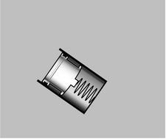
a / A simple pressure gauge consists of a cylinder open at one end, with a piston and a spring inside. The depth to which the spring is depressed is a measure of the pressure. To determine the absolute pressure, the air needs to be pumped out of the interior of the gauge, so that there is no air pressure acting outward on the piston. In many practical gauges, the back of the piston is open to the atmosphere, so the pressure the gauge registers equals the pressure of the fluid minus the pressure of the atmosphere.
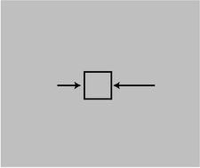
b / This doesn't happen. If pressure could vary horizontally in equilibrium, the cube of water would accelerate horizontally. This is a contradiction, since we assumed the fluid was in equilibrium.
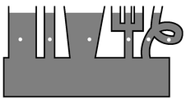
c / The pressure is the same at all the points marked with dots.
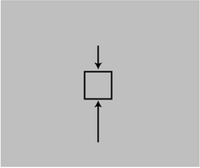
d / This does happen. The sum of the forces from the surrounding parts of the fluid is upward, canceling the downward force of gravity.

Pressure
If you're at the bottom of a pool, you can't relieve the pain in your ears by turning your head. The water's force on your eardrum is always the same, and is always perpendicular to the surface where the eardrum contacts the water. If your ear is on the east side of your head, the water's force is to the west. If you keep your ear in the same spot while turning around so your ear is on the north, the force will still be the same in magnitude, and it will change its direction so that it is still perpendicular to the eardrum: south. This shows that pressure has no direction in space, i.e. it is a scalar. The direction of the force is determined by the orientation of the surface on which the pressure acts, not by the pressure itself. A fluid flowing over a surface can also exert frictional forces, which are parallel to the surface, but the present discussion is restricted to fluids at rest.
Experiments also show that a fluid's force on a surface is proportional to the surface area. The vast force of the water behind a dam, for example, in proportion to the dam's great surface area. (The bottom of the dam experiences a higher proportion of its force.)
Based on these experimental results, it appears that the useful way to define pressure is as follows. The pressure of a fluid at a given point is defined as F⊥/A, where A is the area of a small surface inserted in the fluid at that point, and F⊥ is the component of the fluid's force on the surface which is perpendicular to the surface. (In the case of a moving fluid, fluid friction forces can act parallel to the surface, but we're only dealing with stationary fluids, so there is only an F⊥.)
This is essentially how a pressure gauge works. The reason that the surface must be small is so that there will not be any significant different in pressure between one part of it and another part. The SI units of pressure are evidently N/m², and this combination can be abbreviated as the pascal, 1 Pa=1 N/m². The pascal turns out to be an inconveniently small unit, so car tires, for example, normally have pressures imprinted on them in units of kilopascals.

Example 1: Pressure in U.S. units
In U.S. units, the unit of force is the pound, and the unit of distance is the inch. The unit of pressure is therefore pounds per square inch, or p.s.i. (Note that the pound is not a unit of mass.)

Example 2: Atmospheric pressure in U.S. and metric units
◊ A figure that many people in the U.S. remember is that atmospheric pressure is about 15 pounds per square inch. What is this in metric units? Solution:
= 1.0×10⁵ N/m²
= 100 kPa

Only pressure differences are normally significant.
If you spend enough time on an airplane, the pain in your ears subsides. This is because your body has gradually been able to admit more air into the cavity behind the eardrum. Once the pressure inside is equalized with the pressure outside, the inward and outward forces on your eardrums cancel out, and there is no physical sensation to tell you that anything unusual is going on. For this reason, it is normally only pressure differences that have any physical significance. Thus deep-sea fish are perfectly healthy in their habitat because their bodies have enough internal pressure to cancel the pressure from the water in which they live; if they are caught in a net and brought to the surface rapidly, they explode because their internal pressure is so much greater than the low pressure outside.

Example 3: Getting killed by a pool pump
◊ My house has a pool, which I maintain myself. A pool always needs to have its water circulated through a filter for several hours a day in order to keep it clean. The filter is a large barrel with a strong clamp that holds the top and bottom halves together. My filter has a prominent warning label that warns me not to try to open the clamps while the pump is on, and it shows a cartoon of a person being struck by the top half of the pump. The cross-sectional area of the filter barrel is 0.25 m². Like most pressure gauges, the one on my pool pump actually reads the difference in pressure between the pressure inside the pump and atmospheric pressure. The gauge reads 90 kPa. What is the force that is trying to pop open the filter?
◊ If the gauge told us the absolute pressure of the water inside, we'd have to find the force of the water pushing outward and the force of the air pushing inward, and subtract in order to find the total force. Since air surrounds us all the time, we would have to do such a subtraction every time we wanted to calculate anything useful based on the gauge's reading. The manufacturers of the gauge decided to save us from all this work by making it read the difference in pressure between inside and outside, so all we have to do is multiply the gauge reading by the cross-sectional area of the filter:
F = PA
= (90×10³ N/m²)( 0.25 m²)
= 22000 N
That's a lot of force!
The word “suction” and other related words contain a hidden misunderstanding related to this point about pressure differences. When you suck water up through a straw, there is nothing in your mouth that is attracting the water upward. The force that lifts the water is from the pressure of the water in the cup. By creating a partial vacuum in your mouth, you decreased the air's downward force on the water so that it no longer exactly canceled the upward force.

Variation of pressure with depth
The pressure within a fluid in equilibrium can only depend on depth, due to gravity. If the pressure could vary from side to side, then a piece of the fluid in between, b, would be subject to unequal forces from the parts of the fluid on its two sides. Since fluids do not exhibit shear forces, there would be no other force that could keep this piece of fluid from accelerating. This contradicts the assumption that the fluid was in equilibrium.
self-check: How does this proof fail for solids? (answer in the back of the PDF version of the book)
To find the variation with depth, we consider the vertical forces acting on a tiny, imaginary cube of the fluid having infinitesimal height d y and areas d A on the top and bottom. Using positive numbers for upward forces, we have
P_{bottom}d A - P_{top}d A - F_{g} = 0 .
The weight of the fluid is F_{g} = mg = ρ Vg = ρ d Ad y g, where ρ is the density of the fluid, so the difference in pressure is
d P = -ρ g d y .
A more elegant way of writing this is in terms of a dot product, d P = ρg⋅dy, which automatically takes care of the plus or minus sign, depending on the relative directions of the g and dy vectors, and avoids any requirements about the coordinate system.
The factor of ρ explains why we notice the difference in pressure when diving 3 m down in a pool, but not when going down 3 m of stairs. The equation only tells us the difference in pressure, not the absolute pressure. The pressure at the surface of a swimming pool equals the atmospheric pressure, not zero, even though the depth is zero at the surface. The blood in your body does not even have an upper surface.
In cases where g and ρ are independent of depth, we can integrate both sides of the equation to get everything in terms of finite differences rather than differentials: Δ P = -ρ g Δ y.
self-check: In which of the following situations is the equation Δ P = -ρ g Δ y valid? Why?
(1) difference in pressure between a tabletop and the feet (i.e. predicting the pressure of the feet on the floor)
(2) difference in air pressure between the top and bottom of a tall building
(3) difference in air pressure between the top and bottom of Mt. Everest
(4) difference in pressure between the top of the earth's mantle and the center of the earth
(5) difference in pressure between the top and bottom of an airplane's wing (answer in the back of the PDF version of the book)

Example 4: Pressure of lava underneath a volcano
◊ A volcano has just finished erupting, and a pool of molten lava is lying at rest in the crater. The lava has come up through an opening inside the volcano that connects to the earth's molten mantle. The density of the lava is 4.1 g/cm³. What is the pressure in the lava underneath the base of the volcano, 3000 m below the surface of the pool?
◊
Δ P = ρ gΔ y
= ( 4.1 g/cm³)( 9.8 m/s²)(3000 m)
= ( 4.1×10⁶ g/m³)
= ( 4.1×10³ kg/m³)
= 1.2×10⁸ N/m²
= 1.2×10⁸ Pa
This is the difference between the pressure we want to find and atmospheric pressure at the surface. The latter, however, is tiny compared to the Δ P we just calculated, so what we've found is essentially the pressure, P.

Example 5: Atmospheric pressure
Gases, unlike liquids, are quite compressible, and at a given temperature, the density of a gas is approximately proportional to the pressure. The proportionality constant is discussed on page 251, but for now let's just call it k, ρ= kP. Using this fact, we can find the variation of atmospheric pressure with altitude, assuming constant temperature:
d P = -ρ g d y
d P = - kPg d y
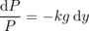
Pressure falls off exponentially with height. There is no sharp cutoff to the atmosphere, but the exponential gets extremely small by the time you're ten or a hundred miles up.

e / We have to wait for the thermometer to equilibrate its temperature with the temperature of Irene's armpit.

f / Thermal equilibrium can be prevented. Otters have a coat of fur that traps air bubbles for insulation. If a swimming otter was in thermal equilibrium with cold water, it would be dead. Heat is still conducted from the otter's body to the water, but much more slowly than it would be in a warm-blooded animal that didn't have this special adaptation.
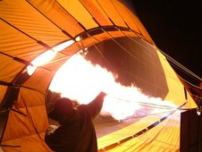
g / A hot air balloon is inflated. Because of thermal expansion, the hot air is less dense than the surrounding cold air, and therefore floats as the cold air drops underneath it and pushes it up out of the way.
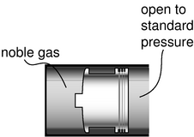
h / A simplified version of an ideal gas thermometer. The whole instrument is allowed to come into thermal equilibrium with the substance whose temperature is to be measured, and the mouth of the cylinder is left open to standard pressure. The volume of the noble gas gives an indication of temperature.
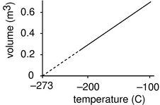
i / The volume of 1 kg of neon gas as a function of temperature (at standard pressure). Although neon would actually condense into a liquid at some point, extrapolating the graph gives to zero volume gives the same temperature as for any other gas: absolute zero.

Temperature

Thermal equilibrium
We use the term temperature casually, but what is it exactly? Roughly speaking, temperature is a measure of how concentrated the heat energy is in an object. A large, massive object with very little heat energy in it has a low temperature.
But physics deals with operational definitions, i.e. definitions of how to measure the thing in question. How do we measure temperature? One common feature of all temperature-measuring devices is that they must be left for a while in contact with the thing whose temperature is being measured. When you take your temperature with a fever thermometer, you are waiting for the mercury inside to come up to the same temperature as your body. The thermometer actually tells you the temperature of its own working fluid (in this case the mercury). In general, the idea of temperature depends on the concept of thermal equilibrium. When you mix cold eggs from the refrigerator with flour that has been at room temperature, they rapidly reach a compromise temperature. What determines this compromise temperature is conservation of energy, and the amount of energy required to heat or cool each substance by one degree. But without even having constructed a temperature scale, we can see that the important point is the phenomenon of thermal equilibrium itself: two objects left in contact will approach the same temperature. We also assume that if object A is at the same temperature as object B, and B is at the same temperature as C, then A is at the same temperature as C. This statement is sometimes known as the zeroth law of thermodynamics, so called because after the first, second, and third laws had been developed, it was realized that there was another law that was even more fundamental.

Thermal expansion
The familiar mercury thermometer operates on the principle that the mercury, its working fluid, expands when heated and contracts when cooled. In general, all substances expand and contract with changes in temperature. The zeroth law of thermodynamics guarantees that we can construct a comparative scale of temperatures that is independent of what type of thermometer we use. If a thermometer gives a certain reading when it's in thermal equilibrium with object A, and also gives the same reading for object B, then A and B must be the same temperature, regardless of the details of how the thermometers works.
What about constructing a temperature scale in which every degree represents an equal step in temperature? The Celsius scale has 0 as the freezing point of water and 100 as its boiling point. The hidden assumption behind all this is that since two points define a line, any two thermometers that agree at two points must agree at all other points. In reality if we calibrate a mercury thermometer and an alcohol thermometer in this way, we will find that a graph of one thermometer's reading versus the other is not a perfectly straight y=x line. The subtle inconsistency becomes a drastic one when we try to extend the temperature scale through the points where mercury and alcohol boil or freeze. Gases, however, are much more consistent among themselves in their thermal expansion than solids or liquids, and the noble gases like helium and neon are more consistent with each other than gases in general. Continuing to search for consistency, we find that noble gases are more consistent with each other when their pressure is very low.
As an idealization, we imagine a gas in which the atoms interact only with the sides of the container, not with each other. Such a gas is perfectly nonreactive (as the noble gases very nearly are), and never condenses to a liquid (as the noble gases do only at extremely low temperatures). Its atoms take up a negligible fraction of the available volume. Any gas can be made to behave very much like this if the pressure is extremely low, so that the atoms hardly ever encounter each other. Such a gas is called an ideal gas, and we define the Celsius scale in terms of the volume of the gas in a thermometer whose working substance is an ideal gas maintained at a fixed (very low) pressure, and which is calibrated at 0 and 100 degrees according to the melting and boiling points of water. The Celsius scale is not just a comparative scale but an additive one as well: every step in temperature is equal, and it makes sense to say that the difference in temperature between 18 and 28°C is the same as the difference between 48 and 58.

Absolute zero and the Kelvin scale
We find that if we extrapolate a graph of volume versus temperature, the volume becomes zero at nearly the same temperature for all gases: -273°C. Real gases will all condense into liquids at some temperature above this, but an ideal gas would achieve zero volume at this temperature, known as absolute zero. The most useful temperature scale in scientific work is one whose zero is defined by absolute zero, rather than by some arbitrary standard like the melting point of water. The temperature scale used universally in scientific work, called the Kelvin scale, is the same as the Celsius scale, but shifted by 273 degrees to make its zero coincide with absolute zero. Scientists use the Celsius scale only for comparisons or when a change in temperature is all that is required for a calculation. Only on the Kelvin scale does it make sense to discuss ratios of temperatures, e.g. to say that one temperature is twice as hot as another.

Example 6: Which temperature scale to use
◊ You open an astronomy book and encounter the equation
for the light emitted by a star as a function of its surface temperature. What temperature scale is implied?
◊ The equation tells us that doubling the temperature results in the emission of 16 times as much light. Such a ratio only makes sense if the Kelvin scale is used.
Although we can achieve as good an approximation to an ideal gas as we wish by making the pressure very low, it seems nevertheless that there should be some more fundamental way to define temperature. We will construct a more fundamental scale of temperature in section 5.4.

5.2 Microscopic Description of an Ideal Gas

Evidence for the kinetic theory
Why does matter have the thermal properties it does? The basic answer must come from the fact that matter is made of atoms. How, then, do the atoms give rise to the bulk properties we observe? Gases, whose thermal properties are so simple, offer the best chance for us to construct a simple connection between the microscopic and macroscopic worlds.
A crucial observation is that although solids and liquids are nearly incompressible, gases can be compressed, as when we increase the amount of air in a car's tire while hardly increasing its volume at all. This makes us suspect that the atoms in a solid are packed shoulder to shoulder, while a gas is mostly vacuum, with large spaces between molecules. Most liquids and solids have densities about 1000 times greater than most gases, so evidently each molecule in a gas is separated from its nearest neighbors by a space something like 10 times the size of the molecules themselves.
If gas molecules have nothing but empty space between them, why don't the molecules in the room around you just fall to the floor? The only possible answer is that they are in rapid motion, continually rebounding from the walls, floor and ceiling. In section 2.4 I have already given some of the evidence for the kinetic theory of heat, which states that heat is the kinetic energy of randomly moving molecules. This theory was proposed by Daniel Bernoulli in 1738, and met with considerable opposition because it seemed as though the molecules in a gas would eventually calm down and settle into a thin film on the floor. There was no precedent for this kind of perpetual motion. No rubber ball, however elastic, rebounds from a wall with exactly as much energy as it originally had, nor do we ever observe a collision between balls in which none of the kinetic energy at all is converted to heat and sound. The analogy is a false one, however. A rubber ball consists of atoms, and when it is heated in a collision, the heat is a form of motion of those atoms. An individual molecule, however, cannot possess heat. Likewise sound is a form of bulk motion of molecules, so colliding molecules in a gas cannot convert their kinetic energy to sound. Molecules can indeed induce vibrations such as sound waves when they strike the walls of a container, but the vibrations of the walls are just as likely to impart energy to a gas molecule as to take energy from it. Indeed, this kind of exchange of energy is the mechanism by which the temperatures of the gas and its container become equilibrated.

Pressure, volume, and temperature
A gas exerts pressure on the walls of its container, and in the kinetic theory we interpret this apparently constant pressure as the averaged-out result of vast numbers of collisions occurring every second between the gas molecules and the walls. The empirical facts about gases can be summarized by the relation
which really only holds exactly for an ideal gas. Here n is the number of molecules in the sample of gas.

Example 7: Volume related to temperature
The proportionality of volume to temperature at fixed pressure was the basis for our definition of temperature.

Example 8: Pressure related to temperature
Pressure is proportional to temperature when volume is held constant. An example is the increase in pressure in a car's tires when the car has been driven on the freeway for a while and the tires and air have become hot.
We now connect these empirical facts to the kinetic theory of a classical ideal gas. For simplicity, we assume that the gas is monoatomic (i.e. each molecule has only one atom), and that it is confined to a cubical box of volume V, with L being the length of each edge and A the area of any wall. An atom whose velocity has an x component v_{x} will collide regularly with the left-hand wall, traveling a distance 2L parallel to the x axis between collisions with that wall. The time between collisions is Δ t=2L/v_{x}, and in each collision the x component of the atom's momentum is reversed from -mv_{x} to mv_{x}. The total force on the wall is
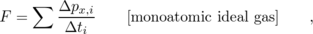
where the index i refers to the individual atoms. Substituting Δ p_{x,i}=2mv_{x,i} and Δ t_{i}=2L/v_{x,i}, we have
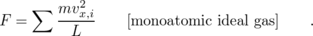
The quantity mv_{x,i}² is twice the contribution to the kinetic energy from the part of the atoms' center of mass motion that is parallel to the x axis. Since we're assuming a monoatomic gas, center of mass motion is the only type of motion that gives rise to kinetic energy. (A more complex molecule could rotate and vibrate as well.) If the quantity inside the sum included the y and z components, it would be twice the total kinetic energy of all the molecules. By symmetry, it must therefore equal 2/3 of the total kinetic energy, so
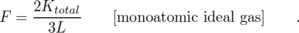
Dividing by A and using AL=V, we have
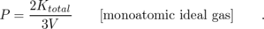
This can be connected to the empirical relation PV ∝ nT if we multiply by V on both sides and rewrite K_{total} as , where is the average kinetic energy per molecule:
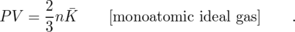
For the first time we have an interpretation for the temperature based on a microscopic description of matter: in a monoatomic ideal gas, the temperature is a measure of the average kinetic energy per molecule. The proportionality between the two is , where the constant of proportionality k, known as Boltzmann's constant, has a numerical value of . In terms of Boltzmann's constant, the relationship among the bulk quantities for an ideal gas becomes
which is known as the ideal gas law. Although I won't prove it here, this equation applies to all ideal gases, even though the derivation assumed a monoatomic ideal gas in a cubical box. (You may have seen it written elsewhere as PV=NRT, where N=n/N_{A} is the number of moles of atoms, R=kN_{A}, and N_{A}=6.0×10²³, called Avogadro's number, is essentially the number of hydrogen atoms in 1 g of hydrogen.)

Example 9: Pressure in a car tire
◊ After driving on the freeway for a while, the air in your car's tires heats up from 10°C to 35°C. How much does the pressure increase?
◊ The tires may expand a little, but we assume this effect is small, so the volume is nearly constant. From the ideal gas law, the ratio of the pressures is the same as the ratio of the absolute temperatures,
P₂/ P₁
= T₂/ T₁
= 1.09 ,
or a 9% increase.

Discussion Questions
◊ Compare the amount of energy needed to heat 1 liter of helium by 1 degree with the energy needed to heat 1 liter of xenon. In both cases, the heating is carried out in a sealed vessel that doesn't allow the gas to expand. (The vessel is also well insulated.)
◊ Repeat discussion question A if the comparison is 1 kg of helium versus 1 kg of xenon (equal masses, rather than equal volumes).
◊ Repeat discussion question A, but now compare 1 liter of helium in a vessel of constant volume with the same amount of helium in a vessel that allows expansion beyond the initial volume of 1 liter. (This could be a piston, or a balloon.)

5.3 Entropy as a Macroscopic Quantity

Efficiency and grades of energy
Some forms of energy are more convenient than others in certain situations. You can't run a spring-powered mechanical clock on a battery, and you can't run a battery-powered clock with mechanical energy. However, there is no fundamental physical principle that prevents you from converting 100% of the electrical energy in a battery into mechanical energy or vice-versa. More efficient motors and generators are being designed every year. In general, the laws of physics permit perfectly efficient conversion within a broad class of forms of energy.
Heat is different. Friction tends to convert other forms of energy into heat even in the best lubricated machines. When we slide a book on a table, friction brings it to a stop and converts all its kinetic energy into heat, but we never observe the opposite process, in which a book spontaneously converts heat energy into mechanical energy and starts moving! Roughly speaking, heat is different because it is disorganized. Scrambling an egg is easy. Unscrambling it is harder.
We summarize these observations by saying that heat is a lower grade of energy than other forms such as mechanical energy.
Of course it is possible to convert heat into other forms of energy such as mechanical energy, and that is what a car engine does with the heat created by exploding the air-gasoline mixture. But a car engine is a tremendously inefficient device, and a great deal of the heat is simply wasted through the radiator and the exhaust. Engineers have never succeeded in creating a perfectly efficient device for converting heat energy into mechanical energy, and we now know that this is because of a deeper physical principle that is far more basic than the design of an engine.
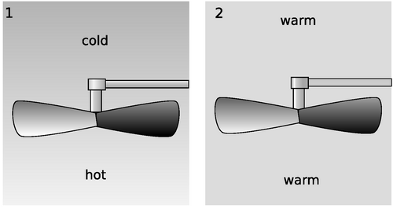
a / 1. The temperature difference between the hot and cold parts of the air can be used to extract mechanical energy, for example with a fan blade that spins because of the rising hot air currents. 2. If the temperature of the air is first allowed to become uniform, then no mechanical energy can be extracted. The same amount of heat energy is present, but it is no longer accessible for doing mechanical work.
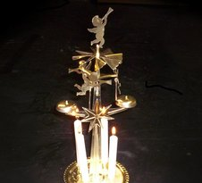
b / A heat engine. Hot air from the candles rises through the fan blades, and makes the angels spin.
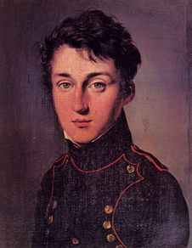
c / Sadi Carnot (1796-1832)
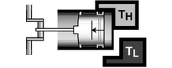
d / The beginning of the first expansion stroke, in which the working gas is kept in thermal equilibrium with the hot reservoir.
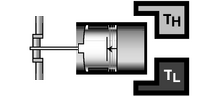
e / The beginning of the second expansion stroke, in which the working gas is thermally insulated. The working gas cools because it is doing work on the piston and thus losing energy.
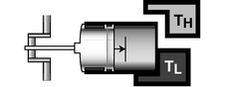
f / The beginning of the first compression stroke. The working gas begins the stroke at the same temperature as the cold reservoir, and remains in thermal contact with it the whole time. The engine does negative work.
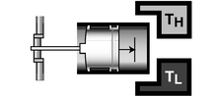
g / The beginning of the second compression stroke, in which mechanical work is absorbed, heating the working gas back up to T_{H}.

Heat engines
Heat may be more useful in some forms than in other, i.e., there are different grades of heat energy. In figure a/1, the difference in temperature can be used to extract mechanical work with a fan blade. This principle is used in power plants, where steam is heated by burning oil or by nuclear reactions, and then allowed to expand through a turbine which has cooler steam on the other side. On a smaller scale, there is a Christmas toy, b, that consists of a small propeller spun by the hot air rising from a set of candles, very much like the setup shown in the figure.
In figure a/2, however, no mechanical work can be extracted because there is no difference in temperature. Although the air in a/2 has the same total amount of energy as the air in a/1, the heat in a/2 is a lower grade of energy, since none of it is accessible for doing mechanical work.
In general, we define a heat engine as any device that takes heat from a reservoir of hot matter, extracts some of the heat energy to do mechanical work, and expels a lesser amount of heat into a reservoir of cold matter. The efficiency of a heat engine equals the amount of useful work extracted, W, divided by the amount of energy we had to pay for in order to heat the hot reservoir. This latter amount of heat is the same as the amount of heat the engine extracts from the high-temperature reservoir, Q_{H}. (The letter Q is the standard notation for a transfer of heat.) By conservation of energy, we have Q_{H}=W+Q_{L}, where Q_{L} is the amount of heat expelled into the low-temperature reservoir, so the efficiency of a heat engine, W/Q_{H}, can be rewritten as
It turns out that there is a particular type of heat engine, the Carnot engine, which, although not 100% efficient, is more efficient than any other. The grade of heat energy in a system can thus be unambiguously defined in terms of the amount of heat energy in it that cannot be extracted even by a Carnot engine.
How can we build the most efficient possible engine? Let's start with an unnecessarily inefficient engine like a car engine and see how it could be improved. The radiator and exhaust expel hot gases, which is a waste of heat energy. These gases are cooler than the exploded air-gas mixture inside the cylinder, but hotter than the air that surrounds the car. We could thus improve the engine's efficiency by adding an auxiliary heat engine to it, which would operate with the first engine's exhaust as its hot reservoir and the air as its cold reservoir. In general, any heat engine that expels heat at an intermediate temperature can be made more efficient by changing it so that it expels heat only at the temperature of the cold reservoir.
Similarly, any heat engine that absorbs some energy at an intermediate temperature can be made more efficient by adding an auxiliary heat engine to it which will operate between the hot reservoir and this intermediate temperature.
Based on these arguments, we define a Carnot engine as a heat engine that absorbs heat only from the hot reservoir and expels it only into the cold reservoir. Figures d-g show a realization of a Carnot engine using a piston in a cylinder filled with a monoatomic ideal gas. This gas, known as the working fluid, is separate from, but exchanges energy with, the hot and cold reservoirs. As proved on page 745, this particular Carnot engine has an efficiency given by
where T_{L} is the temperature of the cold reservoir and T_{H} is the temperature of the hot reservoir.
Even if you do not wish to dig into the details of the proof, the basic reason for the temperature dependence is not so hard to understand. Useful mechanical work is done on strokes d and e, in which the gas expands. The motion of the piston is in the same direction as the gas's force on the piston, so positive work is done on the piston. In strokes f and g, however, the gas does negative work on the piston. We would like to avoid this negative work, but we must design the engine to perform a complete cycle. Luckily the pressures during the compression strokes are lower than the ones during the expansion strokes, so the engine doesn't undo all its work with every cycle. The ratios of the pressures are in proportion to the ratios of the temperatures, so if T_{L} is 20% of T_{H}, the engine is 80% efficient.
We have already proved that any engine that is not a Carnot engine is less than optimally efficient, and it is also true that all Carnot engines operating between a given pair of temperatures T_{H} and T_{L} have the same efficiency. (This can be proved by the methods of section 5.4.) Thus a Carnot engine is the most efficient possible heat engine.
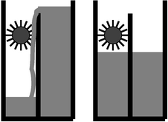
h / Entropy can be understood using the metaphor of a water wheel. Letting the water levels equalize is like letting the entropy maximize. Taking water from the high side and putting it into the low side increases the entropy. Water levels in this metaphor correspond to temperatures in the actual definition of entropy.

Entropy
We would like to have some numerical way of measuring the grade of energy in a system. We want this quantity, called entropy, to have the following two properties:
(1) Entropy is additive. When we combine two systems and consider them as one, the entropy of the combined system equals the sum of the entropies of the two original systems. (Quantities like mass and energy also have this property.)
(2) The entropy of a system is not changed by operating a Carnot engine within it.
It turns out to be simpler and more useful to define changes in entropy than absolute entropies. Suppose as an example that a system contains some hot matter and some cold matter. It has a relatively high grade of energy because a heat engine could be used to extract mechanical work from it. But if we allow the hot and cold parts to equilibrate at some lukewarm temperature, the grade of energy has gotten worse. Thus putting heat into a hotter area is more useful than putting it into a cold area. Motivated by these considerations, we define a change in entropy as follows:
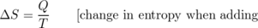
A system with a higher grade of energy has a lower entropy.

Example 10: Entropy is additive.
Since changes in entropy are defined by an additive quantity (heat) divided by a non-additive one (temperature), entropy is additive.

Example 11: Entropy isn't changed by a Carnot engine.
The efficiency of a heat engine is defined by
efficiency = 1 - Q_{L}/ Q_{H} ,
and the efficiency of a Carnot engine is
efficiency = 1 - T_{L}/ T_{H} ,
so for a Carnot engine we have Q_{L}/ Q_{H} = T_{L}/ T_{H}, which can be rewritten as Q_{L}/ T_{L} = Q_{H}/ T_{H}. The entropy lost by the hot reservoir is therefore the same as the entropy gained by the cold one.

Example 12: Entropy increases in heat conduction.
When a hot object gives up energy to a cold one, conservation of energy tells us that the amount of heat lost by the hot object is the same as the amount of heat gained by the cold one. The change in entropy is - Q/ T_{H}+ Q/ T_{L}, which is positive because T_{L}< T_{H}.

Example 13: Entropy is increased by a non-Carnot engine.
The efficiency of a non-Carnot engine is less than 1 - T_{L}/ T_{H}, so Q_{L}/ Q_{H} > T_{L}/ T_{H} and Q_{L}/ T_{L} > Q_{H}/ T_{H}. This means that the entropy increase in the cold reservoir is greater than the entropy decrease in the hot reservoir.

Example 14: A book sliding to a stop
A book slides across a table and comes to a stop. Once it stops, all its kinetic energy has been transformed into heat. As the book and table heat up, their entropies both increase, so the total entropy increases as well.
All of these examples involved closed systems, and in all of them the total entropy either increased or stayed the same. It never decreased. Here are two examples of schemes for decreasing the entropy of a closed system, with explanations of why they don't work.

Example 15: Using a refrigerator to decrease entropy?
◊ A refrigerator takes heat from a cold area and dumps it into a hot area. (1) Does this lead to a net decrease in the entropy of a closed system? (2) Could you make a Carnot engine more efficient by running a refrigerator to cool its low-temperature reservoir and eject heat into its high-temperature reservoir?
◊ (1) No. The heat that comes off of the radiator coils is a great deal more than the heat the fridge removes from inside; the difference is what it costs to run your fridge. The heat radiated from the coils is so much more than the heat removed from the inside that the increase in the entropy of the air in the room is greater than the decrease of the entropy inside the fridge. The most efficient refrigerator is actually a Carnot engine running in reverse, which leads to neither an increase nor a decrease in entropy.
(2) No. The most efficient refrigerator is a reversed Carnot engine. You will not achieve anything by running one Carnot engine in reverse and another forward. They will just cancel each other out.

Example 16: Maxwell's demon
◊ Maxwell imagined a pair of rooms, their air being initially in thermal equilibrium, having a partition across the middle with a tiny door. A miniscule demon is posted at the door with a little ping-pong paddle, and his duty is to try to build up faster-moving air molecules in room B and slower moving ones in room A. For instance, when a fast molecule is headed through the door, going from A to B, he lets it by, but when a slower than average molecule tries the same thing, he hits it back into room A. Would this decrease the total entropy of the pair of rooms?
◊ No. The demon needs to eat, and we can think of his body as a little heat engine, and his metabolism is less efficient than a Carnot engine, so he ends up increasing the entropy rather than decreasing it.
Observations such as these lead to the following hypothesis, known as the second law of thermodynamics:
The entropy of a closed system always increases, or at best stays the same: .
At present our arguments to support this statement may seem less than convincing, since they have so much to do with obscure facts about heat engines. In the following section we will find a more satisfying and fundamental explanation for the continual increase in entropy. To emphasize the fundamental and universal nature of the second law, here are a few exotic examples.

Example 17: Entropy and evolution
A favorite argument of many creationists who don't believe in evolution is that evolution would violate the second law of thermodynamics: the death and decay of a living thing releases heat (as when a compost heap gets hot) and lessens the amount of energy available for doing useful work, while the reverse process, the emergence of life from nonliving matter, would require a decrease in entropy. Their argument is faulty, since the second law only applies to closed systems, and the earth is not a closed system. The earth is continuously receiving energy from the sun.

Example 18: The heat death of the universe
Living things have low entropy: to demonstrate this fact, observe how a compost pile releases heat, which then equilibrates with the cooler environment. We never observe dead things to leap back to life after sucking some heat energy out of their environments! The only reason life was able to evolve on earth was that the earth was not a closed system: it got energy from the sun, which presumably gained more entropy than the earth lost.
Victorian philosophers spent a lot of time worrying about the heat death of the universe: eventually the universe would have to become a high-entropy, lukewarm soup, with no life or organized motion of any kind. Fortunately (?), we now know a great many other things that will make the universe inhospitable to life long before its entropy is maximized. Life on earth, for instance, will end when the sun evolves into a giant star and vaporizes our planet.

Example 19: Hawking radiation
Any process that could destroy heat (or convert it into nothing but mechanical work) would lead to a reduction in entropy. Black holes are supermassive stars whose gravity is so strong that nothing, not even light, can escape from them once it gets within a boundary known as the event horizon. Black holes are commonly observed to suck hot gas into them. Does this lead to a reduction in the entropy of the universe? Of course one could argue that the entropy is still there inside the black hole, but being able to “hide” entropy there amounts to the same thing as being able to destroy entropy.
The physicist Steven Hawking was bothered by this question, and finally realized that although the actual stuff that enters a black hole is lost forever, the black hole will gradually lose energy in the form of light emitted from just outside the event horizon. This light ends up reintroducing the original entropy back into the universe at large.

Discussion Question
◊ In this discussion question, you'll think about a car engine in terms of thermodynamics. Note that an internal combustion engine doesn't fit very well into the theoretical straightjacket of a heat engine. For instance, a heat engine has a high-temperature heat reservoir at a single well-defined temperature, T_{H}. In a typical car engine, however, there are several very different temperatures you could imagine using for T_{H}: the temperature of the engine block (∼100°C), the walls of the cylinder (∼250°C), or the temperature of the exploding air-gas mixture (∼1000°C, with significant changes over a four-stroke cycle). Let's use T_{H}∼1000°C.
Burning gas supplies heat energy Q_{H} to your car's engine. The engine does mechanical work W, but also expels heat Q_{L} into the environment through the radiator and the exhaust. Conservation of energy gives
Q_{H} = Q_{L}+W ,
and the relative proportions of Q_{L} and W are usually about 90% to 10%. (Actually it depends quite a bit on the type of car, the driving conditions, etc.)
(1) Q_{L} is obviously undesirable: you pay for it, but all it does is heat the neighborhood. Suppose that engineers do a really good job of getting rid of the effects that create Q_{L}, such as friction. Could Q_{L} ever be reduced to zero, at least theoretically?
(2) A gallon of gas releases about 140 MJ of heat Q_{H} when burned. Estimate the change in entropy of the universe due to running a typical car engine and burning one gallon of gas. (You'll have to estimate how hot the environment is. For the sake of argument, assume that the work done by the engine, W, remains in the form of mechanical energy, although in reality it probably ends up being changed into heat when you step on the brakes.) Is your result consistent with the second law of thermodynamics?
(3) What would happen if you redid the calculation in #2, but assumed Q_{L}=0? Is this consistent with your answer to #1?
◊ Example 11 on page 256 showed that entropy isn't changed by a Carnot engine, by using the expression for the efficiency of a Carnot engine. Prove the same thing by applying the definition of entropy to each of the four strokes of the Carnot engine.

5.4 Entropy as a Microscopic Quantity (Optional)
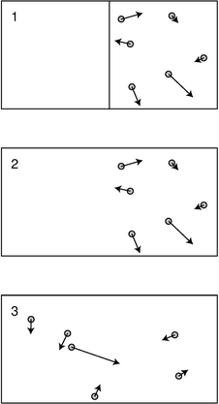
a / A gas expands freely, doubling its volume.
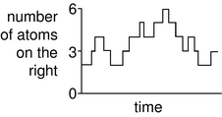
b / An unusual fluctuation in the distribution of the atoms between the two sides of the box. There has been no external manipulation as in figure a/1.

A microscopic view of entropy
To understand why the second law of thermodynamics is always true, we need to see what entropy really means at the microscopic level. An example that is easy to visualize is the free expansion of a monoatomic gas. Figure a/1 shows a box in which all the atoms of the gas are confined on one side. We very quickly remove the barrier between the two sides, a/2, and some time later, the system has reached an equilibrium, a/3. Each snapshot shows both the positions and the momenta of the atoms, which is enough information to allow us in theory to extrapolate the behavior of the system into the future, or the past. However, with a realistic number of atoms, rather than just six, this would be beyond the computational power of any computer.¹
But suppose we show figure a/2 to a friend without any further information, and ask her what she can say about the system's behavior in the future. She doesn't know how the system was prepared. Perhaps, she thinks, it was just a strange coincidence that all the atoms happened to be in the right half of the box at this particular moment. In any case, she knows that this unusual situation won't last for long. She can predict that after the passage of any significant amount of time, a surprise inspection is likely to show roughly half the atoms on each side. The same is true if you ask her to say what happened in the past. She doesn't know about the barrier, so as far as she's concerned, extrapolation into the past is exactly the same kind of problem as extrapolation into the future. We just have to imagine reversing all the momentum vectors, and then all our reasoning works equally well for backwards extrapolation. She would conclude, then, that the gas in the box underwent an unusual fluctuation, b, and she knows that the fluctuation is very unlikely to exist very far into the future, or to have existed very far into the past.
What does this have to do with entropy? Well, state a/3 has a greater entropy than state a/2. It would be easy to extract mechanical work from a/2, for instance by letting the gas expand while pressing on a piston rather than simply releasing it suddenly into the void. There is no way to extract mechanical work from state a/3. Roughly speaking, our microscopic description of entropy relates to the number of possible states. There are a lot more states like a/3 than there are states like a/2. Over long enough periods of time --- long enough for equilibration to occur --- the system gets mixed up, and is about equally likely to be in any of its possible states, regardless of what state it was initially in. We define some number that describes an interesting property of the whole system, say the number of atoms in the right half of the box, R. A high-entropy value of R is one like R=3, which allows many possible states. We are far more likely to encounter R=3 than a low-entropy value like R=0 or R=6. 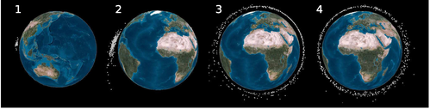
c / Earth orbit is becoming cluttered with space junk, and the pieces can be thought of as the “molecules” comprising an exotic kind of gas. These image shows the evolution of a cloud of debris arising from a 2007 Chinese test of an anti-satellite rocket. Panels 1-4 show the cloud five minutes, one hour, one day, and one month after the impact. The entropy seems to have maximized by panel 4.
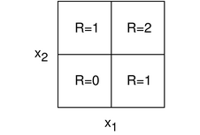
d / The phase space for two atoms in a box.
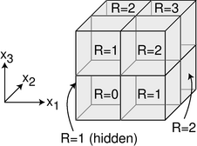
e / The phase space for three atoms in a box.
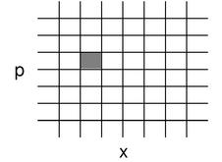
f / A phase space for a single atom in one dimension, taking momentum into account.

Phase space
There is a problem with making this description of entropy into a mathematical definition. The problem is that it refers to the number of possible states, but that number is theoretically infinite. To get around the problem, we coarsen our description of the system. For the atoms in figure a, we don't really care exactly where each atom is. We only care whether it is in the right side or the left side. If a particular atom's left-right position is described by a coordinate x, then the set of all possible values of x is a line segment along the x axis, containing an infinite number of points. We break this line segment down into two halves, each of width Δ x, and we consider two different values of x to be variations on the same state if they both lie in the same half. For our present purposes, we can also ignore completely the y and z coordinates, and all three momentum components, p_{x}, p_{y}, and p_{z}.
Now let's do a real calculation. Suppose there are only two atoms in the box, with coordinates x₁ and x₂. We can give all the relevant information about the state of the system by specifying one of the cells in the grid shown in figure d. This grid is known as the phase space of the system. The lower right cell, for instance, describes a state in which atom number 1 is in the right side of the box and atom number 2 in the left. Since there are two possible states with R=1 and only one state with R=2, we are twice as likely to observe R=1, and R=1 has higher entropy than R=2.
Figure e shows a corresponding calculation for three atoms, which makes the phase space three-dimensional. Here, the R=1 and 2 states are three times more likely than R=0 and 3. Four atoms would require a four-dimensional phase space, which exceeds our ability to visualize. Although our present example doesn't require it, a phase space can describe momentum as well as position, as shown in figure f. In general, a phase space for a monoatomic gas has six dimensions per atom (one for each coordinate and one for each momentum component).
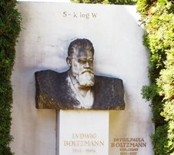
g / Ludwig Boltzmann's tomb, inscribed with his equation for entropy.
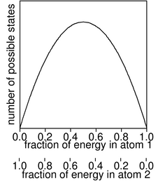
h / A two-atom system has the highest number of available states when the energy is equally divided. Equal energy division is therefore the most likely possibility at any given moment in time.
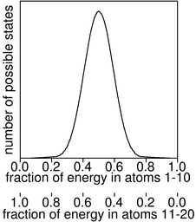
i / When two systems of 10 atoms each interact, the graph of the number of possible states is narrower than with only one atom in each system.

Microscopic definitions of entropy and temperature
Two more issues need to be resolved in order to make a microscopic definition of entropy.
First, if we defined entropy as the number of possible states, it would be a multiplicative quantity, not an additive one: if an ice cube in a glass of water has M₁ states available to it, and the number of states available to the water is M₂, then the number of possible states of the whole system is the product M₁ M₂. To get around this problem, we take the natural logarithm of the number of states, which makes the entropy additive because of the property of the logarithm ln (M₁ M₂) = ln M₁ + ln M₂.
The second issue is a more trivial one. The concept of entropy was originally invented as a purely macroscopic quantity, and the macroscopic definition Δ S = Q/T, which has units of J/K, has a different calibration than would result from defining S=ln M. The calibration constant we need turns out to be simply the Boltzmann constant, k.
\mythmhdr{Microscopic definition of entropy} The entropy of a system is S = k ln M, where M is the number of available states.²
This also leads to a more fundamental definition of temperature. Two systems are in thermal equilibrium when they have maximized their combined entropy through the exchange of energy. Here the energy possessed by one part of the system, E₁ or E₂, plays the same role as the variable R in the examples of free expansion above. A maximum of a function occurs when the derivative is zero, so the maximum entropy occurs when
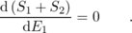
We assume the systems are only able to exchange heat energy with each other, d E₁=-d E₂, so
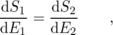
and since the energy is being exchanged in the form of heat we can make the equations look more familiar if we write d Q for an amount of heat to be transferred into either system:
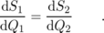
In terms of our previous definition of entropy, this is equivalent to 1/T₁=1/T₂, which makes perfect sense since the systems are in thermal equilibrium. According to our new approach, entropy has already been defined in a fundamental manner, so we can take this as a definition of temperature:
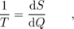
where d S represents the increase in the system's entropy from adding heat d Q to it.

Examples with small numbers of atoms
Let's see how this applies to an ideal, monoatomic gas with a small number of atoms. To start with, consider the phase space available to one atom. Since we assume the atoms in an ideal gas are noninteracting, their positions relative to each other are really irrelevant. We can therefore enumerate the number of states available to each atom just by considering the number of momentum vectors it can have, without considering its possible locations. The relationship between momentum and kinetic energy is E=(p_{x}²+p_{y}²+p_{z}²)/2m, so if for a fixed value of its energy, we arrange all of an atom's possible momentum vectors with their tails at the origin, their tips all lie on the surface of a sphere in phase space with radius . The number of possible states for that atom is proportional to the sphere's surface area, which in turn is proportional to the square of the sphere's radius, |p|²=2mE.
Now consider two atoms. For any given way of sharing the energy between the atoms, E=E₁+E₂, the number of possible combinations of states is proportional to E₁E₂. The result is shown in figure h. The greatest number of combinations occurs when we divide the energy equally, so an equal division gives maximum entropy.
By increasing the number of atoms, we get a graph whose peak is narrower, i. With more than one atom in each system, the total energy is E=(p_{x,1}²+p_{y,1}²+p_{z,1}²+p_{x,2}²+p_{y,2}²+p_{z,2}²+...)/2m. With n atoms, a total of 3n momentum coordinates are needed in order to specify their state, and such a set of numbers is like a single point in a 3n-dimensional space (which is impossible to visualize). For a given total energy E, the possible states are like the surface of a 3n-dimensional sphere, with a surface area proportional to p^{3n-1}, or E^{(3n-1)/2}. The graph in figure i, for example, was calculated according to the formula E₁^{29/2}E₂^{29/2}=E₁^{29/2}(E-E₁)^{29/2}.
Since graph i is narrower than graph h, the fluctuations in energy sharing are smaller. If we inspect the system at a random moment in time, the energy sharing is very unlikely to be more lopsided than a 40-60 split. Now suppose that, instead of 10 atoms interacting with 10 atoms, we had a 10²³ atoms interacting with 10²³ atoms. The graph would be extremely narrow, and it would be a statistical certainty that the energy sharing would be nearly perfectly equal. This is why we never observe a cold glass of water to change itself into an ice cube sitting in some warm water!
By the way, note that although we've redefined temperature, these examples show that things are coming out consistent with the old definition, since we saw that the old definition of temperature could be described in terms of the average energy per atom, and here we're finding that equilibration results in each subset of the atoms having an equal share of the energy.

Entropy of a monoatomic ideal gas
Let's calculate the entropy of a monoatomic ideal gas of n atoms. This is an important example because it allows us to show that our present microscopic treatment of thermodynamics is consistent with our previous macroscopic approach, in which temperature was defined in terms of an ideal gas thermometer.
The number of possible locations for each atom is V/Δ x³, where Δ x is the size of the space cells in phase space. The number of possible combinations of locations for the atoms is therefore (V/Δ x³)^{n}.
The possible momenta cover the surface of a 3n-dimensional sphere, whose surface area is proportional to E^{(3n-1)/2}. In terms of phase-space cells, this area corresponds to E^{(3n-1)/2} / Δ p^{3n-1} possible combinations of momenta, multiplied by some constant of proportionality which depends on m, the atomic mass, and n, the number of atoms. To avoid having to calculate this constant of proportionality, we limit ourselves to calculating the part of the entropy that does not depend on n, so the resulting formula will not be useful for comparing entropies of ideal gas samples with different numbers of atoms.
The final result for the number of available states is
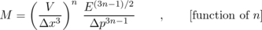
so the entropy is
where the distinction between n and n-1 has been ignored. Using PV=nkT and E=(3/2)nkT, we can also rewrite this as
where “…” indicates terms that may depend on Δ x, Δ p, and n, but that have no effect on comparisons of gas samples with the same number of atoms.
self-check: Why does it make sense that the temperature term has a positive sign in the above example, while the pressure term is negative? Why does it make sense that the whole thing is proportional to n? (answer in the back of the PDF version of the book)
To show consistency with the macroscopic approach to thermodynamics, we need to show that these results are consistent with the behavior of an ideal-gas thermometer. Using the new definition 1/T=d S/d Q, we have 1/T=d S/d E, since transferring an amount of heat d Q into the gas increases its energy by a corresponding amount. Evaluating the derivative, we find 1/T=(3/2)nk/E, or E=(3/2)nkT, which is the correct relation for a monoatomic ideal gas.

The arrow of time, or “This way to the Big Bang”
What about the second law of thermodynamics? The second law defines a forward direction to time, “time's arrow.” The microscopic treatment of entropy, however, seems to have mysteriously sidestepped that whole issue. A graph like figure b on page 261, showing a fluctuation away from equilibrium, would look just as natural if we flipped it over to reverse the direction of time. After all, the basic laws of physics are conservation laws, which don't distinguish between past and future. Our present picture of entropy suggests that we restate the second law of thermodynamics as follows: low-entropy states are short-lived. An ice cube can't exist forever in warm water. We no longer have to distinguish past from future.
But how do we reconcile this with our strong psychological sense of the direction of time, including our ability to remember the past but not the future? Why do we observe ice cubes melting in water, but not the time-reversed version of the same process?
The answer is that there is no past-future asymmetry in the laws of physics, but there is a past-future asymmetry in the universe. The universe started out with the Big Bang. (Some of the evidence for the Big Bang theory is given on page 299.) The early universe had a very low entropy, and low-entropy states are short-lived. What does “short-lived” mean here, however? Hot coffee left in a paper cup will equilibrate with the air within ten minutes or so. Hot coffee in a thermos bottle maintains its low-entropy state for much longer, because the coffee is insulated by a vacuum between the inner and outer walls of the thermos. The universe has been mostly vacuum for a long time, so it's well insulated. Also, it takes billions of years for a low-entropy normal star like our sun to evolve into the high-entropy cinder known as a white dwarf.
The universe, then, is still in the process of equilibrating, and all the ways we have of telling the past from the future are really just ways of determining which direction in time points toward the Big Bang, i.e. which direction points to lower entropy. The psychological arrow of time, for instance, is ultimately based on the thermodynamic arrow. In some general sense, your brain is like a computer, and computation has thermodynamic effects. In even the most efficient possible computer, for example, erasing one bit of memory decreases its entropy from k ln 2 (two possible states) to k ln 1 (one state), for a drop of about 10⁻²³ J/K. One way of determining the direction of the psychological arrow of time is that forward in psychological time is the direction in which, billions of years from now, all consciousness will have ceased; if consciousness was to exist forever in the universe, then there would have to be a never-ending decrease in the universe's entropy. This can't happen, because low-entropy states are short-lived.
Relating the direction of the thermodynamic arrow of time to the existence of the Big Bang is a satisfying way to avoid the paradox of how the second law can come from basic laws of physics that don't distinguish past from future. There is a remaining mystery, however: why did our universe have a Big Bang that was low in entropy? It could just as easily have been a maximum-entropy state, and in fact the number of possible high-entropy Big Bangs is vastly greater than the number of possible low-entropy ones. The question, however, is probably not one that can be answered using the methods of science. All we can say is that if the universe had started with a maximum-entropy Big Bang, then we wouldn't be here to wonder about it.

Quantum mechanics and zero entropy
The previous discussion would seem to imply that absolute entropies are never well defined, since any calculation of entropy will always end up having terms that depend on Δ p and Δ x. For instance, we might think that cooling an ideal gas to absolute zero would give zero entropy, since there is then only one available momentum state, but there would still be many possible position states. We'll see later in this book, however, that the quantum mechanical uncertainty principle makes it impossible to know the location and position of a particle simultaneously with perfect accuracy. The best we can do is to determine them with an accuracy such that the product Δ pΔ x is equal to a constant called Planck's constant. According to quantum physics, then, there is a natural minimum size for rectangles in phase space, and entropy can be defined in absolute terms. Another way of looking at it is that according to quantum physics, the gas as a whole has some well-defined ground state, which is its state of minimum energy. When the gas is cooled to absolute zero, the scene is not at all like what we would picture in classical physics, with a lot of atoms lying around motionless. It might, for instance, be a strange quantum-mechanical state called the Bose-Einstein condensate, which was achieved for the first time recently with macroscopic amounts of atoms. Classically, the gas has many possible states available to it at zero temperature, since the positions of the atoms can be chosen in a variety of ways. The classical picture is a bad approximation under these circumstances, however. Quantum mechanically there is only one ground state, in which each atom is spread out over the available volume in a cloud of probability. The entropy is therefore zero at zero temperature. This fact, which cannot be understood in terms of classical physics, is known as the third law of thermodynamics.

Summary of the laws of thermodynamics
Here is a summary of the laws of thermodynamics:
- The zeroth law of thermodynamics (page 247) If object A is at the same temperature as object B, and B is at the same temperature as C, then A is at the same temperature as C.
- The first law of thermodynamics (page 242) Energy is
[4] conserved.
- The second law of thermodynamics (page 258) The entropy of a closed system always increases, or at best stays the same: .
- The third law of thermodynamics (page 268) The entropy of a system approaches zero as its temperature approaches absolute zero.
From a modern point of view, only the first law deserves to be called a fundamental law of physics. Once Boltmann discovered the microscopic nature of entropy, the zeroth and second laws could be understood as statements about probability: a system containing a large number of particles is overwhelmingly likely to do a certain thing, simply because the number of possible ways to do it is extremely large compared to the other possibilities. The third law is also now understood to be a consequence of more basic physical principles, but to explain the third law, it's not sufficient simply to know that matter is made of atoms: we also need to understand the quantum-mechanical nature of those atoms, discussed in chapter 12. Historically, however, the laws of thermodynamics were discovered in the eighteenth century, when the atomic theory of matter was generally considered to be a hypothesis that couldn't be tested experimentally. Ideally, with the publication of Boltzmann's work on entropy in 1877, the zeroth and second laws would have been immediately demoted from the status of physical laws, and likewise the development of quantum mechanics in the 1920's would have done the same for the third law.
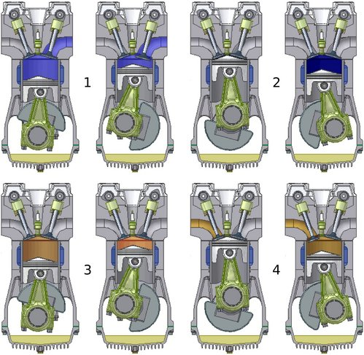
j / The Otto cycle. 1. In the exhaust stroke, the piston expels the burned air-gas mixture left over from the preceding cycle. 2. In the intake stroke, the piston sucks in fresh air-gas mixture. 3. In the compression stroke, the piston compresses the mixture, and heats it. 4. At the beginning of the power stroke, the spark plug fires, causing the air-gas mixture to burn explosively and heat up much more. The heated mixture expands, and does a large amount of positive mechanical work on the piston.

5.5 More about Heat Engines (Optional)
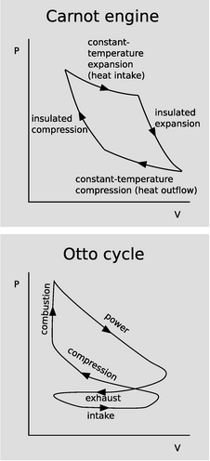
a / P-V diagrams for a Carnot engine and an Otto engine.
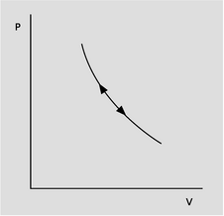
b / Example 21,

c / Example 22.
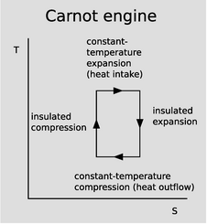
e / A T-S diagram for a Carnot engine.
So far, the only heat engine we've discussed in any detail has been a fictitious Carnot engine, with a monoatomic ideal gas as its working gas. As a more realistic example, figure j shows one full cycle of a cylinder in a standard gas-burning automobile engine. This four-stroke cycle is called the Otto cycle, after its inventor, German engineer Nikolaus Otto. The Otto cycle is more complicated than a Carnot cycle, in a number of ways:
- The working gas is physically pumped in and out of the cylinder through valves, rather than being sealed and reused indefinitely as in the Carnot engine.
- The cylinders are not perfectly insulated from the engine block, so heat energy is lost from each cylinder by conduction. This makes the engine less efficient that a Carnot engine, because heat is being discharged at a temperature that is not as cool as the environment.
- Rather than being heated by contact with an external heat reservoir, the air-gas mixture inside each cylinder is heated by internal combusion: a spark from a spark plug burns the gasoline, releasing heat.
- The working gas is not monoatomic. Air consists of diatomic molecules (N₂ and O₂), and gasoline of polyatomic molecules such as octane (C₈H₁₈).
- The working gas is not ideal. An ideal gas is one in which the molecules never interact with one another, but only with the walls of the vessel, when they collide with it. In a car engine, the molecules are interacting very dramatically with one another when the air-gas mixture explodes (and less dramatically at other times as well, since, for example, the gasoline may be in the form of microscopic droplets rather than individual molecules).
This is all extremely complicated, and it would be nice to have some way of understanding and visualizing the important properties of such a heat engine without trying to handle every detail at once. A good method of doing this is a type of graph known as a P-V diagram. As proved in homework problem 2, the equation d W=Fd x for mechanical work can be rewritten as d W=Pd V in the case of work done by a piston. Here P represents the pressure of the working gas, and V its volume. Thus, on a graph of P versus V, the area under the curve represents the work done. When the gas expands, d x is positive, and the gas does positive work. When the gas is being compressed, d x is negative, and the gas does negative work, i.e., it absorbs energy. Notice how, in the diagram of the Carnot engine in the top panel of figure a, the cycle goes clockwise around the curve, and therefore the part of the curve in which negative work is being done (arrowheads pointing to the left) are below the ones in which positive work is being done. This means that over all, the engine does a positive amount of work. This net work equals the area under the top part of the curve, minus the area under the bottom part of the curve, which is simply the area enclosed by the curve. Although the diagram for the Otto engine is more complicated, we can at least compare it on the same footing with the Carnot engine. The curve forms a figure-eight, because it cuts across itself. The top loop goes clockwise, so as in the case of the Carnot engine, it represents positive work. The bottom loop goes counterclockwise, so it represents a net negative contribution to the work. This is because more work is expended in forcing out the exhaust than is generated in the intake stroke.
To make an engine as efficient as possible, we would like to make the loop have as much area as possible. What is it that determines the actual shape of the curve? First let's consider the constant-temperature expansion stroke that forms the top of the Carnot engine's P-V plot. This is analogous to the power stroke of an Otto engine. Heat is being sucked in from the hot reservoir, and since the working gas is always in thermal equilibrium with the hot reservoir, its temperature is constant. Regardless of the type of gas, we therefore have PV=nkT with T held constant, and thus P∝ V⁻¹ is the mathematical shape of this curve --- a y=1/x graph, which is a hyperbola. This is all true regardless of whether the working gas is monoatomic, diatomic, or polyatomic. (The bottom of the loop is likewise of the form P∝ V⁻¹, but with a smaller constant of proportionality due to the lower temperature.)
Now consider the insulated expansion stroke that forms the right side of the curve for the Carnot engine. The reason the gas cools is that it is doing work on the piston, and since it's insulated, it can't replenish that energy from the hot reservoir anymore. By conservation of energy, the energy it's giving away via the piston must be matched by a corresponding reduction in the random kinetic energies of its own molecules. This process is affected by whether the gas is monoatomic, diatomic, or polyatomic. The atoms in a monoatomic gas can only have kinetic energy due to their motion in space,
along the three coordinate axes. We say that is has three degrees of freedom. In a diatomic gas, however, it is possible for the molecule to rotate end over end. This represents a two more degrees of freedom, since there are two axes about which it can rotate. When a diatomic gas expands, it acts like a person who is starving to death, but discovers hidden reserves of strength. The energy taken from it can come from the three types of kinetic energy due to motion through space, but it can also be supplied by reducing its rotational energy. It can be shown that, at equilibrium, every degree of freedom has an equal share of energy. (On the average, it's kT/2 per degree of freedom for each molecule.) Therefore, a diatomic gas undergoing insulated expansion only supplies 3/5 of the energy from its motion through space, the other 2/5 coming from its rotation. This means that the reduction in the speed of the motion through space is not as severe, and therefore the P-V curve is gentler. A polyatomic gas has not just two but three axes about which it can rotate, so its P-V curve is more gentle still. In general, we have P∝ V^{-γ} for the insulated expansion of an ideal gas, where γ=5/3, 7/5, or 4/3 in the case of a monoatomic, diatomic, or polyatomic gas, respectively. (The monoatomic case is analyzed on page 744.) The number γ can be interpreted as the ratio C_{P}/C_{V}, where C_{P}, the heat capacity at constant pressure, is the amount of heat required to raise the temperature of the gas by one degree while keeping its pressure constant, and C_{V} is the corresponding quantity under conditions of constant volume.

Example 20: The compression ratio
Operating along a constant-temperature stroke, the amount of mechanical work done by a heat engine can be calculated as follows:
PV = nkT
Setting c=nkT to simplify the writing,
P = cV⁻¹
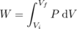
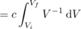
= c ln V_{f} - c ln V_{i}
= c ln (V_{f}/V_{i})
The ratio V_{f}/V_{i} is called the compression ratio of the engine, and higher values result in more power along this stroke. Along an insulated stroke, we have P∝ V^{-γ}, with γ≠1, so the result for the work no longer has this perfect mathematical property of depending only on the ratio V_{f}/V_{i}. Nevertheless, the compression ratio is still a good figure of merit for predicting the performance of any heat engine, including an internal combustion engine. High compression ratios tend to make the working gas of an internal combustion engine heat up so much that it spontaneously explodes. When this happens in an Otto-cycle engine, it can cause ignition before the sparkplug fires, an undesirable effect known as pinging. For this reason, the compression ratio of an Otto-cycle automobile engine cannot normally exceed about 10. In a diesel engine, however, this effect is used intentionally, as an alternative to sparkplugs, and compression ratios can be 20 or more.

Example 21: Sound
Figure b shows a P-V plot for a sound wave. As the pressure oscillates up and down, the air is heated and cooled by its compression and expansion. Heat conduction is a relatively slow process, so typically there is not enough time over each cycle for any significant amount of heat to flow from the hot areas to the cold areas. (This is analogous to insulated compression or expansion of a heat engine; in general, a compression or expansion of this type, with no transfer of heat, is called adiabatic.) The pressure and volume of a particular little piece of the air are therefore related according to P∝ V^{-γ}. The cycle of oscillation consists of motion back and forth along a single curve in the P-V plane, and since this curve encloses zero volume, no mechanical work is being done: the wave (under the assumed ideal conditions) propagates without any loss of energy due to friction.

Example 22: Measuring γ using the “spring of air”
Figure c shows an experiment that can be used to measure the γ of a gas. When the mass m is inserted into bottle's neck, which has cross-sectional area A, the mass drops until it compresses the air enough so that the pressure is enough to support its weight. The observed frequency ω of oscillations about this equilibrium position y_{o} can be used to extract the γ of the gas.
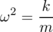
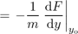
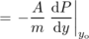
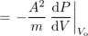
We make the bottle big enough so that its large surface-to-volume ratio prevents the conduction of any significant amount of heat through its walls during one cycle, so P∝ V^{-γ}, and d P/d V=-γ P/V. Thus,
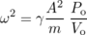
What is remarkable about this experiment is that although the technology needed to construct it has been been available for centuries, it allows us to find out the shape of the molecules in a gas! That is, with the proper interpretation, it answers a question that, even as late as Boltzmann's lifetime, would have been looked down on as being unscientific, in the same class as debates about how many angels could dance on the head of a pin.

Example 23: The Helmholtz resonator
When you blow over the top of a beer bottle, you produce a pure tone. As you drink more of the beer, the pitch goes down. This is similar to example 22, except that instead of a solid mass m sitting inside the neck of the bottle, the moving mass is the air itself. As air rushes in and out of the bottle, its velocity is highest at the bottleneck, and since kinetic energy is proportional to the square of the velocity, essentially all of the kinetic energy is that of the air that's in the neck. In other words, we can replace m with ALρ, where L is the length of the neck, and ρ is the density of the air. Substituting into the earlier result, we find that the resonant frequency is
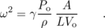
This is known as a Helmholtz resonator. As shown in figure d, a violin or an acoustic guitar has a Helmholtz resonance, since air can move in and out through the f-holes. Problem 10 is a more quantitative exploration of this.
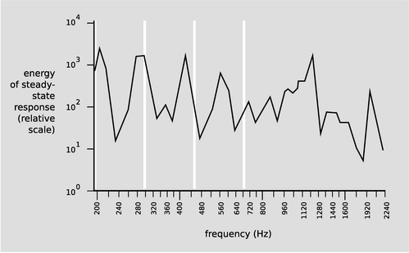
d / The resonance curve of a 1713 Stradivarius violin, measured by Carleen Hutchins. There are a number of different resonance peaks, some strong and some weak; the ones near 200 and 400 Hz are vibrations of the wood, but the one near 300 Hz is a resonance of the air moving in and out through those holes shaped like the letter F. The white lines show the frequencies of the four strings.
We have already seen, based on the microscopic nature of entropy, that any Carnot engine has the same efficiency, and the argument only employed the assumption that the engine met the definition of a Carnot cycle: two insulated strokes, and two constant-temperature strokes. Since we didn't have to make any assumptions about the nature of the working gas being used, the result is evidently true for diatomic or polyatomic molecules, or for a gas that is not ideal. This result is surprisingly simple and general, and a little mysterious --- it even applies to possibilities that we have not even considered, such as a Carnot engine designed so that the working “gas” actually consists of a mixture of liquid droplets and vapor, as in a steam engine. How can it always turn out so simple, given the kind of mathematical complications that were swept under the rug in example 20? A better way to understand this result is by switching from P-V diagrams to a diagram of temperature versus entropy, as shown in figure e. An infinitesimal transfer of heat d Q gives rise to a change in entropy d S=d Q/T, so the area under the curve on a T-S plot gives the amount of heat transferred. The area under the top edge of the box in figure e, extending all the way down to the axis, represents the amount of heat absorbed from the hot reservoir, while the smaller area under the bottom edge represents the heat wasted into the cold reservoir. By conservation of energy, the area enclosed by the box therefore represents the amount of mechanical work being done, as for a P-V diagram. We can now see why the efficiency of a Carnot engine is independent of any of the physical details: the definition of a Carnot engine guarantees that the T-S diagram will be a rectangular box, and the efficiency depends only on the relative heights of the top and bottom of the box.
\backofchapterboilerplate{thermo}

Homework Problems
1. [0]{stpvol} (a) Show that under conditions of standard pressure and temperature, the volume of a sample of an ideal gas depends only on the number of molecules in it.
(b) One mole is defined as 6.0×10²³ atoms. Find the volume of one mole of an ideal gas, in units of liters, at standard temperature and pressure (0°C and 101 kPa). (answer check available at lightandmatter.com)
2. A gas in a cylinder expands its volume by an amount d V, pushing out a piston. Show that the work done by the gas on the piston is given by d W = Pd V.
3. [0]{he} (a) A helium atom contains 2 protons, 2 electrons, and 2 neutrons. Find the mass of a helium atom. (answer check available at lightandmatter.com)
(b) Find the number of atoms in 1.0 kg of helium. (answer check available at lightandmatter.com)
(c) Helium gas is monoatomic. Find the amount of heat needed to raise the temperature of 1.0 kg of helium by 1.0 degree C. (This is known as helium's heat capacity at constant volume.) (answer check available at lightandmatter.com)
4. Refrigerators, air conditioners, and heat pumps are heat engines that work in reverse. You put in mechanical work, and the effect is to take heat out of a cooler reservoir and deposit heat in a warmer one: Q_{L}+W=Q_{H}. As with the heat engines discussed previously, the efficiency is defined as the energy transfer you want (Q_{L} for a refrigerator or air conditioner, Q_{H} for a heat pump) divided by the energy transfer you pay for (W).
Efficiencies are supposed to be unitless, but the efficiency of an air conditioner is normally given in terms of an EER rating (or a more complex version called an SEER). The EER is defined as Q_{L}/W, but expressed in the barbaric units of of Btu/watt-hour. A typical EER rating for a residential air conditioner is about 10 Btu/watt-hour, corresponding to an efficiency of about 3. The standard temperatures used for testing an air conditioner's efficiency are 80° F (27°C) inside and 95° F (35°C) outside.
(a) What would be the EER rating of a reversed Carnot engine used as an air conditioner? (answer check available at lightandmatter.com)
(b) If you ran a 3-kW residential air conditioner, with an efficiency of 3, for one hour, what would be the effect on the total entropy of the universe? Is your answer consistent with the second law of thermodynamics? (answer check available at lightandmatter.com)
5. Estimate the pressure at the center of the Earth, assuming it is of constant density throughout. Note that g is not constant with respect to depth --- as shown in example 18 on page 71, g equals Gmr/b³ for r, the distance from the center, less than b, the earth's radius.
(a) State your result in terms of G, m, and b.(answer check available at lightandmatter.com)
(b) Show that your answer from part a has the right units for pressure.
(c) Evaluate the result numerically. (answer check available at lightandmatter.com)
(d) Given that the earth's atmosphere is on the order of one thousandth the earth's radius, and that the density of the earth is several thousand times greater than the density of the lower atmosphere, check that your result is of a reasonable order of magnitude.
6. (a) Determine the ratio between the escape velocities from the surfaces of the earth and the moon. (answer check available at lightandmatter.com)
(b) The temperature during the lunar daytime gets up to about 130°C. In the extremely thin (almost nonexistent) lunar atmosphere, estimate how the typical velocity of a molecule would compare with that of the same type of molecule in the earth's atmosphere. Assume that the earth's atmosphere has a temperature of 0°C. (answer check available at lightandmatter.com)
(c) Suppose you were to go to the moon and release some fluorocarbon gas, with molecular formula C_{n}F_{2n+2}. Estimate what is the smallest fluorocarbon molecule (lowest n) whose typical velocity would be lower than that of an N₂ molecule on earth in proportion to the moon's lower escape velocity. The moon would be able to retain an atmosphere made of these molecules. (answer check available at lightandmatter.com)
7. Most of the atoms in the universe are in the form of gas that is not part of any star or galaxy: the intergalactic medium (IGM). The IGM consists of about 10⁻⁵ atoms per cubic centimeter, with a typical temperature of about 10³ K. These are, in some sense, the density and temperature of the universe (not counting light, or the exotic particles known as “dark matter”). Calculate the pressure of the universe (or, speaking more carefully, the typical pressure due to the IGM).(answer check available at lightandmatter.com)
8. A sample of gas is enclosed in a sealed chamber. The gas consists of molecules, which are then split in half through some process such as exposure to ultraviolet light, or passing an electric spark through the gas. The gas returns to thermal equilibrium with the surrounding room. How does its pressure now compare with its pressure before the molecules were split?
9. Even when resting, the human body needs to do a certain amount of mechanical work to keep the heart beating. This quantity is difficult to define and measure with high precision, and also depends on the individual and her level of activity, but it's estimated to be about 1 to 5 watts. Suppose we consider the human body as nothing more than a pump. A person who is just lying in bed all day needs about 1000 kcal/day worth of food to stay alive. (a) Estimate the person's thermodynamic efficiency as a pump, and (b) compare with the maximum possible efficiency imposed by the laws of thermodynamics for a heat engine operating across the difference between a body temperature of 37°C and an ambient temperature of 22°C. (c) Interpret your answer.\hwans{hwans:heart-efficiency}
10. Example 23 on page 274 suggests analyzing the resonance of a violin at 300 Hz as a Helmholtz resonance. However, we might expect the equation for the frequency of a Helmholtz resonator to be a rather crude approximation here, since the f-holes are not long tubes, but slits cut through the face of the instrument, which is only about 2.5 mm thick. (a) Estimate the frequency that way anyway, for a violin with a volume of about 1.6 liters, and f-holes with a total area of 10 cm². (b) A common rule of thumb is that at an open end of an air column, such as the neck of a real Helmholtz resonator, some air beyond the mouth also vibrates as if it was inside the tube, and that this effect can be taken into account by adding 0.4 times the diameter of the tube for each open end (i.e., 0.8 times the diameter when both ends are open). Applying this to the violin's f-holes results in a huge change in L, since the ∼ 7 mm width of the f-hole is considerably greater than the thickness of the wood. Try it, and see if the result is a better approximation to the observed frequency of the resonance.\hwans{hwans:violin-helmholtz}

Footnotes
[1] Even with smaller numbers of atoms, there is a problem with this kind of brute-force computation, because the tiniest measurement errors in the initial state would end up having large effects later on.
[2] This is the same relation as the one on Boltzmann's tomb, just in a slightly different notation.

6. Waves
Table of Contents

Contents
Section 6.1 - Free Waves
Section 6.2 - Bounded Waves

a / The vibrations of this electric bass string are converted to electrical vibrations, then to sound vibrations, and finally to vibrations of our eardrums.

Chapter 6. Waves
Dandelion. Cello. Read those two words, and your brain instantly conjures a stream of associations, the most prominent of which have to do with vibrations. Our mental category of “dandelion-ness” is strongly linked to the color of light waves that vibrate about half a million billion times a second: yellow. The velvety throb of a cello has as its most obvious characteristic a relatively low musical pitch --- the note you're spontaneously imagining right now might be one whose sound vibrations repeat at a rate of a hundred times a second.
Evolution seems to have designed our two most important senses around the assumption that our environment is made of waves, whereas up until now, we've mostly taken the view that Nature can be understood by breaking her down into smaller and smaller parts, ending up with particles as her most fundamental building blocks. Does that work for light and sound? Sound waves are disturbances in air, which is made of atoms, but light, on the other hand, isn't a vibration of atoms. Light, unlike sound, can travel through a vacuum: if you're reading this by sunlight, you're taking advantage of light that had to make it through millions of miles of vacuum to get to you. Waves, then, are not just a trick that vibrating atoms can do. Waves are one of the basic phenomena of the universe. At the end of this book, we'll even see that the things we've been calling particles, such as electrons, are really waves!¹

6.1 Free Waves
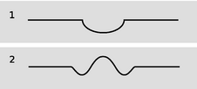
a / Your finger makes a depression in the surface of the water, 1. The wave patterns starts evolving, 2, after you remove your finger.
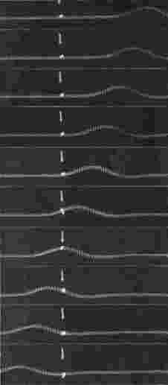
d / As the wave pulse goes by, the ribbon tied to the spring is not carried along. The motion of the wave pattern is to the right, but the medium (spring) is moving from side to side, not to the right. (PSSC Physics)

e / Example 2. The surfer is dragging his hand in the water.

f / Example 3: a breaking wave.
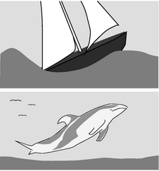
g / Example 4. The boat has run up against a limit on its speed because it can't climb over its own wave. Dolphins get around the problem by leaping out of the water.
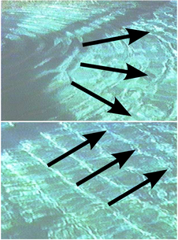
h / Circular and linear wave patterns.
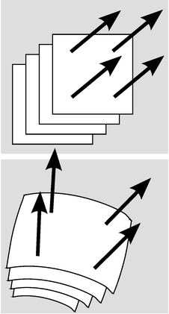
i / Plane and spherical wave patterns.

Wave motion
Let's start with an intuition-building exercise that deals with waves in matter, since they're easier than light waves to get your hands on. Put your fingertip in the middle of a cup of water and then remove it suddenly. You'll have noticed two results that are surprising to most people. First, the flat surface of the water does not simply sink uniformly to fill in the volume vacated by your finger. Instead, ripples spread out, and the process of flattening out occurs over a long period of time, during which the water at the center vibrates above and below the normal water level. This type of wave motion is the topic of the present section. Second, you've found that the ripples bounce off of the walls of the cup, in much the same way that a ball would bounce off of a wall. In the next section we discuss what happens to waves that have a boundary around them. Until then, we confine ourselves to wave phenomena that can be analyzed as if the medium (e.g. the water) was infinite and the same everywhere.
It isn't hard to understand why removing your fingertip creates ripples rather than simply allowing the water to sink back down uniformly. The initial crater, a/1, left behind by your finger has sloping sides, and the water next to the crater flows downhill to fill in the hole. The water far away, on the other hand, initially has no way of knowing what has happened, because there is no slope for it to flow down. As the hole fills up, the rising water at the center gains upward momentum, and overshoots, creating a little hill where there had been a hole originally. The area just outside of this region has been robbed of some of its water in order to build the hill, so a depressed “moat” is formed, a/2. This effect cascades outward, producing ripples.
There are three main ways in which wave motion differs from the motion of objects made of matter.
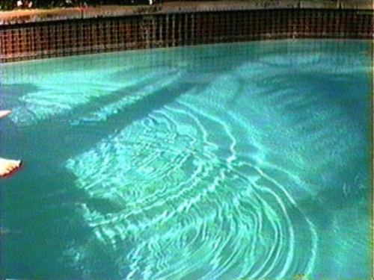
b / The two circular patterns of ripples pass through each other. Unlike material objects, wave patterns can overlap in space, and when this happens they combine by addition.

1. Superposition
If you watched the water in the cup carefully, you noticed the ghostlike behavior of the reflected ripples coming back toward the center of the cup and the outgoing ripples that hadn't yet been reflected: they passed right through each other. This is the first, and the most profound, difference between wave motion and the motion of objects: waves do not display any repulsion of each other analogous to the normal forces between objects that come in contact. Two wave patterns can therefore overlap in the same region of space, as shown in figure b. Where the two waves coincide, they add together. For instance, suppose that at a certain location in at a certain moment in time, each wave would have had a crest 3 cm above the normal water level. The waves combine at this point to make a 6-cm crest. We use negative numbers to represent depressions in the water. If both waves would have had a troughs measuring -3 cm, then they combine to make an extra-deep -6 cm trough. A +3 cm crest and a -3 cm trough result in a height of zero, i.e. the waves momentarily cancel each other out at that point. This additive rule is referred to as the principle of superposition, “superposition” being merely a fancy word for “adding.”
Superposition can occur not just with sinusoidal waves like the ones in the figure above but with waves of any shape. The figures on the following page show superposition of wave pulses. A pulse is simply a wave of very short duration. These pulses consist only of a single hump or trough. If you hit a clothesline sharply, you will observe pulses heading off in both directions. This is analogous to the way ripples spread out in all directions when you make a disturbance at one point on water. The same occurs when the hammer on a piano comes up and hits a string.
Experiments to date have not shown any deviation from the principle of superposition in the case of light waves. For other types of waves, it is typically a very good approximation for low-energy waves.
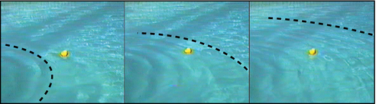
c / As the wave pattern passes the rubber duck, the duck stays put. The water isn't moving with the wave.

2. The medium is not transported with the wave.
The sequence of three photos in figure c shows a series of water waves before it has reached a rubber duck (left), having just passed the duck (middle) and having progressed about a meter beyond the duck (right). The duck bobs around its initial position, but is not carried along with the wave. This shows that the water itself does not flow outward with the wave. If it did, we could empty one end of a swimming pool simply by kicking up waves! We must distinguish between the motion of the medium (water in this case) and the motion of the wave pattern through the medium. The medium vibrates; the wave progresses through space.
self-check: In figure d, you can detect the side-to-side motion of the spring because the spring appears blurry. At a certain instant, represented by a single photo, how would you describe the motion of the different parts of the spring? Other than the flat parts, do any parts of the spring have zero velocity? (answer in the back of the PDF version of the book)

Example 1: A worm
The worm in the figure is moving to the right. The wave pattern, a pulse consisting of a compressed area of its body, moves to the left. In other words, the motion of the wave pattern is in the opposite direction compared to the motion of the medium.
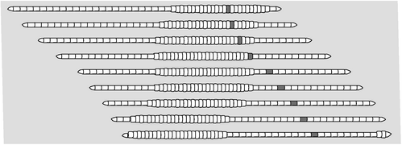

Example 2: Surfing
The incorrect belief that the medium moves with the wave is often reinforced by garbled secondhand knowledge of surfing. Anyone who has actually surfed knows that the front of the board pushes the water to the sides, creating a wake --- the surfer can even drag his hand through the water, as in in figure e. If the water was moving along with the wave and the surfer, this wouldn't happen. The surfer is carried forward because forward is downhill, not because of any forward flow of the water. If the water was flowing forward, then a person floating in the water up to her neck would be carried along just as quickly as someone on a surfboard. In fact, it is even possible to surf down the back side of a wave, although the ride wouldn't last very long because the surfer and the wave would quickly part company.

3. A wave's velocity depends on the medium.
A material object can move with any velocity, and can be sped up or slowed down by a force that increases or decreases its kinetic energy. Not so with waves. The speed of a wave, depends on the properties of the medium (and perhaps also on the shape of the wave, for certain types of waves). Sound waves travel at about 340 m/s in air, 1000 m/s in helium. If you kick up water waves in a pool, you will find that kicking harder makes waves that are taller (and therefore carry more energy), not faster. The sound waves from an exploding stick of dynamite carry a lot of energy, but are no faster than any other waves. In the following section we will give an example of the physical relationship between the wave speed and the properties of the medium.

Example 3: Breaking waves
The velocity of water waves increases with depth. The crest of a wave travels faster than the trough, and this can cause the wave to break.
Once a wave is created, the only reason its speed will change is if it enters a different medium or if the properties of the medium change. It is not so surprising that a change in medium can slow down a wave, but the reverse can also happen. A sound wave traveling through a helium balloon will slow down when it emerges into the air, but if it enters another balloon it will speed back up again! Similarly, water waves travel more quickly over deeper water, so a wave will slow down as it passes over an underwater ridge, but speed up again as it emerges into deeper water.

Example 4: Hull speed
The speeds of most boats, and of some surface-swimming animals, are limited by the fact that they make a wave due to their motion through the water. The boat in figure g is going at the same speed as its own waves, and can't go any faster. No matter how hard the boat pushes against the water, it can't make the wave move ahead faster and get out of the way. The wave's speed depends only on the medium. Adding energy to the wave doesn't speed it up, it just increases its amplitude.
A water wave, unlike many other types of wave, has a speed that depends on its shape: a broader wave moves faster. The shape of the wave made by a boat tends to mold itself to the shape of the boat's hull, so a boat with a longer hull makes a broader wave that moves faster. The maximum speed of a boat whose speed is limited by this effect is therefore closely related to the length of its hull, and the maximum speed is called the hull speed. Sailboats designed for racing are not just long and skinny to make them more streamlined --- they are also long so that their hull speeds will be high.

Wave patterns
If the magnitude of a wave's velocity vector is preordained, what about its direction? Waves spread out in all directions from every point on the disturbance that created them. If the disturbance is small, we may consider it as a single point, and in the case of water waves the resulting wave pattern is the familiar circular ripple, h/1. If, on the other hand, we lay a pole on the surface of the water and wiggle it up and down, we create a linear wave pattern, h/2. For a three-dimensional wave such as a sound wave, the analogous patterns would be spherical waves and plane waves, i.
Infinitely many patterns are possible, but linear or plane waves are often the simplest to analyze, because the velocity vector is in the same direction no matter what part of the wave we look at. Since all the velocity vectors are parallel to one another, the problem is effectively one-dimensional. Throughout this chapter and the next, we will restrict ourselves mainly to wave motion in one dimension, while not hesitating to broaden our horizons when it can be done without too much complication.

Discussion Questions
◊ The left panel of the figure shows a sequence of snapshots of two positive pulses on a coil spring as they move through each other. In the right panel, which shows a positive pulse and a negative one, the fifth frame has the spring just about perfectly flat. If the two pulses have essentially canceled each other out perfectly, then why does the motion pick up again? Why doesn't the spring just stay flat?
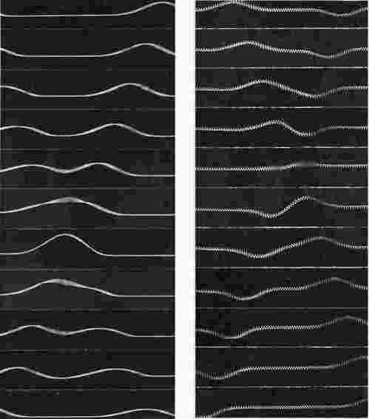
j / Discussion question A.
◊ Sketch two positive wave pulses on a string that are overlapping but not right on top of each other, and draw their superposition. Do the same for a positive pulse running into a negative pulse.
◊ A traveling wave pulse is moving to the right on a string. Sketch the velocity vectors of the various parts of the string. Now do the same for a pulse moving to the left.
◊ In a spherical sound wave spreading out from a point, how would the energy of the wave fall off with distance?
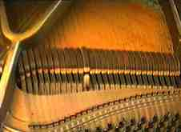
k / Hitting a key on a piano causes a hammer to come up from underneath and hit a string (actually a set of three). The result is a pair of pulses moving away from the point of impact.
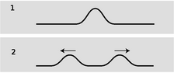
l / A pulse on a string splits in two and heads off in both directions.
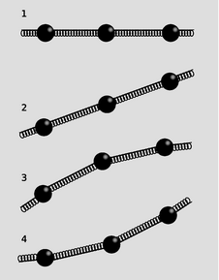
m / Modeling a string as a series of masses connected by springs.
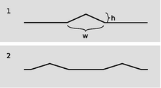
n / A triangular pulse spreads out.

Waves on a string
So far you've learned some counterintuitive things about the behavior of waves, but intuition can be trained. The first half of this subsection aims to build your intuition by investigating a simple, one-dimensional type of wave: a wave on a string. If you have ever stretched a string between the bottoms of two open-mouthed cans to talk to a friend, you were putting this type of wave to work. Stringed instruments are another good example. Although we usually think of a piano wire simply as vibrating, the hammer actually strikes it quickly and makes a dent in it, which then ripples out in both directions. Since this chapter is about free waves, not bounded ones, we pretend that our string is infinitely long.
After the qualitative discussion, we will use simple approximations to investigate the speed of a wave pulse on a string. This quick and dirty treatment is then followed by a rigorous attack using the methods of calculus, which turns out to be both simpler and more general.

Intuitive ideas
Consider a string that has been struck, l/1, resulting in the creation of two wave pulses, l/2, one traveling to the left and one to the right. This is analogous to the way ripples spread out in all directions from a splash in water, but on a one-dimensional string, “all directions” becomes “both directions.”
We can gain insight by modeling the string as a series of masses connected by springs, m. (In the actual string the mass and the springiness are both contributed by the molecules themselves.) If we look at various microscopic portions of the string, there will be some areas that are flat, 1, some that are sloping but not curved, 2, and some that are curved, 3 and 4. In example 1 it is clear that both the forces on the central mass cancel out, so it will not accelerate. The same is true of 2, however. Only in curved regions such as 3 and 4 is an acceleration produced. In these examples, the vector sum of the two forces acting on the central mass is not zero. The important concept is that curvature makes force: the curved areas of a wave tend to experience forces resulting in an acceleration toward the mouth of the curve. Note, however, that an uncurved portion of the string need not remain motionless. It may move at constant velocity to either side.

Approximate treatment
We now carry out an approximate treatment of the speed at which two pulses will spread out from an initial indentation on a string. For simplicity, we imagine a hammer blow that creates a triangular dent, n/1. We will estimate the amount of time, t, required until each of the pulses has traveled a distance equal to the width of the pulse itself. The velocity of the pulses is then ± w/t.
As always, the velocity of a wave depends on the properties of the medium, in this case the string. The properties of the string can be summarized by two variables: the tension, T, and the mass per unit length, μ (Greek letter mu).
If we consider the part of the string encompassed by the initial dent as a single object, then this object has a mass of approximately μ w (mass/length × length=mass). (Here, and throughout the derivation, we assume that h is much less than w, so that we can ignore the fact that this segment of the string has a length slightly greater than w.) Although the downward acceleration of this segment of the string will be neither constant over time nor uniform across the pulse, we will pretend that it is constant for the sake of our simple estimate. Roughly speaking, the time interval between n/1 and n/2 is the amount of time required for the initial dent to accelerate from rest and reach its normal, flattened position. Of course the tip of the triangle has a longer distance to travel than the edges, but again we ignore the complications and simply assume that the segment as a whole must travel a distance h. Indeed, it might seem surprising that the triangle would so neatly spring back to a perfectly flat shape. It is an experimental fact that it does, but our analysis is too crude to address such details.
The string is kinked, i.e. tightly curved, at the edges of the triangle, so it is here that there will be large forces that do not cancel out to zero. There are two forces acting on the triangular hump, one of magnitude T acting down and to the right, and one of the same magnitude acting down and to the left. If the angle of the sloping sides is θ, then the total force on the segment equals 2T sinθ. Dividing the triangle into two right triangles, we see that sinθ equals h divided by the length of one of the sloping sides. Since h is much less than w, the length of the sloping side is essentially the same as w/2, so we have sinθ = 2h/w, and F=4Th/w. The acceleration of the segment (actually the acceleration of its center of mass) is
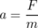
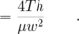
The time required to move a distance h under constant acceleration a is found by solving h=(1/2)at² to yield
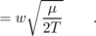
Our final result for the speed of the pulses is
v = w/t
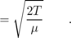
The remarkable feature of this result is that the velocity of the pulses does not depend at all on w or h, i.e. any triangular pulse has the same speed. It is an experimental fact (and we will also prove rigorously below) that any pulse of any kind, triangular or otherwise, travels along the string at the same speed. Of course, after so many approximations we cannot expect to have gotten all the numerical factors right. The correct result for the speed of the pulses is
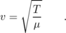
The importance of the above derivation lies in the insight it brings ---that all pulses move with the same speed --- rather than in the details of the numerical result. The reason for our too-high value for the velocity is not hard to guess. It comes from the assumption that the acceleration was constant, when actually the total force on the segment would diminish as it flattened out.

Treatment using calculus
After expending considerable effort for an approximate solution, we now display the power of calculus with a rigorous and completely general treatment that is nevertheless much shorter and easier. Let the flat position of the string define the x axis, so that y measures how far a point on the string is from equilibrium. The motion of the string is characterized by y(x,t), a function of two variables. Knowing that the force on any small segment of string depends on the curvature of the string in that area, and that the second derivative is a measure of curvature, it is not surprising to find that the infinitesimal force d F acting on an infinitesimal segment d x is given by
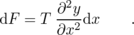
(This can be proved by vector addition of the two infinitesimal forces acting on either side.) The symbol ∂ stands for a partial derivative, e.g. ∂/∂ x means a derivative with respect to x that is evaluated while treating t as a constant. The acceleration is then a =d F/d m, or, substituting d m=μ d x,
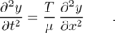
The second derivative with respect to time is related to the second derivative with respect to position. This is no more than a fancy mathematical statement of the intuitive fact developed above, that the string accelerates so as to flatten out its curves.
Before even bothering to look for solutions to this equation, we note that it already proves the principle of superposition, because the derivative of a sum is the sum of the derivatives. Therefore the sum of any two solutions will also be a solution.
Based on experiment, we expect that this equation will be satisfied by any function y(x,t) that describes a pulse or wave pattern moving to the left or right at the correct speed v. In general, such a function will be of the form y=f(x-vt) or y=f(x+vt), where f is any function of one variable. Because of the chain rule, each derivative with respect to time brings out a factor of v. Evaluating the second derivatives on both sides of the equation gives
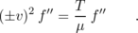
Squaring gets rid of the sign, and we find that we have a valid solution for any function f, provided that v is given by

Sound and light waves

Sound waves
The phenomenon of sound is easily found to have all the characteristics we expect from a wave phenomenon:
- Sound waves obey superposition. Sounds do not knock other sounds out of the way when they collide, and we can hear more than one sound at once if they both reach our ear simultaneously.
- The medium does not move with the sound. Even standing in front of a titanic speaker playing earsplitting music, we do not feel the slightest breeze.
- The velocity of sound depends on the medium. Sound travels faster in helium than in air, and faster in water than in helium. Putting more energy into the wave makes it more intense, not faster. For example, you can easily detect an echo when you clap your hands a short distance from a large, flat wall, and the delay of the echo is no shorter for a louder clap.
Although not all waves have a speed that is independent of the shape of the wave, and this property therefore is irrelevant to our collection of evidence that sound is a wave phenomenon, sound does nevertheless have this property. For instance, the music in a large concert hall or stadium may take on the order of a second to reach someone seated in the nosebleed section, but we do not notice or care, because the delay is the same for every sound. Bass, drums, and vocals all head outward from the stage at 340 m/s, regardless of their differing wave shapes.
If sound has all the properties we expect from a wave, then what type of wave is it? It is a series of compressions and expansions of the air. Even for a very loud sound, the increase or decrease compared to normal atmospheric pressure is no more than a part per million, so our ears are apparently very sensitive instruments. In a vacuum, there is no medium for the sound waves, and so they cannot exist. The roars and whooshes of space ships in Hollywood movies are fun, but scientifically wrong.

Light waves
Entirely similar observations lead us to believe that light is a wave, although the concept of light as a wave had a long and tortuous history. It is interesting to note that Isaac Newton very influentially advocated a contrary idea about light. The belief that matter was made of atoms was stylish at the time among radical thinkers (although there was no experimental evidence for their existence), and it seemed logical to Newton that light as well should be made of tiny particles, which he called corpuscles (Latin for “small objects”). Newton's triumphs in the science of mechanics, i.e. the study of matter, brought him such great prestige that nobody bothered to question his incorrect theory of light for 150 years. One persuasive proof that light is a wave is that according to Newton's theory, two intersecting beams of light should experience at least some disruption because of collisions between their corpuscles. Even if the corpuscles were extremely small, and collisions therefore very infrequent, at least some dimming should have been measurable. In fact, very delicate experiments have shown that there is no dimming.
The wave theory of light was entirely successful up until the 20th century, when it was discovered that not all the phenomena of light could be explained with a pure wave theory. It is now believed that both light and matter are made out of tiny chunks which have both wave and particle properties. For now, we will content ourselves with the wave theory of light, which is capable of explaining a great many things, from cameras to rainbows.
If light is a wave, what is waving? What is the medium that wiggles when a light wave goes by? It isn't air. A vacuum is impenetrable to sound, but light from the stars travels happily through zillions of miles of empty space. Light bulbs have no air inside them, but that doesn't prevent the light waves from leaving the filament. For a long time, physicists assumed that there must be a mysterious medium for light waves, and they called it the ether (not to be confused with the chemical). Supposedly the ether existed everywhere in space, and was immune to vacuum pumps. The details of the story are more fittingly reserved for later in this course, but the end result was that a long series of experiments failed to detect any evidence for the ether, and it is no longer believed to exist. Instead, light can be explained as a wave pattern made up of electrical and magnetic fields.
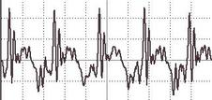
o / A graph of pressure versus time for a periodic sound wave, the vowel “ah.”
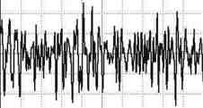
p / A similar graph for a nonperiodic wave, “sh.”
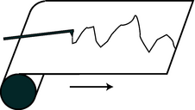
q / A strip chart recorder.
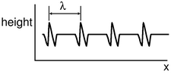
r / A water wave profile created by a series of repeating pulses.
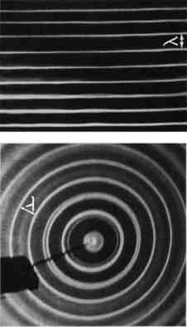
s / Wavelengths of linear and circular waves. (PSSC Physics)
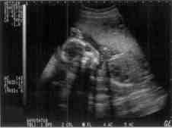
t / Ultrasound, i.e. sound with frequencies higher than the range of human hearing, was used to make this image of a fetus. The resolution of the image is related to the wavelength, since details smaller than about one wavelength cannot be resolved. High resolution therefore requires a short wavelength, corresponding to a high frequency.
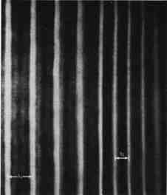
u / A water wave traveling into a region with different depth will change its wavelength.

Periodic waves

Period and frequency of a periodic wave
You choose a radio station by selecting a certain frequency. We have already defined period and frequency for vibrations,
but what do they signify in the case of a wave? We can recycle our previous definition simply by stating it in terms of the vibrations that the wave causes as it passes a receiving instrument at a certain point in space. For a sound wave, this receiver could be an eardrum or a microphone. If the vibrations of the eardrum repeat themselves over and over, i.e. are periodic, then we describe the sound wave that caused them as periodic. Likewise we can define the period and frequency of a wave in terms of the period and frequency of the vibrations it causes. As another example, a periodic water wave would be one that caused a rubber duck to bob in a periodic manner as they passed by it.
The period of a sound wave correlates with our sensory impression of musical pitch. A high frequency (short period) is a high note. The sounds that really define the musical notes of a song are only the ones that are periodic. It is not possible to sing a nonperiodic sound like “sh” with a definite pitch.
The frequency of a light wave corresponds to color. Violet is the high-frequency end of the rainbow, red the low-frequency end. A color like brown that does not occur in a rainbow is not a periodic light wave. Many phenomena that we do not normally think of as light are actually just forms of light that are invisible because they fall outside the range of frequencies our eyes can detect. Beyond the red end of the visible rainbow, there are infrared and radio waves. Past the violet end, we have ultraviolet, x-rays, and gamma rays.

Graphs of waves as a function of position
Some waves, light sound waves, are easy to study by placing a detector at a certain location in space and studying the motion as a function of time. The result is a graph whose horizontal axis is time. With a water wave, on the other hand, it is simpler just to look at the wave directly. This visual snapshot amounts to a graph of the height of the water wave as a function of position. Any wave can be represented in either way.
An easy way to visualize this is in terms of a strip chart recorder, an obsolescing device consisting of a pen that wiggles back and forth as a roll of paper is fed under it. It can be used to record a person's electrocardiogram, or seismic waves too small to be felt as a noticeable earthquake but detectable by a seismometer. Taking the seismometer as an example, the chart is essentially a record of the ground's wave motion as a function of time, but if the paper was set to feed at the same velocity as the motion of an earthquake wave, it would also be a full-scale representation of the profile of the actual wave pattern itself. Assuming, as is usually the case, that the wave velocity is a constant number regardless of the wave's shape, knowing the wave motion as a function of time is equivalent to knowing it as a function of position.

Wavelength
Any wave that is periodic will also display a repeating pattern when graphed as a function of position. The distance spanned by one repetition is referred to as one wavelength. The usual notation for wavelength is λ, the Greek letter lambda. Wavelength is to space as period is to time.

Wave velocity related to frequency and wavelength
Suppose that we create a repetitive disturbance by kicking the surface of a swimming pool. We are essentially making a series of wave pulses. The wavelength is simply the distance a pulse is able to travel before we make the next pulse. The distance between pulses is λ, and the time between pulses is the period, T, so the speed of the wave is the distance divided by the time,
v = λ/T .
This important and useful relationship is more commonly written in terms of the frequency,
v = fλ .

Example 5: Wavelength of radio waves
◊ The speed of light is . What is the wavelength of the radio waves emitted by KLON, a station whose frequency is 88.1 MHz?
◊ Solving for wavelength, we have
λ = v/ f
/(88.1}×10⁶ s⁻¹)
The size of a radio antenna is closely related to the wavelength of the waves it is intended to receive. The match need not be exact (since after all one antenna can receive more than one wavelength!), but the ordinary “whip” antenna such as a car's is 1/4 of a wavelength. An antenna optimized to receive KLON's signal (which is the only one my car radio is ever tuned to) would have a length of (3.4 m)/4 = 0.85 m.
The equation v=f λ defines a fixed relationship between any two of the variables if the other is held fixed. The speed of radio waves in air is almost exactly the same for all wavelengths and frequencies (it is exactly the same if they are in a vacuum), so there is a fixed relationship between their frequency and wavelength. Thus we can say either “Are we on the same wavelength?” or “Are we on the same frequency?”
A different example is the behavior of a wave that travels from a region where the medium has one set of properties to an area where the medium behaves differently. The frequency is now fixed, because otherwise the two portions of the wave would otherwise get out of step, causing a kink or discontinuity at the boundary, which would be unphysical. (A more careful argument is that a kink or discontinuity would have infinite curvature, and waves tend to flatten out their curvature. An infinite curvature would flatten out infinitely fast, i.e. it could never occur in the first place.) Since the frequency must stay the same, any change in the velocity that results from the new medium must cause a change in wavelength.
The velocity of water waves depends on the depth of the water, so based on λ=v/f, we see that water waves that move into a region of different depth must change their wavelength, as shown in figure u. This effect can be observed when ocean waves come up to the shore. If the deceleration of the wave pattern is sudden enough, the tip of the wave can curl over, resulting in a breaking wave.

A note on dispersive waves
The discussion of wave velocity given here is actually a little bit of an oversimplification for a wave whose velocity depends on its frequency and wavelength. Such a wave is called a dispersive wave. Nearly all the waves we deal with in this course are nondispersive, but the issue becomes important in chapter 12, where it is discussed in detail.

Sinusoidal waves
Sinusoidal waves are the most important special case of periodic waves. In fact, many scientists and engineers would be uncomfortable with defining a waveform like the “ah” vowel sound as having a definite frequency and wavelength, because they consider only sine waves to be pure examples of a certain frequency and wavelengths. Their bias is not unreasonable, since the French mathematician Fourier showed that any periodic wave with frequency f can be constructed as a superposition of sine waves with frequencies f, 2f, 3f, … In this sense, sine waves are the basic, pure building blocks of all waves. (Fourier's result so surprised the mathematical community of France that he was ridiculed the first time he publicly presented his theorem.)
However, what definition to use is really a matter of convenience. Our sense of hearing perceives any two sounds having the same period as possessing the same pitch, regardless of whether they are sine waves or not. This is undoubtedly because our ear-brain system evolved to be able to interpret human speech and animal noises, which are periodic but not sinusoidal. Our eyes, on the other hand, judge a color as pure (belonging to the rainbow set of colors) only if it is a sine wave.

Discussion Questions
◊ Suppose we superimpose two sine waves with equal amplitudes but slightly different frequencies, as shown in the figure. What will the superposition look like? What would this sound like if they were sound waves?
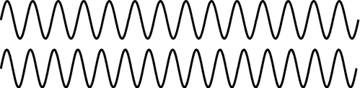
v / Discussion question A.
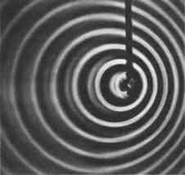
w / The pattern of waves made by a point source moving to the right across the water. Note the shorter wavelength of the forward-emitted waves and the longer wavelength of the backward-going ones.

x / The galaxy M100 in the constellation Coma Berenices. Under higher magnification, the milky clouds reveal themselves to be composed of trillions of stars.
y / How do astronomers know what mixture of wavelengths a star emitted originally, so that they can tell how much the Doppler shift was? This image (obtained by the author with equipment costing about $5, and no telescope) shows the mixture of colors emitted by the star Sirius. (If you have the book in black and white, blue is on the left and red on the right.) The star appears white or bluish-white to the eye, but any light looks white if it contains roughly an equal mixture of the rainbow colors, i.e. of all the pure sinusoidal waves with wavelengths lying in the visible range. Note the black “gap teeth.” These are the fingerprint of hydrogen in the outer atmosphere of Sirius. These wavelengths are selectively absorbed by hydrogen. Sirius is in our own galaxy, but similar stars in other galaxies would have the whole pattern shifted toward the red end, indicating they are moving away from us.
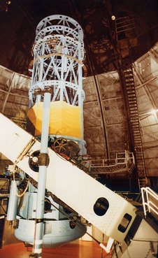
z / The telescope at Mount Wilson used by Hubble.
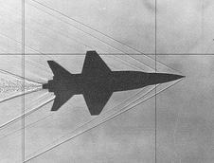
aa / Shock waves are created by the X-15 rocket plane, flying at 3.5 times the speed of sound.
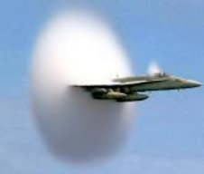
ab / This fighter jet has just accelerated past the speed of sound. The sudden decompression of the air causes water droplets to condense, forming a cloud.

The Doppler effect
Figure w shows the wave pattern made by the tip of a vibrating rod which is moving across the water. If the rod had been vibrating in one place, we would have seen the familiar pattern of concentric circles, all centered on the same point. But since the source of the waves is moving, the wavelength is shortened on one side and lengthened on the other. This is known as the Doppler effect.
Note that the velocity of the waves is a fixed property of the medium, so for example the forward-going waves do not get an extra boost in speed as would a material object like a bullet being shot forward from an airplane.
We can also infer a change in frequency. Since the velocity is constant, the equation v=fλ tells us that the change in wavelength must be matched by an opposite change in frequency: higher frequency for the waves emitted forward, and lower for the ones emitted backward. The frequency Doppler effect is the reason for the familiar dropping-pitch sound of a race car going by. As the car approaches us, we hear a higher pitch, but after it passes us we hear a frequency that is lower than normal.
The Doppler effect will also occur if the observer is moving but the source is stationary. For instance, an observer moving toward a stationary source will perceive one crest of the wave, and will then be surrounded by the next crest sooner than she otherwise would have, because she has moved toward it and hastened her encounter with it. Roughly speaking, the Doppler effect depends only the relative motion of the source and the observer, not on their absolute state of motion (which is not a well-defined notion in physics) or on their velocity relative to the medium.
Restricting ourselves to the case of a moving source, and to waves emitted either directly along or directly against the direction of motion, we can easily calculate the wavelength, or equivalently the frequency, of the Doppler-shifted waves. Let u be the velocity of the source. The wavelength of the forward-emitted waves is shortened by an amount uT equal to the distance traveled by the source over the course of one period. Using the definition f=1/T and the equation v=fλ, we find for the wavelength λ' of the Doppler-shifted wave the equation
A similar equation can be used for the backward-emitted waves, but with a plus sign rather than a minus sign.

Example 6: Doppler-shifted sound from a race car
◊ If a race car moves at a velocity of 50 m/s, and the velocity of sound is 340 m/s, by what percentage are the wavelength and frequency of its sound waves shifted for an observer lying along its line of motion?
◊ For an observer whom the car is approaching, we find
so the shift in wavelength is 15%. Since the frequency is inversely proportional to the wavelength for a fixed value of the speed of sound, the frequency is shifted upward by
i.e. a change of 18%. (For velocities that are small compared to the wave velocities, the Doppler shifts of the wavelength and frequency are about the same.)

Example 7: Doppler shift of the light emitted by a race car
◊ What is the percent shift in the wavelength of the light waves emitted by a race car's headlights?
◊ Looking up the speed of light in the back of the book, , we find
i.e. the percentage shift is only 0.000017%.
The second example shows that under ordinary earthbound circumstances, Doppler shifts of light are negligible because ordinary things go so much slower than the speed of light. It's a different story, however, when it comes to stars and galaxies, and this leads us to a story that has profound implications for our understanding of the origin of the universe.

The Big Bang
As soon as astronomers began looking at the sky through telescopes, they began noticing certain objects that looked like clouds in deep space. The fact that they looked the same night after night meant that they were beyond the earth's atmosphere. Not knowing what they really were, but wanting to sound official, they called them “nebulae,” a Latin word meaning “clouds” but sounding more impressive. In the early 20th century, astronomers realized that although some really were clouds of gas (e.g. the middle “star” of Orion's sword, which is visibly fuzzy even to the naked eye when conditions are good), others were what we now call galaxies: virtual island universes consisting of trillions of stars (for example the Andromeda Galaxy, which is visible as a fuzzy patch through binoculars). Three hundred years after Galileo had resolved the Milky Way into individual stars through his telescope, astronomers realized that the universe is made of galaxies of stars, and the Milky Way is simply the visible part of the flat disk of our own galaxy, seen from inside.
This opened up the scientific study of cosmology, the structure and history of the universe as a whole, a field that had not been seriously attacked since the days of Newton. Newton had realized that if gravity was always attractive, never repulsive, the universe would have a tendency to collapse. His solution to the problem was to posit a universe that was infinite and uniformly populated with matter, so that it would have no geometrical center. The gravitational forces in such a universe would always tend to cancel out by symmetry, so there would be no collapse. By the 20th century, the belief in an unchanging and infinite universe had become conventional wisdom in science, partly as a reaction against the time that had been wasted trying to find explanations of ancient geological phenomena based on catastrophes suggested by biblical events like Noah's flood.
In the 1920's astronomer Edwin Hubble began studying the Doppler shifts of the light emitted by galaxies. A former college football player with a serious nicotine addiction, Hubble did not set out to change our image of the beginning of the universe. His autobiography seldom even mentions the cosmological discovery for which he is now remembered. When astronomers began to study the Doppler shifts of galaxies, they expected that each galaxy's direction and velocity of motion would be essentially random. Some would be approaching us, and their light would therefore be Doppler-shifted to the blue end of the spectrum, while an equal number would be expected to have red shifts. What Hubble discovered instead was that except for a few very nearby ones, all the galaxies had red shifts, indicating that they were receding from us at a hefty fraction of the speed of light. Not only that, but the ones farther away were receding more quickly. The speeds were directly proportional to their distance from us.
Did this mean that the earth (or at least our galaxy) was the center of the universe? No, because Doppler shifts of light only depend on the relative motion of the source and the observer. If we see a distant galaxy moving away from us at 10% of the speed of light, we can be assured that the astronomers who live in that galaxy will see ours receding from them at the same speed in the opposite direction. The whole universe can be envisioned as a rising loaf of raisin bread. As the bread expands, there is more and more space between the raisins. The farther apart two raisins are, the greater the speed with which they move apart.
The universe's expansion is presumably decelerating because of gravitational attraction among the galaxies. We do not presently know whether there is enough mass in the universe to cause enough attraction to halt the expansion eventually. But perhaps more interesting than the distant future of the universe is what its present expansion implies about its past. Extrapolating backward in time using the known laws of physics, the universe must have been denser and denser at earlier and earlier times. At some point, it must have been extremely dense and hot, and we can even detect the radiation from this early fireball, in the form of microwave radiation that permeates space. The phrase Big Bang was originally coined by the doubters of the theory to make it sound ridiculous, but it stuck, and today essentially all astronomers accept the Big Bang theory based on the very direct evidence of the red shifts and the cosmic microwave background radiation.
Finally it should be noted what the Big Bang theory is not. It is not an explanation of why the universe exists. Such questions belong to the realm of religion, not science. Science can find ever simpler and ever more fundamental explanations for a variety of phenomena, but ultimately science takes the universe as it is according to observations.
Furthermore, there is an unfortunate tendency, even among many scientists, to speak of the Big Bang theory was a description of the very first event in the universe, which caused everything after it. Although it is true that time may have had a beginning (Einstein's theory of general relativity admits such a possibility), the methods of science can only work within a certain range of conditions such as temperature and density. Beyond a temperature of about 10⁹ K, the random thermal motion of subatomic particles becomes so rapid that its velocity is comparable to the speed of light. Early enough in the history of the universe, when these temperatures existed, Newtonian physics becomes less accurate, and we must describe nature using the more general description given by Einstein's theory of relativity, which encompasses Newtonian physics as a special case. At even higher temperatures, beyond about 10³³ degrees, physicists know that Einstein's theory as well begins to fall apart, but we don't know how to construct the even more general theory of nature that would work at those temperatures. No matter how far physics progresses, we will never be able to describe nature at infinitely high temperatures, since there is a limit to the temperatures we can explore by experiment and observation in order to guide us to the right theory. We are confident that we understand the basic physics involved in the evolution of the universe starting a few minutes after the Big Bang, and we may be able to push back to milliseconds or microseconds after it, but we cannot use the methods of science to deal with the beginning of time itself.

A note on Doppler shifts of light
If Doppler shifts depend only on the relative motion of the source and receiver, then there is no way for a person moving with the source and another person moving with the receiver to determine who is moving and who isn't. Either can blame the Doppler shift entirely on the other's motion and claim to be at rest herself. This is entirely in agreement with the principle stated originally by Galileo that all motion is relative.
On the other hand, a careful analysis of the Doppler shifts of water or sound waves shows that it is only approximately true, at low speeds, that the shifts just depend on the relative motion of the source and observer. For instance, it is possible for a jet plane to keep up with its own sound waves, so that the sound waves appear to stand still to the pilot of the plane. The pilot then knows she is moving at exactly the speed of sound. The reason this doesn't disprove the relativity of motion is that the pilot is not really determining her absolute motion but rather her motion relative to the air, which is the medium of the sound waves.
Einstein realized that this solved the problem for sound or water waves, but would not salvage the principle of relative motion in the case of light waves, since light is not a vibration of any physical medium such as water or air. Beginning by imagining what a beam of light would look like to a person riding a motorcycle alongside it, Einstein eventually came up with a radical new way of describing the universe, in which space and time are distorted as measured by observers in different states of motion. As a consequence of this Theory of Relativity, he showed that light waves would have Doppler shifts that would exactly, not just approximately, depend only on the relative motion of the source and receiver.

Discussion Questions
◊ If an airplane travels at exactly the speed of sound, what would be the wavelength of the forward-emitted part of the sound waves it emitted? How should this be interpreted, and what would actually happen? What happens if it's going faster than the speed of sound? Can you use this to explain what you see in figures aa and ab?
◊ If bullets go slower than the speed of sound, why can a supersonic fighter plane catch up to its own sound, but not to its own bullets?
◊ If someone inside a plane is talking to you, should their speech be Doppler shifted?

6.2 Bounded Waves
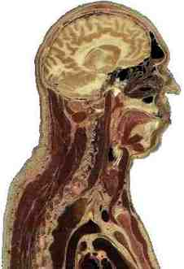
a / A cross-sectional view of a human body, showing the vocal tract.
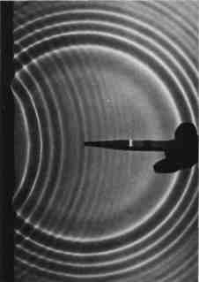
b / Circular water waves are reflected from a boundary on the left. (PSSC Physics)
Speech is what separates humans most decisively from animals. No other species can master syntax, and even though chimpanzees can learn a vocabulary of hand signs, there is an unmistakable difference between a human infant and a baby chimp: starting from birth, the human experiments with the production of complex speech sounds.
Since speech sounds are instinctive for us, we seldom think about them consciously. How do we do control sound waves so skillfully? Mostly we do it by changing the shape of a connected set of hollow cavities in our chest, throat, and head. Somehow by moving the boundaries of this space in and out, we can produce all the vowel sounds. Up until now, we have been studying only those properties of waves that can be understood as if they existed in an infinite, open space with no boundaries. In this chapter we address what happens when a wave is confined within a certain space, or when a wave pattern encounters the boundary between two different media, such as when a light wave moving through air encounters a glass windowpane.
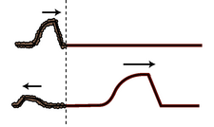
d / An uninverted reflection. The reflected pulse is reversed front to back, but is not upside-down.
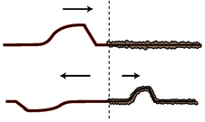
e / An inverted reflection. The reflected pulse is reversed both front to back and top to bottom.
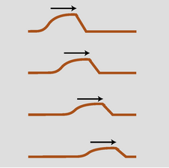
f / A pulse traveling through a highly absorptive medium.

Reflection, transmission, and absorption

Reflection and transmission
Sound waves can echo back from a cliff, and light waves are reflected from the surface of a pond. We use the word reflection, normally applied only to light waves in ordinary speech, to describe any such case of a wave rebounding from a barrier. Figure (a) shows a circular water wave being reflected from a straight wall. In this chapter, we will concentrate mainly on reflection of waves that move in one dimension, as in figure c/1.
Wave reflection does not surprise us. After all, a material object such as a rubber ball would bounce back in the same way. But waves are not objects, and there are some surprises in store.
First, only part of the wave is usually reflected. Looking out through a window, we see light waves that passed through it, but a person standing outside would also be able to see her reflection in the glass. A light wave that strikes the glass is partly reflected and partly transmitted (passed) by the glass. The energy of the original wave is split between the two. This is different from the behavior of the rubber ball, which must go one way or the other, not both.
Second, consider what you see if you are swimming underwater and you look up at the surface. You see your own reflection. This is utterly counterintuitive, since we would expect the light waves to burst forth to freedom in the wide-open air. A material projectile shot up toward the surface would never rebound from the water-air boundary!
What is it about the difference between two media that causes waves to be partly reflected at the boundary between them? Is it their density? Their chemical composition? Ultimately all that matters is the speed of the wave in the two media. A wave is partially reflected and partially transmitted at the boundary between media in which it has different speeds. For example, the speed of light waves in window glass is about 30% less than in air, which explains why windows always make reflections. Figure c shows examples of wave pulses being reflected at the boundary between two coil springs of different weights, in which the wave speed is different.
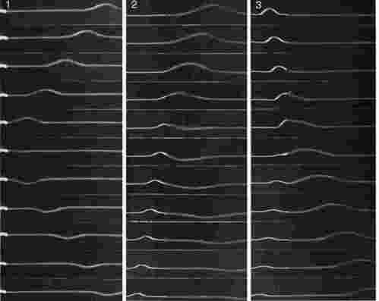
c / 1. A wave on a coil spring, initially traveling to the left, is reflected from the fixed end. 2. A wave in the lighter spring, where the wave speed is greater, travels to the left and is then partly reflected and partly transmitted at the boundary with the heavier coil spring, which has a lower wave speed. The reflection is inverted. 3. A wave moving to the right in the heavier spring is partly reflected at the boundary with the lighter spring. The reflection is uninverted. (PSSC Physics)
Reflections such as b and c/1, where a wave encounters a massive fixed object, can usually be understood on the same basis as cases like c/2 and c/3 where two media meet. Example c/1, for instance, is like a more extreme version of example c/2. If the heavy coil spring in c/2 was made heavier and heavier, it would end up acting like the fixed wall to which the light spring in c/1 has been attached.
self-check: In figure c/1, the reflected pulse is upside-down, but its depth is just as big as the original pulse's height. How does the energy of the reflected pulse compare with that of the original? (answer in the back of the PDF version of the book)

Example 8: Fish have internal ears.
Why don't fish have ear-holes? The speed of sound waves in a fish's body is not much different from their speed in water, so sound waves are not strongly reflected from a fish's skin. They pass right through its body, so fish can have internal ears.

Example 9: Whale songs traveling long distances
Sound waves travel at drastically different speeds through rock, water, and air. Whale songs are thus strongly reflected both at both the bottom and the surface. The sound waves can travel hundreds of miles, bouncing repeatedly between the bottom and the surface, and still be detectable. Sadly, noise pollution from ships has nearly shut down this cetacean version of the internet.

Example 10: Long-distance radio communication
Radio communication can occur between stations on opposite sides of the planet. The mechanism is entirely similar to the one explained in the previous example, but the three media involved are the earth, the atmosphere, and the ionosphere.
self-check: Sonar is a method for ships and submarines to detect each other by producing sound waves and listening for echoes. What properties would an underwater object have to have in order to be invisible to sonar? (answer in the back of the PDF version of the book)
The use of the word “reflection” naturally brings to mind the creation of an image by a mirror, but this might be confusing, because we do not normally refer to “reflection” when we look at surfaces that are not shiny. Nevertheless, reflection is how we see the surfaces of all objects, not just polished ones. When we look at a sidewalk, for example, we are actually seeing the reflecting of the sun from the concrete. The reason we don't see an image of the sun at our feet is simply that the rough surface blurs the image so drastically.

Inverted and uninverted reflections
Notice how the pulse reflected back to the right in example c/2 comes back upside-down, whereas the one reflected back to the left in c/3 returns in its original upright form. This is true for other waves as well. In general, there are two possible types of reflections, a reflection back into a faster medium and a reflection back into a slower medium. One type will always be an inverting reflection and one noninverting.
It's important to realize that when we discuss inverted and uninverted reflections on a string, we are talking about whether the wave is flipped across the direction of motion (i.e. upside-down in these drawings). The reflected pulse will always be reversed front to back, as shown in figures d and e. This is because it is traveling in the other direction. The leading edge of the pulse is what gets reflected first, so it is still ahead when it starts back to the left --- it's just that “ahead” is now in the opposite direction.

Absorption
So far we have tacitly assumed that wave energy remains as wave energy, and is not converted to any other form. If this was true, then the world would become more and more full of sound waves, which could never escape into the vacuum of outer space. In reality, any mechanical wave consists of a traveling pattern of vibrations of some physical medium, and vibrations of matter always produce heat, as when you bend a coathangar back and forth and it becomes hot. We can thus expect that in mechanical waves such as water waves, sound waves, or waves on a string, the wave energy will gradually be converted into heat. This is referred to as absorption. The reduction in the wave's energy can also be described as a reduction in amplitude, the relationship between them being, as with a vibrating object, E∝ A².
The wave suffers a decrease in amplitude, as shown in figure f. The decrease in amplitude amounts to the same fractional change for each unit of distance covered. For example, if a wave decreases from amplitude 2 to amplitude 1 over a distance of 1 meter, then after traveling another meter it will have an amplitude of 1/2. That is, the reduction in amplitude is exponential. This can be proved as follows. By the principle of superposition, we know that a wave of amplitude 2 must behave like the superposition of two identical waves of amplitude 1. If a single amplitude-1 wave would die down to amplitude 1/2 over a certain distance, then two amplitude-1 waves superposed on top of one another to make amplitude 1+1=2 must die down to amplitude 1/2+1/2=1 over the same distance.
self-check: As a wave undergoes absorption, it loses energy. Does this mean that it slows down? (answer in the back of the PDF version of the book)
In many cases, this frictional heating effect is quite weak. Sound waves in air, for instance, dissipate into heat extremely slowly, and the sound of church music in a cathedral may reverberate for as much as 3 or 4 seconds before it becomes inaudible. During this time it has traveled over a kilometer! Even this very gradual dissipation of energy occurs mostly as heating of the church's walls and by the leaking of sound to the outside (where it will eventually end up as heat). Under the right conditions (humid air and low frequency), a sound wave in a straight pipe could theoretically travel hundreds of kilometers before being noticeable attenuated.
In general, the absorption of mechanical waves depends a great deal on the chemical composition and microscopic structure of the medium. Ripples on the surface of antifreeze, for instance, die out extremely rapidly compared to ripples on water. For sound waves and surface waves in liquids and gases, what matters is the viscosity of the substance, i.e. whether it flows easily like water or mercury or more sluggishly like molasses or antifreeze. This explains why our intuitive expectation of strong absorption of sound in water is incorrect. Water is a very weak absorber of sound (viz. whale songs and sonar), and our incorrect intuition arises from focusing on the wrong property of the substance: water's high density, which is irrelevant, rather than its low viscosity, which is what matters.
Light is an interesting case, since although it can travel through matter, it is not itself a vibration of any material substance. Thus we can look at the star Sirius, 10¹⁴ km away from us, and be assured that none of its light was absorbed in the vacuum of outer space during its 9-year journey to us. The Hubble Space Telescope routinely observes light that has been on its way to us since the early history of the universe, billions of years ago. Of course the energy of light can be dissipated if it does pass through matter (and the light from distant galaxies is often absorbed if there happen to be clouds of gas or dust in between).

Example 11: Soundproofing
Typical amateur musicians setting out to soundproof their garages tend to think that they should simply cover the walls with the densest possible substance. In fact, sound is not absorbed very strongly even by passing through several inches of wood. A better strategy for soundproofing is to create a sandwich of alternating layers of materials in which the speed of sound is very different, to encourage reflection.
The classic design is alternating layers of fiberglass and plywood. The speed of sound in plywood is very high, due to its stiffness, while its speed in fiberglass is essentially the same as its speed in air. Both materials are fairly good sound absorbers, but sound waves passing through a few inches of them are still not going to be absorbed sufficiently. The point of combining them is that a sound wave that tries to get out will be strongly reflected at each of the fiberglass-plywood boundaries, and will bounce back and forth many times like a ping pong ball. Due to all the back-and-forth motion, the sound may end up traveling a total distance equal to ten times the actual thickness of the soundproofing before it escapes. This is the equivalent of having ten times the thickness of sound-absorbing material.

Example 12: Radio transmission
A radio transmitting station must have a length of wire or cable connecting the amplifier to the antenna. The cable and the antenna act as two different media for radio waves, and there will therefore be partial reflection of the waves as they come from the cable to the antenna. If the waves bounce back and forth many times between the amplifier and the antenna, a great deal of their energy will be absorbed. There are two ways to attack the problem. One possibility is to design the antenna so that the speed of the waves in it is as close as possible to the speed of the waves in the cable; this minimizes the amount of reflection. The other method is to connect the amplifier to the antenna using a type of wire or cable that does not strongly absorb the waves. Partial reflection then becomes irrelevant, since all the wave energy will eventually exit through the antenna.

Discussion Questions
◊ A sound wave that underwent a pressure-inverting reflection would have its compressions converted to expansions and vice versa. How would its energy and frequency compare with those of the original sound? Would it sound any different? What happens if you swap the two wires where they connect to a stereo speaker, resulting in waves that vibrate in the opposite way?
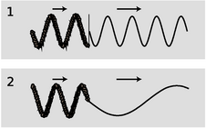
g / 1. A change in frequency without a change in wavelength would produce a discontinuity in the wave. 2. A simple change in wavelength without a reflection would result in a sharp kink in the wave.
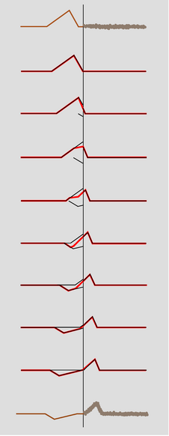
h / A pulse being partially reflected and partially transmitted at the boundary between two strings in which the wave speed is different. The top drawing shows the pulse heading to the right, toward the heaver string. For clarity, all but the first and last drawings are schematic. Once the reflected pulse begins to emerge from the boundary, it adds together with the trailing parts of the incident pulse. Their sum, shown as a wider line, is what is actually observed.
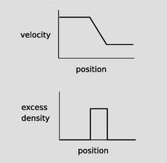
i / A wave pattern in freeway traffic.
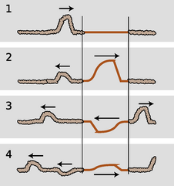
j / A pulse encounters two boundaries.
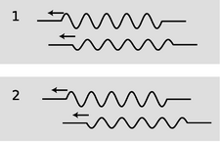
k / A sine wave has been reflected at two different boundaries, and the two reflections interfere.

Quantitative treatment of reflection
In this subsection we analyze the reasons why reflections occur at a speed-changing boundary, predict quantitatively the intensities of reflection and transmission, and discuss how to predict for any type of wave which reflections are inverting and which are uninverting.

Why reflection occurs
To understand the fundamental reasons for what does occur at the boundary between media, let's first discuss what doesn't happen. For the sake of concreteness, consider a sinusoidal wave on a string. If the wave progresses from a heavier portion of the string, in which its velocity is low, to a lighter-weight part, in which it is high, then the equation v=fλ tells us that it must change its frequency, or its wavelength, or both. If only the frequency changed, then the parts of the wave in the two different portions of the string would quickly get out of step with each other, producing a discontinuity in the wave, g/1. This is unphysical, so we know that the wavelength must change while the frequency remains constant, g/2.
But there is still something unphysical about figure g/2. The sudden change in the shape of the wave has resulted in a sharp kink at the boundary. This can't really happen, because the medium tends to accelerate in such a way as to eliminate curvature. A sharp kink corresponds to an infinite curvature at one point, which would produce an infinite acceleration, which would not be consistent with the smooth pattern of wave motion envisioned in fig. g/2. Waves can have kinks, but not stationary kinks.
We conclude that without positing partial reflection of the wave, we cannot simultaneously satisfy the requirements of (1) continuity of the wave, and (2) no sudden changes in the slope of the wave. In other words, we assume that both the wave and its derivative are continuous functions.)
Does this amount to a proof that reflection occurs? Not quite. We have only proved that certain types of wave motion are not valid solutions. In the following subsection, we prove that a valid solution can always be found in which a reflection occurs. Now in physics, we normally assume (but seldom prove formally) that the equations of motion have a unique solution, since otherwise a given set of initial conditions could lead to different behavior later on, but the Newtonian universe is supposed to be deterministic. Since the solution must be unique, and we derive below a valid solution involving a reflected pulse, we will have ended up with what amounts to a proof of reflection.

Intensity of reflection
I will now show, in the case of waves on a string, that it is possible to satisfy the physical requirements given above by constructing a reflected wave, and as a bonus this will produce an equation for the proportions of reflection and transmission and a prediction as to which conditions will lead to inverted and which to uninverted reflection. We assume only that the principle of superposition holds, which is a good approximations for waves on a string of sufficiently small amplitude.
Let the unknown amplitudes of the reflected and transmitted waves be R and T, respectively. An inverted reflection would be represented by a negative value of R. We can without loss of generality take the incident (original) wave to have unit amplitude. Superposition tells us that if, for instance, the incident wave had double this amplitude, we could immediately find a corresponding solution simply by doubling R and T.
Just to the left of the boundary, the height of the wave is given by the height 1 of the incident wave, plus the height R of the part of the reflected wave that has just been created and begun heading back, for a total height of 1+R. On the right side immediately next to the boundary, the transmitted wave has a height T. To avoid a discontinuity, we must have
1+R = T .
Next we turn to the requirement of equal slopes on both sides of the boundary. Let the slope of the incoming wave be s immediately to the left of the junction. If the wave was 100% reflected, and without inversion, then the slope of the reflected wave would be -s, since the wave has been reversed in direction. In general, the slope of the reflected wave equals -sR, and the slopes of the superposed waves on the left side add up to s-sR. On the right, the slope depends on the amplitude, T, but is also changed by the stretching or compression of the wave due to the change in speed. If, for example, the wave speed is twice as great on the right side, then the slope is cut in half by this effect. The slope on the right is therefore s(v₁/v₂)T, where v₁ is the velocity in the original medium and v₂ the velocity in the new medium. Equality of slopes gives s-sR = s(v₁/v₂)T, or
Solving the two equations for the unknowns R and T gives
and
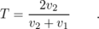
The first equation shows that there is no reflection unless the two wave speeds are different, and that the reflection is inverted in reflection back into a fast medium.
The energies of the transmitted and reflected wavers always add up to the same as the energy of the original wave. There is never any abrupt loss (or gain) in energy when a wave crosses a boundary; conversion of wave energy to heat occurs for many types of waves, but it occurs throughout the medium. The equation for T, surprisingly, allows the amplitude of the transmitted wave to be greater than 1, i.e. greater than that of the incident wave. This does not violate conservation of energy, because this occurs when the second string is less massive, reducing its kinetic energy, and the transmitted pulse is broader and less strongly curved, which lessens its potential energy.

Inverted and uninverted reflections in general (optional)
For waves on a string, reflections back into a faster medium are inverted, while those back into a slower medium are uninverted. Is this true for all types of waves? The rather subtle answer is that it depends on what property of the wave you are discussing.
Let's start by considering wave disturbances of freeway traffic. Anyone who has driven frequently on crowded freeways has observed the phenomenon in which one driver taps the brakes, starting a chain reaction that travels backward down the freeway as each person in turn exercises caution in order to avoid rear-ending anyone. The reason why this type of wave is relevant is that it gives a simple, easily visualized example of our description of a wave depends on which aspect of the wave we have in mind. In steadily flowing freeway traffic, both the density of cars and their velocity are constant all along the road. Since there is no disturbance in this pattern of constant velocity and density, we say that there is no wave. Now if a wave is touched off by a person tapping the brakes, we can either describe it as a region of high density or as a region of decreasing velocity.
The freeway traffic wave is in fact a good model of a sound wave, and a sound wave can likewise be described either by the density (or pressure) of the air or by its speed. Likewise many other types of waves can be described by either of two functions, one of which is often the derivative of the other with respect to position.
Now let's consider reflections. If we observe the freeway wave in a mirror, the high-density area will still appear high in density, but velocity in the opposite direction will now be described by a negative number. A person observing the mirror image will draw the same density graph, but the velocity graph will be flipped across the x axis, and its original region of negative slope will now have positive slope. Although I don't know any physical situation that would correspond to the reflection of a traffic wave, we can immediately apply the same reasoning to sound waves, which often do get reflected, and determine that a reflection can either be density-inverting and velocity-uninverting or density-uninverting and velocity-inverting.
This same type of situation will occur over and over as one encounters new types of waves, and to apply the analogy we need only determine which quantities, like velocity, become negated in a mirror image and which, like density, stay the same.
A light wave, for instance consists of a traveling pattern of electric and magnetic fields. All you need to know in order to analyze the reflection of light waves is how electric and magnetic fields behave under reflection; you don't need to know any of the detailed physics of electricity and magnetism. An electric field can be detected, for example, by the way one's hair stands on end. The direction of the hair indicates the direction of the electric field. In a mirror image, the hair points the other way, so the electric field is apparently reversed in a mirror image. The behavior of magnetic fields, however, is a little tricky. The magnetic properties of a bar magnet, for instance, are caused by the aligned rotation of the outermost orbiting electrons of the atoms. In a mirror image, the direction of rotation is reversed, say from clockwise to counterclockwise, and so the magnetic field is reversed twice: once simply because the whole picture is flipped and once because of the reversed rotation of the electrons. In other words, magnetic fields do not reverse themselves in a mirror image. We can thus predict that there will be two possible types of reflection of light waves. In one, the electric field is inverted and the magnetic field uninverted. In the other, the electric field is uninverted and the magnetic field inverted.

Interference effects
If you look at the front of a pair of high-quality binoculars, you will notice a greenish-blue coating on the lenses. This is advertised as a coating to prevent reflection. Now reflection is clearly undesirable --- we want the light to go in the binoculars --- but so far I've described reflection as an unalterable fact of nature, depending only on the properties of the two wave media. The coating can't change the speed of light in air or in glass, so how can it work? The key is that the coating itself is a wave medium. In other words, we have a three-layer sandwich of materials: air, coating, and glass. We will analyze the way the coating works, not because optical coatings are an important part of your education but because it provides a good example of the general phenomenon of wave interference effects.
There are two different interfaces between media: an air-coating boundary and a coating-glass boundary. Partial reflection and partial transmission will occur at each boundary. For ease of visualization let's start by considering an equivalent system consisting of three dissimilar pieces of string tied together, and a wave pattern consisting initially of a single pulse. Figure j/1 shows the incident pulse moving through the heavy rope, in which its velocity is low. When it encounters the lighter-weight rope in the middle, a faster medium, it is partially reflected and partially transmitted. (The transmitted pulse is bigger, but nevertheless has only part of the original energy.) The pulse transmitted by the first interface is then partially reflected and partially transmitted by the second boundary, j/3. In figure j/4, two pulses are on the way back out to the left, and a single pulse is heading off to the right. (There is still a weak pulse caught between the two boundaries, and this will rattle back and forth, rapidly getting too weak to detect as it leaks energy to the outside with each partial reflection.)
Note how, of the two reflected pulses in j/4, one is inverted and one uninverted. One underwent reflection at the first boundary (a reflection back into a slower medium is uninverted), but the other was reflected at the second boundary (reflection back into a faster medium is inverted).
Now let's imagine what would have happened if the incoming wave pattern had been a long sinusoidal wave train instead of a single pulse. The first two waves to reemerge on the left could be in phase, k/1, or out of phase, k/2, or anywhere in between. The amount of lag between them depends entirely on the width of the middle segment of string. If we choose the width of the middle string segment correctly, then we can arrange for destructive interference to occur, k/2, with cancellation resulting in a very weak reflected wave.
This whole analysis applies directly to our original case of optical coatings. Visible light from most sources does consist of a stream of short sinusoidal wave-trains such as the ones drawn above. The only real difference between the waves-on-a-rope example and the case of an optical coating is that the first and third media are air and glass, in which light does not have the same speed. However, the general result is the same as long as the air and the glass have light-wave speeds that either both greater than the coating's or both less than the coating's.
The business of optical coatings turns out to be a very arcane one, with a plethora of trade secrets and “black magic” techniques handed down from master to apprentice. Nevertheless, the ideas you have learned about waves in general are sufficient to allow you to come to some definite conclusions without any further technical knowledge. The self-check and discussion questions will direct you along these lines of thought.
self-check: Color corresponds to wavelength of light waves. Is it possible to choose a thickness for an optical coating that will produce destructive interference for all colors of light? (answer in the back of the PDF version of the book)
This example was typical of a wide variety of wave interference effects. With a little guidance, you are now ready to figure out for yourself other examples such as the rainbow pattern made by a compact disc or by a layer of oil on a puddle.

Discussion Questions
◊ Is it possible to get complete destructive interference in an optical coating, at least for light of one specific wavelength?
◊ Sunlight consists of sinusoidal wave-trains containing on the order of a hundred cycles back-to-back, for a length of something like a tenth of a millimeter. What happens if you try to make an optical coating thicker than this?
◊ Suppose you take two microscope slides and lay one on top of the other so that one of its edges is resting on the corresponding edge of the bottom one. If you insert a sliver of paper or a hair at the opposite end, a wedge-shaped layer of air will exist in the middle, with a thickness that changes gradually from one end to the other. What would you expect to see if the slides were illuminated from above by light of a single color? How would this change if you gradually lifted the lower edge of the top slide until the two slides were finally parallel?
◊ An observation like the one described in the previous discussion question was used by Newton as evidence against the wave theory of light! If Newton didn't know about inverting and noninverting reflections, what would have seemed inexplicable to him about the region where the air layer had zero or nearly zero thickness?
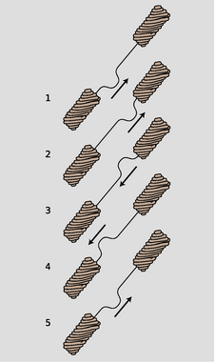
l / A pulse bounces back and forth.
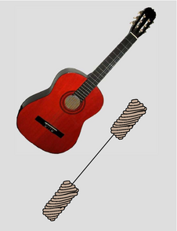
m / We model a guitar string attached to the guitar's body at both ends as a light-weight string attached to extremely heavy strings at its ends.
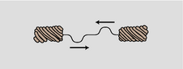
n / The period of this double-pulse pattern is half of what we'd otherwise expect.
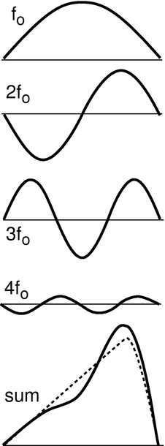
o / Any wave can be made by superposing sine waves.
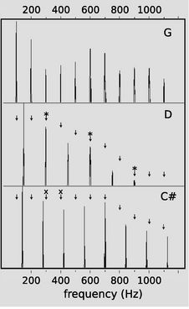
p / Graphs of loudness versus frequency for the vowel “ah,” sung as three different musical notes. G is consonant with D, since every overtone of G that is close to an overtone of D (marked “*”) is at exactly the same frequency. G and C♯ are dissonant together, since some of the overtones of G (marked “x”) are close to, but not right on top of, those of C♯.
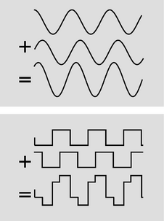
q / If you take a sine wave and make a copy of it shifted over, their sum is still a sine wave. The same is not true for a square wave.
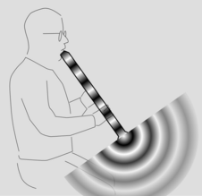
r / Surprisingly, sound waves undergo partial reflection at the open ends of tubes as well as closed ones.
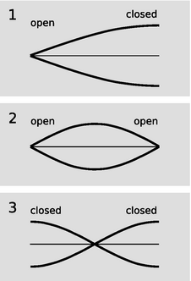
t / Graphs of excess density versus position for the lowest-frequency standing waves of three types of air columns. Points on the axis have normal air density.
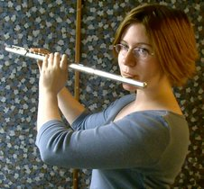
u / A concert flute is an asymmetric air column, open at one end and closed at the other.

Waves bounded on both sides
In the example of the previous section, it was theoretically true that a pulse would be trapped permanently in the middle medium, but that pulse was not central to our discussion, and in any case it was weakening severely with each partial reflection. Now consider a guitar string. At its ends it is tied to the body of the instrument itself, and since the body is very massive, the behavior of the waves when they reach the end of the string can be understood in the same way as if the actual guitar string was attached on the ends to strings that were extremely massive. Reflections are most intense when the two media are very dissimilar. Because the wave speed in the body is so radically different from the speed in the string, we should expect nearly 100% reflection.
Although this may seem like a rather bizarre physical model of the actual guitar string, it already tells us something interesting about the behavior of a guitar that we would not otherwise have understood. The body, far from being a passive frame for attaching the strings to, is actually the exit path for the wave energy in the strings. With every reflection, the wave pattern on the string loses a tiny fraction of its energy, which is then conducted through the body and out into the air. (The string has too little cross-section to make sound waves efficiently by itself.) By changing the properties of the body, moreover, we should expect to have an effect on the manner in which sound escapes from the instrument. This is clearly demonstrated by the electric guitar, which has an extremely massive, solid wooden body. Here the dissimilarity between the two wave media is even more pronounced, with the result that wave energy leaks out of the string even more slowly. This is why an electric guitar with no electric pickup can hardly be heard at all, and it is also the reason why notes on an electric guitar can be sustained for longer than notes on an acoustic guitar.
If we initially create a disturbance on a guitar string, how will the reflections behave? In reality, the finger or pick will give the string a triangular shape before letting it go, and we may think of this triangular shape as a very broad “dent” in the string which will spread out in both directions. For simplicity, however, let's just imagine a wave pattern that initially consists of a single, narrow pulse traveling up the neck, l/1. After reflection from the top end, it is inverted, l/3. Now something interesting happens: figure l/5 is identical to figure l/1. After two reflections, the pulse has been inverted twice and has changed direction twice. It is now back where it started. The motion is periodic. This is why a guitar produces sounds that have a definite sensation of pitch.
self-check: Notice that from l/1 to l/5, the pulse has passed by every point on the string exactly twice. This means that the total distance it has traveled equals 2 L, where L is the length of the string. Given this fact, what are the period and frequency of the sound it produces, expressed in terms of L and v, the velocity of the wave? (answer in the back of the PDF version of the book)
Note that if the waves on the string obey the principle of superposition, then the velocity must be independent of amplitude, and the guitar will produce the same pitch regardless of whether it is played loudly or softly. In reality, waves on a string obey the principle of superposition approximately, but not exactly. The guitar, like just about any acoustic instrument, is a little out of tune when played loudly. (The effect is more pronounced for wind instruments than for strings, but wind players are able to compensate for it.)
Now there is only one hole in our reasoning. Suppose we somehow arrange to have an initial setup consisting of two identical pulses heading toward each other, as in figure (g). They will pass through each other, undergo a single inverting reflection, and come back to a configuration in which their positions have been exactly interchanged. This means that the period of vibration is half as long. The frequency is twice as high.
This might seem like a purely academic possibility, since nobody actually plays the guitar with two picks at once! But in fact it is an example of a very general fact about waves that are bounded on both sides. A mathematical theorem called Fourier's theorem states that any wave can be created by superposing sine waves. The figure on the left shows how even by using only four sine waves with appropriately chosen amplitudes, we can arrive at a sum which is a decent approximation to the realistic triangular shape of a guitar string being plucked. The one-hump wave, in which half a wavelength fits on the string, will behave like the single pulse we originally discussed. We call its frequency f_{o}. The two-hump wave, with one whole wavelength, is very much like the two-pulse example. For the reasons discussed above, its frequency is 2f_{o}. Similarly, the three-hump and four-hump waves have frequencies of 3f_{o} and 4f_{o}.
Theoretically we would need to add together infinitely many such wave patterns to describe the initial triangular shape of the string exactly, although the amplitudes required for the very high frequency parts would be very small, and an excellent approximation could be achieved with as few as ten waves.
We thus arrive at the following very general conclusion. Whenever a wave pattern exists in a medium bounded on both sides by media in which the wave speed is very different, the motion can be broken down into the motion of a (theoretically infinite) series of sine waves, with frequencies f_{o}, 2f_{o}, 3f_{o}, … Except for some technical details, to be discussed below, this analysis applies to a vast range of sound-producing systems, including the air column within the human vocal tract. Because sounds composed of this kind of pattern of frequencies are so common, our ear-brain system has evolved so as to perceive them as a single, fused sensation of tone.

Musical applications
Many musicians claim to be able to pick out by ear several of the frequencies 2f_{o}, 3f_{o}, ..., called overtones or harmonics of the fundamental f_{o}, but they are kidding themselves. In reality, the overtone series has two important roles in music, neither of which depends on this fictitious ability to “hear out” the individual overtones.
First, the relative strengths of the overtones is an important part of the personality of a sound, called its timbre (rhymes with “amber”). The characteristic tone of the brass instruments, for example, is a sound that starts out with a very strong harmonic series extending up to very high frequencies, but whose higher harmonics die down drastically as the attack changes to the sustained portion of the note.
Second, although the ear cannot separate the individual harmonics of a single musical tone, it is very sensitive to clashes between the overtones of notes played simultaneously, i.e. in harmony. We tend to perceive a combination of notes as being dissonant if they have overtones that are close but not the same. Roughly speaking, strong overtones whose frequencies differ by more than 1% and less than 10% cause the notes to sound dissonant. It is important to realize that the term “dissonance” is not a negative one in music. No matter how long you search the radio dial, you will never hear more than three seconds of music without at least one dissonant combination of notes. Dissonance is a necessary ingredient in the creation of a musical cycle of tension and release. Musically knowledgeable people do not usually use the word “dissonant” as a criticism of music, and if they do, what they are really saying is that the dissonance has been used in a clumsy way, or without providing any contrast between dissonance and consonance.
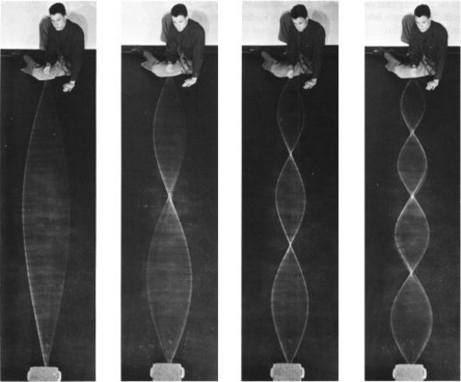
s / Standing waves on a rope. (PSSC Physics.)

Standing waves
Figure s shows sinusoidal wave patterns made by shaking a rope. I used to enjoy doing this at the bank with the pens on chains, back in the days when people actually went to the bank. You might think that I and the person in the photos had to practice for a long time in order to get such nice sine waves. In fact, a sine wave is the only shape that can create this kind of wave pattern, called a standing wave, which simply vibrates back and forth in one place without moving. The sine wave just creates itself automatically when you find the right frequency, because no other shape is possible.
If you think about it, it's not even obvious that sine waves should be able to do this trick. After all, waves are supposed to travel at a set speed, aren't they? The speed isn't supposed to be zero! Well, we can actually think of a standing wave as a superposition of a moving sine wave with its own reflection, which is moving the opposite way. Sine waves have the unique mathematical property that the sum of sine waves of equal wavelength is simply a new sine wave with the same wavelength. As the two sine waves go back and forth, they always cancel perfectly at the ends, and their sum appears to stand still.
Standing wave patterns are rather important, since atoms are really standing-wave patterns of electron waves. You are a standing wave!

Standing-wave patterns of air columns
The air column inside a wind instrument or the human vocal tract behaves very much like the wave-on-a-string example we've been concentrating on so far, the main difference being that we may have either inverting or noninverting reflections at the ends.
Some organ pipes are closed at both ends. The speed of sound is different in metal than in air, so there is a strong reflection at the closed ends, and we can have standing waves. These reflections are both density-noninverting, so we get symmetric standing-wave patterns, such as the one shown in figure t/1.
Figure r shows the sound waves in and around a bamboo Japanese flute called a shakuhachi, which is open at both ends of the air column. We can only have a standing wave pattern if there are reflections at the ends, but that is very counterintuitive --- why is there any reflection at all, if the sound wave is free to emerge into open space, and there is no change in medium? Recall the reason why we got reflections at a change in medium: because the wavelength changes, so the wave has to readjust itself from one pattern to another, and the only way it can do that without developing a kink is if there is a reflection. Something similar is happening here. The only difference is that the wave is adjusting from being a plane wave to being a spherical wave. The reflections at the open ends are density-inverting, t/2, so the wave pattern is pinched off at the ends. Comparing panels 1 and 2 of the figure, we see that although the wave pattens are different, in both cases the wavelength is the same: in the lowest-frequency standing wave, half a wavelength fits inside the tube. Thus, it isn't necessary to memorize which type of reflection is inverting and which is inverting. It's only necessary to know that the tubes are symmetric.
Finally, we can have an asymmetric tube: closed at one end and open at the other. A common example is the concert flute, u. The standing wave with the lowest frequency is therefore one in which 1/4 of a wavelength fits along the length of the tube, as shown in figure t/3.
If both ends are open (as in the flute) or both ends closed (as in some organ pipes), then the standing wave pattern must be symmetric. The lowest-frequency wave fits half a wavelength in the tube, t/2-3.
If both ends are open (as in the flute) or both ends closed (as in some organ pipes), then the standing wave pattern must be symmetric. The lowest-frequency wave fits half a wavelength in the tube.
self-check: Draw a graph of pressure versus position for the first overtone of the air column in a tube open at one end and closed at the other. This will be the next-to-longest possible wavelength that allows for a point of maximum vibration at one end and a point of no vibration at the other. How many times shorter will its wavelength be compared to the frequency of the lowest-frequency standing wave, shown in the figure? Based on this, how many times greater will its frequency be? (answer in the back of the PDF version of the book)

Example 13: The speed of sound
We can get a rough and ready derivation of the equation for the speed of sound by analyzing the standing waves in a cylindrical air column as a special type of Helmholtz resonance (example 23 on page 274), in which the cavity happens to have the same cross-sectional area as the neck. Roughly speaking, the regions of maximum density variation act like the cavity. The regions of minimum density variation, on the other hand, are the places where the velocity of the air is varying the most; these regions throttle back the speed of the vibration, because of the inertia of the moving air. If the cylinder has cross-sectional area A, then the “cavity” and “neck” parts of the wave both have lengths of something like λ/2, and the volume of the “cavity” is about Aλ/2. We get , where the factor (…) represents numerical stuff that we can't possibly hope to have gotten right with such a crude argument. The correct result is in fact . Isaac Newton attempted the same calculation, but didn't understand the thermodynamic effects involved, and therefore got a result that didn't have the correct factor of γ.
\backofchapterboilerplate{waves}

Homework Problems
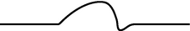
a / Problem 2

b / Problem 3.
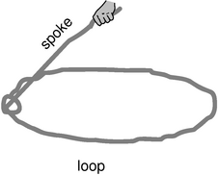
c / Problem 9.
C | 261.6 Hz
D | 293.7
E | 329.6
F | 349.2
G | 392.0
A | 440.0
Bflat | 466.2
Problem 15.} 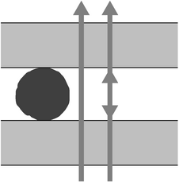
d / Problem 17.
1. The following is a graph of the height of a water wave as a function of position, at a certain moment in time.
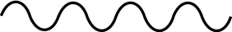Trace this graph onto another piece of paper, and then sketch below it the corresponding graphs that would be obtained if
(a) the amplitude and frequency were doubled while the velocity remained the same;
(b) the frequency and velocity were both doubled while the amplitude remained unchanged;
(c) the wavelength and amplitude were reduced by a factor of three while the velocity was doubled.
Problem by Arnold Arons.
2. (a) The graph shows the height of a water wave pulse as a function of position. Draw a graph of height as a function of time for a specific point on the water. Assume the pulse is traveling to the right.
(b) Repeat part a, but assume the pulse is traveling to the left.
(c) Now assume the original graph was of height as a function of time, and draw a graph of height as a function of position, assuming the pulse is traveling to the right.
(d) Repeat part c, but assume the pulse is traveling to the left.
Problem by Arnold Arons.
3. The figure shows one wavelength of a steady sinusoidal wave traveling to the right along a string. Define a coordinate system in which the positive x axis points to the right and the positive y axis up, such that the flattened string would have y=0. Copy the figure, and label with “y=0” all the appropriate parts of the string. Similarly, label with “v=0” all parts of the string whose velocities are zero, and with “a=0” all parts whose accelerations are zero. There is more than one point whose velocity is of the greatest magnitude. Pick one of these, and indicate the direction of its velocity vector. Do the same for a point having the maximum magnitude of acceleration.
Problem by Arnold Arons.
4. [0]{dopplerf} Find an equation for the relationship between the Doppler-shifted frequency of a wave and the frequency of the original wave, for the case of a stationary observer and a source moving directly toward or away from the observer.
5. Suggest a quantitative experiment to look for any deviation from the principle of superposition for surface waves in water. Try to make your experiment simple and practical.
6. [2]{hangingstring} A string hangs vertically, free at the bottom and attached at the top.
(a) Find the velocity of waves on the string as a function of the distance from the bottom
(b) Find the acceleration of waves on the string.\hwans{hwans:hangingstring}
(c) Interpret your answers to parts a and b for the case where a pulse comes down and reaches the end of the string. What happens next? Check your answer against experiment and conservation of energy.
7. [0]{middlec} The musical note middle C has a frequency of 262 Hz. What are its period and wavelength?
8. [0]{dopplersing} Singing that is off-pitch by more than about 1% sounds bad. How fast would a singer have to be moving relative to a the rest of a band to make this much of a change in pitch due to the Doppler effect?
9. [2]{lasso} The simplest trick with a lasso is to spin a flat loop in a horizontal plane. The whirling loop of a lasso is kept under tension mainly due to its own rotation. Although the spoke's force on the loop has an inward component, we'll ignore it. The purpose of this problem, which is based on one by A.P. French, is to prove a cute fact about wave disturbances moving around the loop. As far as I know, this fact has no practical implications for trick roping! Let the loop have radius r and mass per unit length μ, and let its angular velocity be ω.
(a) Find the tension, T, in the loop in terms of r, μ, and ω. Assume the loop is a perfect circle, with no wave disturbances on it yet. \hwhint{hwhint:lasso} \hwans{hwans:lasso}
(b) Find the velocity of a wave pulse traveling around the loop. Discuss what happens when the pulse moves is in the same direction as the rotation, and when it travels contrary to the rotation.
10. At a particular moment in time, a wave on a string has a shape described by y=3.5cos (0.73π x+0.45π t+0.37π). The stuff inside the cosine is in radians. Assume that the units of the numerical constants are such that x, y, and t are in SI units.
(a) Is the wave moving in the positive x or the negative x direction?
(b) Find the wave's period, frequency, wavelength.
(c) Find the wave's velocity.
(d) Find the maximum velocity of any point on the string, and compare with the magnitude and direction of the wave's velocity. (answer check available at lightandmatter.com)
11. [0]{mirage} Light travels faster in warmer air. Use this fact to explain the formation of a mirage appearing like the shiny surface of a pool of water when there is a layer of hot air above a road.
12. [0]{airwaterrefl} (a) Compute the amplitude of light that is reflected back into air at an air-water interface, relative to the amplitude of the incident wave. Assume that the light arrives in the direction directly perpendicular to the surface.The speeds of light in air and water are 3.0×10⁸ and 2.2×10⁸ m/s, respectively.
(b) Find the energy of the reflected wave as a fraction of the incident energy. \hwhint{hwhint:airwaterrefl}(answer check available at lightandmatter.com)
13. A B-flat clarinet (the most common kind) produces its lowest note, at about 230 Hz, when half of a wavelength fits inside its tube. Compute the length of the clarinet. \hwans{hwans:clarinet}
14. (a) A good tenor saxophone player can play all of the following notes without changing her fingering, simply by altering the tightness of her lips: E♭ (150 Hz), E♭ (300 Hz), B♭ (450 Hz), and E♭ (600 Hz). How is this possible?
(I'm not asking you to analyze the coupling between the lips, the reed, the mouthpiece, and the air column, which is very complicated.) (b) Some saxophone players are known for their ability to use this technique to play “freak notes,” i.e. notes above the normal range of the instrument. Why isn't it possible to play notes below the normal range using this technique?
15. The table gives the frequencies of the notes that make up the key of F major, starting from middle C and going up through all seven notes.
(a) Calculate the first five or six harmonics of C and G, and determine whether these two notes will be consonant or dissonant.
(b) Do the same for C and B♭. (Recall that harmonics that differ by about 1-10% cause dissonance.)
16. [2]{maxtransmission} (a) A wave pulse moves into a new medium, where its velocity is greater by a factor α. Find an expression for the fraction, f, of the wave energy that is transmitted, in terms of α. Note that, as discussed in the text, you cannot simply find f by squaring the amplitude of the transmitted wave. \hwans{hwans:maxtransmission}
(b) Suppose we wish to transmit a pulse from one medium to another, maximizing the fraction of the wave energy transmitted. To do so, we sandwich another layer in between them, so that the wave moves from the initial medium, where its velocity is v₁, through the intermediate layer, where it is v₂, and on into the final layer, where it becomes v₃. What is the optimal value of v₂? (Assume that the middle layer is thicker than the length of the pulse, so there are no interference effects. Also, although there will be later echoes that are transmitted after multiple reflections back and forth across the middle layer, you are only to optimize the strength of the transmitted pulse that is first to emerge. In other words, it's simply a matter of applying your answer from part a twice to find the amount that finally gets through.) \hwans{hwans:maxtransmission}
17. A Fabry-Perot interferometer, shown in the figure being used to measure the diameter of a thin filament, consists of two glass plates with an air gap between them. As a the top plate is moved up or down with a screw, the light passing through the plates goes through a cycle of constructive and destructive interference, which is mainly due to interference between rays that pass straight through and those that are reflected twice back into the air gap. (Although the dimensions in this drawing are distorted for legibility, the glass plates would really be much thicker than the length of the wave-trains of light, so no interference effects would be observed due to reflections within the glass.)
(a) If the top plate is cranked down so that the thickness, d, of the air gap is much less than the wavelength λ of the light, what is the phase relationship between the two rays? (Recall that the phase can be inverted by a reflection.) With d=0, is the interference constructive or destructive?
(b) If d is slowly increased from zero, what is the first value of d for which the interference is the same as at d=0? Express your answer in terms of λ.
(c) Suppose the apparatus is first set up as shown in the figure. The filament is then removed, and n cycles of brightening and dimming are counted while the top plate is brought down to d=0. What is the thickness of the filament, in terms of n and λ?
Based on a problem by D.J. Raymond.

Footnotes
[1] Speaking more carefully, I should say that every basic building block of light and matter has both wave and particle properties.

7. Relativity
Table of Contents

Contents
Section 7.1 - Basic Relativity
Section 7.2 - The Lorentz transformation
Section 7.3 - Dynamics

Chapter 7. Relativity
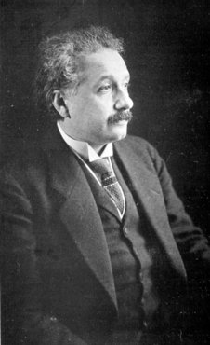
a / Albert Einstein.
Complaining about the educational system is a national sport among professors in the U.S., and I, like my colleagues, am often tempted to imagine a golden age of education in our country's past, or to compare our system unfavorably with foreign ones. Reality intrudes, however, when my immigrant students recount the overemphasis on rote memorization in their native countries and the philosophy that what the teacher says is always right, even when it's wrong.
Albert Einstein's education in late-nineteenth-century Germany was neither modern nor liberal. He did well in the early grades (the myth that he failed his elementary-school classes comes from a misunderstanding based on a reversal of the German numerical grading scale), but in high school and college he began to get in trouble for what today's edspeak calls “critical thinking.”
Indeed, there was much that deserved criticism in the state of physics at that time. There was a subtle contradiction between Maxwell's theory of electromagnetism and Galileo's principle that all motion is relative. Einstein began thinking about this on an intuitive basis as a teenager, trying to imagine what a light beam would look like if you could ride along beside it on a motorcycle at the speed of light. Today we remember him most of all for his radical and far-reaching solution to this contradiction, his theory of relativity, but in his student years his insights were greeted with derision from his professors. One called him a “lazy dog.” Einstein's distaste for authority was typified by his decision as a teenager to renounce his German citizenship and become a stateless person, based purely on his opposition to the militarism and repressiveness of German society. He spent his most productive scientific years in Switzerland and Berlin, first as a patent clerk but later as a university professor. He was an outspoken pacifist and a stubborn opponent of World War I, shielded from retribution by his eventual acquisition of Swiss citizenship.
As the epochal nature of his work began to become evident, some liberal Germans began to point to him as a model of the “new German,” but with the Nazi coup d'etat, staged public meetings began to be held at which Nazi scientists criticized the work of this ethnically Jewish (but spiritually nonconformist) giant of science. Einstein was on a stint as a visiting professor at Caltech when Hitler was appointed chancellor, and never returned to the Nazi state. World War II convinced Einstein to soften his strict pacifist stance, and he signed a secret letter to President Roosevelt urging research into the building of a nuclear bomb, a device that could not have been imagined without his theory of relativity. He later wrote, however, that when Hiroshima and Nagasaki were bombed, it made him wish he could burn off his own fingers for having signed the letter.
This chapter and the next are specifically about Einstein's theory of relativity, but Einstein also began a second, parallel revolution in physics known as the quantum theory, which stated, among other things, that certain processes in nature are inescapably random. Ironically, Einstein was an outspoken doubter of the new quantum ideas, being convinced that “the Old One [God] does not play dice with the universe,” but quantum and relativistic concepts are now thoroughly intertwined in physics. The remainder of this book beyond the present pair of chapters is an introduction to the quantum theory, but we will continually be led back to relativistic ideas.

The structure of this chapter
From the modern point of view, electricity and magnetism becomes much simpler and easier to understand if it is encountered after relativity. Most schools' curricula, however, place electricity and magnetism before relativity. In such a curriculum, section 7.1 should be covered before electricity and magnetism, and then later in the course one can go back and cover all of chapter 7. This chapter is also designed so that it can be read without having previously covered waves.

7.1 Basic Relativity
Absolute, true, and mathematical time ... flows at a constant rate without relation to anything external... Absolute space... without relation to anything external, remains always similar and immovable. -- Isaac Newton (tr. Andrew Motte)

The principle of relativity
Galileo's most important physical discovery was that motion is relative. With modern hindsight, we restate this in a way that shows what made the teenage Einstein suspicious:
\mythmhdr{The principle of Galilean relativity} Matter obeys the same laws of physics in any inertial frame of reference, regardless of the frame's orientation, position, or constant-velocity motion.
Note that it only refers to matter, not light.
Einstein's professors taught that light waves obeyed an entirely different set of rules than material objects. They believed that light waves were a vibration of a mysterious medium called the ether, and that the speed of light should be interpreted as a speed relative to this ether. Thus although the cornerstone of the study of matter had for two centuries been the idea that motion is relative, the science of light seemed to contain a concept that a certain frame of reference was in an absolute state of rest with respect to the ether, and was therefore to be preferred over moving frames.
Now let's think about Albert Einstein's daydream of riding a motorcycle alongside a beam of light. In cyclist Albert's frame of reference, the light wave appears to be standing still. However, James Clerk Maxwell had already constructed a highly successful mathematical description of light waves as patterns of electric and magnetic fields. Einstein on his motorcycle can stick measuring instruments into the wave to monitor the electric and magnetic fields, and they will be constant at any given point. But an electromagnetic wave pattern standing frozen in space like this violates Maxwell's equations and cannot exist. Maxwell's equations say that light waves always move with the same velocity, notated c, equal to 3.0×10⁸ m/s. Einstein could not tolerate this disagreement between the treatment of relative and absolute motion in the theories of matter on the one hand and light on the other. He decided to rebuild physics with a single guiding principle:
\mythmhdr{Einstein's principle of relativity} Both light and matter obey the same laws of physics in any inertial frame of reference, regardless of the frame's orientation, position, or constant-velocity motion.
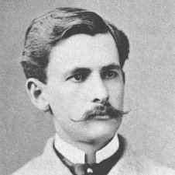
c / Albert Michelson, in 1887, the year of the Michelson-Morley experiment.
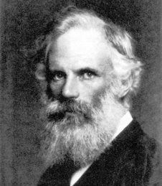
d / George FitzGerald, 1851-1901.
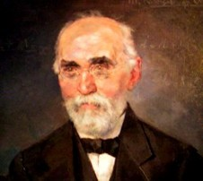
e / Hendrik Lorentz, 1853-1928.

Distortion of time and space
This is hard to swallow. If a dog is running away from me at 5 m/s relative to the sidewalk, and I run after it at 3 m/s, the dog's velocity in my frame of reference is 2 m/s. According to everything we have learned about motion, the dog must have different speeds in the two frames: 5 m/s in the sidewalk's frame and 2 m/s in mine. How, then, can a beam of light have the same speed as seen by someone who is chasing the beam? 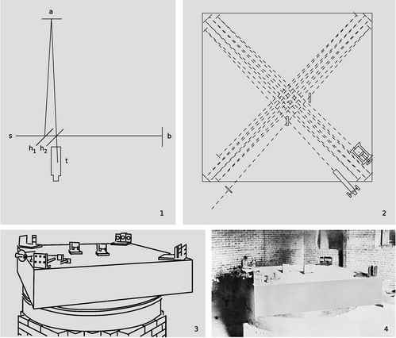
a / The Michelson-Morley experiment, shown in photographs, and drawings from the original 1887 paper. 1. A simplified drawing of the apparatus. A beam of light from the source, s, is partially reflected and partially transmitted by the half-silvered mirror h₁. The two half-intensity parts of the beam are reflected by the mirrors at a and b, reunited, and observed in the telescope, t. If the earth's surface was supposed to be moving through the ether, then the times taken by the two light waves to pass through the moving ether would be unequal, and the resulting time lag would be detectable by observing the interference between the waves when they were reunited. 2. In the real apparatus, the light beams were reflected multiple times. The effective length of each arm was increased to 11 meters, which greatly improved its sensitivity to the small expected difference in the speed of light. 3. In an earlier version of the experiment, they had run into problems with its “extreme sensitiveness to vibration,” which was “so great that it was impossible to see the interference fringes except at brief intervals ... even at two o'clock in the morning.” They therefore mounted the whole thing on a massive stone floating in a pool of mercury, which also made it possible to rotate it easily. 4. A photo of the apparatus. Note that it is underground, in a room with solid brick walls.
In fact the strange constancy of the speed of light had shown up in the now-famous Michelson-Morley experiment of 1887. Michelson and Morley set up a clever apparatus to measure any difference in the speed of light beams traveling east-west and north-south. The motion of the earth around the sun at 110,000 km/hour (about 0.01% of the speed of light) is to our west during the day. Michelson and Morley believed in the ether hypothesis, so they expected that the speed of light would be a fixed value relative to the ether. As the earth moved through the ether, they thought they would observe an effect on the velocity of light along an east-west line. For instance, if they released a beam of light in a westward direction during the day, they expected that it would move away from them at less than the normal speed because the earth was chasing it through the ether. They were surprised when they found that the expected 0.01% change in the speed of light did not occur.Although the Michelson-Morley experiment was nearly two decades in the past by the time Einstein published his first paper on relativity in 1905, it's unclear how much it influenced Einstein. Michelson and Morley themselves were uncertain about whether the result was to be trusted, or whether systematic and random errors were masking a real effect from the ether. There were a variety of competing theories, each of which could claim some support from the shaky data. Some physicists believed that the ether could be dragged along by matter moving through it, which inspired variations on the experiment that were conducted on mountaintops in thin-walled buildings, b, or with one arm of the appartus out in the open, and the other surrounded by massive lead walls. In the standard sanitized textbook version of the history of science, every scientist does his experiments without any preconceived notions about the truth, and any disagreement is quickly settled by a definitive experiment. In reality, this period of confusion about the Michelson-Morley experiment lasted for four decades, and a few reputable skeptics, including Miller, continued to believe that Einstein was wrong, and kept trying different variations of the experiment as late as the 1920's. Most of the remaining doubters were convinced by an extremely precise version of the experiment performed by Joos in 1930, although you can still find kooks on the internet who insist that Miller was right, and that there was a vast conspiracy to cover up his results. 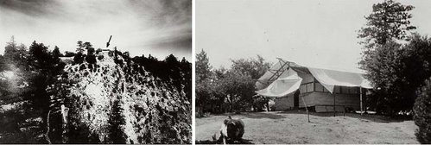
b / Dayton Miller thought that the result of the Michelson-Morley experiment could be explained because the ether had been pulled along by the dirt, and the walls of the laboratory. This motivated him to carry out a series of experiments at the top of Mount Wilson, in a building with thin walls.
Before Einstein, some physicists who did believe the negative result of the Michelson-Morley experiment came up with explanations that preserved the ether. In the period from 1889 to 1895, Hendrik Lorentz and George FitzGerald suggested that the negative result of the Michelson-Morley experiment could be explained if the earth, and every physical object on its surface, was contracted slightly by the strain of the earth's motion through the ether.¹
How did Einstein explain this strange refusal of light waves to obey the usual rules of addition and subtraction of velocities due to relative motion? He had the originality and bravery to suggest a radical solution. He decided that space and time must be stretched and compressed as seen by observers in different frames of reference. Since velocity equals distance divided by time, an appropriate distortion of time and space could cause the speed of light to come out the same in a moving frame. This conclusion could have been reached by the physicists of two generations before, on the day after Maxwell published his theory of light, but the attitudes about absolute space and time stated by Newton were so strongly ingrained that such a radical approach did not occur to anyone before Einstein.

Time distortion
Consider the situation shown in figure f. Aboard a rocket ship we have a tube with mirrors at the ends. If we let off a flash of light at the bottom of the tube, it will be reflected back and forth between the top and bottom. It can be used as a clock: by counting the number of times the light goes back and forth we get an indication of how much time has passed. (This may not seem very practical, but a real atomic clock does work on essentially the same principle.) Now imagine that the rocket is cruising at a significant fraction of the speed of light relative to the earth. Motion is relative, so for a person inside the rocket, f/1, there is no detectable change in the behavior of the clock, just as a person on a jet plane can toss a ball up and down without noticing anything unusual. But to an observer in the earth's frame of reference, the light appears to take a zigzag path through space, f/2, increasing the distance the light has to travel. 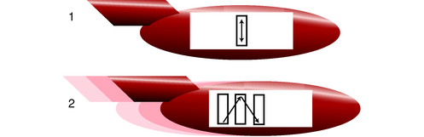
f / A light beam bounces between two mirrors in a spaceship.
If we didn't believe in the principle of relativity, we could say that the light just goes faster according to the earthbound observer. Indeed, this would be correct if the speeds were not close to the speed of light, and if the thing traveling back and forth was, say, a ping-pong ball. But according to the principle of relativity, the speed of light must be the same in both frames of reference. We are forced to conclude that time is distorted, and the light-clock appears to run more slowly than normal as seen by the earthbound observer. In general, a clock appears to run most quickly for observers who are in the same state of motion as the clock, and runs more slowly as perceived by observers who are moving relative to the clock.
We can easily calculate the size of this time-distortion effect. In the frame of reference shown in figure f/1, moving with the spaceship, let t₁ be the time required for the beam of light to move from the bottom to the top. An observer on the earth, who sees the situation shown in figure f/2, disagrees, and says this motion took a longer time t₂. Let v be the velocity of the spaceship relative to the earth. In frame 2, the light beam travels along the hypotenuse of a right triangle whose base has length
base = vt₂ .
Observers in the two frames of reference agree on the vertical distance traveled by the beam, i.e. the height of the triangle perceived in frame 2, and an observer in frame 1 says that this height is the distance covered by a light beam in time t₁, so the height is
height = ct₁ .
The hypotenuse of this triangle is the distance the light travels in frame 2,
hypotenuse = ct₂ .
Using the Pythagorean theorem, we can relate these three quantities, and solving for t₂ we find
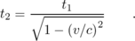
The amount of distortion is given by the factor , and this quantity appears so often that we give it a special name, γ (Greek letter gamma),
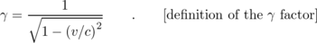
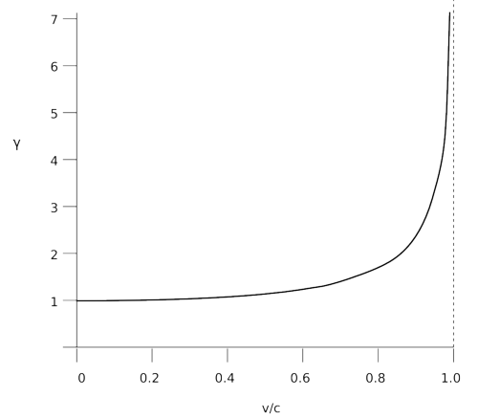
g / The behavior of the γ factor.
self-check: What is γ when v=0? What does this mean? (answer in the back of the PDF version of the book)

Distortion of space
The speed of light is supposed to be the same in all frames of reference, and a speed is a distance divided by the time. We can't change time without changing distance, since then the speed couldn't come out the same. A rigorous treatment requires some delicacy, but we postpone that to section 7.2 and state for now the apparently reasonable result that if time is distorted by a factor of γ, then lengths must also be distorted according to the same ratio. An object in motion appears longest to someone who is at rest with respect to it, and is shortened along the direction of motion as seen by other observers.
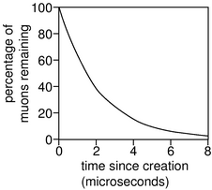
h / Decay of muons created at rest with respect to the observer.
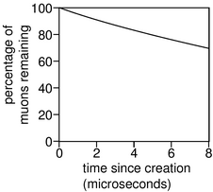
i / Decay of muons moving at a speed of 0.995c with respect to the observer.
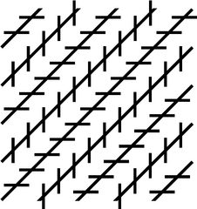
Discussion question B

Applications

Nothing can go faster than the speed of light.
What happens if we want to send a rocket ship off at, say, twice the speed of light, v=2c? Then γ will be . But your math teacher has always cautioned you about the severe penalties for taking the square root of a negative number. The result would be physically meaningless, so we conclude that no object can travel faster than the speed of light. Even travel exactly at the speed of light appears to be ruled out for material objects, since then γ would be infinite.
Einstein had therefore found a solution to his original paradox about riding on a motorcycle alongside a beam of light, resulting in a violation of Maxwell's theory of electromagnetism. The paradox is resolved because it is impossible for the motorcycle to travel at the speed of light.
Most people, when told that nothing can go faster than the speed of light, immediately begin to imagine methods of violating the rule. For instance, it would seem that by applying a constant force to an object for a long time, we could give it a constant acceleration, which would eventually cause it to go faster than the speed of light. We will take up these issues in section 7.3.

Cosmic-ray muons
A classic experiment to demonstrate time distortion uses observations of cosmic rays. Cosmic rays are protons and other atomic nuclei from outer space. When a cosmic ray happens to come the way of our planet, the first earth-matter it encounters is an air molecule in the upper atmosphere. This collision then creates a shower of particles that cascade downward and can often be detected at the earth's surface. One of the more exotic particles created in these cosmic ray showers is the muon (named after the Greek letter mu, μ). The reason muons are not a normal part of our environment is that a muon is radioactive, lasting only 2.2 microseconds on the average before changing itself into an electron and two neutrinos. A muon can therefore be used as a sort of clock, albeit a self-destructing and somewhat random one! Figures h and i show the average rate at which a sample of muons decays, first for muons created at rest and then for high-velocity muons created in cosmic-ray showers. The second graph is found experimentally to be stretched out by a factor of about ten, which matches well with the prediction of relativity theory:
Since a muon takes many microseconds to pass through the atmosphere, the result is a marked increase in the number of muons that reach the surface.
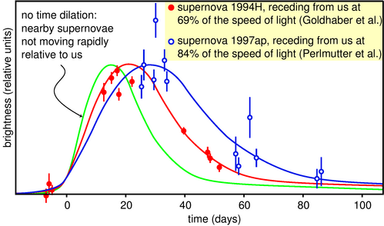
j / Light curves of supernovae, showing a time-dilation effect for supernovae that are in motion relative to us.

Time dilation for objects larger than the atomic scale
Our world is (fortunately) not full of human-scale objects moving at significant speeds compared to the speed of light. For this reason, it took over 80 years after Einstein's theory was published before anyone could come up with a conclusive example of drastic time dilation that wasn't confined to cosmic rays or particle accelerators. Recently, however, astronomers have found definitive proof that entire stars undergo time dilation. The universe is expanding in the aftermath of the Big Bang, so in general everything in the universe is getting farther away from everything else. One need only find an astronomical process that takes a standard amount of time, and then observe how long it appears to take when it occurs in a part of the universe that is receding from us rapidly. A type of exploding star called a type Ia supernova fills the bill, and technology is now sufficiently advanced to allow them to be detected across vast distances. Figure j shows convincing evidence for time dilation in the brightening and dimming of two distant supernovae.

The twin paradox
A natural source of confusion in understanding the time-dilation effect is summed up in the so-called twin paradox, which is not really a paradox. Suppose there are two teenaged twins, and one stays at home on earth while the other goes on a round trip in a spaceship at relativistic speeds (i.e. speeds comparable to the speed of light, for which the effects predicted by the theory of relativity are important). When the traveling twin gets home, he has aged only a few years, while his brother is now old and gray. (Robert Heinlein even wrote a science fiction novel on this topic, although it is not one of his better stories.)
The “paradox” arises from an incorrect application of the principle of relativity to a description of the story from the traveling twin's point of view. From his point of view, the argument goes, his homebody brother is the one who travels backward on the receding earth, and then returns as the earth approaches the spaceship again, while in the frame of reference fixed to the spaceship, the astronaut twin is not moving at all. It would then seem that the twin on earth is the one whose biological clock should tick more slowly, not the one on the spaceship. The flaw in the reasoning is that the principle of relativity only applies to frames that are in motion at constant velocity relative to one another, i.e., inertial frames of reference. The astronaut twin's frame of reference, however, is noninertial, because his spaceship must accelerate when it leaves, decelerate when it reaches its destination, and then repeat the whole process again on the way home. Their experiences are not equivalent, because the astronaut twin feels accelerations and decelerations. A correct treatment requires some mathematical complication to deal with the changing velocity of the astronaut twin, but the result is indeed that it's the traveling twin who is younger when they are reunited.
The twin “paradox” really isn't a paradox at all. It may even be a part of your ordinary life. The effect was first verified experimentally by synchronizing two atomic clocks in the same room, and then sending one for a round trip on a passenger jet. (They bought the clock its own ticket and put it in its own seat.) The clocks disagreed when the traveling one got back, and the discrepancy was exactly the amount predicted by relativity. The effects are strong enough to be important for making the global positioning system (GPS) work correctly. If you've ever taken a GPS receiver with you on a hiking trip, then you've used a device that has the twin “paradox” programmed into its calculations. Your handheld GPS box talks to a system onboard a satellite, and the satellite is moving fast enough that its time dilation is an important effect. So far no astronauts have gone fast enough to make time dilation a dramatic effect in terms of the human lifetime. The effect on the Apollo astronauts, for instance, was only a fraction of a second, since their speeds were still fairly small compared to the speed of light. (As far as I know, none of the astronauts had twin siblings back on earth!)

An example of length contraction
Figure k shows an artist's rendering of the length contraction for the collision of two gold nuclei at relativistic speeds in the RHIC accelerator in Long Island, New York, which went on line in 2000. The gold nuclei would appear nearly spherical (or just slightly lengthened like an American football) in frames moving along with them, but in the laboratory's frame, they both appear drastically foreshortened as they approach the point of collision. The later pictures show the nuclei merging to form a hot soup, in which experimenters hope to observe a new form of matter.
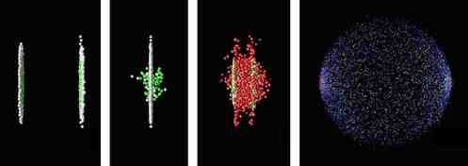
k / Colliding nuclei show relativistic length contraction.

Discussion Questions
◊ On a spaceship moving at relativistic speeds, would a lecture seem even longer and more boring than normal?
◊ A question that students often struggle with is whether time and space can really be distorted, or whether it just seems that way. Compare with optical illusions or magic tricks. How could you verify, for instance, that the lines in the figure are actually parallel? Are relativistic effects the same or not?
◊ If you were in a spaceship traveling at the speed of light (or extremely close to the speed of light), would you be able to see yourself in a mirror?
◊ Mechanical clocks can be affected by motion. For example, it was a significant technological achievement to build a clock that could sail aboard a ship and still keep accurate time, allowing longitude to be determined. How is this similar to or different from relativistic time dilation?
◊ What would the shapes of the two nuclei in the RHIC experiment look like to a microscopic observer riding on the left-hand nucleus? To an observer riding on the right-hand one? Can they agree on what is happening? If not, why not --- after all, shouldn't they see the same thing if they both compare the two nuclei side-by-side at the same instant in time?
◊ If you stick a piece of foam rubber out the window of your car while driving down the freeway, the wind may compress it a little. Does it make sense to interpret the relativistic length contraction as a type of strain that pushes an object's atoms together like this? How does this relate to discussion question E?

7.2 The Lorentz transformation
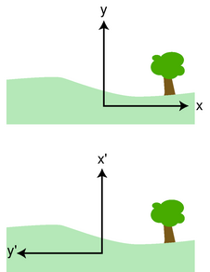
a / Two observers describe the same landscape with different coordinate systems.

Coordinate transformations in general
In section 7.1 the emphasis was on demonstrating some of the fundamental relativistic phenomena, without getting tangled up in too much mathematics. However, the issues that were glossed over there would come back to bite us if we never examined them carefully, and we haven't yet seen the full extent of relativity's attack on the traditional and intuitive concepts of space and time.

Rotation
For guidance, let's look at the mathematical treatment of the part of the principle of relativity that states that the laws of physics are the same regardless of the orientation of the coordinate system. Suppose that two observers are in frames of reference that are at rest relative to each other, and they set up coordinate systems with their origins at the same point, but rotated by 90 degrees, as in figure a. To go back and forth between the two systems, we can use the equations
x' = y
y' = - x
A set of equations such as this one for changing from one system of coordinates to another is called a coordinate transformation, or just a transformation for short.
Similarly, if the coordinate systems differed by an angle of 5 degrees, we would have
x' = (cos 5°) x + (sin 5°) y
y' = (-sin 5°) x + (cos 5°) y
Since cos 5°=0.997 is very close to one, and sin 5°=0.087 is close to zero, the rotation through a small angle has only a small effect, which makes sense. The equations for rotation are always of the form

Galilean transformation for frames moving relative to each other
Einstein wanted to see if he could find a rule for changing between coordinate systems that were moving relative to each other. As a second warming-up example, let's look at the transformation between frames of reference in relative motion according to Galilean relativity, i.e. without any distortion of space and time. Suppose the x' axis is moving to the right at a velocity v relative to the x axis. The transformation is simple:
t' = t
Again we have an equation with constants multiplying the variables, but now the variables are distance and time. The interpretation of the -vt term is the observer moving with the origin x' system sees a steady reduction in distance to an object on the right and at rest in the x system. In other words, the object appears to be moving according to the x' observer, but at rest according to x. The fact that the constant in front of x in the first equation equals one tells us that there is no distortion of space according to Galilean relativity, and similarly the second equation tells us there is no distortion of time.
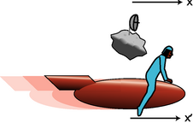
b / The x,t frame is defined from the asteroid, and the x',t' frame from the astronaut.

Derivation of the Lorentz transformation
Guided by analogy, Einstein decided to look for a transformation between frames in relative motion that would have the form
x' = Ax + Bt
t' = Cx + D t .
(Any form more complicated than this, for example equations including x² or t² terms, would violate the part of the principle of relativity that says the laws of physics are the same in all locations.) For historical reasons, this is called a Lorentz transformation. The constants A, B, C, and D would depend only on the relative velocity, v, of the two frames. Galilean relativity had been amply verified by experiment for values of v much less than the speed of light, so at low speeds we must have A≈1, B≈ -v, C≈0, and D≈1. For high speeds, however, the constants A and D would start to become measurably different from 1, providing the distortions of time and space needed so that the speed of light would be the same in all frames of reference.
self-check: What units would the constants A, B, C, and D need to have? (answer in the back of the PDF version of the book)

Natural units
Despite the reputation for difficulty of Einstein's theories, the derivation of Einstein's transformations is fairly straightforward. The algebra, however, can appear more cumbersome than necessary unless we adopt a choice of units that is better adapted to relativity than the metric units of meters and seconds. The form of the transformation equations shows that time and space are not even entirely separate entities. Life is easier if we adopt a new set of units:
{}-Time is measured in seconds.
* -Distance is also measured in units of seconds. A distance of one second is how far light travels in one second of time.
{}In these units, the speed of light equals one by definition:
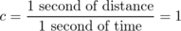
All velocities are represented by unitless numbers in this system, so for example v=0.5 would describe motion at half the speed of light.

Example 1: Converting a formula from ordinary units to natural units
In ordinary units, the equation for the Lorentz factor γ is
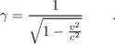
Suppose we want to reexpress this in natural units. One way of doing it would be to redo the derivation on page 330, but with the simplifying assumption of c=1. However, this would just mean eliminating any c that appears in a multiplication or division, so rather than retracing the trail of breadcrumbs, we can just eliminate the c's from the final result:
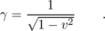

Example 2: Converting a formula from natural units to ordinary units
In reality, the reason for using natural units in the first place is to make derivations simpler. Therefore a much more common situation is that you get a formula in natural units as the result of some symbolic calculation, but then you need to convert it to ordinary units in order to plug in numbers that you have in ordinary units. Working in the opposite direction, we observe that the equation doesn't make any sense in metric units, because you can't take a unitless number like 1 and subtract from it a quantity that has units of m²/s². That would be like subtracting three gallons from seven miles! Even if we don't remember how the formula was derived, we know that the derivation in natural units and the derivation in ordinary units could only have differed by the presence or absence of factors of c in various places. Therefore, we know we can recover the result in metric units simply by inserting factors of c wherever they're needed in order to turn the nonsense into sense. One way of doing this would be to divide the v² term by c², which makes it into a unitless quantity that it's possible to subtract from 1. The result is . (It might seem like the result wouldn't be unique, since we could instead fix the 1 by multiplying it by c², giving c²-v² inside the square root. However, the units of the right-hand side of the equation would then be s/m, so we'd also need to change the left-hand side to γ/c, and then the result would be exactly equivalent .)

Example 3: A black hole
Here's an example where you don't even have the option of rederiving the equation from scratch. A black hole of mass m has an invisible spherical boundary of radius r surrounding it, and any object that comes in closer than that can never escape. The radius is given in natural units by r=2Gm, where G is Newton's gravitational constant. All of this can be partly, but not completely, explained using special relativity. For instance, we can try calculating the distance at which escape velocity becomes greater than the speed of light. However, this would be a swindle, because special relativity doesn't include gravity --- to get a correct relativistic treatment of gravity, we'd need general relativity, which is beyond the scope of this book. (One way you can tell that the naive calculation using escape velocity isn't really correct is that it makes it sound as though an object could still be hoisted out of a black hole on a cable, but that's actually not true according to general relativity.) But even though you don't know enough physics to derive the equation correctly from scratch, you can still convert it to metric units. The units of G are m³/kg⋅s², so the units of Gm are m³/s². This doesn't equal meters, so the equation r=2Gm is nonsense if you interpret it directly in metric units. However, the units do work if you change it to r=2Gm/c², so that's what the equation must be in metric units.

Derivation of the Lorentz transformation
We now want to find out how the constants A, B, C, and D in the transformation equations
x' = Ax + Bt
t' = Cx + Dt
depend on velocity. For vividness, we imagine that the x,t frame is defined by an asteroid at x=0, and the x',t' frame by a rocket ship at x'=0. The rocket ship is coasting at a constant speed v relative to the asteroid, and as it passes the asteroid they synchronize their clocks to read t=0 and t'=0.

Asteroid time as perceived by the rocket
In section 7.1, we've already found that a clock seems to run more slowly by a factor of γ to an observer in motion with respect to the clock. A clock on the asteroid has x=0, so if the rocket pilot monitors the ticking of a clock on the asteroid via radio signals, the Lorentz transformation gives t'=Dt. The idea of time running more slowly by a factor of γ is expressed by t'=γ t, so we have
D=γ .

Asteroid's motion as seen by the rocket
Straightforward algebra can be used to reverse the transformation equations so that they give x and t in terms of x' and t'. The result for x is x=(Dx'-Bt')/(AD-BC). The asteroid's frame of reference has its origin defined by the asteroid itself, so the asteroid is always at x=0. In the rocket's frame, the asteroid falls behind according to the equation x'=-vt', and substituting this into the equation for x gives 0=(-Dvt'-Bt')/(AD-BC). This requires us to have B=-vD, or
B=-vγ .
So far in this derivation, we've been able to avoid talking about events that happen in different places and at different times, but we won't be able to avoid that anymore. We need to compare the perception of space and time by observers on the rocket and the asteroid, but this can be a bit tricky because our usual ideas about measurement contain hidden assumptions. If, for instance, we want to measure the length of a box, we imagine we can lay a ruler down on it, take in the scene visually, and take the measurement using the ruler's scale on the right side of the box while the left side of the box is simultaneously lined up with the butt of the ruler. The assumption that we can take in the whole scene at once with our eyes is, however, based on the assumption that light travels with infinite speed to our eyes. Since we will be dealing with relative motion at speeds comparable to the speed of light, we have to spell out our methods of measuring distance.
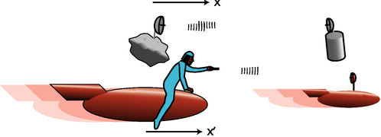
c / To discuss distances and time intervals between different events, we imagine that each frame of reference has observers in more than one place.
We will therefore imagine an explicit procedure for the asteroid and the rocket pilot to make their distance measurements: they send electromagnetic signals (light or radio waves) back and forth to their own remote stations. For instance the asteroid's station will send it a message to tell it the time at which the rocket went by. The asteroid's station is at rest with respect to the asteroid, and the rocket's is at rest with respect to the rocket (and therefore in motion with respect to the asteroid).
The measurement of time is likewise fraught with danger if we are careless, which is why we have had to spell out procedures for the synchronization of clocks between the asteroid and the rocket. The asteroid must also synchronize its clock with its remote stations's clock by adjusting them until flashes of light released by both the asteroid and its station at equal clock readings are received on the opposite sides at equal clock readings. The rocket pilot must go through the same kind of synchronization procedure with her remote station.

Rocket's motion as seen by the asteroid
The origin of the rocket's x',t' frame is defined by the rocket itself, so the rocket always has x'=0. Let the asteroid's remote station be at position x in the asteroid's frame. The asteroid sees the rocket travel at speed v, so the asteroid's remote station sees the rocket pass it when x equals vt. The equation x'=Ax+Bt then becomes 0=Avt+Bt, which implies a relationship between A and B: B=-Av. (In the Galilean version, we had B=-v and A=1.) Thus,
A=γ .
This boils down to a statement that length contraction occurs in the same proportion as time dilation, as we'd already argued less rigorously.

Agreement on the speed of light
Suppose the rocket pilot releases a flash of light in the forward direction as she passes the asteroid at t=t'=0. As seen in the asteroid's frame, we might expect this pulse to travel forward faster than normal because it was emitted by the moving rocket, but the principle of relativity tells us this is not so. The flash reaches the asteroid's remote station when x equals ct, and since we are working in natural units, this is equivalent to x=t. The speed of light must be the same in the rocket's frame, so we must also have x'=t' when the flash gets there. Setting x' =Ax+Bt equal to t' = Cx+ Dt and substituting in x=t, we find A+B=C+D, so we deduce C=B+A-D=B, or
C=-vγ .
We have now arrived at the correct relativistic equation for transforming between frames in relative motion. For completeness, I will include, without proof, the trivial transformations of the y and z coordinates.
x' = γ x - v γ t
t' = -vγ x + γ t
y' = y
z' = z
These equations are valid provided that (1) the two coordinate systems coincide at t=t'=0; and (2) the observer in the x',y',z',t' frame is moving at velocity v relative to the x,y,z,t frame, and the motion is in the direction of the x axis.
self-check: What happens to the Lorentz transformation in the case where v equals zero? (answer in the back of the PDF version of the book)
We now turn to some subversive consequences of these equations.
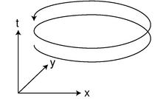
f / The world-line of the earth as it orbits the sun.
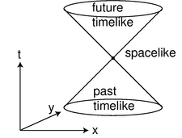
g / The light cone.
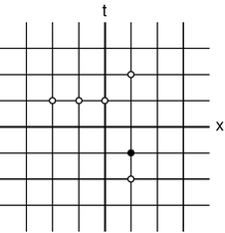
Discussion question A.
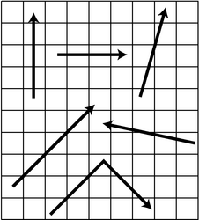
Discussion question B.

Spacetime

No absolute time
The fact that the equation for time is not just t'=t tells us we're not in Kansas anymore --- Newton's concept of absolute time is dead. One way of understanding this is to think about the steps described for synchronizing the four clocks:
(1) The asteroid's clock --- call it A1 --- was synchronized with the clock on its remote station, A2.
(2) The rocket pilot synchronized her clock, R1, with A1, at the moment when she passed the asteroid.
(3) The clock on the rocket's remote station, R2, was synchronized with R1.
Now if A2 matches A1, A1 matches R1, and R1 matches R2, we would expect A2 to match R2. This cannot be so, however. The rocket pilot released a flash of light as she passed the asteroid. In the asteroid's frame of reference, that light had to travel the full distance to the asteroid's remote station before it could be picked up there. In the rocket pilot's frame of reference, however, the asteroid's remote station is rushing at her, perhaps at a sizeable fraction of the speed of light, so the flash has less distance to travel before the asteroid's station meets it. Suppose the rocket pilot sets things up so that R2 has just enough of a head start on the light flash to reach A2 at the same time the flash of light gets there. Clocks A2 and R2 cannot agree, because the time required for the light flash to get there was different in the two frames. Thus, two clocks that were initially in agreement will disagree later on.

d / Different observers don't agree that the flashes of light hit the front and back of the ship simultaneously.

No simultaneity
Part of the concept of absolute time was the assumption that it was valid to say things like, “I wonder what my uncle in Beijing is doing right now.” In the nonrelativistic world-view, clocks in Los Angeles and Beijing could be synchronized and stay synchronized, so we could unambiguously define the concept of things happening simultaneously in different places. It is easy to find examples, however, where events that seem to be simultaneous in one frame of reference are not simultaneous in another frame. In figure d, a flash of light is set off in the center of the rocket's cargo hold. According to a passenger on the rocket, the flashes have equal distances to travel to reach the front and back walls, so they get there simultaneously. But an outside observer who sees the rocket cruising by at high speed will see the flash hit the back wall first, because the wall is rushing up to meet it, and the forward-going part of the flash hit the front wall later, because the wall was running away from it. Only when the relative velocity of two frames is small compared to the speed of light will observers in those frames agree on the simultaneity of events.

The garage paradox
One of the most famous of all the so-called relativity paradoxes has to do with our incorrect feeling that simultaneity is well defined. The idea is that one could take a schoolbus and drive it at relativistic speeds into a garage of ordinary size, in which it normally would not fit. Because of the length contraction, the bus would supposedly fit in the garage. The paradox arises when we shut the door and then quickly slam on the brakes of the bus. An observer in the garage's frame of reference will claim that the bus fit in the garage because of its contracted length. The driver, however, will perceive the garage as being contracted and thus even less able to contain the bus. The paradox is resolved when we recognize that the concept of fitting the bus in the garage “all at once” contains a hidden assumption, the assumption that it makes sense to ask whether the front and back of the bus can simultaneously be in the garage. Observers in different frames of reference moving at high relative speeds do not necessarily agree on whether things happen simultaneously. The person in the garage's frame can shut the door at an instant he perceives to be simultaneous with the front bumper's arrival at the back wall of the garage, but the driver would not agree about the simultaneity of these two events, and would perceive the door as having shut long after she plowed through the back wall.
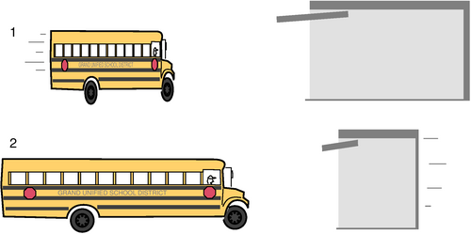
e / In the garage's frame of reference, 1, the bus is moving, and can fit in the garage. In the bus's frame of reference, the garage is moving, and can't hold the bus.

Spacetime
We consider x, y, and z to be three axes in space. There can be no physical distinction between them, since rotation transformations like the ones given on page 337 can interchange or mix together the three coordinates. One observer can say that two different points in space have the same value of x, but a different observer working in a differently oriented coordinate system would say they have different x values; this shows that the x axis can't be singled out from the others in any physically meaningful way.
In relativity, Lorentz transformations can mix the space variables with the time variable, and different observers will not necessarily agree on whether two events are simultaneous, i.e. on whether they have the same t. Thus there is no unique, physically meaningful way to defined a time axis and set it apart from the space axes. The three space coordinates and the time coordinate are really just four coordinates that allow us to describe points in a four-dimensional space, which we call spacetime.
What does this mean? We can't visualize four dimensions. One technique for visualizing spacetime is to ignore one of the space dimensions, cutting the total number back down to three. For instance, the earth orbits the sun within a certain plane, so if we define x and y axes within the orbital plane, the z axis is not very interesting, and we can ignore it for purposes of describing the earth's motion. If we visualize x, y, and t in three dimensions, the points in spacetime visited by the earth form a helical curve, f. The earth stays “above” the circle defined by its orbit in the x-y plane. The earth will visit the same x-y point over and over, but it never visits the same spacetime point again, because t changes by one year over each orbit. Every point in spacetime is called an event.
It might seem that the mixing of space and time is so insane that virtually anything can happen, but there is a good way of bringing order to the madness. Continuing with the same mode of visualization, imagine that at a certain moment at a certain point in space (at a certain event in spacetime), a flash of light is emitted. The light pulse travels outward in all directions, forming an expanding spherical shell. If we ignore one of the space dimensions, this becomes an expanding circle, like a ripple on a pond. In x-y-t space, the ripple becomes a cone, g. If we are present at the emission of the light pulse, then events inside this light cone are ones that we may be able to observe in the future. For instance, if we just stay put, we will be present at every event that lies along the axis of the cone. If we were to move off at 99.99999% of the speed of light, we could witness a bunch of the events along a world line lying just inside the cone. Events in the region of spacetime outside the light cone, however, are ones we can never experience firsthand. For instance, consider an event that is happening right now, in a galaxy far, far away. This event lies in the spacelike region outside the light cone, directly away from the tip of the cone in the direction perpendicular to its axis. We can't travel a large distance in an instant, since it's impossible to go faster than light, so we can never get to this event. The spacelike region consists of points whose distance from us in space is greater (in natural units) than their distance from us in time, so we can never visit them without traveling faster than light.
The great thing about the light cone is that everyone has to agree on it. A Lorentz transformation will skew and distort all of spacetime, but it will leave the light cone alone, since the light cone is defined by a flash of light, and all observers agree on the speed of light.
It's also possible to make a light cone that extends backward into the past. These are events that we can remember or get information about, but that we can never visit again because they lie in our past.

The spacetime interval
The light cone is helpful because it stays the same when you do a Lorentz transformation. Is there anything else that stays the same? For guidance, consider rotations. In a rotation, distances and angles stay the same. Now if you were an ant living on a telephone wire, you'd only know about one dimension, and the only type of rotation you'd be able to understand would be a 180-degree flip, which wouldn't change the lengths of line segments. But suppose there was some unsuspected second dimension to space. A one-meter line segment, with Δ x=1.0 m, that was rotated 60 degrees into this second dimension would then have Δ x=0.5 m. The existence of the newly discovered dimension has broken the rule that rotations don't change values of Δ x. However, an ant named Pythagoras might realize that there was a new way to redefine distance, as , so distances would stay the same in two-dimensional space. For reasons that will become apparent shortly, it turns out to be more convenient to work with the square of the distance, Δ x²+Δ y², which we call an interval. Generalizing to three dimensions is a snap: we just define the interval as Δ x²+Δ y²+Δ z².
Now what about the generalization to four dimensions? The quantity Δ x²+Δ y²+Δ z² doesn't stay the same when we do a Lorentz transformation --- distances get contracted. We might try Δ x²+Δ y²+Δ z²+Δ t² (in natural units), but that wouldn't work, as you can easily verify by trying an example. We already know that the light cone stays the same under a Lorentz transformation, and the light cone is defined by the equation (distance)/(time)=(speed of light), or (distance)=(time) in natural units, which is equivalent to
or
Δ x²+Δ y²+Δ z²-Δ t² = 0 .
With this motivation, we define² the interval between two events in spacetime as Δ x²+Δ y²+Δ z²-Δ t². With this definition, the interval stays the same under a Lorentz transformation. Events with a zero interval between them are in each other's light cones. A positive interval indicates a spacelike relationship, and a negative one shows a timelike relationship. The possibility of a negative result is the reason for working with the quantity Δ x²+Δ y²+Δ z²-Δ t² rather than .

Example 4: The interval and the correspondence principle
What happens if we try to interpret the interval in a nonrelativistic context? The equation for the interval is expressed in natural units. Suppose we take two events in the everyday world. For instance, my dog barks, and I turn around to look at why he's barking. In natural units, both the Δ t and the Δ x between these two events would be expressed in units of seconds. The Δ t is something like a second or half a second. The Δ x would be a few meters in SI units, but in natural units, it converts to the time light would take to travel a few meters, which would be on the order of 10⁻⁸ s. We find, then, that the Δ x makes a negligibly small contribution to the interval compared to the Δ t. In other words, we never encounter spacelike or lightlike intervals in our everyday experience; all the intervals we experience directly are timelike. Nonrelativistically, when nothing is traveling at an appreciable fraction of the speed of light, the interval is essentially the same as Δ t².
How are we to interpret this? The interval is the same in all frames of reference, and in nonrelativistic situations, this means that Δ t must be the same for all observers. But this is exactly what we expect in Galilean relativity. In the Galilean transformations, the absolute nature of time is expressed in the equation t'=t. This is an example of the correspondence principle, which states that when a new physical theory supersedes an old one, it must be consistent with the old one within the old one's domain of validity.

Discussion Questions
◊ The graphs for discussion questions A and B represent spacetime with one space dimension. Each square on the graph is one light-year wide and one year tall. In A, the dots represent civilizations in different times and on different planets. The planets all happen to lie along the same line, so we don't need y or z coordinates to show their locations. None of the planets are in rapid motion relative to each other, so we don't have to worry right now about whose frame of reference the graph depicts --- they all agree.
(1) How many different planets are represented on the graph?
(2) The black dot represents a historian. Draw the historian's light cone.
(3) The historian is interested in getting information that has been preserved by civilizations in her past, and also hopes to preserve information about her own civilization for those in her future. By what methods could this be accomplished for the events shown as white circles?
◊ Which of the world lines are possible, and which are impossible? Could they represent light? Matter? What does this have to do with the light cone?
◊ The graph below is unlike the other ones we've been considering because it represents two dimensions of space at a certain instant. In each case, show what happens to the letter R when you do the transformation. Are the laws of physics the same in the x', y' coordinates? In other words, if the transformation is suddenly applied to your physics lab, will experiments still come out the same?
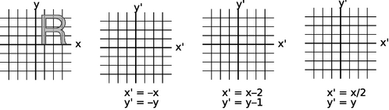
◊ The following graphs show one space dimension and one time dimension.
(1) In each case, apply the transformation
x' = x+(0.2)t
t' = t
to the indicated events.
(2) How would you interpret the meaning of the transformation?
(3) In each case are there special relationships between the two events? Do observers in these two frames of reference agree on these relationships?
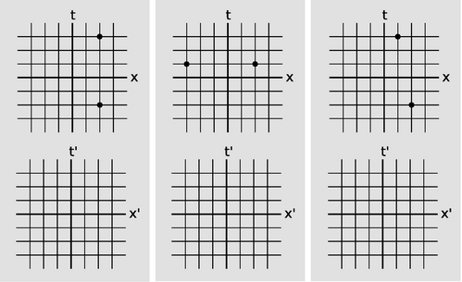
Discussion question D.
◊ This is similar to discussion question D, but with the following transformation:
x' = (1.67)x+(-1.34)t
t' = (-1.34)x+(1.67)t
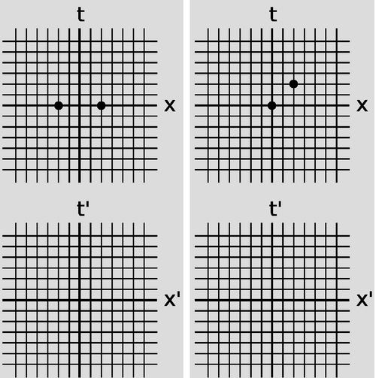
h / Discussion question E.

7.3 Dynamics
So far we have said nothing about how to predict motion in relativity. Do Newton's laws still work? Do conservation laws still apply? The answer is yes, but many of the definitions need to be modified, and certain entirely new phenomena occur, such as the conversion of mass to energy and energy to mass, as described by the famous equation E=mc². To cut down on the level of mathematical detail, I have relegated most of the derivations to page 745, presenting mainly the results and their physical explanations in this section.

Invariants
The discussion has the potential to become very confusing very quickly because some quantities, force for example, are perceived differently by observers in different frames, whereas in Galilean relativity they were the same in all frames of reference. To clear the smoke it will be helpful to start by identifying quantities that we can depend on not to be different in different frames. We have already seen how the principle of relativity requires that the speed of light is the same in all frames of reference. We say that c is invariant.
Another important invariant is mass. This makes sense, because the principle of relativity states that physics works the same in all reference frames. The mass of an electron, for instance, is the same everywhere in the universe, so its numerical value is one of the basic laws of physics. We should therefore expect it to be the same in all frames of reference as well. (Just to make things more confusing, about 50% of all books say mass is invariant, while 50% describe it as changing. It is possible to construct a self-consistent framework of physics according to either description. Neither way is right or wrong, the two philosophies just require different sets of definitions of quantities like momentum and so on. For what it's worth, Einstein eventually weighed in on the mass-as-an-invariant side of the argument. The main thing is just to be consistent.)
A third invariant is electrical charge. This has been verified to high precision because experiments show that an electric field does not produce any measurable force on a hydrogen atom. If charge varied with speed, then the electron, typically orbiting at about 1% of the speed of light, would not exactly cancel the charge of the proton, and the hydrogen atom would have a net charge.

Combination of velocities
The impossibility of motion faster than light is a radical difference between relativistic and nonrelativistic physics, and we can get at most of the issues in this section by considering the flaws in various plans for going faster than light. The simplest argument of this kind is as follows. Suppose Janet takes a trip in a spaceship, and accelerates until she is moving at v=0.9 (90% of the speed of light in natural units) relative to the earth. She then launches a space probe in the forward direction at a speed u=0.2 relative to her ship. Isn't the probe then moving at a velocity of 1.1 times the speed of light relative to the earth?
The problem with this line of reasoning is that the distance covered by the probe in a certain amount of time is shorter as seen by an observer in the earthbound frame of reference, due to length contraction. Velocities are therefore combined not by simple addition but by a more complex method, which we derive on page 745 by performing two transformations in a row. In our example, the first transformation would be from the earth's frame to Janet's, the second from Janet's to the probe's. The result is


Example 5: Janet's probe
Applying the equation to Janet's probe, we find
v_{combined}
= 0.93 ,
so it's still going quite a bit slower than the speed of light

Example 6: Combination of velocities in unnatural units
In a system of units, like the metric system, with c≠1, all our symbols for velocity should be replaced with velocities divided by c, so we have
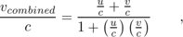
or
v_{combined}
When u and v are both much less than the speed of light, the quantity uv/ c² is very close to zero, and we recover the nonrelativistic approximation, v_{combined}= u+ v.
The second example shows the correspondence principle at work: when a new scientific theory replaces an old one, the two theories must agree within their common realm of applicability.

Momentum and force

Momentum
We begin our discussion of relativistic momentum with another scheme for going faster than light. Imagine that a freight train moving at a velocity of 0.6 (v=0.6c in unnatural units) strikes a ping-pong ball that is initially at rest, and suppose that in this collision no kinetic energy is converted into other forms such as heat and sound. We can easily prove based on conservation of momentum that in a very unequal collision of this kind, the smaller object flies off with double the velocity with which it was hit. (This is because the center of mass frame of reference is essentially the same as the frame tied to the freight train, and in the center of mass frame both objects must reverse their initial momenta.) So doesn't the ping-pong ball fly off with a velocity of 1.2, i.e. 20% faster than the speed of light?
The answer is that since p=mv led to this contradiction with the structure of relativity, p=mv must not be the correct equation for relativistic momentum. Apparently p=mv is only a low-velocity approximation to the correct relativistic result. We need to find a new expression for momentum that agrees approximately with p=mv at low velocities, and that also agrees with the principle of relativity, so that if the law of conservation of momentum holds in one frame of reference, it also is obeyed in every other frame. A proof is given on page 745 that such an equation is
which differs from the nonrelativistic version only by the factor of γ. At low velocities γ is very close to 1, so p=mv is approximately true, in agreement with the correspondence principle. At velocities close to the speed of light, γ approaches infinity, and so an object would need infinite momentum to reach the speed of light.

Force
What happens if you keep applying a constant force to an object, causing it to accelerate at a constant rate until it exceeds the speed of light? The hidden assumption here is that Newton's second law, a=F/m, is still true. It isn't. Experiments show that at speeds comparable to the speed of light, a=F/m is wrong. The equation that still is true is
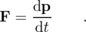
You could apply a constant force to an object forever, increasing its momentum at a steady rate, but as the momentum approached infinity, the velocity would approach the speed of light. In general, a force produces an acceleration significantly less than F/m at relativistic speeds.
Would passengers on a spaceship moving close to the speed of light perceive every object as being more difficult to accelerate, as if it was more massive? No, because then they would be able to detect a change in the laws of physics because of their state of motion, which would violate the principle of relativity. The way out of this difficulty is to realize that force is not an invariant. What the passengers perceive as a small force causing a small change in momentum would look to a person in the earth's frame of reference like a large force causing a large change in momentum. As a practical matter, conservation laws are usually more convenient tools for relativistic problem solving than procedures based on the force concept.
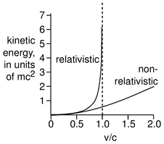
a / A comparison of the relativistic and nonrelativistic expressions for kinetic energy.
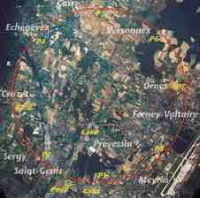
b / The Large Hadron Collider. The red circle shows the location of the underground tunnel which the LHC will share with a preexisting accelerator.

Kinetic energy
Since kinetic energy equals , wouldn't a sufficient amount of energy cause v to exceed the speed of light? You're on to my methods by now, so you know this is motivation for a redefinition of kinetic energy. The work-kinetic energy theorem is derived on page 745 using the correct relativistic treatment of force. The result is
Since γ approaches infinity as velocity approaches the speed of light, an infinite amount of energy would be required in order to make an object move at the speed of light.

Example 7: Kinetic energy in unnatural units
How can this equation be converted back into units in which the speed of light does not equal one? One approach would be to redo the derivation on page 745 in unnatural units. A far simpler approach is simply to add factors of c where necessary to make the metric units look consistent. Suppose we decide to modify the right side in order to make its units consistent with the energy units on the left. The ordinary nonrelativistic definition of kinetic energy as shows that the units on the left are
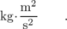
The factor of γ-1 is unitless, so the mass units on the right need to be multiplied by m²/s² to agree with the left. This means that we need to multiply the right side by c²:
K = mc²(γ-1)
This is beginning to resemble the famous E= mc² equation, which we will soon attack head-on.

Example 8: The correspondence principle for kinetic energy
It's far from obvious that this result, even in its metric-unit form, reduces to the familiar at low speeds, as required by the correspondence principle. To show this, we need to find a low-velocity approximation for γ. In metric units, the equation for γ reads as
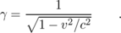
Reexpressing this as , and making use of the approximation (1+ε)^{p}≈1+ pε for small ε, the equation for gamma becomes
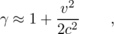
which can readily be used to show .

Example 9: The large hadron collider
◊ The Large Hadron³ Collider (LHC), being built in Switzerland, is a ring with a radius of 4.3 km, designed to accelerate two counterrotating beams of protons to energies of 1.1×10⁻⁶ J per proton. (A microjoule is quite a healthy energy for a subatomic particle!) The ring has to be so big because the inward force from the accelerator's magnets would not be great enough to make the protons curve more tightly at top speed.
(a) What inward force must be exerted on each proton?
(b) In a purely Newtonian world where there were no relativistic effects, how much smaller could the LHC be if it was to produce proton beams moving at speeds close to the speed of light?
◊(a) Since the protons have velocity vectors with constant magnitudes, γ is constant, so let's start by computing it. We'll work the whole problem in SI units, since none of the data are given in natural units. Looking up the mass of a proton, we have
= 1.5×10⁻¹⁰ J .
The kinetic energy is thousands of times greater than mc², so the protons go very close to the speed of light. Under these conditions there is no significant difference between γ and γ-1, so
= 7.3×10³
We analyze the circular motion in the laboratory frame of reference, since that is the frame of reference in which the LHC's magnets sit, and their fields were calibrated by instruments at rest with respect to them. The inward force required is
F = d p/d t
= d( mγ v)/d t
= m γ d v/d t
= m γ a .
Except for the factor of γ, this is the same result we would have had in Newtonian physics, where we already know the equation a= v²/ r for the inward acceleration in uniform circular motion. Since the velocity is essentially the speed of light, we have a= c²/ r. The force required is
F = m γ c²/r
This looks a little funny, but the units check out, since a joule is the same as a newton-meter. The result is
F = 2.6×10⁻¹⁰ N
(b) In a Newtonian universe,
F = mv²/ r
= mc²/ r
r = mc²/ F
In a nonrelativistic world, it would be a table-top accelerator! The energies and momenta, however, would be smaller.

Equivalence of mass and energy
The treatment of relativity so far has been purely mechanical, so the only form of energy we have discussed is kinetic. For example, the storyline for the introduction of relativistic momentum was based on collisions in which no kinetic energy was converted to other forms. We know, however, that collisions can result in the production of heat, which is a form of kinetic energy at the molecular level, or the conversion of kinetic energy into entirely different forms of energy, such as light or electrical energy.
Let's consider what happens if a blob of putty moving at velocity v hits another blob that is initially at rest, sticking to it, and as much kinetic energy as possible is converted into heat. (It is not possible for all the kinetic energy to be converted to heat, because then conservation of momentum would be violated.) The nonrelativistic result is that to obey conservation of momentum the two blobs must fly off together at v/2.
Relativistically, however, an interesting thing happens. A hot object has more momentum than a cold object! This is because the relativistically correct expression for momentum is p=mγ v, and the more rapidly moving molecules in the hot object have higher values of γ. There is no such effect in nonrelativistic physics, because the velocities of the moving molecules are all in random directions, so the random motion's contribution to momentum cancels out.
In our collision, the final combined blob must therefore be moving a little more slowly than the expected v/2, since otherwise the final momentum would have been a little greater than the initial momentum. To an observer who believes in conservation of momentum and knows only about the overall motion of the objects and not about their heat content, the low velocity after the collision would seem to be the result of a magical change in the mass, as if the mass of two combined, hot blobs of putty was more than the sum of their individual masses.

Heat energy is equivalent to mass.
Now we know that mass is invariant, and no molecules were created or destroyed, so the masses of all the molecules must be the same as they always were. The change is due to the change in γ with heating, not to a change in m. But how much does the mass appear to change? On page 745 we prove that the perceived change in mass exactly equals the change in heat energy between two temperatures, i.e. changing the heat energy by an amount E changes the effective mass of an object by E as well. This looks a bit odd because the natural units of energy and mass are the same. Converting back to ordinary units by our usual shortcut of introducing factors of c, we find that changing the heat energy by an amount E causes the apparent mass to change by m=E/c². Rearranging, we have the famous E=mc².

All energy is equivalent to mass.
But this whole argument was based on the fact that heat is a form of kinetic energy at the molecular level. Would E=mc² apply to other forms of energy as well? Suppose a rocket ship contains some electrical energy stored in a battery. If we believed that E=mc² applied to forms of kinetic energy but not to electrical energy, then we would have to believe that the pilot of the rocket could slow the ship down by using the battery to run a heater! This would not only be strange, but it would violate the principle of relativity, because the result of the experiment would be different depending on whether the ship was at rest or not. The only logical conclusion is that all forms of energy are equivalent to mass. Running the heater then has no effect on the motion of the ship, because the total energy in the ship was unchanged; one form of energy was simply converted to another.

Example 10: A rusting nail
◊ A 50-gram iron nail is left in a cup of water until it turns entirely to rust. The energy released is about 0.5 MJ (megajoules). In theory, would a sufficiently precise scale register a change in mass? If so, how much?
◊ The energy will appear as heat, which will be lost to the environment. So the total mass-energy of the cup, water, and iron will indeed be lessened by 0.5 MJ. (If it had been perfectly insulated, there would have been no change, since the heat energy would have been trapped in the cup.) Converting to mass units, we have
m= E/ c²
= 6×10⁻¹²
= 6×10⁻¹² kg ,
so the change in mass is too small to measure with any practical technique. This is because the square of the speed of light is such a large number in metric units.

Energy participates in gravitational forces.
In the example we tacitly assumed that the increase in mass would show up on a scale, i.e. that its gravitational attraction with the earth would increase. Strictly speaking, however, we have only proved that energy relates to inertial mass, i.e. to phenomena like momentum and the resistance of an object to a change in its state of motion. Even before Einstein, however, experiments had shown to a high degree of precision that any two objects with the same inertial mass will also exhibit the same gravitational attractions, i.e. have the same gravitational mass. For example, the only reason that all objects fall with the same acceleration is that a more massive object's inertia is exactly in proportion to the greater gravitational forces in which it participates. We therefore conclude that energy participates in gravitational forces in the same way mass does. The total gravitational attraction between two objects is proportional not just to the product of their masses, m₁m₂, as in Newton's law of gravity, but to the quantity (m₁+E₁)(m₂+E₂). (Even this modification does not give a complete, self-consistent theory of gravity, which is only accomplished through the general theory of relativity.)
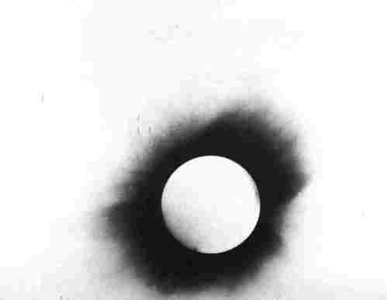
c / Example 11.

Example 11: Gravity bending light
Mass and energy are equivalent. The energy of a beam of light is equivalent to a certain amount of mass, and the beam is therefore deflected by a gravitational field. Einsteinճ prediction of this effect was verified in 1919 by astronomers who photographed stars in the dark sky surrounding the sun during an eclipse. (If there was no eclipse, the glare of the sun would prevent the stars from being observed.) Figure c is a photographic negative, so the circle that appears bright is actually the dark face of the moon, and the dark area is really the bright corona of the sun. The stars, marked by lines above and below them, appeared at positions slightly different than their normal ones, indicating that their light had been bent by the sunճ gravity on its way to our planet.

Example 12: Black holes
A star with sufficiently strong gravity can prevent light from leaving. Quite a few black holes have been detected via their gravitational forces on neighboring stars or clouds of dust.

Creation and destruction of particles
Since mass and energy are beginning to look like two sides of the same coin, it may not be so surprising that nature displays processes in which particles are actually destroyed or created; energy and mass are then converted back and forth on a wholesale basis. This means that in relativity there are no separate laws of conservation of energy and conservation of mass. There is only a law of conservation of mass plus energy (referred to as mass-energy). In natural units, E+m is conserved, while in ordinary units the conserved quantity is E+mc².

Example 13: Electron-positron annihilation
Natural radioactivity in the earth produces positrons, which are like electrons but have the opposite charge. A form of antimatter, positrons annihilate with electrons to produce gamma rays, a form of high-frequency light. Such a process would have been considered impossible before Einstein, because conservation of mass and energy were believed to be separate principles, and the process eliminates 100% of the original mass. In metric units, the amount of energy produced by annihilating 1 kg of matter with 1 kg of antimatter is
E = mc²
= 2×10¹⁷ J ,
which is on the same order of magnitude as a day's energy consumption for the entire world!
Positron annihilation forms the basis for the medical imaging procedure called a PET (positron emission tomography) scan, in which a positron-emitting chemical is injected into the patient and mapped by the emission of gamma rays from the parts of the body where it accumulates.
Note that the idea of mass as an invariant is separate from the idea that mass is not separately conserved. Invariance is the statement that all observers agree on a particle's mass regardless of their motion relative to the particle. Mass may be created or destroyed if particles are created or destroyed, and in such a situation mass invariance simply says that all observers will agree on how much mass was created or destroyed.
\backofchapterboilerplate{rel}

Homework Problems
1. As of 2006, the best atomic clocks have accuracies of about one part in 10¹⁵. How does this compare with the time dilation effect produced if the clock takes a trip aboard a jet moving at 300 m/s? Would the effect be measurable? \hwhint{hwhint:atomicclock}
2. [0]{gammatov} (a) Find an expression for v in terms of γ
(answer check available at lightandmatter.com) (b) Using your result from part a, show that for very large values of γ, v gets close to the speed of light.
3. (a) Reexpress the Lorentz transformation equations using ordinary metric units where c≠1. The point here is to practice the technique for converting any formula from natural units to metric units, by inserting factors of c wherever necessary in order to make the units make sense, as in the examples 2 and 3 on page 339. That means you shouldn't go back and redo the whole derivation from scratch.(answer check available at lightandmatter.com)
(b) Show that for speeds that are small compared to the speed of light, these equations are identical to the Galilean equations.
4. (a) Make up a numerical example of two events, and show that the if we defined the spacetime interval as Δ x²+Δ y²+Δ z²+Δ t², we would not get consistent results when we Lorentz-transformed the events into a different frame of reference.
(b) Show that, for the particular example you chose in part a, the quantity Δ x²+Δ y²+Δ z²-Δ t² does come out the same in both frames.
(c) Ignoring the y and z space dimensions, prove that Δ x²-Δ t² stays the same under a Lorentz transformation for motion along the x axis. You're proving this in general now, not just checking it for one numerical example.
(d) Reexpress the definition Δ x²+Δ y²+Δ z²-Δ t² of the spacetime interval in unnatural units, where c≠1.
5. Make up a numerical example, in a particular frame of reference, of two events with a spacelike interval between them. Make event 2 occur after event 1. Now show by using a Lorentz transformation that you can find another frame of reference in which event 2 occurs before event 1.
To get from event 1 to event 2, or vice versa, you would have to travel faster than light. Therefore there can't be a cause-and-effect relationship between the two events, and it doesn't really matter which one we consider to have happened first. On the other hand, if faster-than-light travel was possible, then time travel paradoxes would be possible in this kind of situation. For example, event 2 could be your birth, and event 1 could be when you kill your own grandmother before she has any children.
6. [0]{veladdition} (a) A spacecraft traveling at 1.0000×10⁷ m/s relative to the earth releases a probe in the forward direction at a relative speed of 2.0000×10⁷ m/s. How fast is the probe moving relative to the earth? How does this compare with the nonrelativistic result? (answer check available at lightandmatter.com)
(b) Repeat the calculation, but with both velocities equal to c/2. How does this compare with the nonrelativistic result?(answer check available at lightandmatter.com)
7. (a) Show that when two velocities are combined relativistically, and one of them equals the speed of light, the result also equals the speed of light.
(b) Explain why it has to be this way based on the principle of relativity. (Note that it doesn't work to say that it has to be this way because motion faster than c is impossible. That isn't what the principle of relativity says, and it also doesn't handle the case where the velocities are in opposite direction.)
8. [0]{cosmicraygamma} Cosmic-ray particles with relativistic velocities are continually bombarding the earth's atmosphere. They are protons and other atomic nuclei. Suppose a carbon nucleus (containing six protons and six neutrons) arrives with an energy of 10⁻⁷ J, which is unusually high, but not unheard of. By what factor is its length shortened as seen by an observer in the earth's frame of reference? \hwhint{hwhint:cosmicraygamma}(answer check available at lightandmatter.com)
9. [0]{freeneutron} (a) A free neutron (as opposed to a neutron bound into an atomic nucleus) is unstable, and decays radioactively into a proton, an electron, and a particle called a neutrino. (This process can also occur for a neutron in a nucleus, but then other forms of mass-energy are involved as well.) The masses are as follows:
neutron | 1.67495×10 ⁻ ²⁷ kg
proton | 1.67265×10 ⁻ ²⁷ kg
electron | 0.00091×10 ⁻ ²⁷ kg
neutrino | negligible
Find the energy released in the decay of a free neutron.(answer check available at lightandmatter.com)
(b) We might imagine that a proton could decay into a neutron, a positron, and a neutrino. Although such a process can occur within a nucleus, explain why it cannot happen to a free proton. (If it could, hydrogen would be radioactive!)
10. (a) Find a relativistic equation for the velocity of an object in terms of its mass and momentum (eliminating γ). Work in natural units. (answer check available at lightandmatter.com)
(b) Show that your result is approximately the same as the classical value, p/m, at low velocities.
(c) Show that very large momenta result in speeds close to the speed of light.
11. (a) Prove the equation E²-p²=m² for a material object, where E=mγ is the total mass-energy.
(b) Using this result, show that an object with zero mass must move at the speed of light.
(c) This equation can be applied more generally, to light for instance. Use it to find the momentum of a beam of light having energy E. (answer check available at lightandmatter.com)
(d) Convert your answer from the previous part into ordinary units.(answer check available at lightandmatter.com)
\hwans{hwans:relemom}
12. Starting from the equation v_{combined}γ_{combined} = derived on page 745, complete the proof of v_{combined} = (v₁+v₂)/(1+v₁v₂).
13. [2]{reldoppler} A source of light with frequency f is moving toward an observer at velocity v (or away from the observer if v is negative). Find the relativistically correct equation for the Doppler shift of the light. \hwhint{hwhint:reldoppler}
14. An antielectron collides with an electron that is at rest. (An antielectron is a form of antimatter that is just like an electron, but with the opposite charge.) The antielectron and electron annihilate each other and produce two gamma rays. (A gamma ray is a form of light. It has zero mass.) Gamma ray 1 is moving in the same direction as the antielectron was initially going, and gamma ray 2 is going in the opposite direction. Throughout this problem, you should work in natural units and use the notation E to mean the total mass-energy of a particle, i.e. its mass plus its kinetic energy. Find the energies of the two gamma-rays, E₁ and E₂, in terms of m, the mass of an electron or antielectron, and E_{o}, the initial mass-energy of the antielectron. You'll need the result of problem 11a.
15. (a) Use the result of problem 11d to show that if light with power P is reflected perpendicularly from a perfectly reflective surface, the force on the surface is 2P/c.
(b) Estimate the maximum mass of a thin film that is to be levitated by a 100-watt lightbulb. (solution in the pdf version of the book){hwsoln:levitatewithlight}
16. When an object moves at a speed extremely close to the speed of light, we refer to its motion as “ultrarelativistic.” Find an approximation for the γ of an object in ultrarelativistic motion at a velocity of (1-ε)c, where ε is small. This approximation can be useful in cases where ε is so small that your calculator would round off the expression to zero, giving a γ=∞.(answer check available at lightandmatter.com)
17. Our sun lies at a distance of 26,000 light years from the center of the galaxy, where there are some spectactular sights to see, including a supermassive black hole that is rapidly eating up the surrounding interstellar gas and dust. Rich tourist Bill Gates IV buys a spaceship, and heads for the galactic core at a speed of 99.99999% of the speed of light.
(a) According to observers on Earth, how long does it take before he gets back? (Ignore the short time he actually spends sightseeing at the core.)(answer check available at lightandmatter.com)
(b) In Bill's frame of reference, how much time passes?(answer check available at lightandmatter.com)
(c) When you compare your answer to part b with the round-trip distance, do you conclude that Bill considers himself to be moving faster than the speed of light? If so, how do you reconcile this with relativity? If not, then resolve the apparent paradox.
18. A velocity of 4/5 the speed of light results in γ=5/3, which is a nice simple fraction: one integer divided by another. Find one or more additional examples like this (not the trivial cases v=0 or -4/5).
19. Expand the equation K = m(γ-1) in a Taylor series, and find the first two nonvaninishing terms. Show that the first term is the classical expression for kinetic energy.
20. Expand the relativistic equation for momentum in a Taylor series, and find the first two nonvaninishing terms. Show that the first term is the classical expression.
21. Astronauts in three different spaceships are communicating with each other. Those aboard ships A and B agree on the rate at which time is passing, but they disagree with the ones on ship C.
(a) Describe the motion of the other two ships according to Alice, who is aboard ship A.
(b) Give the description according to Betty, whose frame of reference is ship B.
(c) Do the same for Cathy, aboard ship C.
22. The earth is orbiting the sun, and therefore is contracted relativistically in the direction of its motion. Compute the amount by which its diameter shrinks in this direction.
23. Radiocative particle a decays, annihilating itself and producing two particles b and c, of unequal mass. Consider this process in the frame of reference in which particle a was at rest before the decay.
(a) In the special case where very little energy is released in the decay, and particles b and c have nonrelativistic speeds, prove using classical physics that the particle with the lower mass must have the higher kinetic energy.
(b) Find an expression for the mass-energy E_{c} of particle c, in terms of the masses m_{a}, m_{b}, and m_{c}. Hint: work in natural units, and make use of the result of problem 11a.(answer check available at lightandmatter.com)
(c) Show that the units of your answer make sense.
(d) Show that your expression has the correct behavior in the case of m_{b}=m_{c}.
(e) A process of this type is the decay of a K⁺ particle into a π⁺ and a π₀ (called pions). The masses are 493.7, 139.6, and 135.0 MeV, respectively. (MeV are a unit of energy, but in natural units, they can also be a unit of mass.) Find the mass-energies and kinetic energies of the two pions, and verify that the nonrelativistic prediction of part (a) is still correct, even in the fully relativistic case.
24. (a) Find an expression, in natural units, for the velocity of a particle having mass m and mass-energy E.
(b) Show that the units of your equation make sense.
(c) Your answer involves a square root, which could be either the positive or the negative root. Explain what this represents physically, and why it makes sense.
(d) Discuss the limit of E >> m, both mathematically and physically.
(e) Rewrite your expression in SI units. Don't rederive it from scratch. Simply determine how it needs to be altered by inserting factors of c in order to make the units work out in the SI.
25. In the equation for the relativistic addition of velocities u and v, consider the limit in which u approaches 1, but v simultaneously approaches -1. Give both a physical and a mathematical interpretation.
\begin{exsection} \extitle{A}{The Michelson-Morley Experiment}
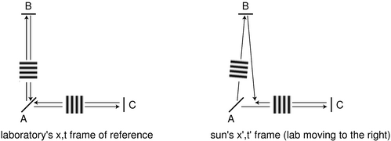In this exercise you will analyze the Michelson-Morley experiment, and find what the results should have been according to Galilean relativity and Einstein's theory of relativity. A beam of light coming from the west (not shown) comes to the half-silvered mirror A. Half the light goes through to the east, is reflected by mirror C, and comes back to A. The other half is reflected north by A, is reflected by B, and also comes back to A. When the beams reunite at A, part of each ends up going south, and these parts interfere with one another. If the time taken for a round trip differs by, for example, half the period of the wave, there will be destructive interference.
The point of the experiment was to search for a difference in the experimental results between the daytime, when the laboratory was moving west relative to the sun, and the nighttime, when the laboratory was moving east relative to the sun. Galilean relativity and Einstein's theory of relativity make different predictions about the results. According to Galilean relativity, the speed of light cannot be the same in all reference frames, so it is assumed that there is one special reference frame, perhaps the sun's, in which light travels at the same speed in all directions; in other frames, Galilean relativity predicts that the speed of light will be different in different directions, e.g. slower if the observer is chasing a beam of light. There are four different ways to analyze the experiment:
- Laboratory's frame of reference, Galilean relativity. This is not a useful way to analyze the experiment, since one does not know how fast light will travel in various directions.
- Sun's frame of reference, Galilean relativity. We assume that in this special frame of reference, the speed of light is the same in all directions: we call this speed c. In this frame, the laboratory moves with velocity v, and mirrors A, B, and C move while the light beam is in flight.
- Laboratory's frame of reference, Einstein's theory of relativity. The analysis is extremely simple. Let the length of each arm be L. Then the time required to get from A to either mirror is L/c, so each beam's round-trip time is 2L/c.
- Sun's frame of reference, Einstein's theory of relativity. We analyze this case by starting with the laboratory's frame of reference and then transforming to the sun's frame.
Groups 1-4 work in the sun's frame of reference according to Galilean relativity.
Group 1 finds time AC. Group 2 finds time CA. Group 3 finds time AB. Group 4 finds time BA.
Groups 5 and 6 transform the lab-frame results into the sun's frame according to Einstein's theory.
Group 5 transforms the x and t when ray ACA gets back to A into the sun's frame of reference, and group 6 does the same for ray ABA.
Discussion:
Michelson and Morley found no change in the interference of the waves between day and night. Which version of relativity is consistent with their results?
What does each theory predict if v approaches c?
What if the arms are not exactly equal in length?
Does it matter if the “special” frame is some frame other than the sun's?
\extitle{B}{Sports in Slowlightland}
In Slowlightland, the speed of light is 20 mi/hr ≈ 32 km/hr ≈ 9 m/s. Think of an example of how relativistic effects would work in sports. Things can get very complex very quickly, so try to think of a simple example that focuses on just one of the following effects:
- relativistic momentum
- relativistic kinetic energy
- relativistic addition of velocities
- time dilation and length contraction
- Doppler shifts of light
- equivalence of mass and energy
- time it takes for light to get to an athlete's eye
- deflection of light rays by gravity
\end{exsection}

Footnotes
[1] See discussion question F on page 336, and homework problem 22
[2] The definition Δ t²-Δ x²-Δ y²-Δ z² is equally valid. It's just a matter of convention. You have to be careful when using the literature to make sure you don't mix equations that assume inconsistent choices of the signs.
[3] “Hadron” refers to particles like protons and neutrons, which participate in nuclear forces.

http://www.lightandmatter.com/html_books/0sn/ch01/ch01.html
http://www.lightandmatter.com/html_books/0sn/ch02/ch02.html

